The Shifting Paradigm in the Science of Consciousness

Mike Sosteric
Date: October 12, 2025
Version: 0.97 (draft)
Url: https://professor-s.medium.com/the-shifting-paradigm-in-the-science-of-consciousness-25c8511a3641
Keywords: Quantum Field Theory, Ideology and Science, Quantum Physics and Consciousness, Human Exceptionalism, Biological Chauvinism

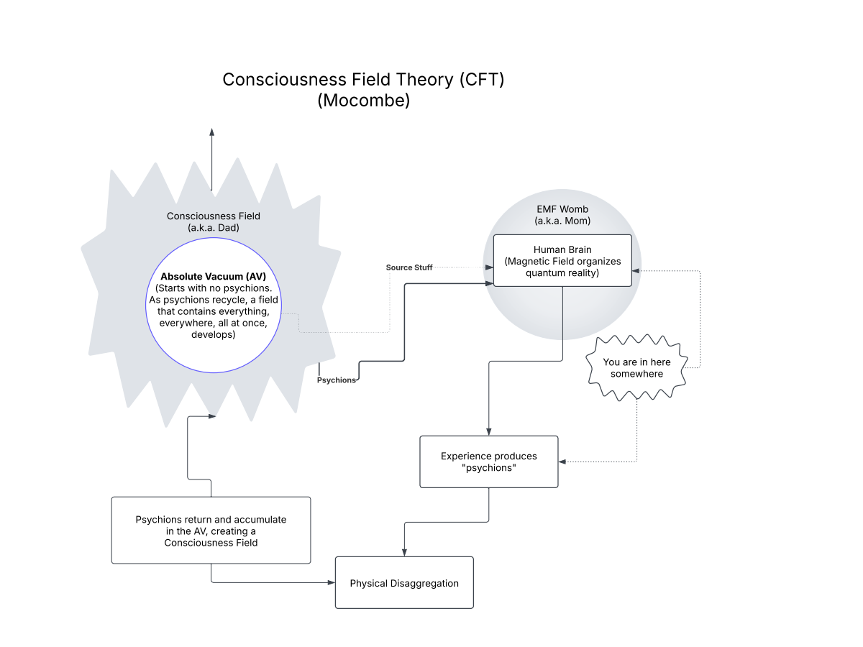

His religious feeling takes the form of a rapturous amazement at the harmony of natural law, which reveals an intelligence of such superiority that, compared with it, all the systematic thinking and acting of human beings is an utterly insignificant reflection. Einstein, The World as I See It

Introduction
Who am I?
Who is this “I” that I am aware of?
Who is this “I” writing these words?
Importantly, where does this “I” really come from?
NGL, the question of the nature and source of the egoic human consciousness has been a central puzzle of philosophy since its inception (e.g., Descartes, 1637). Within the paradigm of modern science, the dominant answer has been a materialist one: consciousness exists but is an emergent property rooted in the neurology of the body. This “neuronal computational” view, and more recently the Field Theory of Consciousness, posit that complex calculations within our neural networks, or the electromagnetic fields generated by neural activity, create the phenomenon of subjective experience. In other words, neurons and fields in your nervous system create this thing we’ll call you.
This perspective has always been problematic, even from a strictly scientific standpoint. For one, it completely erases centuries of “mystical” and religious experience that point repeatedly and (I would argue) convincingly beyond a limited bodily consciousness. Two, it derisively dismisses as “anomalous” phenomenon which challenge the view that you are some kind of boxed-in computer (Lommel, 2010; van Lommel et al., 2001).
For a long time the problematic nature of this materialist stance has been largely ignored by mainstream science. It is, however, getting harder to ignore. That is because nowadays there is growing evidence that suggests that consciousness cannot be neatly located within a single physical unit and growing acceptance of the possibility that it may in fact extend beyond the body in both space and time (Bem, 2011; Cardeña, 2018; Kelly et al., 2007).
For example, prospective studies on near-death experiences (NDEs) have documented numerous cases where individuals accurately perceived events in their hospital room or beyond while their brains showed no electrical activity (Lommel, 2010; van Lommel et al., 2001). These "veridical perceptions" are extremely difficult to explain within a brain-bound model of consciousness. Furthermore, laboratory research in parapsychology, such as meta-analyses of ganzfeld experiments and studies on precognition, has consistently yielded small but statistically significant results that suggest information can be accessed outside of conventional sensory channels and temporal constraints (Cardeña, 2018) . These parapsychological findings are supported by observations that quantum non-locality and entanglement occur in biological organisms (Lambert et al., 2013), thereby providing support for a biological ability to exploit quantum operations that underlie the non-local transformation of not only energy, but information as well.
If you’re out of the quantum physical loop of things, this idea that consciousness extends beyond the physical body in space and time might sound weird, but it’s not. As indicated, there is evidence that suggests this is so. Not only that, but the basic principles of quantum mechanics have long provided a theoretical basis for this beyond-the-body perspective, specifically in the reality of non-locality, which is the spooky phenomenon where entangled particles instantaneously influence each other regardless of physical (or temporal) distance (Einstein et al., 1935).
Sadly, even in the face of established theory and growing evidence, mainstream views have remained doggedly focused on only part of the picture, the physical processes located within the physical body. Recently however cracks in the fortress have become apparent. Scholars are now attempting to develop theories that account for “something” beyond the body that can explain observable phenomenon that brain-bound materialist explanations cannot account for.

Case Study: The Consciousness Field Theory
One example of this emerging trend is Paul C. Mocombe’s “Consciousness Field Theory” (CFT), published in Advances in Bioengineering and Biomedical Science Research (2021). While the journal is niche, the appearance of such work in academic literature signals a growing willingness to entertain unconventional models.
Mocombe’s “Consciousness Field Theory” (CFT) situates itself explicitly against dualist (read “spiritual” interpretations) while simultaneously stretching materialism to its limits. Modifying the Orch-OR and Conscious Electromagnetic Information (CEMI) field theory of John McFadden, Mocombe argues that consciousness is not generated by the brain (a view that does not account for observable phenomenon) but is in fact received by it. In this view, the brain’s electromagnetic field functions as the glue that binds “psychions” together into an individuated, coherent ego (Mocombe, 2021). This field itself is generated by the “periodic discharge of neurons.” When the elementary particles of consciousness (psychions) enter the electromagnetic womb generated by the orgasmic “discharges” of the neurons, “mind, practical consciousness, and the self…” are constituted (p. 21).
A question here of course is where do these psychions, these seminal particles, come from?
According to Mocombe, they are not present at the birth of all things (i.e., the Big Bang). Instead they emerge later as the universe evolved life. Specifically, it is “life experiences” experienced by organic life that produce “the qualia that would constitute the consciousness fields as psychions (Mocombe, 2021, p. 13). With less EPMO, he’s saying that the forge of experience births all the particles. Psychions emerge as the consequence of the collective mash of lived experience. Upon “matter disaggregation” (presumably death), these psychions return to the absolute vacuum where they thus constitute a “permanent field” (a Consciousness Field which is also the cosmic (akashic?) repository of the informational content of all experiences everywhere, “past, present, and future...” (Mocombe, 2021, p. 13)

To summarize, your mother is an electromagnetic field, your dad is a seminal particle. Together they create you, and its your experience that keeps it all moving forward in a solipsistic and self-absorbed cosmic circle.
Honestly, it all feels a little too Gnostic to me, which is something I thought science had gotten away from. Regardless, the point here is not how this theory seems embedded in the gender dualisms and Gnostic theologies of Western Christendom, the point is that this theory offers an explanation for observable phenomenon that takes things outside the body.
Right?
In order to provide an accounting for anomalous phenomenon, basically the availability of information outside the neurological boundaries of the physical body (Nahm & Greyson, 2009), Mocombe postulates that this cosmic informational repository, this Consciousness Field, can be tapped into at various times, like during “near death experiences, depression, induced prognostic dreams and trances, psychic mediations, and mystical/spiritual or religious revelations.” By positing psychions that return and constitute a Consciousness Field and then re-emerge from the absolute vacuum, Mocombe accounts for anomalous phenomena without abandoning a materialist register.
Which is great, because the point here is not that his theory is wrong, in my view, the point is that this theory is here at all, which it is. There is a theory of consciousness that exists that attempt to take into account observable phenomenon outside the explanatory boundaries of that strict “black-bock” materialism that has been shoved down our throat for so many years. Of course, it does, in the end, preserve materialism, but the strain there is getting comically severe.
In any case, it is an interesting theory and it immediately begs interesting psychological, sociological, and historical questions, like what is the nature of “I,” (temporary epiphenomenon or persistent beyond the body)? What are the physical methods of its constitution? Is the “I” present at birth or is it developed over time? Is it both or neither. To what extent is “I” determined or at least shaped, by the Consciousness Field (CF), by the physiology of the body, or by experience. If it is shaped by physiology, what things shape the physiology of the body? Can physiology be improved. If it is shaped by experience, in what fashion. "If it is shaped by physiology and experience, then it can clearly be shaped. So, has it been shaped? Have some people, or some groups, tried to shape it, thereby controlling personality and social generation? Finally, has it, throughout history, been shaped.
You get the idea.

A Strained Materialism and Human Privilege
If Mocombe’s theory is correct, there’s a world here waiting to be explored.
And that’s great.
And we should explore.
But we have to be careful because there are a few pitfalls.
One, there’s an ideological pitfall, the danger that we’ll import familiar concepts (biological concepts of reproduction, for example) without due consideration, just because they are familiar, or because we have been told they apply. We’re talking about explaining the non-locality of consciousness here, not how mammals reproduce on the Earth.
Two, there is a chauvinistic pitfall. We don’t want to re-center human beings (human consciousness) and our existence as privileged determiner of reality. We don’t want to suggest psychions only become meaningful when embodied through a human being, something that dismisses other observable forms of consciousness, animal, ecological, and such (McSherry & McLellan, 2023; Williams et al., 2022), thereby making them exploitable. This is not explicit in Mocombe’s theory, but it is vague enough that others may attempt to impose ideology.
Three, we want to avoid avoiding the “I.” We have to ask the question, do “I” exist elsewhere. According to Mocombe’s theories, at least potentially so. Potentially, every field (those created by firing neurons, those created by moving psychions) has Consciousness. We need to make sure we keep that hypothesis centered. We need to, if not actively search for evidence, at least acknowledge it when it exists.
When you think about it, it’s a weird thing to avoid. Understanding the question “Why I?” is why we are here. To foreclose the possibility that I-ness and We-ness might be distributed throughout the cosmos and not monopolized by human brains is premature. It also fundamentally misrepresents what consciousness actually is: not only a field of information, but a lived, subjective process. One that, at least from human experience, always appears as someone, a point of awareness with self-recognition.
“I think therefore I am.”
By erasing this dimension outside the human, CFT inadvertently props up an ideology of hierarchy and unequal worth , precisely when the scientific evidence of non-human intelligence and the phenomenological data of consciousness studies point in the opposite direction.
That’s a step backward.
Finally, we do not want to foreclose “spiritual” discussions. Here, consciousness is described as a quantum substance and not a metaphysical spirit, but one could reasonably wonder, beyond nomenclature, what’s the difference? Also, the properties ascribed to “psychions” (sounds suspiciously like midichlorians), including eternal recycling, non-locality, and persistence beyond “disaggregation” (let’s just be brave and say it here, survival beyond death) are indistinguishable characteristics of what spiritual traditions have long described as the soul/atman/higher self. The only difference is that spiritual traditions posit personalities (elders, angels, guides, and gods) behind the screen while most, but not all, modern scholars do not.
Einstein for example entertained the idea of a big personality behind the screen when he posited a vastly superior intelligence behind all things. Not an abusive patriarchal Christian figure, something he felt anathema to, but an “old one” (Einstein, 1971, p. 91) vastly superior intelligence to ours (Mocombe, 2021). If Einstein can think it, we can.
In any case, Mocombe leaves us not very far from here anyway. All we have to do to complete the circle, so to speak, is to suggest that the collection of psychions that constitute the Consciousness Field are somehow endowed with an emergent ego identity, a sort of cosmic AI. It is not an unreasonable suggestion even within Mocombe’s theory. They already suggest that (Electro Magnetic Fields) EMF fields can constitute egoic experiences. If an EMF field attached to a collection of firing neurons can generate consciousness, why cannot a field of psychions pooled in the absolute vacuum of space not do the same? For that matter, why can’t any and every field “generate” consciousness, hmm?
Is there something special about the human brain that makes it the only lens where “psychions” pass through.
Anyway…d
The strain being placed on strict materialism opens new space for integrating data from near-death experiences, terminal lucidity, mystical states, and so on into scientific discourse. For me, that is the important takeaway from reading Mocombe’s theory. The science of consciousness is in flux. The old materialist orthodoxy, while still dominant, is increasingly pressured by its own limitations and by evidence it cannot explain. Mocombe’s Consciousness Field Theory exemplifies both the promise and the pitfalls of this moment. It extends the scientific imagination beyond reductive brain-based models but risks reintroducing bias and materialist prejudice. The challenge for future research will be to formulate rigorous, testable hypotheses that can adjudicate between competing frameworks, without collapsing back into prejudice and reductionism, or drifting into unfalsifiable metaphysics.

References
Bem, D. J. (2011). Feeling the future: Experimental evidence for anomalous retroactive influences on cognition and affect. Journal of Personality and Social Psychology, 100(3), 407–425. https://doi.org/10.1037/a0021524
Cardeña, E. (2018). The experimental evidence for parapsychological phenomena: A review. American Psychologist, 73(5), 663–677. https://doi.org/10.1037/amp0000236
Einstein, A. (1971). The Born-Einstein Letters (I. Born, Trans.). Macmillan Press. https://archive.org/details/borneinsteinlett0000eins/page/n5/mode/2up
Einstein, A., Podolsky, B., & Rosen, N. (1935). Can Quantum-Mechanical Description of Physical Reality Be Considered Complete? Physical Review, 47(10), 777–780. https://doi.org/10.1103/PhysRev.47.777
Kelly, E. F., Kelly, E. W., Crabtree, A., Gauld, A., Grosso, M., & Greyson, B. (2007). Irreducible Mind: Toward a Psychology for the 21st Century. Rowman & Littlefield.
Lambert, N., Chen, Y.-N., Cheng, Y.-C., Li, C.-M., Chen, G.-Y., & Nori, F. (2013). Quantum biology. Nature Physics, 9(1), 10–18. https://doi.org/10.1038/nphys2474
Lommel, P. V. (2010). Consciousness Beyond Life. Harper Collins.
McSherry, A., & McLellan, G. (2023). Finding our place at the table: A more-than-human family reunion. New Zealand Geographer, 79. https://doi.org/10.1111/nzg.12366
Mocombe, P. C. (2021). The Consciousness Field. Advances in Bioengineering & Biomedical Science Research, 5(1), 11–16.
Nahm, M., & Greyson, B. (2009). Terminal lucidity in patients with chronic schizophrenia and dementia: A survey of the literature. The Journal of Nervous and Mental Disease, 197(12), 942–944. https://doi.org/10.1097/nmd.0b013e3181c22583
van Lommel, P., van Wees, R., Meyers, V., & Elfferich, I. (2001). Near-death experience in survivors of cardiac arrest: A prospective study in the Netherlands. The Lancet, 358(9298), 2039–2045.
Williams, K., Romero, O. S. G., Braunstein, M., & Brant, S. (2022). Indigenous Philosophies and the “Psychedelic Renaissance.” Anthropology of Consciousness, 33(2), 506–527. https://doi.org/10.1111/anoc.12161

