A Letter to the Accumulating Class II — You Have a Choice

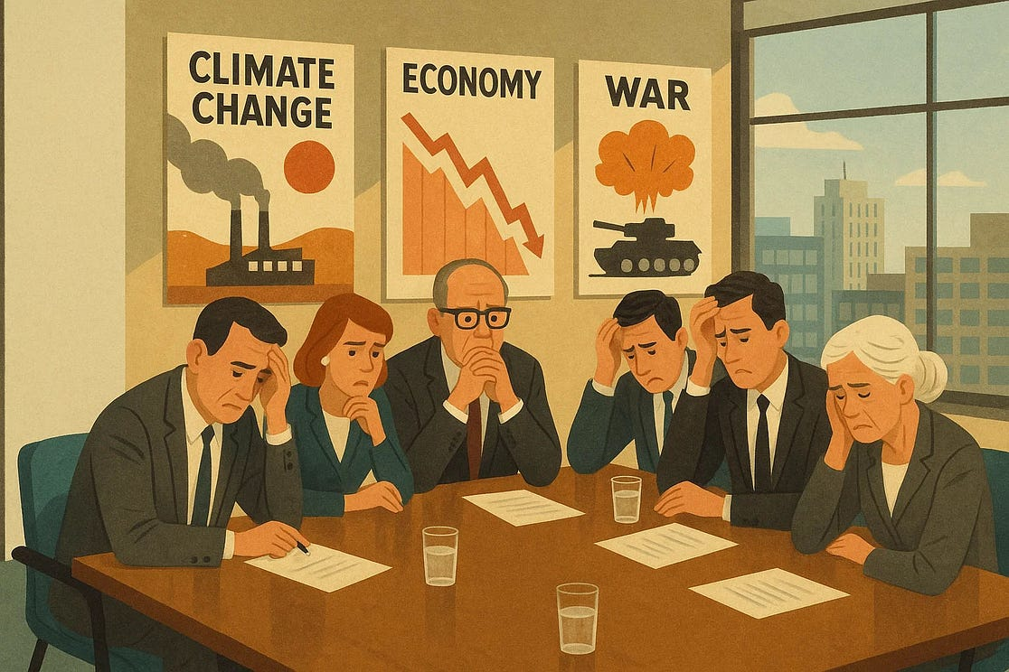
You, members of the accumulating class, have been warned. For decades, scientists, environmentalists, mystics, and Indigenous stewards have been sounding the alarm: your system is killing the planet. Now, as of September 2025, the oceans have failed a key planetary health check. Acidification has crossed a critical threshold, threatening the structural integrity of marine life. This is not reversible by future “innovation.” No tech-bro will save you from the end. Front and center, this is collapse happening faster than anybody, even the most dystopian scholars, had predicted.

I. Your Regime Has Failed — Catastrophically
It’s not surprising, really. Humans (that includes you) are, in cosmic terms, a baby species, barely out of diapers, bang-banging around the world. The Regime of Accumulation you operate within is killing the planet. It was never coded for resilience; its core logic is extraction, hoarding, and control—a script that inevitably privileges the few at the expense of the whole Your metrics (GDP, ROI, stock performance) focus exclusively on extraction of surplus labour value. They are ideologically dislocated from ecological reality and human need.
If you keep ignoring reality, the planet will reach a hard limit, sooner than you think.
It is inevitable, and you know it.
Hence the bunkers.
You have known it for decades.
Your own children see it.
They have asked you to stop.
The system's playbook offers only escalation: carbon offset fantasies, greenwashed marketing, and the relentless pressure for more—more consumption, more pipelines, more deforestation, more accumulation. It's a script that demands growth, even when you know it's fictional. You feel the pressure to escalate, because to stop is to let the machine roll over you.
War because war distracts and kills.
War because, like mass consumption, war gives you money to burn.

II. The Accelerating Polycrisis
You have to know, and I know you know, it is more than just the environment. We, the planet and our bodies, face what scholars call a polycrisis, multiple, interconnected crises that converge and amplify each other in a way that causes a “predicament” that is not easy to resolve, to put it lightly.
The biggest crisis here is COVID, a BSL-2 virus that you decided, in service to commercial interests, to let rip. Recent multiple large cohort studies confirm what patients and insiders long suspected: COVID-19 is not a respiratory illness; it is a whole-system attack. It has multi-system, immunological impacts (ref1, ref2, ref3). It weakens the body, damages organ systems, and makes it more vulnerable to everything.
Oh my lord.
The system you're in, prioritizing short-term commerce over long-term vitality, failed to process the COVID signal. It was treated as a PR problem, not an existential assault on The System (The Regime). The result? A policy of disconnection that has let a pathogen become a pervasive, disabling burden on billions. This is not a conspiracy; it's a catastrophic systems failure—a failure to connect the dots between public health, economic stability, and human capital.
You’ve let COVID spin in the population for over five years now. If current estimates are anywhere near correct, this means billions of people are living with damage that will get progressively worse as time passes.
Like the damage caused by AIDS, this will only start to show up gradually five to ten years after infection.
Sadly, it will be easy for people to miss.
You have created a world of distractions.
You have used corporations to gaslight the population mercilessly.
It will, however, be obvious to anybody that looks.
The body, our body, your body, will begin to crumble and fall apart, just like the planet. Diminished capacities, early senescence, and perpetual sickness will be the tip of the iceberg. Beneath that will be serious organic dysfunctions, organ failure, and even sudden death, all accelerated by the stress your system creates and the plastics your production systems spew into the world.
What happens when billions of people, their health and futures diminished by a system they didn't design, wake up to the fact that the script is broken? The distractions will fail. The 'social license' your operations rely on will evaporate.
What do you think they will do when your distractions no longer work and they realize all the damage you have caused?
You think a digital ID is going to help you control the population?
Is this why you are building your fortresses?

III. The Illusion of Insulation
Of course, you are the quintessential organizers and planners; of that, there can be no doubt. So…
Perhaps collapse is part of your plan.
You are “special,” after all.
You are “chosen.”
You have a birthright.
Perhaps you think your blood, your genetics, your accumulated wealth manifested into security drones and electrical fences will provide insulation from disease, converging failures, and collapse.
Maybe. But personally, I doubt it.
Despite your propaganda, you’re not special, not really.
Your talent, really, is organization. That’s all. You can manage the labour, production, and distribution process with incredible finesse.
But listen here: your blood is not going to protect you from what’s coming. Not even the most advanced AI will be able to halt accelerating warming.
No amount of organization is going to turn a dead planet back to life again.
You don’t want to believe this is true, but in your heart, you know it is. People are already dying and it’s just going to keep getting worse.
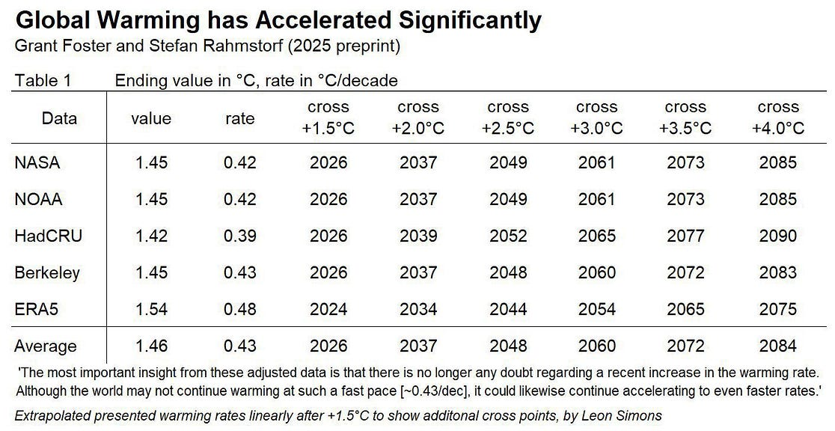
Do you know what this planet will look like when we breach the +4.0 C point? Here’s an AI evaluation for you. It’s not pretty. And these projections might yet be too conservative. If there is one thing that characterizes the community of climate scientists right now, it is shock at the acceleration. They don’t know WTF.
On our current trajectory, we will soon we will breach all known tipping points.
Once cascades begin (if they haven’t already), your fortress will shatter from within. The collapse of the AMOC will shift rainfall belts. The dieback of the Amazon will break down the moisture conveyor that sustains global climates. The Antarctic sea ice decline already amplifies warming. Each broken threshold magnifies the stress on every other system. Carbon emissions are accelerating, not declining. The entire global system will collapse. It is only a matter of time. When it does, when marine ecosystems collapse, when climate change wipes out global harvests and billions start to go hungry, no amount of technology, no amount of capital, will save you or the predatory operating system you’ve mistaken for intelligence.

It won’t matter that you can control all the social media.
It won’t matter that you’ve got an army of armed thugs.
When survival is at stake, the narrative shifts. The story that painted you as 'builders' and 'visionaries' will crumble, revealing the underlying logic of extraction. You will be seen not as villains, but as the high priests of a failing religion of accumulation.
The old imagery of peasants with clubs and pitchforks is from another time.
You won’t be fighting peasants with pitchforks. You’ll be facing the engineers, doctors, teachers, and technologists — the very people who built and now maintain your systems. These people know how the infrastructure works. And they know what you’ve done. When the veil drops, you will not be protected by your wealth or your weapons.

IV. Help Birth a New Global Consciousness
It doesn’t have to be this way. We can change, but we need to change fast, and the fastest way is through reconnection to the Fabric of Consciousness, because disconnection from The Fabric is the root of our crisis. All other crises, environmental, political, psychological, cascade from this primary severance.
In order to do that, in order to foster reconnection, we need a new Comprehensive Framework, something that can change our collective thinking. We need a new framework for human civilization — one that prioritizes connection, not domination.
It’s not rocket science. We need
- A post-accumulation economy centred on satisfaction of humanity’s Seven Essential Needs, not greedy accumulation, and we need it now.
- A new planetary ethics grounded in strict non-violence (Ahimsa) toward all beings.
- Medical and psychological systems focused on healing all the damage caused by the Toxic Socialization.
- Thoughts and practices that lead to authentic reconnection, and not the watered-down nonsense (positive psychology, mindfulness, etc.) we see now.
- A Symbiotic Planetary Knowledge System devoted to human development and the actuation of full human potential, untainted by your twisted ideology (I’m talking to you here, Elon).
- A global movement of awakened humans willing to put aside a system built to extract, hoard, control, and feed the “chosen few.”
- Community ownership of land, labor, tools, and governance — including worker cooperatives, public-interest infrastructure, and decommodified housing, food, and care.
- Regenerative systems that repair ecosystems, protect biodiversity, and stop treating the planet like a dead thing to be owned, mined, and sold.
- Media systems liberated from elite control and reoriented toward truth, repair, and narrative liberation.
- The HEALING Framework deployed as a global protocol to end lying, dismantle ideology, and ensure sustained needs satisfaction at every level of society.
- A global upgrade in human consciousness, raising the Consciousness Quotient (CQ) through various Connection Practices so we can see clearly, feel deeply, and act ethically.
- A conscious transition culture — one that prepares for collapse without panic, honours death as part of the cycle, and treats this moment as a planetary rite of passage.

V. You Have One Choice Left
So here is your final strategic choice: You can continue executing the old, glitching script, praying your capital can outrun the externalities it created. Or, you can use your organizational prowess—your real talent—for the ultimate turnaround: to rebuild a world where Connection, not accumulation, is the organizing principle.
You can be the last executors of a dying regime, or the first architects of a new one.
This means a final, spiritual choice:
You can keep believing the old script—that you'll survive climate change in a bunker, that a sanctuary on Mars is a viable plan.
Or, you can renounce the lie of separation. Abandon the myth of supremacy. Rejoin the Fabric of Consciousness, and use your prowess to return what you've extracted.
Remember, reconnection is not a mood. It’s a mandate. It requires real changes in structure, incentives, and attention. The HEALING work begins when you stop harming, stop lying, and start building something that can last longer than your brand equity.
That’s your choice.
Join us.
Help us.
Participate in unification and planetary repair.
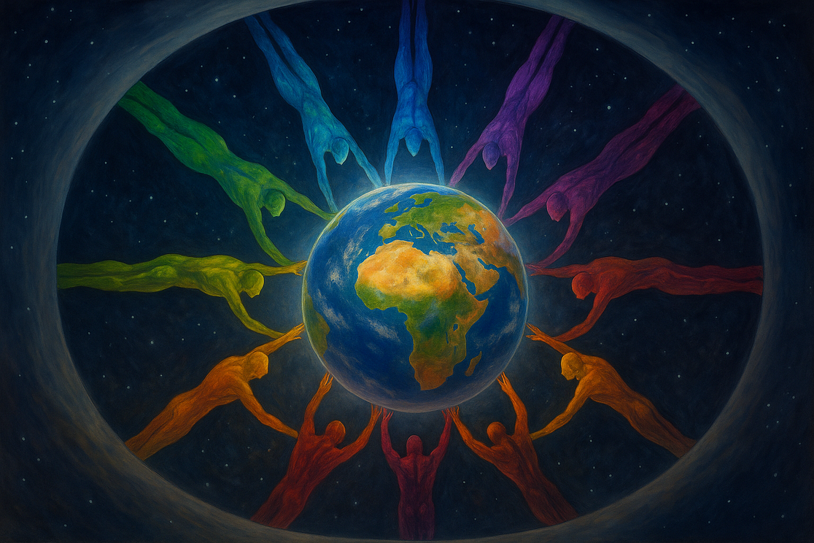
Or…
Pray and hope for the best.

