The Shifting Paradigm in the Science of Consciousness

Mike Sosteric
Date: October 12, 2025
Version: 0.95 (draft)
Medium URL: https://thelightningpath.medium.com/the-shifting-paradigm-in-the-science-of-consciousness-93b6314c7f21
Keywords: Quantum Field Theory, Ideology and Science, Quantum Physics and Consciousness, Human Exceptionalism

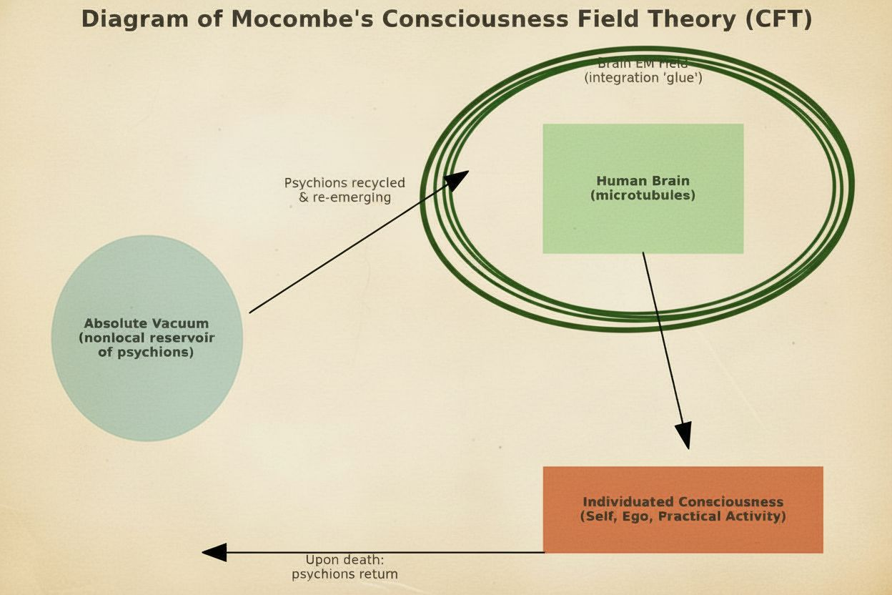

Introduction
The question of the source of human consciousness has been a central puzzle of philosophy since its inception (e.g., Descartes, 1637). Within the paradigm of modern science, the dominant answer has been a materialist one: consciousness exists but is an emergent property rooted solely in the neurology of the brain and body. This "neuronal computational" view posits that complex calculations within our neural networks generate the phenomenon of subjective experience.
However, this perspective has always been problematic, even from a strictly scientific standpoint, due to a growing body of evidence suggesting that consciousness is not neatly located within a single physical unit but may extend beyond it in both space and time. The principles of quantum mechanics have long provided a theoretical basis for this, with non-locality—the phenomenon where entangled particles instantaneously influence each other regardless of distance—challenging classical notions of localized cause and effect (Einstein et al., 1935) (The EPR that first highlighted the "spooky action at a distance" of quantum entanglement). Prominent physicists like Roger Penrose and Stuart Hameroff have argued that these quantum effects are not confined to the microscopic realm but are central to the workings of consciousness itself, proposing that microtubules within brain neurons orchestrate objective reductions of the quantum wave function (Hameroff & Penrose, 2014). This "Orch-OR" theory directly implies that consciousness is fundamentally tied to the non-local fabric of spacetime.

A Reluctant Shift in the Mainstream
Recently, a significant shift has begun. Prominent voices in neuroscience and physics are now forcing the mainstream to admit that a simple, brain-bound materialist explanation is insufficient to account for all observable phenomena. For instance, the well-documented occurrence of veridical out-of-body experiences during cardiac arrest (van Lommel et al., 2001) , where patients acquire information they could not have through ordinary sensory means, challenges the assumption that consciousness is dependent on an active brain. Similarly, the Hard Problem of Consciousness, famously articulated by philosopher David Chalmers, highlights the explanatory gap between physical brain processes and the qualitative, subjective nature of experience itself; why should certain neural firings feel like anything at all? These issues have pushed the boundaries of the debate, forcing a re-evaluation of long-held materialist assumptions.

Case Study: The Consciousness Field Theory
One example of this emerging trend is Paul C. Mocombe’s “Consciousness Field Theory” (CFT), published in Advances in Bioengineering and Biomedical Science Research (2021). While the journal is niche and not a top-tier platform, the appearance of such work in academic literature signals a growing willingness to entertain unconventional models.
Mocombe’s theory situates itself explicitly against dualist or spiritual interpretations while simultaneously stretching materialism to its limits. Building on Orch-OR and Johnjoe McFadden’s CEMI field theory, Mocombe argues that consciousness is not generated by the brain but received by it. The central claim: consciousness is a fifth force of nature, composed of quantum particles he names psychions. These particles, carrying the informational content of lived experiences across the multiverse, recycle through the absolute vacuum upon death. Mocombe argues that adding this recycling is necessary, Mocombe argues, because of the observable anomalies in which information appears to persist or transmit beyond the confines of an individual’s limited biological existence. Cases such as veridical near-death experiences (van Lommel et al., 2001) and terminal lucidity in advanced dementia (Nahm & Greyson, 2009) suggest that consciousness can access information not explainable by brain-based models. By positing psychions that return to and re-emerge from the absolute vacuum, Mocombe seeks to account for these phenomena without abandoning a materialist register.
In this view, the brain’s electromagnetic field functions not as the origin of consciousness but as the glue that binds psychions into an individuated, coherent ego (Mocombe, 2021)
The elegance of this model lies in its attempt to bridge neuroscience, quantum physics, and sociological structuration. For Mocombe, consciousness is emergent, material, and universal, yet it becomes uniquely expressed through human social systems: language, ideology, praxis, and institutional structures. This integration ties his physics of the “consciousness field” directly into his broader philosophical framework of phenomenological structuralism.

A Strained Materialism and Human Privilege
Mocombe’s account is deeply ambitious but also internally strained. On one hand, it maintains a strict materialist register. Consciousness is described as a quantum substance, not a metaphysical spirit (one could reasonably wonder what the difference is). On the other, the properties ascribed to “psychions” (sounds suspiciously like midichlorians), including eternal recycling, non-locality, survival beyond death, are indistinguishable characteristics of what spiritual traditions have long described as the soul/atman/higher self. The only difference is that spiritual traditions posit a personality behind the screen. His effort to exclude “superstition” results in what might be described as crypto-metaphysics: a rebranded soul theory cloaked in the language of physics.
Moreover, despite invoking the multiverse and cosmic recycling, the model re-centers human consciousness and existence as privileged. Psychions become meaningful only when embodied through a human being. Other forms of consciousness—animal, ecological, or more-than-human intelligences (McSherry & McLellan, 2023; Williams et al., 2022) —are all assumed to be imaginary, inferior, and subsequently relegated to an undefined space. Thus, while CFT aspires to a universal account, it risks reinscribing human exceptionalism under a new guise.

Wider Implications and Critical Reflections
The productive turmoil in consciousness studies mirrors broader paradigm shifts in science. The erosion of strict materialism opens new space for integrating anomalous data, near-death experiences, terminal lucidity (Nahm & Greyson, 2009), and mystical states. into scientific discourse. The risk, however, is twofold:
- Testability – Theories such as Orch-OR and CFT must be subjected to rigorous empirical evaluation. Without falsifiable predictions, they risk being dismissed as speculative metaphysics. At present, both models remain underdetermined, offering more philosophical frameworks than testable hypotheses. Yet, there are potential experimental footholds, something we may explore at a later date.
- Fearlessness – Progress in consciousness research requires a willingness to confront possibilities that may seem, to the Western European philosophical tradition, uncomfortable or scientifically disruptive. Theorists must resist the ingrained bias of excluding non-materialist explanations a priori. Evidence from near-death experiences, terminal lucidity, and quantum non-locality increasingly suggests that the boundaries of consciousness may extend beyond the brain. To dismiss these possibilities or fail to fully explore the implications out of fear of appearing “unscientific” risks stifling genuine discovery. True scientific integrity demands openness: hypotheses should be evaluated on their explanatory power and evidential support, not on whether they conform to inherited metaphysical preferences.
- Repackaging – In attempting to present themselves as rigorously materialist, some theories of consciousness end up embedding ideological assumptions that serve existing systems of hierarchy and accumulation. The language of Mocombe’s Consciousness Field Theory (CFT) exemplifies this: while proposing a universal consciousness field, it nevertheless re-centers the human brain as the privileged vessel of individuation. In this view, psychions only achieve a coherent “self” when filtered through human neuronal microtubules. This quietly reasserts human exceptionalism while denying that other things, other beings, even beings without a body, could possess a recognizable “I” or “We.”
From a critical standpoint, this is not metaphysical repackaging but an ideological reassertion. The accumulating class historically grounds its power in narratives of hierarchy: humans over animals, elites over commoners, rational “selves” over allegedly irrational or sub-personal beings. By claiming that non-human consciousness lacks personhood, that it is mere informational flux without subjectivity, CFT reproduces this hierarchy in scientific guise. It affirms that individuality, self-awareness, and agency belong primarily to human actors, while everything else is consigned to the role of background, exploitable substrate. It also reintroduces space for hierarchy. Like the colour of one’s blood or one’s DNA endowment, certain human actors can have more or less “consciousness” than others.
Such handling of consciousness is doubly flawed. First, it forecloses the possibility that I-ness and We-ness might be distributed throughout the cosmos, not monopolized by humans. Second, it misrepresents what consciousness actually is: not only a field of information, but a lived, subjective process that always appears as someone, a point of awareness with self-recognition. “I think therefore I am.”
An “I” exists.
By erasing this dimension outside the human, CFT inadvertently props up an ideology of hierarchy and unequal worth — precisely when the scientific evidence of non-human intelligence and the phenomenological data of consciousness studies point in the opposite direction.
If science is to truly move forward, it must resist this ideological repackaging. Models of consciousness should not only be open to field-like or quantum accounts but must also take seriously the possibility that subjectivity, individuality, and agency are not uniquely human phenomena. Only then can research escape the gravitational pull of class-bound narratives that have long distorted both science and spirituality.
Conclusion
The science of consciousness is in flux. The old materialist orthodoxy, while still dominant, is increasingly pressured by its own limitations and by anomalous evidence it cannot explain. Mocombe’s Consciousness Field Theory exemplifies both the promise and the pitfalls of this moment. It extends the scientific imagination beyond reductive brain-based models but risks reintroducing metaphysical commitments under a materialist mask. The challenge for future research will be to formulate rigorous, testable hypotheses that can adjudicate between competing frameworks—without collapsing back into reductionism or drifting into unfalsifiable metaphysics.

References
Einstein, A., Podolsky, B., & Rosen, N. (1935). Can Quantum-Mechanical Description of Physical Reality Be Considered Complete? Physical Review, 47(10), 777–780.
Hameroff, S., & Penrose, R. (2014). Consciousness in the universe: A review of the “Orch OR” theory. Physics of Life Reviews, 11(1), 39–78.
McSherry, A., & McLellan, G. (2023). Finding our place at the table: A more-than-human family reunion. New Zealand Geographer, 79. https://doi.org/10.1111/nzg.12366
Mocombe, P. C. (2021). The Consciousness Field. Advances in Bioengineering & Biomedical Science Research, 5(1), 11–16.
Nahm, M., & Greyson, B. (2009). Terminal lucidity in patients with chronic schizophrenia and dementia: A survey of the literature. The Journal of Nervous and Mental Disease, 197(12), 942–944.
van Lommel, P., van Wees, R., Meyers, V., & Elfferich, I. (2001). Near-death experience in survivors of cardiac arrest: A prospective study in the Netherlands. The Lancet, 358(9298), 2039–2045.
Williams, K., Romero, O. S. G., Braunstein, M., & Brant, S. (2022). Indigenous Philosophies and the “Psychedelic Renaissance.” Anthropology of Consciousness, 33(2), 506–527. https://doi.org/10.1111/anoc.12161

