The Shifting Paradigm in the Science of Consciousness

Mike Sosteric
Date: October 12, 2025
Version: 0.97 (draft)
Medium URL: https://thelightningpath.medium.com/the-shifting-paradigm-in-the-science-of-consciousness-93b6314c7f21
Keywords: Quantum Field Theory, Ideology and Science, Quantum Physics and Consciousness, Human Exceptionalism, Biological Chauvinism

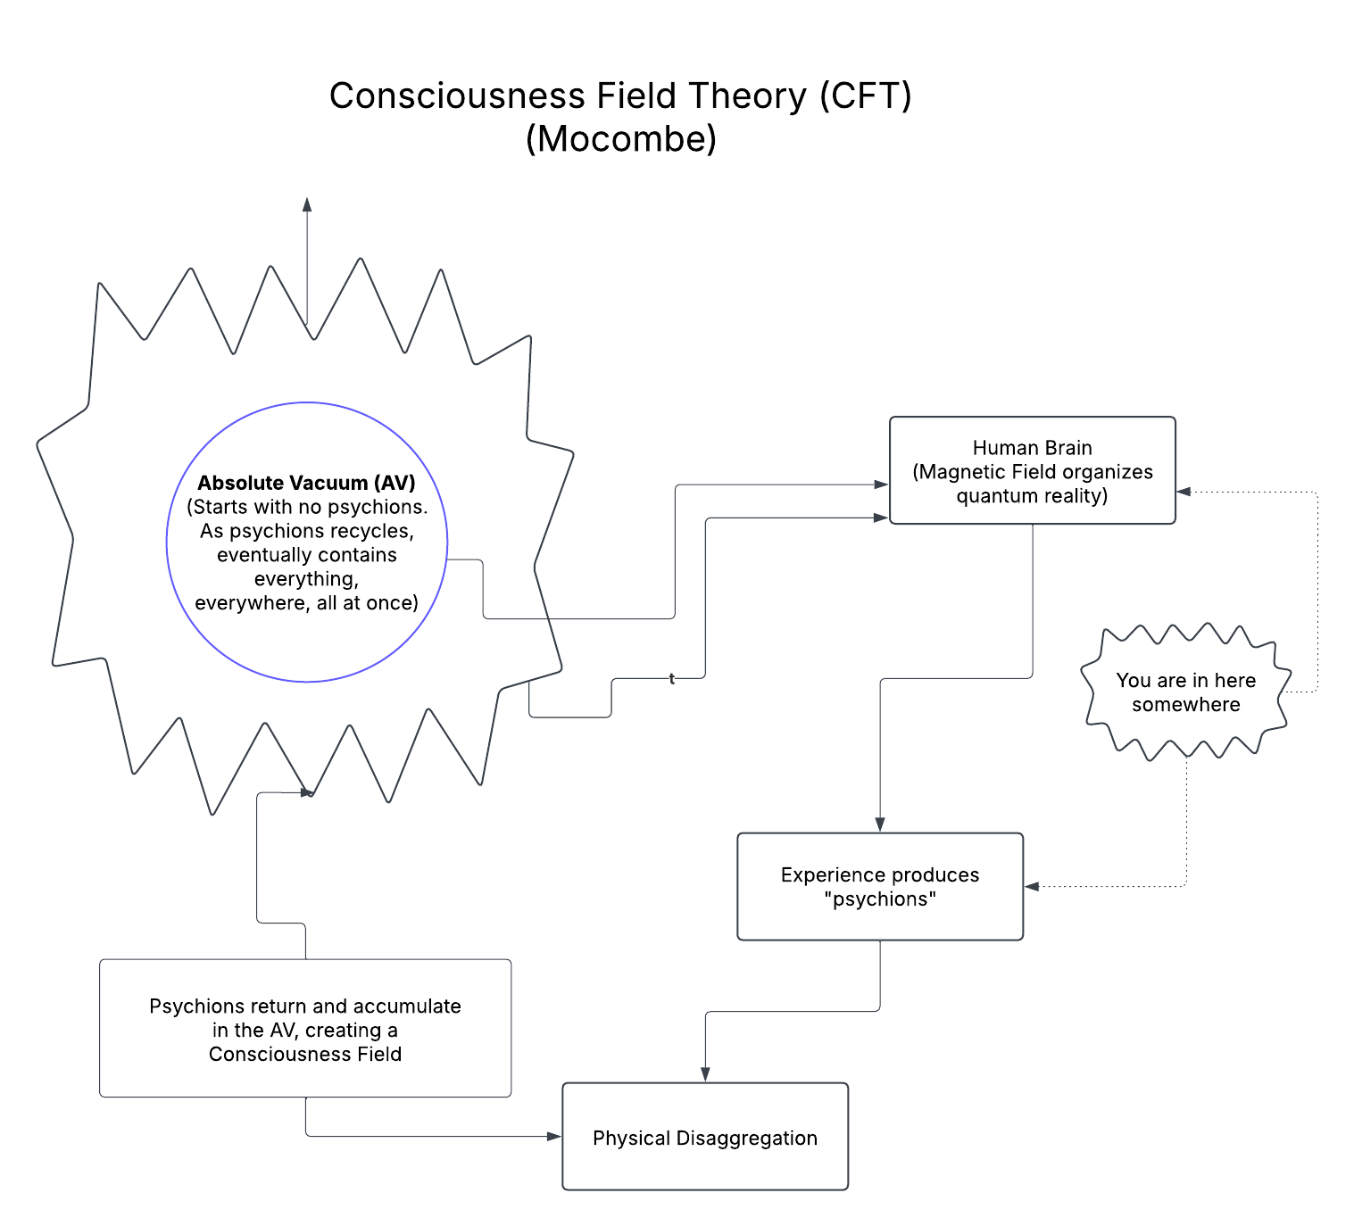

His religious feeling takes the form of a rapturous amazement at the harmony of natural law, which reveals an intelligence of such superiority that, compared with it, all the systematic thinking and acting of human beings is an utterly insignificant reflection. Einstein, The World as I See It

Introduction

Who am I?
Who is this “I” that I am aware of?
Who is this “I” writing these words?
Importantly, where does this “I” really come from?
I’m not going to lie.
The question of the nature and source of the egoed human consciousness has been a central puzzle of philosophy since its inception (e.g., Descartes, 1637). Within the paradigm of modern science, the dominant answer has been a materialist one: consciousness exists but is an emergent property rooted in the neurology of the body. This “neuronal computational” view posits that complex calculations within our neural networks generate the phenomenon of subjective experience.
This perspective has always been problematic, even from a strictly scientific standpoint. For one, it completely erases centuries of “mystical” and religious experience that point repeatedly and (I would argue) convincingly beyond a limited bodily consciousness. Two, it derisively dismisses anomalous phenomenon which challenge the brain as a boxed in computer view (Lommel, 2010; van Lommel et al., 2001).
It is getting harder to ignore, however, because nowadays there is growing evidence that suggests that consciousness cannot be neatly located within a single physical unit but may in fact extend beyond the body in both space and time (Bem, 2011; Cardeña, 2018; Kelly et al., 2007). That evidence is getting strong enough to force theoretical reconciliation.
If you’re out of the quantum physical loop of things, this idea that consciousness extends beyond the physical body in space and time might sound weird. But it’s not. The principles of quantum mechanics have long provided a theoretical basis for this beyond-the-body perspective, specifically in the reality of non-locality, which is the spooky phenomenon where entangled particles instantaneously influence each other regardless of physical or temporal distance (Einstein et al., 1935). The point is, it’s not as strange as it might first sound.

A Reluctant Shift in the Mainstream
Sadly, even in the face of established theory and growing evidence, mainstream views have remained doggedly focused on physical processes located within the physical body. Recently however cracks in the fortress have become apparent. Scholars are now attempting to develop theories that account for observable phenomenon that brain-bound materialist explanations cannot account.

Case Study: The Consciousness Field Theory
One example of this emerging trend is Paul C. Mocombe’s “Consciousness Field Theory” (CFT), published in Advances in Bioengineering and Biomedical Science Research (2021). While the journal is niche, the appearance of such work in academic literature signals a growing willingness to entertain unconventional models.
Mocombe’s theory situates itself explicitly against dualist (read “spiritual” interpretations) while simultaneously stretching materialism to its limits. Modifying the Orch-OR and CEMI field theory of John McFadden, Mocombe argues that consciousness is not generated by the brain but in fact received by it. In this view, the brain’s electromagnetic field functions as the glue that binds “psychions” together into an individuated, coherent ego (Mocombe, 2021). This field itself is generated by the “periodic discharge of neurons.” When psychions enter the electromagnetic field generated by the orgasmic discharges of the neurons, the field “constitutes” the “mind, practical consciousness, and the self…” (p. 21).
The central claim is this: consciousness is a fifth force of nature, composed of quantum particles he names psychions.
Note that these psychion particles are not present at the birth of all things (i.e., the Big Bang). Instead they emerge later as the universe evolved life. Specifically, it is the “life experiences” that life produces that produce ”the qualia that would constitute the consciousness fields as psychions (Mocombe, 2021, p. 13). To translate, psychions emerge here as the consequence of the collective mash of lived experience, experience which, upon “matter disaggregation” (presumably death) “returns” to the absolute vacuum. The returned psychions thus constitute a “permanent field” (a Consciousness Field or CF), basically a cosmic repository of the informational content of all experiences everywhere, “past, present, and future...” (Mocombe, 2021, p. 13)
It’s a bit like the old Gnostic snake eating its tail meme.
In order to provide an accounting for anomalous phenomenon, Mocombe postulates that this cosmic informational repository can be tapped into at various times, like during “near death experiences, depression, induced prognostic dreams and trances, psychic mediations, and mystical/spiritual or religious revelations.” Access to this Consciousness Field is required to explain observable anomalies in which information appears to persist or transmit beyond the confines of an individual’s limited biological existence (Nahm & Greyson, 2009). By positing psychions that return and constitute a Consciousness Field and then re-emerge from the absolute vacuum as the foundation of “I”, Mocombe accounts for anamolous phenomena without abandoning a materialist register.
It is an interesting theory and it immediately begs interesting questions, like how does the magnetic field “shape” consciousness and can that shaping be altered in some fashion, by drugs or experiences and such. Where does the “I” come from in all this? Is that present at birth or is it developed over time? How is it constituted? To what extent is it determined, by the CF or by experience? Can it be shaped, thereby controlling personality generation? Does they “I” persist after dissaggregation?
You get the idea.
If Mocombe’s theory is correct, there’s a world here waiting to be explored.
The model is brilliant and elegant in the way it attempts to bridge neuroscience, quantum physics, and even sociological structuration, but in a materialist fashion. For Mocombe, consciousness is emergent from the materials of the universe, yet it becomes uniquely expressed through human brains, human social systems, language, ideology, praxis, and institutional structures. This integration ties his physics of the “consciousness field” directly into his broader philosophical framework of phenomenological structuralism.

A Strained Materialism and Human Privilege
Mocombe’s account is deeply ambitious but also internally strained. On the one hand, it maintains a strict materialist register. Consciousness is described as a quantum substance, not a metaphysical spirit (one could reasonably wonder what the difference is). On the other hand, the properties ascribed to “psychions” (sounds suspiciously like midichlorians), including eternal recycling, non-locality, survival beyond death, are indistinguishable characteristics of what spiritual traditions have long described as the soul/atman/higher self. The only difference is that spiritual traditions posit a personality behind the screen. His effort to exclude “superstition” results in what might be described as crypto-metaphysics: a rebranded soul theory, stripped of an important essence and cloaked in the language of physics.
Moreover, despite invoking the multiverse and cosmic recycling, the model re-centers human consciousness and existence as privileged determiner of reality. Psychions become meaningful only when embodied through a human being. Other forms of consciousness, animal, ecological, or more-than-human intelligences (McSherry & McLellan, 2023; Williams et al., 2022), are all assumed to be imaginary, inferior, and subsequently relegated to an undefined space. Thus, while CFT aspires to a universal account, it risks reinscribing biological chauvinism under a new guise.

Wider Implications and Critical Reflections
The productive turmoil in consciousness studies mirrors broader paradigm shifts in science. The erosion of strict materialism opens new space for integrating anomalous data, near-death experiences, terminal lucidity, and mystical states into scientific discourse. The risk, however, is threefold:
- Testability – Theories such as Orch-OR and CFT must be subjected to rigorous empirical evaluation. Without falsifiable predictions, they risk being dismissed as speculative metaphysics. At present, both models remain under-determined, offering more philosophical frameworks than testable hypotheses.
- Fearlessness – Progress in consciousness research requires a willingness to confront possibilities that may seem, to the Western European philosophical tradition, uncomfortable or scientifically disruptive. Theorists must resist the ingrained bias of excluding non-materialist explanations a priori. Evidence from near-death experiences, terminal lucidity, and quantum non-locality increasingly suggests that the boundaries of consciousness may extend beyond the brain. To dismiss these possibilities or fail to fully explore the implications out of fear of appearing “unscientific” risks stifling genuine discovery. True scientific integrity demands openness: hypotheses should be evaluated on their explanatory power and evidential support, not on whether they conform to inherited metaphysical preferences.
- Repackaging – In attempting to present themselves as rigorously materialist, some theories of consciousness end up embedding ideological assumptions that serve existing systems of hierarchy and accumulation. The language of Mocombe’s Consciousness Field Theory (CFT) exemplifies this: while proposing a universal consciousness field, it nevertheless re-centers the human brain as the privileged vessel of individuation. In this view, psychions only achieve a coherent “self” when filtered through human neuronal microtubules. This quietly reasserts biological chauvinism while denying that other things, other beings, even beings without a body, could possess a recognizable “I” or “We.”
From a critical standpoint, this is ideological reassertion. The accumulating class historically grounds its exploitative designs in in narratives of hierarchy: humans over animals, elites over commoners, rational “selves” over allegedly irrational or sub-personal beings. By claiming that non-human consciousness lacks person-hood, that it is mere informational flux without subjectivity, CFT reproduces this hierarchy in scientific guise. It affirms that individuality, self-awareness, and agency belong primarily to human actors, while everything else is consigned to the role of background, exploitable substrate. It also reintroduces space for hierarchy. Like the colour of one’s blood or one’s DNA endowment, certain human actors can have more or less “consciousness” than others.
Such handling of consciousness is doubly flawed. First, it forecloses the possibility that I-ness and We-ness might be distributed throughout the cosmos and not monopolized by human brains. Second, it fundamentally misrepresents what consciousness actually is: not only a field of information, but a lived, subjective process that always appears as someone, a point of awareness with self-recognition.
“I think therefore I am.”
By erasing this dimension outside the human, CFT inadvertently props up an ideology of hierarchy and unequal worth — precisely when the scientific evidence of non-human intelligence and the phenomenological data of consciousness studies point in the opposite direction.
If science is to truly move forward, it must resist this ideological repackaging. Models of consciousness should not only be open to field-like or quantum accounts but must also take seriously the possibility that subjectivity, individuality, and agency are not uniquely human phenomena. Only then can research escape the gravitational pull of class-bound narratives that have long distorted both science and spirituality .
Conclusion
The science of consciousness is in flux. The old materialist orthodoxy, while still dominant, is increasingly pressured by its own limitations and by anomalous evidence it cannot explain. Mocombe’s Consciousness Field Theory exemplifies both the promise and the pitfalls of this moment. It extends the scientific imagination beyond reductive brain-based models but risks reintroducing bias and materialist prejudice. The challenge for future research will be to formulate rigorous, testable hypotheses that can adjudicate between competing frameworks, without collapsing back into reductionism or drifting into unfalsifiable metaphysics.

References
Bem, D. J. (2011). Feeling the future: Experimental evidence for anomalous retroactive influences on cognition and affect. Journal of Personality and Social Psychology, 100(3), 407–425. https://doi.org/10.1037/a0021524
Cardeña, E. (2018). The experimental evidence for parapsychological phenomena: A review. American Psychologist, 73(5), 663–677. https://doi.org/10.1037/amp0000236
Einstein, A., Podolsky, B., & Rosen, N. (1935). Can Quantum-Mechanical Description of Physical Reality Be Considered Complete? Physical Review, 47(10), 777–780. https://doi.org/10.1103/PhysRev.47.777
Kelly, E. F., Kelly, E. W., Crabtree, A., Gauld, A., Grosso, M., & Greyson, B. (2007). Irreducible Mind: Toward a Psychology for the 21st Century. Rowman & Littlefield.
Lommel, P. V. (2010). Consciousness Beyond Life. Harper Collins.
McSherry, A., & McLellan, G. (2023). Finding our place at the table: A more-than-human family reunion. New Zealand Geographer, 79. https://doi.org/10.1111/nzg.12366
Mocombe, P. C. (2021). The Consciousness Field. Advances in Bioengineering & Biomedical Science Research, 5(1), 11–16.
Nahm, M., & Greyson, B. (2009). Terminal lucidity in patients with chronic schizophrenia and dementia: A survey of the literature. The Journal of Nervous and Mental Disease, 197(12), 942–944. https://doi.org/10.1097/nmd.0b013e3181c22583
van Lommel, P., van Wees, R., Meyers, V., & Elfferich, I. (2001). Near-death experience in survivors of cardiac arrest: A prospective study in the Netherlands. The Lancet, 358(9298), 2039–2045.
Williams, K., Romero, O. S. G., Braunstein, M., & Brant, S. (2022). Indigenous Philosophies and the “Psychedelic Renaissance.” Anthropology of Consciousness, 33(2), 506–527. https://doi.org/10.1111/anoc.12161

