The red pill or the blue pill: Endless consumption or sustainable future?

Mike Sosteric
Date: 2019-02-11
Source: The Conversation
URL: https://theconversation.com/the-red-pill-or-the-blue-pill-endless-consumption-or-sustainable-future-110473
In 2015, a bomb went off in my home. One moment I was counselling a client about a childhood abuse issue, and then the next thing I knew, we were talking about Islamophobia and a border crisis. At the time I thought, “Canada does not have an immigration problem.” It was only later when I realized we’d been attacked.

Read more: World War Three is being waged in cyberspace

It was not a conventional bomb. There was no concussive blast, nobody died directly. However, after the 2016 United States election placed Donald Trump in power, the nature of the attack became crystal clear. A small group of rich white oligarchs had manipulated and weaponized the masses (i.e. the “poorly educated”) with the express purpose of slipping in an authoritarian regime.

Informational strategies
They used sophisticated manipulation, duplicitous search algorithms, big-data techniques and social media. Sadly, as the reported activities of Trump’s former chief strategist Steve Bannon to push populist revolt across Europe indicate, the U.S. was only one of the first stops.
If early results are any indication, the Third World War information carpet bombing has had great effect, with an upsurge in far-right populism across Europe. But why now? Is it racism, sexism and homophobia? Is it a corporate/fascist agenda aimed at shoring up dying old energy industries?
The answer is yes and no.

Wealth preservation
Yes, because all these things are shifting pieces on the chessboard. And no, because all these things are shifting pieces on the chessboard. The question is, “what’s the real game?” The answer is easy enough. The game is preservation of an ancient system of wealth accumulation in the face of growing global resistance and crises. This system of wealth accumulation has gone by many names over the centuries, but like Karl Marx said, everywhere it is always the same.

https://www.youtube.com/watch?v=TMmDebW_OBI&t=2s

Obviously, this is not the first challenge this ancien regime — an ancient system of private accumulation and forced inequality — has faced. In the past, the players have been able to preserve this system of accumulation, which I expose in my free book Rocket Scientists’ Guide to Money and the Economy. However this time, preservation is not possible because the system is facing at least three accelerating global crises that are going to bring it down.

Crisis of legitimacy
The people of earth — the pawns on the chess board — have been using the internet to educate themselves for decades now and and they are increasingly rejecting the system and its associated careless consumption, of commodities such as meat, processed food, alcohol, cars and big malls. This rejection is causing a slow-burning growth crisis.
In the past, new products and services, market expansion, an adjustment here or there and a bit of illiberal hegemony, which is American domination through war and violence, rather than the export of liberal democracy, could have doused the flames.

Crisis of automation
Increasing automation, however, is fanning the flames. Rapid workforce reductions of an estimated 35 to 49 per cent are expected in the next few years. Unless something changes, the system will be unable to accommodate the disruption. Mass unemployment, shattered safety nets, financial meltdown of an already teetering global system and refugee crises will be the inevitable result.
These fires have been contained before. However, now a third ecological crises is throwing accelerant on the flames.

Crisis of finite resources
Fantasy aside, eternal growth on a sphere of finite resources inevitably leads to global catastrophe. There is only so much a small planet can take.
You’d think growing realization of reality would galvanize even the most conservative elites who certainly see the future they’re leaving their children. The problem is that players are addicted to cash and they will sacrifice even their own children just to get their next fix. If the addicts retain control, our children are facing a grim future of fire, flood drought, food insecurity, famine, growing civil unrest which makes “business as usual” impossible, authoritarian repression and outright global war.
The human race probably will not go extinct, but even the rich will suffer.

Red pill, blue pill
https://www.youtube.com/watch?v=zQ1_IbFFbzA

In the 1999 film ‘The Matrix,’ Morpheus offers the character Neo a choice of two pills: the blue pill allows him to continue in his existence as he knows it, but the red pill reveals the truth of the life he lives.
The way I see it, like Neo in the film The Matrix, we have two choices. Choice one is to follow the Trump gambit and try to keep going “business as usual,” but more and more people are rejecting the idea that this is possible. In any case, this choice allows suicidal economic growth and addictive accumulation to continue, but at the cost of ecological and psychological collapse, symbolized by the growing electronic waste stream.
In this scenario, we cope with civil unrest, food insecurity, famine and such with blocked borders, authoritarian regimes and disciplinary collars on our private security forces, just to make sure we can control them.
Choice two is to get rid of the Regime of Accumulation and replace it with a sustainable utopia based on fair production, distribution and healthy, not addictive motivations.
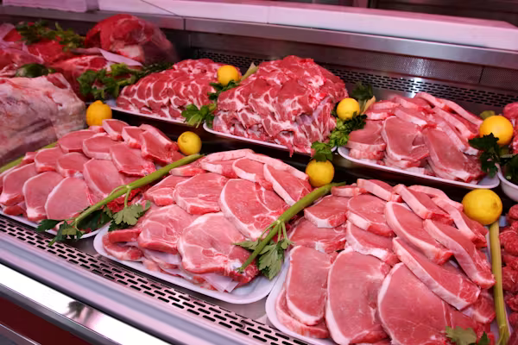
Reduced consumption of meat reflects the rejection of a system that causes people to consume without consideration of the consequences. Shutterstock

Disrupting the system
It is possible. We have the administrative and productive technology (the education system, the communication networks, the logistics, the control systems, the legal systems), if we use them properly, the resources, if we use them wisely, and the money we need to get it all done.
It won’t be easy and there will be much disruption, but we can lubricate the transformation and mitigate economic displacement via a global reduction of the workweek, the forgiveness of global debt and a global guaranteed income. If managing the transition and not focusing on business as usual is our goal, we’ll be fine.
As the economy shifts away from growth-fed accumulation to the next big economic trend, humane forms of service and quality of life will increase for everybody. With less time scrambling to make useless things and manipulate people into buying them, we’d have more time for ourselves and for authentic and healthy growth. This would mean health, happiness and increased satisfaction of our highest human needs.
California Senator Kamala Harris says that we’re at an “inflection point” in our world, our nation, even ourselves. Clearly, we all have an important choice to make.

