The Catholic Church is a rich male collective

Mike Sosteric
Date: 2018-09-23
Source: The Conversation
URL: https://theconversation.com/the-catholic-church-is-a-rich-male-collective-101958

I’m a typical sociologist, meaning I am skeptical about religion and human spirituality. Although I attended Catholic Church as a small child, I could see the hypocrisy, even as a child. I rejected that religion at an early age.
My undergraduate sociological training reinforced my atheism. My sociological lectures and sociological canons all decried and denounced the irrationality of human religion.
I dutifully read Marx’s Critique of Hegel’s Philosophy of Right and dismissed religion as an opiate delusion. I understood from Max Weber that religion was pure ideology, and made an oath not to get fooled again. I agreed with Peter Berger that religions were superstitions “beyond the pale” of respectable discussions.
At one point, I’d even have gone go so far as to call myself a devotee of evolutionary biologist Richard Dawkins, who sees religion as — among other more negative things — a crime against childhood.
Like a lot of my sociological colleagues, I heaped derision on the faithful. However, one day I decided to put aside my sociological roots and take a closer look myself.

Religion is the problem
As a researcher who looks at religions, I dug around and I was surprised by what I found.
I looked at the Western Tarot and found it was created as a propaganda tool.
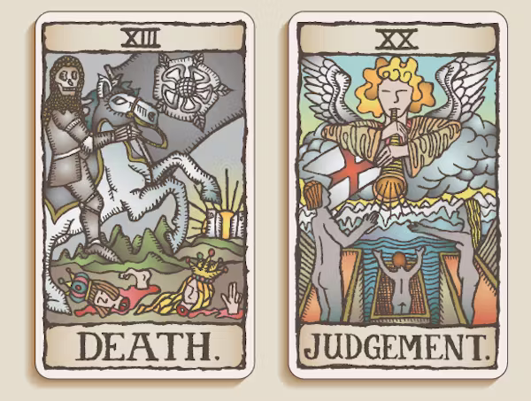
I discovered the remarkable story of Bartolomé de Las Casas, a brutal colonizer who one day saw the light and decided to fight for the slaves instead of immolating them.
I read the research of psychology professor Abraham Harold Maslow, who said everyone has a mystical experience. I examined the origins of global beliefs and found that although our beliefs are different, they seem to originate from the same place.
After this research, I wondered why the sociological “founders” had mostly ignored these mystical experiences. I decided to pick up the Bible and read; I was surprised by what I learned.

Jesus was a revolutionary leader
I expected to find either a passive shepherd who had died for our sins or a shady street corner dealer waiting for the next addict.
What I found instead was a modest, egalitarian but charismatic and revolutionary leader. The text I read showed that he was a leader who thought of women as equals, didn’t like commercial activity, didn’t think the rich could be authentic and absolutely hated the wealthy local elites.
He told his students to be cautious of elites because “they are corrupt” and lead people astray.
He said “they do not practise what they preach” and called them wicked, blind, self-indulgent, hypocrite fools; pretty on the outside but rotten and unclean deep within.
After reading the Gospels, it seemed to me that in the story, Jesus was a charismatic and popular revolutionary who had angered local elites and was assassinated as a result.

The big lie
The elites were afraid that should the people crown this new leader king, as they seemed ready to do, they would lose their control of power.
To head off the threat, the top male elites, the “chief priests and the Pharisees”), convened their version of the Supreme Court (the Sanhedrin) and plotted an untimely death for Jesus.
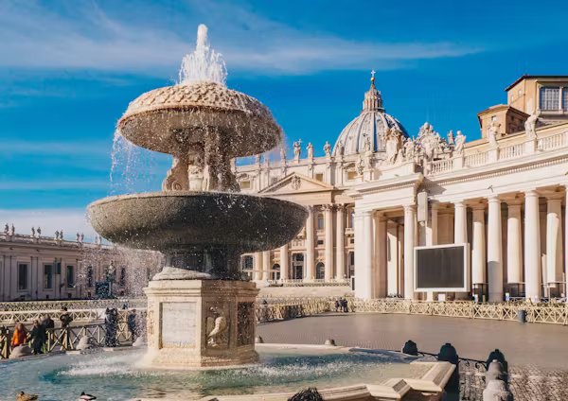
Vatican City is a symbol of the Catholic Church’s enormous wealth. (Shutterstock)
To accomplish their goal, the elites told a lie, what I call the “Caiaphas Lie,” to turn the people against him. Once the lie spread as truth, Jesus went into hiding but was arrested by local elites who threatened Roman leaders into a public shaming and brutal execution.
To my sociologically trained eye, the assassination was a clear attempt to suppress teachings that awakened the public to elite corruption. It was designed to put the public back to sleep.
Unfortunately for the elites, their first suppression attempt didn’t work. The assassination turned Jesus into a martyr, as he himself knew it would.
After his death, the word spread fast, with thousands and thousands of Jews and gentiles being converted at once.
We see the conversion of Roman centurions, traditional priests, foreign state officials and top-level elites (e.g., Saul’s Conversion in Acts 9). There is conversion “through the whole region” — Iconium, Lystra, Derbe, Syria, Philippi,Thessalonica, Berea, Athens, Corinth and Ephesus.
Christ’s martyrdom created a steamroller that spread throughout the whole world. It enraged local elites and lead to pogroms (Acts 8: 1-4), mass deportation and pervasive persecution.

Early Christians were socialists
Why put so much effort into assassination and suppression? The answer is that Jesus wasn’t just an anti-authoritarian, he was a socialist revolutionary leader. He told wealthy folks to redistribute their wealth and his followers did the same.
Jesus and the early Christians were about equality and freedom from the “yoke of slavery.” They dismissed political, ethnic and gender hierarchies and said we should all help the weak, not destroy them.
In 2 Corinthians 8: 13-15, the apostle Paul admonishes the Corinthians and tells them to “strive for equality” by redistributing their wealth. In a passage prescient of Karl Marx’s famous quote: “From each according to their abilities, to each according to their needs,” Paul reminds the Corinthians to share. “The one who gathered much did not have too much, and the one who gathered little did not have too little.”
All of the above was rooted in Christ and his followers’ dismissal of authoritarian spirituality in favour of a radical “we are all God” cosmology. Jesus claimed to be God but “so are you,” he said (John 10:24,Corinthians 6:19 Colossians 3:11).
In other words: Don’t listen to authority. Don’t listen to tradition. Don’t follow their rules. Give your possessions away. Help the weak. Live in peace with all people. Redistribute wealth. I am God. You are God. We are God.
Why were my expectations so out of line with the actual story told in the Bible?

The Church is a rich male collective
The Catholic priests I listened to as a child didn’t talk about Jesus the revolutionary; they told me the same “big lie” the elites in the Bible told. They made me recite that same lie every Sunday. By the time I was 10, the Catholic Church had burned the lie deep into my mind.
If you believe the Church is a continuation of Christ’s teachings, this is confusing.
However, once you learn the Catholic Church is a collection of elite patriarchs brought into formal power by edicts and actions of the Roman Emperors Constantine and Theodosius, it begins to become clear. When you realize the Church is one of the richest and most powerful male collectives in the world, it comes into clear focus.

