Title

Mike Sosteric

30 Seconds: ~70–110 words
- 60 Seconds: ~130–170 word
There’s this idea that keeps popping up. It’s this idea that the world is a “school,” a “prison,” a forge and that we are here to learn lessons, or be punished (karma), or tempered, or tested, or evolved towards some future gold-medal pinnacle, or whatever.
I’m sure you’re familiar.
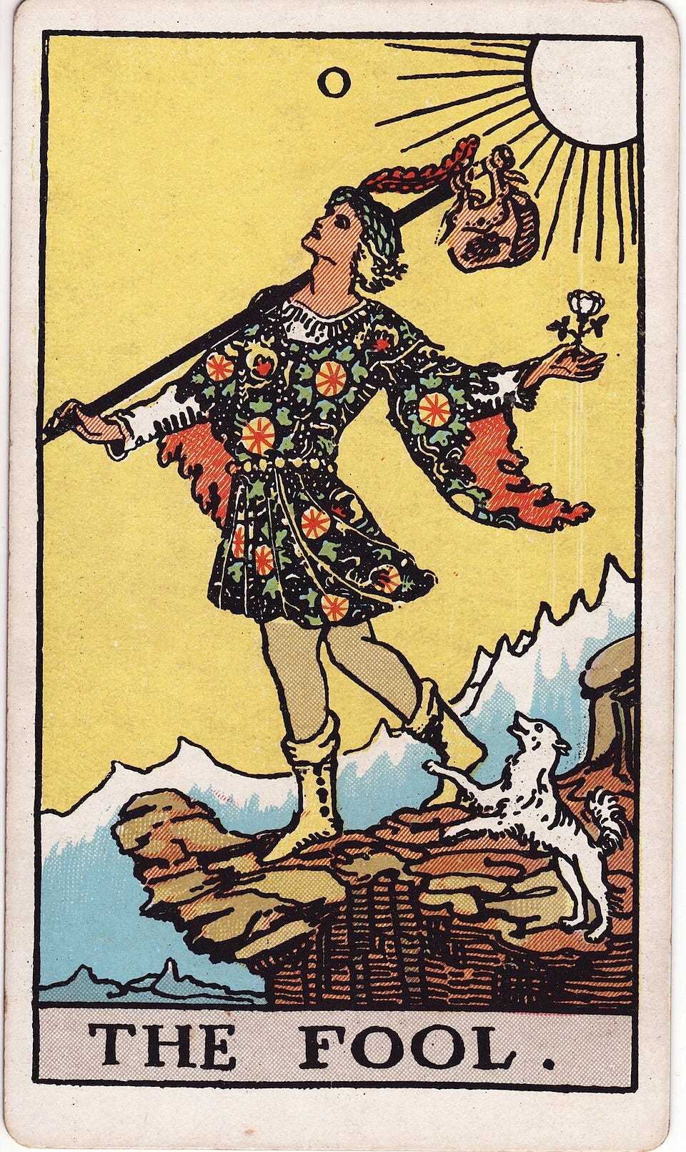
This idea is rooted in a particular view of who we are as a species. This idea is basically that we are all deficient in some way, that we need education, discipline, tempering, or development in evolutionary forges. We are souls in training, humans with an ape-like lineage, and consequently we all have to engage some form of struggle to reform, or perform, or whatever.
I call this the “fool in school” and we’ve all heard it, and I know that you all have heard it.

But what if that’s not true?
What if this story that we’ve been told over and over again is just that, a story made up by somebody many years ago?
What if we are not “fools in school?
What if we told a different story?
I mean, I can think of a different story. In my story, this world isn’t a school or a prison. It is not a forge and we are not here to learn lessons. In my story we do not have karma to pay off and we’re not advancing towards some distance evolutionary pinnacle. In my story we already have the potential for greatness. To manifest that, all we need is a better environment.

