The Vision of Vannevar bush

Mike Sosteric for
The Peace Table

Version .90

Abstract

The Vision of Vannevar Bush
I have spoken previously about Maslow’s vision for a Peace Table, a first step on a path forward to a better world. Maslow wasn’t the only scientist with a vision. Vannevar Bush also saw a path forward to a better world.
For those of you who don’t know, engineer and science administrator Vannevar Bush was an intellectual and institutional giant, right up there at the top. He was the director of the Office of Scientific Research and Development, the man who coordinated six thousand American scientists in the single largest mobilization of scientific talent in human history, and the author of what may be the most important essay ever written about humanity’s relationship with knowledge.
And that’s just on the surface.
Underneath, he was laying the groundwork for nothing less than a revolution in how human beings think, remember, and understand. He wasn’t just talking tech. He was proposing a new relationship between the human mind and the accumulated wisdom of the species. A comprehensive framework for a new, associative knowledge order aimed at giving humanity “access to and command over the inherited knowledge of the ages.”
Surprising?
Not really. Bush wasn’t the first scholar to recognize that civilization’s survival depends on how we manage what we know. But he understood with uncommon clarity that the tools we use to record and transmit knowledge shape the very thoughts we are capable of thinking. Like Maslow’s Psychology for the Peace Table, Bush’s project was not just a weak tweak, it is a full on revolution, a comprehensive framework for redirecting science from domination to understanding.
Ambitious?
Definitely. As director of the OSRD, Bush had just overseen the creation of the most destructive weapons the world had ever known. Now, as World War II drew to a close, he posed a question that should still echo in every laboratory and university today: what should these researchers do when peace returns? His answer was enlightned — scientists must redirect their talents from instruments of destruction to “pacific instruments” that expand human intellect. Science had extended physical powers for centuries; it was time, he argued, to amplify the powers of the mind.
Visionary?
Absolutely! Bush’s utopian aspiration started, as these things often do, with a crisis. He saw a “growing mountain of research” overwhelming investigators, researchers “staggered by the findings and conclusions of thousands of other workers,” unable to find time to grasp discoveries outside their narrow fields. He cited Mendel’s genetic laws, lost to science for a generation because his publication never reached the right readers — a catastrophe being repeated constantly.
From this crisis of information management, he envisioned a future where walnut-sized cameras would record observations automatically, where voice-operated typewriters would transcribe speech into text, where microfilm would shrink a million-volume library into a desk drawer, and where computing machines would operate at speeds a hundred times faster than anything then existing, performing complex mathematics and logical operations automatically.
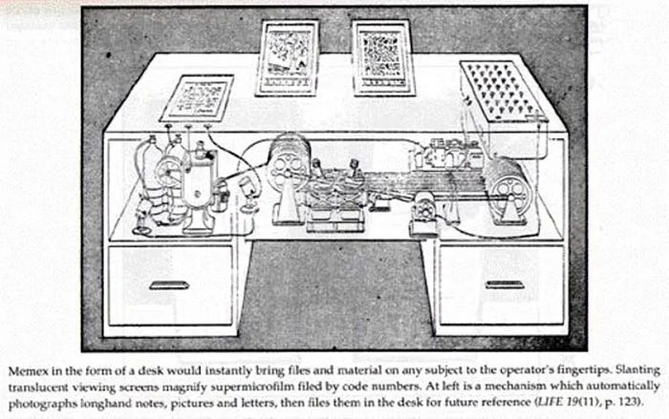
But the centerpiece, the revolutionary heart of his vision, was the memex — a mechanized private file and library that would serve as “an enlarged intimate supplement to [man’s] memory.” This desk-sized device would store books, records, and communications on microfilm, consulted through translucent projection screens. But the memex’s revolutionary feature was associative indexing: users could permanently link any two items by creating “trails” of connection, mirroring how the human mind actually works. Unlike rigid alphabetical or numerical filing, these associative trails allowed information to be organized by conceptual relationships. A researcher studying Turkish bows could build a trail connecting encyclopedia entries, historical accounts, elasticity textbooks, and personal notes — then share this trail with colleagues by photographing it for their memexes. A new profession of Trail Blazers would emerge, establishing useful pathways through humanity’s collective record.
Most remarkably, Bush speculated about direct neural interfaces. Since all sensory information reaches the brain as electrical vibrations, he asked whether we might someday intercept these currents directly, bypassing mechanical intermediaries. While cautioning that this risked “losing touch with reality,” he noted that encephalographs already recorded brain electrical phenomena. This was 1945 — decades before brain-computer interfaces became a serious research field. Bush wrote with a sense of urgency. As he reflected:
Humanity had built a civilization so complex that mechanized records were essential to “push [the] experiment to its logical conclusion.” The goal was not merely efficiency but wisdom: to “grow in the wisdom of race experience” by truly encompassing humanity’s accumulated knowledge. Science had given humanity weapons of mass destruction; it could yet provide tools for collective understanding.
Amazing?
Indeed he was. In just a few thousand words published in The Atlantic Monthly in July 1945, Bush essentially predicted personal computers, hypertext, the World Wide Web, search engines, digital photography, wearable technology, voice recognition, and knowledge ecosystems like The SpiritWiki. Its influence shaped the work of Douglas Engelbart, Ted Nelson, and Tim Berners-Lee — the very architects of the digital age Bush envisioned while the atomic age was just beginning.
What Else Can I Say?
Bush’s contribution was stunning. He gave us the blueprint for the information age at the very moment the atomic age was dawning. He understood that the summation of human experience was expanding at a “prodigious rate,” and that our methods of recording, transmitting, and reviewing knowledge were “generations old and by now are totally inadequate.” He saw that the economics of complexity had shifted; what was once prohibitively expensive and unreliable was now feasible. And he trusted that scientists, given the right mission, could build tools not for domination but for understanding.
Tragically, Bush’s vision was never fully realized. He died in 1974, just as the digital revolution he had imagined was beginning to take shape. But more than that, the knowledge ecosystem he helped inaugurate was aggressively commercialized, militarized, and systematically fragmented. I am an eyewitness to this corruption. In over two decades of academic work, I have watched as the internet that could have been a global memex for collective wisdom, and that for a brief moment was, became instead a surveillance marketplace, an attention-extraction engine, a tool for division and distraction. I have watched as the “growing mountain of research” became an unclimbable avalanche, as researchers remain “staggered” by the sheer impossibility of finding them. The associative trails Bush envisioned were replaced by algorithmic feeds designed not to enlighten but to addict. The trail blazers were replaced by data miners. The memex was never built; instead, we got the corporate web.
Note, it is crucial to clarify that when I describe this corruption, I am not alleging a secret, coordinated conspiracy in the cloak-and-dagger sense. Rather, I am describing a socio-political and economic process of systematic co-optation that was public, multifaceted, and intentional. These forces operated through visible channels: the channeling of scientific funding toward ever-more-sophisticated weapons rather than “pacific instruments”; the enclosure of knowledge behind paywalls and proprietary platforms; and the transformation of communication technologies into instruments of surveillance and behavioral manipulation. The betrayal of Bush’s vision was the result of this “coordinated campaign” of commercial and military priorities, not a natural evolution due to inherent flaws in his design. To understand this not as technological determinism but as documented historical conflict, class conflict, one need only look to the fundamental divide between Bush’s vision of knowledge as a public good for human wisdom and the basic assumptions and values of contemporary surveillance capitalism and the permanent war economy.
Whatever the reason for this corruption (hint, its addiction to money), it happened in an instant. The emancipatory, wisdom-seeking, trail-blazing impulse so powerfully expressed in the 2000s effectively erased post 2016. The technologies still exist, of course, and still have some influence, but I in a castrated and caricatured form. We have the gadgets Bush predicted, but not the philosophy. We have the web, but not the trails. We have search, but not the wisdom.
It is shocking when you think about it, particularly when you consider where we might be now, empirically and theoretically, if Bush’s vision of associative, wisdom-oriented knowledge systems had been properly supported to grow.
So… what are we going to do?
Well, we have to do something. The inadequacies of our existing knowledge systems has never been clearer. The need for the memex — for tools that truly expand human intellect rather than diminish it — has never been more pressing. The world is facing a polycrisis of information overload, epistemic fragmentation, and algorithmic manipulation. If we don’t do something, things are going to keep getting worse.
Fortunately, we do not have to start from scratch. Currently scholars are working to create knowledge systems that can help move society and the planet forward. The SpiritWiki is one such example. It is a mechanized, associative knowledge system built on the same principles Bush envisioned: trails of connection linking concepts across disciplines, a structure that mirrors how the human mind actually works rather than forcing it into rigid alphabetical or hierarchical boxes. It is designed not to extract attention or sell advertisements, but to give humanity genuine access to and command over the inherited knowledge of the ages, in a single domain, specifically human development. It is a pacific instrument in an age of information warfare, a tool for wisdom rather than manipulation, a place where scholars, writers, professionals, and trail blazers can build the associative pathways that lead to genuine understanding.
Like Bush’s memex, the SpiritWiki stores and connects records, communications, and insights across fields. Like the trails he imagined, its pages are linked by conceptual relationships rather than by the accident of alphabetical order or the tyranny of the algorithm. It is the living realization of what Bush called “an enlarged intimate supplement to [man’s] memory,” updated for the digital age and oriented toward the same goal: to grow in the wisdom of race experience.
We, and by “we” I mean the human species, are about to be drowned in the very knowledge we have created.
We can’t keep acting “normal.”
What else are we going to do?
We’ll talk more about the SpiritWiki next time.

