# CAR RENTAL

# Description Before

The customer would visit the car rental website and navigate to the "Apply for a car rental" page. They would proceed to fill out the request form, providing all the required information, including their email address. Upon submission, the request would be sent to the car rental firm. The firm would carefully review the application, checking for completeness and verifying the presence of an email address. If the application meets the necessary criteria, the car rental firm would send an email to the customer, listing the available cars. Upon receiving the email, the customer would evaluate the options and communicate their decision back to the car rental firm via email. Payment would be made in cash at the rental location.

# Description after

After the implementation, the customer visits the website of the car rental firm. If the customer is already registered, they can log in using their personal info. Otherwise, they need to complete the registration process and have their account added to the car rental firm's database before being able to log in.

Once logged in, the customer selects the desired rental type, either renting a car from the office or opting for car delivery. If the customer chooses to rent a car from the office, there are two payment options available: cash or bank transfer (with an additional bank transfer fee for car delivery). The customer then provides additional rental details and submits the request.

The application is processed by the system, where it undergoes a thorough accuracy check. If the application is correct, the customer is notified of its acceptance and provided with a list of available cars. In case of an incorrect application, it is rejected, and the customer is notified accordingly. Upon receiving the system's response, the customer evaluates the offered cars. If none of the cars meet their requirements, the customer rejects the application and communicates this to the car rental firm. Otherwise, the customer accepts one of the offered cars. For car delivery, the only available payment method is online. Upon arrival at the car rental office, if the customer has not made the payment yet, they can pay on the spot. The rental report is then added to the customer's database. Additionally, the customer has the opportunity to share their opinion about the rental experience on the car rental firm's website.

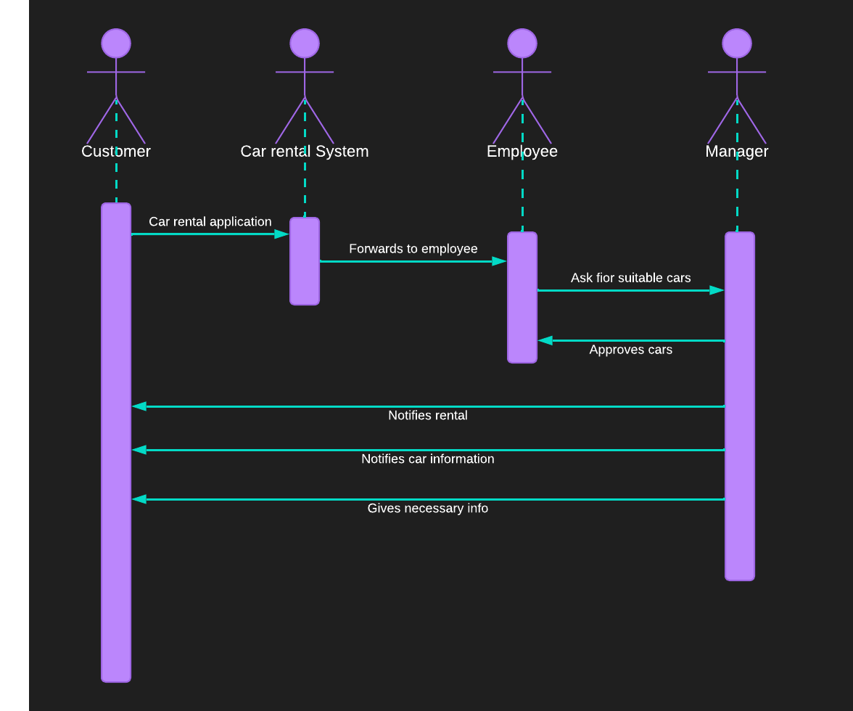

OLD

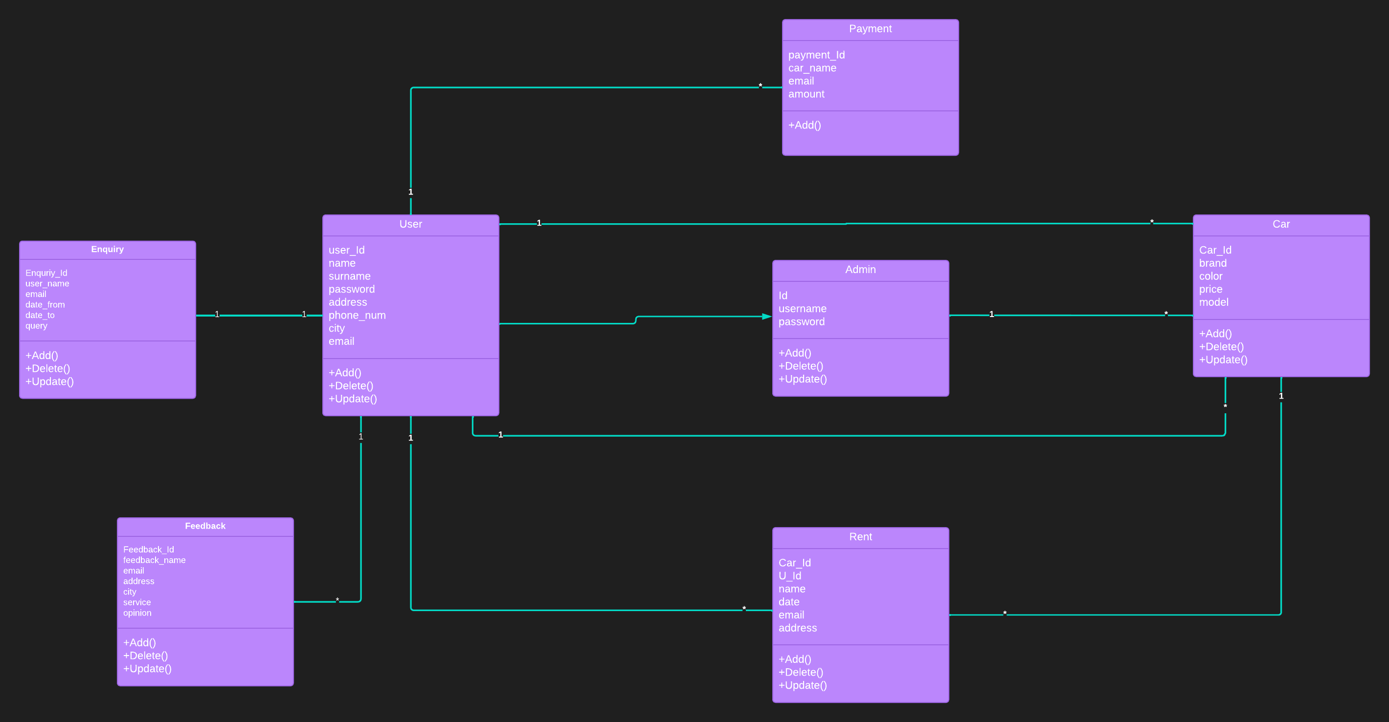

Final simulation video : <https://streamable.com/1evsmt>

Summary  
  
Time Analysis:

In the "before" scenario, the process involved the manual review of applications by the car rental firm, which could introduce delays in the response time to customers.

In the "after" scenario, the implementation of user authentication streamlined the process by automating the application review and notification steps, potentially reducing the overall response time.

Resource Analysis:

In the "before" scenario, the resource utilization primarily relied on manual effort for reviewing applications and communicating with customers via email.

In the "after" scenario, the automated system reduced the need for manual intervention in application processing, potentially optimizing resource allocation and reducing human resource dependency.

Customer Experience:

The addition of user authentication in the "after" scenario enhanced the customer experience by providing a secure login process and personalized account management options.

The availability of online payment for car delivery in the "after" scenario added convenience for customers, eliminating the need for cash payments at the rental location.

Error Handling:

The implementation of user authentication in the "after" scenario enabled better error handling by validating user credentials and preventing unauthorized access to the car rental system.

Any errors or discrepancies in the application process were efficiently communicated to customers, ensuring transparency and prompt resolution.

Overall, the "after" scenario, with the inclusion of user authentication, exhibited potential improvements in time efficiency, resource utilization, customer experience, and error handling compared to the "before" scenario. The simulation analysis highlights the benefits of implementing user authentication in the car rental process, providing a more streamlined and secure experience for both the car rental firm and its customers.