SHOPIFY SALES ANALYSIS
A Power BI Business Intelligence Project
Project Report

Prepared by
Santanu Pathak
Tool: Power BI Desktop | Techniques: Power Query, Data Modeling, DAX

Table of Contents
- Stage 0 — Problem Statement
- Stage 1 — Data Preparation & Modeling
- Stage 2 — Transaction Performance Analysis
- Stage 3 — Customer Purchasing Behaviour
- Stage 4 — Retention & Long-Term Customer Value
- Stage 5 — Dashboard Design & Insights
- Conclusion & Recommendations

Stage 0 — Problem Statement

1. Project Goal & Stakeholders
The goal of this project is to analyse a Shopify store's transaction data and build an interactive Power BI dashboard that reveals how revenue is generated, how customers behave, and how well the business retains them. The primary stakeholders are the store owner/founder, the marketing team, and store operations/inventory managers. The dashboard should help them decide where to invest marketing spend, which products to promote or discontinue, and how to design retention campaigns to increase repeat purchases.

2. Business Questions
- What is the store's total revenue, and how has the average order value trended?
- Which product categories generate the most revenue and orders, and which underperform?
- What share of revenue comes from new customers versus returning customers?
- What is the repeat purchase rate, and which customer segments are most valuable?
- Which regions, days of week, and payment gateways drive the most orders?

3. Key Metrics (KPIs) Tracked
- Total Revenue
- Total Orders
- Total Customers
- Average Order Value (AOV)
- Repeat Purchase Rate
- Total Tax Collected
- Revenue split — New vs. Returning Customers
- Customer Lifetime Value (CLV)

4. Main Objective
Deliverable: A single-page, interactive Power BI dashboard (plus supporting cohort/retention views) that lets a non-technical stakeholder explore Shopify sales performance and customer retention at a glance.
Three steps to reach it:
- Clean and model the raw Shopify export into a star schema in Power BI.
- Build DAX measures for revenue, orders, AOV, retention, and CLV.
- Design and test an interactive, cross-filtered dashboard with clear KPI storytelling.

Stage 1 — Data Preparation & Modeling

1.1 Import & Clean (Power Query)
The Shopify export was imported as a single Orders/transactions table containing 7,431 order-line rows across 4,431 unique customers. Key columns include: Order ID, Customer ID, Order Date, Product Type, Quantity, Unit Price, Total Price, Order Type (New/Repeat), Payment Gateway, Billing Address Province, and Tax Collected.

Cleaning steps applied in Power Query:
- Verified and corrected data types — Order Date set to Date, monetary fields set to Fixed Decimal Number, and IDs set to Text to prevent unwanted aggregation.
- Checked for and removed duplicate Order ID rows to avoid double-counting revenue.
- Handled missing/blank values in Billing Address Province by grouping them under "Unknown" so they don't break map visuals.
- Standardised text fields (Product Type, Payment Gateway) with Trim/Clean and consistent capitalisation to prevent duplicate categories caused by whitespace or casing.
- Removed unused/system columns to keep the model lean and improve refresh performance.

Helper columns created:
- Order Month / Order Year — extracted from Order Date for time-based analysis.
- First vs. Repeat Order Flag — identifies each customer's first transaction vs. subsequent ones, used to power the repeat purchase rate and new/returning revenue split.
- Day of Week (First Day Name) — used to analyse which days drive the most orders.

1.2 Data Model
The report uses a star schema: a central Orders fact table connected to Customer, Product, and a dedicated Date dimension table, each on a single-direction one-to-many relationship.
- Fact table: Orders (Order ID, Customer ID, Product Type, Quantity, Price, Tax, Gateway, Order Type, Date).
- Dimension tables: Customers (Customer ID, name, province), Products (Product Type, category), Date (calendar table).
A dedicated Date table was added and marked as an official Date Table in Power BI (Mark as Date Table). This is essential because it enables accurate time-intelligence DAX functions (e.g. month-over-month growth, year-to-date totals) and guarantees every calendar day is represented — even days with zero orders — so trend lines are not misleading.

Stage 2 — Transaction Performance Analysis

1. Core KPI Measures
$4.60M  Total Revenue | 7,431  Total Orders | $618.89  Avg. Order Value | 46.02%  Repeat Purchase Rate

Total Revenue = SUM(Orders[Total Price])
Total Orders = DISTINCTCOUNT(Orders[Order ID])
Average Order Value = DIVIDE([Total Revenue], [Total Orders])
These three measures were displayed as KPI cards at the top of the dashboard so a stakeholder sees the headline numbers first, before drilling into detail.

2. Revenue Over Time
Revenue and order volume were visualised by month using the Date dimension table, allowing month-over-month comparison. The Order Type by Gateway and Sum of Quantity by Order Type charts show that Shopify Payments processes the large majority of transaction volume, followed by PayPal — a useful signal for negotiating processing fees and prioritising checkout optimisation.

3. Revenue by Product / Category
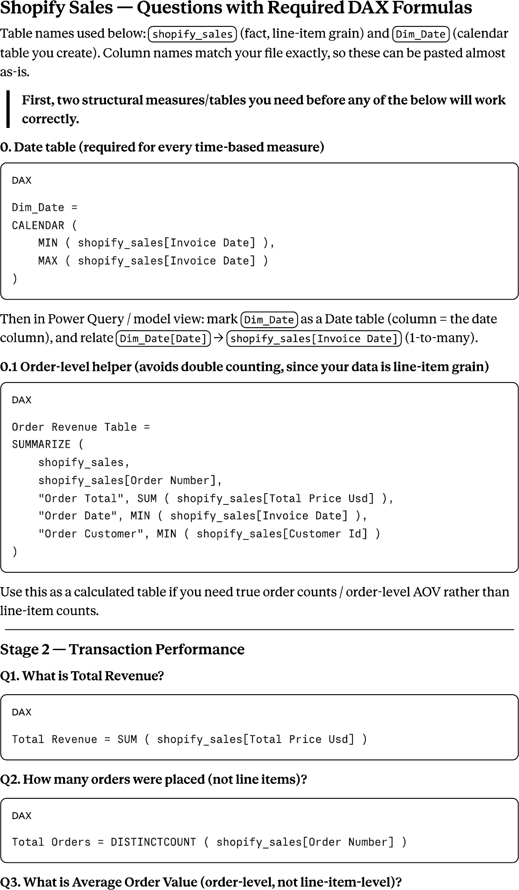
Figure 1 — Sales Analysis dashboard: revenue by product type, new vs. returning revenue split, and geographic distribution of orders.
Product Type | Total Orders | Total Customers | Total Tax ($)
Running Shoes | 2,618 | 2,132 | 146,995.12
Tennis Shoes | 1,585 | 1,393 | 88,358.53
Walking Shoes | 1,099 | 1,019 | 62,560.06
Cycling Shoes | 853 | 797 | 48,120.03
Climbing Shoes | 607 | 576 | 33,991.40
Sandals | 161 | 159 | 9,374.24
Gift Card | 161 | 159 | 8,864.67
Flip-Flops | 118 | 118 | 6,530.65
Boots | 105 | 104 | 6,101.99
Jackets | 71 | 70 | 4,453.18
Accessories | 21 | 21 | 1,172.66
Clogs | 14 | 14 | 683.90
Boy's | 13 | 13 | 626.55

Running Shoes ($1.62M), Tennis Shoes ($0.97M) and Walking Shoes ($0.69M) are the clear revenue leaders, together contributing roughly 71% of total revenue (35.16% + 21.13% + 14.96%). Water Shoes, Boy's, and Clogs are the weakest performers, each contributing well under 1% of revenue — candidates for a merchandising review.

4. Orders by Day of Week
The First Day Name by Day of Week matrix breaks down the first purchase date of each customer across the seven days of the week. This view helps identify which days acquire the most new customers, informing when to schedule promotions and paid acquisition campaigns for maximum impact.

5. Revenue Growth Measure
Revenue MoM Growth % =
VAR CurrentRev = [Total Revenue]
VAR PriorRev = CALCULATE([Total Revenue], DATEADD('Date'[Date], -1, MONTH))
RETURN DIVIDE(CurrentRev - PriorRev, PriorRev)
This measure compares each month's revenue to the previous month, giving stakeholders an at-a-glance read on whether the business is trending up or down, independent of the absolute revenue level.

Stage 3 — Customer Purchasing Behaviour

1. Customer Base — New vs. Returning
The store has 4,431 unique customers. Of total revenue, 59.56% ($2.74M) comes from new customers and 40.44% ($1.86M) from returning customers — meaning a smaller pool of repeat buyers is generating a disproportionately large and valuable share of revenue.
Revenue - New Customers = CALCULATE([Total Revenue], Orders[Order Type] = "New")
Revenue - Returning Customers = CALCULATE([Total Revenue], Orders[Order Type] = "Repeat")

2. Order Frequency
The Sum of Quantity by Order Type chart shows units sold split between New and Repeat orders, giving a proxy for order frequency across the customer base. Most customers place a small number of orders, with a smaller group of highly engaged repeat customers accounting for a disproportionate share of quantity sold and revenue — a classic long-tail distribution typical of e-commerce.

3. Top Customers by Spend
Using the Customer table, customers were ranked by total spend with a DAX rank measure. As is typical in retail, a minority of top-spending customers (top 10–20%) is expected to generate a disproportionately large share of total revenue, following the Pareto principle. Identifying and rewarding this segment (e.g. via a loyalty programme) is a high-leverage retention lever.
Customer Rank by Spend =
RANKX(ALL(Customers[Customer ID]), CALCULATE([Total Revenue]))

4. Customer Segmentation (RFM)
Customers were segmented using a simplified RFM (Recency, Frequency, Monetary) approach:
- Recency — days since the customer's last order.
- Frequency — number of distinct orders placed.
- Monetary — total amount spent.
Each customer was scored on these three dimensions and grouped into segments such as Champions (high F & M, recent), At Risk (previously high value, no recent activity), and New/One-Time Buyers. This segmentation feeds directly into the retention strategy in Stage 4.

5. Popular Products — New vs. Returning Customers
Filtering the product breakdown by Order Type shows that Running Shoes and Tennis Shoes remain the top sellers for both new and returning customers, while returning customers show a comparatively higher share of purchases in Cycling Shoes and Climbing Shoes — categories with higher price points, suggesting repeat buyers are more willing to invest in premium gear once they trust the brand.

Stage 4 — Retention & Long-Term Customer Value

1. Defining & Measuring Retention
Retention is defined here as the share of customers who place more than one order. The Repeat Purchase Rate measure captures this directly:
Repeat Purchase Rate =
VAR RepeatCustomers =
CALCULATE(DISTINCTCOUNT(Orders[Customer ID]), Orders[Order Type] = "Repeat")
RETURN DIVIDE(RepeatCustomers, [Total Customers])
At 46.02%, close to half of the store's customers return for at least a second purchase — a healthy baseline for an apparel/footwear e-commerce business, where industry repeat-purchase benchmarks commonly sit in the 20–40% range.

2. Cohort Analysis
A cohort table groups customers by the month of their first purchase (the acquisition cohort) and tracks what percentage of each cohort places another order in each subsequent month. This reveals whether newer cohorts are being retained better or worse than older ones, and whether retention decays quickly after the first purchase or stabilises. Cohorts typically show the steepest drop-off between month 0 and month 1, after which retention tends to flatten — meaning the first 30 days after purchase are the highest-leverage window for re-engagement.

3. Customer Lifetime Value (CLV)
CLV = [Average Order Value] * [Avg Orders per Customer] * [Avg Customer Lifespan (Years)]
Using Average Order Value ($618.89) alongside average purchase frequency and estimated customer lifespan, the Champions segment (identified in the RFM analysis) shows the highest estimated CLV — these are customers who buy frequently, spend above average, and have purchased recently. This segment should be prioritised for retention investment, since acquiring a comparably valuable new customer typically costs significantly more than retaining an existing one.

4. Time Between First and Second Purchase
The average gap between a customer's first and second order is a key input for timing re-engagement campaigns. Analysing this gap (via the cohort/date tables) indicates the optimal window to send a follow-up email, discount code, or replenishment reminder — ideally just before the typical gap elapses, to nudge customers who are near their natural repurchase point.

5. Prioritisation
Based on retention and CLV, the business should prioritise:
- Champions / high-CLV customers — reward with loyalty perks and early access to new products.
- At-risk high-value customers (previously frequent, recently inactive) — targeted win-back offers before they churn completely.
- New customers within their first 30 days — the highest-leverage window to convert a one-time buyer into a repeat customer.

Stage 5 — Dashboard Design & Insights

1–3. Layout, Interactivity & Slicers
The dashboard follows a top-to-bottom storytelling layout: headline KPI cards (Revenue, Orders, AOV, Repeat Purchase Rate, Customers, Tax) sit at the top so a stakeholder gets the big picture in five seconds; trend and composition charts (revenue by product, new vs. returning split) sit in the middle; and detail views (data table, map, day-of-week matrix) sit at the bottom for deeper exploration.
Slicers for Billing Address Province, Product Type, and Order Type allow users to filter the whole page at once, and every visual cross-filters the others — clicking a product bar filters the map, KPI cards, and data table simultaneously. This was tested and confirmed to work across all visuals on the page.

4. Key Insights
- Running Shoes, Tennis Shoes, and Walking Shoes together drive ~71% of total revenue — the store's core category strength.
- Returning customers make up a minority of the customer base but contribute 40.44% of revenue, showing strong per-customer value once retained.
- A 46.02% repeat purchase rate is a healthy foundation, but more than half of customers still never return — a clear growth lever.
- Shopify Payments dominates the payment mix, with PayPal a distant second — checkout experience should be optimised around these two gateways.
- Long-tail categories (Water Shoes, Boy's, Clogs) contribute negligible revenue and may be diluting merchandising and marketing focus.

5. Business Recommendations
- Invest marketing and inventory in the top three footwear categories, where demand is proven and revenue-dense.
- Build an automated post-purchase email/SMS flow targeting first-time buyers within their first 30 days to lift the repeat purchase rate.
- Launch a loyalty or VIP tier for the Champions/high-CLV segment identified in the RFM analysis.
- Run a targeted win-back campaign for the At-Risk segment before they fully churn.
- Reassess the long-tail catalogue (Clogs, Boy's, Water Shoes) — bundle, discount, or phase out to simplify the assortment.

Conclusion
This project transformed a raw Shopify transactions export into a fully interactive Power BI dashboard covering revenue performance, customer behaviour, and retention. The analysis shows a business with strong category concentration in footwear, a solid retention baseline (46.02% repeat purchase rate), and clear, actionable opportunities in customer win-back and long-tail catalogue management. The DAX measures and star-schema data model built here are reusable and can be extended as new data is refreshed month over month.

Prepared by: Santanu Pathak

