# TEST

The diagram of the database used in the following tasks is presented below.

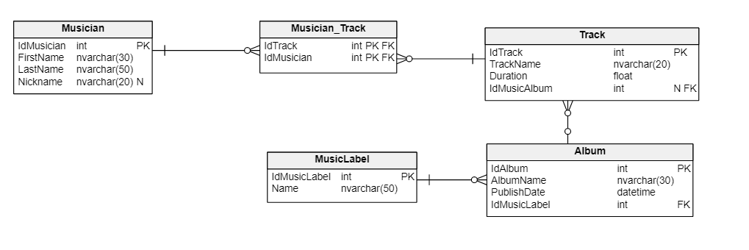The test should be done on the **university database** using Entity Framework Core. Make sure to add sample data to the appropriate tables.

1. Design an endpoint that will return information about a specific musician. The returned JSON object should also contain the list of songs created by him. The endpoint should accept the musician's ID as a parameter. The response does not need to include the albums in which the songs appear. Be aware of the respective error statuses.
2. Design an endpoint that will allow you to add new musician. While adding a new musician it is possible to assign him to a track. If the track specified in the request body does not exist, it should be previously added to the database. The entire operation should be performed within one transaction. Be aware of the respective error statuses.

**Remember about:**

1. Developing a Web API in accordance with the REST approach.
2. Correct naming of variables, controllers, etc.
3. Maintaining the appropriate code structure.
4. Dependency injection in the right places.
5. Error handling.
6. Usage of the DTO.