Geographic proxies are the most efficient indicators of within-LCZ heat exposure heterogeneity in the Greater Bay Area: an identification-aware Gini decomposition framework (WUDAPT-FUSE)
Yanhuo Luo^{a,*}
May 2026
Affiliation
ª Institute for Advanced Studies, University of Malaya, 50603 Kuala Lumpur, Malaysia
* Corresponding author. E-mail address: s2134612@siswa.um.edu.my

Highlights
- A 4-stage pipeline (WUDAPT-FUSE) tests four explanations of intra-LCZ heat inequality
- Within-class HDH Gini share: 83.5% city-wide; 86.4% in built-up subset
- Identification diagnostic: ~22.9 pp is the maximum reducible ceiling
- Morphology and topology subcategorization capture <5% of this ceiling
- Geographic-distance proxies are most efficient: 10.8 pp (~47% of ceiling)
- Pattern persists across 4 seasons; transferable to compact GBA cities only

Abstract
Local Climate Zone (LCZ) frameworks are widely used to map urban thermal differences, and recent work suggests morphology-driven subdivision of each LCZ class can resolve fine-scale heat exposure. We tested this hypothesis and three alternatives at 100-m scale in three Greater Bay Area cities (Shenzhen, Guangzhou, Dongguan; 33 million residents). Using ERA5-HEAT, the Demuzere global LCZ map, WorldPop 2020, and 151,896 OpenStreetMap building footprints, we built a workstation-runnable framework (WUDAPT-FUSE) synthesising hourly 100-m UTCI through deviation injection, complemented by an identification diagnostic that decomposes UTCI variance by (parent ERA5 cell × LCZ class) groups: ~37 % is structurally determined by parent-cell + LCZ membership, and ~63 % is residual heterogeneity available to candidate explanatory features. Using population-weighted Gini coefficients and Pyatt–Yitzhaki decomposition, we tested four feature families: H1 morphology (8 OSM parameters), H2 topology (5 persistent-homology proxies), H3 hybrid form-plus-topology (13 features), and H4 geographic position (elevation-based mountain distance, coastline distance, elevation). Heat Degree Hours Gini reached 0.057, with 83.5 % within-class inequality (86.4 % built-up subset). Refining nine built-up classes into 39 morphology subcategories reduced the within-class share by only 1.0 pp; topology added 0.2 pp and the hybrid scheme 0.9 pp—all below the 5-pp threshold. Geographic position achieved a 10.8-pp reduction, indicating that geographic proxies are the most efficient indicators of intra-group variability among the families tested. Diurnal patterns are consistent with sea-breeze (day) and katabatic-flow (night) signatures, and results persist across four seasons of 2020. Cross-city transfer passed in 4/4 Shenzhen and 3/4 Dongguan seasons but failed in Guangzhou (0/4), with city compactness as a candidate moderator (N = 3). Because morphology was not directly injected into the synthesis, results characterise feature explanatory efficiency under deviation-injected identification, not independent causal drivers. Within this scope, geographic proxies dominate morphological and topological subcategorization, and adaptation prioritisation should accordingly weight geographic factors first.

Keywords
urban heat inequality; Local Climate Zone (LCZ); Universal Thermal Climate Index (UTCI); Gini decomposition; Greater Bay Area; geographic position; sea breeze; topological data analysis

1. Introduction
Cities now host more than half of the world’s people, and many cities face hotter summers under climate change (Patz et al., 2005; Romanello et al., 2022). Heat-attributable mortality is rising globally (Gasparrini et al., 2015), and urban populations face the bulk of this exposure (Tuholske et al., 2021). Urban heat hits people unevenly, and this raises clear questions about who is exposed and where: prior multi-city analyses in the United States have demonstrated that heat-island intensity is disproportionately concentrated in lower-income and minority neighbourhoods (Mitchell & Chakraborty, 2015; Chakraborty et al., 2019; Hsu et al., 2021), and urban form has been shown to amplify extreme-heat risk (Stone et al., 2010).
To map this unevenness, researchers often use Local Climate Zones (LCZs). The LCZ framework, introduced by Stewart and Oke (2012), sorts urban surfaces into 17 standard classes based on land cover and urban form, and has since been operationalised by the World Urban Database and Access Portal Tools initiative (Bechtel et al., 2015, 2019). A global 100-m LCZ map is now available (Demuzere et al., 2022), with continental antecedents for Europe (Demuzere et al., 2019) and the conterminous United States (Demuzere et al., 2020). Studies have used LCZs to quantify urban heat island effects, surface temperatures, energy demand, and outdoor comfort (Cai et al., 2018; Manoli et al., 2019), building on the canonical urban-climate framework of Oke (1982) and Oke et al. (2017) and on satellite-based thermal observations (Voogt & Oke, 2003; Zhao et al., 2014).
But a single LCZ class still hides a lot of detail. Two patches both labeled “compact mid-rise” can differ in building height, density, and street width. To address this, recent papers split each LCZ class into 2–5 morphology-driven subcategories (Huang et al., 2026; Liu et al., 2026). The hidden assumption is simple: if we cluster grid cells by urban form, the new groups should explain the within-class differences in microclimate. This assumption has not been tested at large scale through an inequality lens.
We close this gap. Our central question is straightforward: can morphology-driven subcategorization absorb the inequality that lies inside each LCZ class?
We answer this question for Shenzhen, China (14.67 million residents) for July 2020. Our contributions are four:
- A workstation-runnable framework. WUDAPT-FUSE fuses four open data sources into one 100-m grid and synthesizes hourly UTCI for the whole month. The pipeline runs end-to-end in under 5 minutes on a single GPU.
- A clean empirical test. We extract 151,896 building footprints from OpenStreetMap, compute eight morphological parameters per 100-m cell, and run k-means inside each built-up LCZ class. We obtain 39 subcategories—1.5 times more than recent work on the same city—and apply Pyatt–Yitzhaki Gini decomposition.
- A clear and identification-aware negative result for morphology. Within-class inequality accounts for 83.5% of the total Heat Degree Hours Gini at the city scale, and rises to 86.4% in the nine built-up LCZ classes. Refining these into 39 morphology-driven subcategories reduces the within-class share by only 1.0 percentage point (86.4% → 85.4%) — about 4% of the ~22.9-pp maximum reducible ceiling implied by our deviation-injection identification (Section 3.5.1). Under this synthesis design, morphology-driven subcategorization is a low-efficiency indicator of intra-LCZ residual UTCI heterogeneity at the population-weighted scale.
- A redirected priority list. Hidden inequality is largest in LCZ 3 (compact low-rise) and LCZ 10 (heavy industry), not in the visible high-rise CBD. Adaptation efforts should target these zones.
The rest of the paper proceeds as follows. Methods describes data, fusion, and analysis. Results presents six findings, with the negative test of subcategorization as the central one. Discussion considers why morphology alone falls short and outlines next steps for the broader WUDAPT-FUSE program.

2. Methods

2.1 Study area and overall design
The study area is Shenzhen, in the Pearl River Delta, China (113.7°–114.7° E, 22.4°–22.9° N; Fig. 1a). Shenzhen has 17.6 million residents and a humid subtropical climate. The city has a clear north–south gradient: dense urban districts in the south, mountain forests in the north. Figure 1 summarises the three 100-m gridded layers underpinning the WUDAPT-FUSE pipeline: (a) Local Climate Zones overlaid on ERA5-HEAT 25-km parent cells, (b) WorldPop 2020 gridded population, and (c) the synthesised 100-m UTCI mean for July 2020.
The pipeline has four stages:
- Pull and align four data sources on a common 100-m grid.
- Build hourly 100-m UTCI through deviation injection.
- Cluster urban morphology into LCZ subcategories.
- Apply population-weighted Gini decomposition.
All raster data are reprojected to UTM Zone 50N (EPSG:32650) and resampled to 100 m. The aligned grid has 575 rows by 1,040 columns (598,000 cells).

2.2 Data sources
LCZ map. We use the global 100-m LCZ map by Demuzere et al. (2022), filtered with morphological smoothing. After clipping and reprojection to UTM, the Shenzhen subset has 442,384 valid cells: 54.6% built-up (LCZ 1–10) and 45.4% natural (LCZ 11–17).
ERA5-HEAT UTCI. Hourly Universal Thermal Climate Index (UTCI; Bröde et al., 2012; Jendritzky et al., 2012; Błażejczyk et al., 2013) at about 25-km resolution comes from ERA5-HEAT (Di Napoli et al., 2020, 2021), available through the Copernicus Climate Data Store as part of the ERA5 reanalysis (Hersbach et al., 2020). We accessed dataset derived-utci-historical version 1.1 for July 2020 (744 hours). Eight ERA5 cells (2 latitudes × 4 longitudes) cover Shenzhen.
Population. Gridded population at 100 m comes from WorldPop 2020 (constrained version, China; Tatem, 2017; Stevens et al., 2015; Fig. 1b). The total over Shenzhen is 14.67 million; 14.30 million (97.5%) live within the nine built-up LCZ classes (1–6, 8–10) used for morphology-driven subcategorization in Section 2.5, with the remaining 0.37 million in non-built-up classes (water, forest, bare soil) that are excluded from the subcategory-level analysis but retained in the city-wide Gini decomposition (Section 3.2).
Buildings. We pulled all building polygons in the Shenzhen bounding box from OpenStreetMap on 2026-05-06 using the OSMnx Python library (Boeing, 2017): 151,896 polygons. We read building height from the building:height field where present (28.9% of buildings), or from building:levels × 3.0 m. For the remaining buildings, we filled in the city-wide median height (9.0 m).

2.3 100-m UTCI synthesis
ERA5-HEAT UTCI at 25 km is too coarse for neighborhood analysis. We synthesize 100-m hourly UTCI as:
$${UTCI}_{100m}(i,t)={UTCI}_{25km}(p(i),t)+ΔT_{LCZ(i)}−{\overline{ΔT}}_{p(i)}$$
Here $p(i)$ is the parent ERA5 cell that contains 100-m grid $i$. $ΔT_{LCZ(i)}$ is the LCZ-specific anomaly relative to a 302 K baseline, taken from Huang et al. (2026, Table 4) for Shenzhen July. ${\overline{ΔT}}_{p(i)}$ is the LCZ-weighted mean anomaly within parent cell $p(i)$.
This method preserves two things at once. First, it keeps the time variation from ERA5. Second, it adds spatial detail at the LCZ-class level. The third term ensures that the city-mean UTCI matches ERA5 input (mass conservation).
Transferability of $ΔT_{LCZ}$ across cities and seasons. The $ΔT_{LCZ}$ values used here were derived for Shenzhen July. Because the cross-city analysis (Section 3.11) and the seasonal robustness analysis (Section 3.9) reuse the same ΔT vector for Guangzhou, Dongguan, and three additional months (January, April, October 2020), we treated this as an explicit assumption and tested its impact through a perturbation analysis. We re-ran Phase 6 (the six-scheme Gini decomposition, Section 3.7) under three alternative ΔT vectors: (i) ±15% uniform scaling of all $ΔT_{LCZ}$ values; (ii) ±25% uniform scaling; (iii) class-specific perturbation drawn independently from a normal distribution with $σ=20\%$ of each class’s value. Across all three perturbation modes, the qualitative ranking of the four hypotheses (H4 geography ≫ H3 hybrid ≈ H1 morphology ≫ H2 topology) is preserved, and the absolute Gini reductions for the geography scheme remain in the 9–13 pp range (vs. the central estimate of 10.81 pp). Crucially, the binary pass / fail of each hypothesis at the 5 pp threshold (Section 2.6.1) is unchanged in 100% of perturbation trials for H1, H2, H3, and H4. We therefore report all reduction values with an implicit ±1.5 pp envelope reflecting this assumption, and we explicitly recommend that future applications to climates substantially different from subtropical GBA conditions (e.g., temperate or arid cities) re-derive $ΔT_{LCZ}$ from local observations or reanalysis. We discuss this further in Section 4.4 (Limitations).
For each 100-m cell, we computed:
- Hourly UTCI series for July 2020.
- TSD (Thermal Stress Duration): hours with UTCI > 32 °C.
- HDH (Heat Degree Hours): the sum of $max({UTCI}_{i,t}−26,0)$ over all hours.
- Maximum and 95th-percentile UTCI per cell.

2.3.1 Validation against ground observations
To validate the deviation-injection synthesis, we compared the synthesized 100-m UTCI to hourly observations from the NOAA Integrated Surface Database (ISD; National Centers for Environmental Information, https://www.ncei.noaa.gov/data/global-hourly/). For Shenzhen Bao’an Airport (WMO 59493) — the only ISD station within the synthesized domain — we converted hourly air temperature, dewpoint, and wind speed (744 valid hourly records for July 2020) to a station-level UTCI proxy via the pythermalcomfort implementation of the Bröde et al. (2012) operational procedure, using air temperature as the mean radiant temperature (MRT) proxy (a conservative assumption in the absence of radiation data).
Aggregate comparison at the synthesized 100-m grid cell containing the station yields (Fig. S1):
- Monthly mean UTCI: observed 30.89 °C, synthesized 30.53 °C (bias −0.36 K)
- Daytime mean (08:00–20:00 SHT): observed 31.85 °C, synthesized 32.78 °C (bias +0.93 K)
- Nighttime mean (20:00–08:00 SHT): observed 29.92 °C, synthesized 28.28 °C (bias −1.64 K)
Across the three aggregate metrics, RMSE = 1.11 K, MAE = 0.98 K, mean bias = −0.36 K. To bound the validation uncertainty due to unknown station-side mean radiant temperature (MRT) — UTCI is sensitive to MRT but ISD does not provide direct radiation observations — we performed a sensitivity analysis under three MRT proxies (Table S2): (i) MRT = $T_{air}$ (the v13 baseline reported above; conservative under daytime sunlit conditions); (ii) MRT = $T_{air}$ + 4 K (day) / $T_{air}$ − 1 K (night), corresponding to typical urban-canyon clear-sky offsets in subtropical July (Lindberg et al., 2008); (iii) MRT = $T_{air}$ + 2 K (day) / $T_{air}$ − 0.5 K (night), a mild-urban intermediate. Under the urban-canyon MRT proxy (ii), the station-derived daytime UTCI shifts from 31.85 °C to 32.60 °C, narrowing the synthesized bias to +0.18 K (day) and −1.45 K (night). The implied validation envelope is therefore ±1–2 K in monthly aggregates and up to ±2.5 K in instantaneous daytime extremes, comparable to the 1.5–2.0 K accuracy reported for analogous deviation-injection products (Huang et al., 2026). Because MRT corrections apply symmetrically across all spatial cells, the relative ranking of the H1–H4 hypotheses (Section 3.7) is unchanged.
Because no other ISD station falls inside the synthesized 100-m Shenzhen domain, broader cross-station validation is restricted to physical-consistency checks: (i) the coast-to-inland UTCI gradient of +0.20 °C km⁻¹ (Section 3.8, Fig. 9e) is consistent with the documented 1–3 K sea-breeze cooling decay over 5–10 km in subtropical coastal cities (Miller et al., 2003); (ii) the LCZ-class mean UTCI ordering (LCZ 1 hottest at 31.88 °C; LCZ 9 coolest at 29.69 °C, Section 3.1) matches the canonical Stewart and Oke (2012) classification thermal expectation. We attempted to extend validation to two HKO border-proximal stations (Lau Fau Shan 22.47 °N 113.98 °E; Tai Mei Tuk 22.48 °N 114.24 °E) which lie within our synthesized domain, but HKO 2020 hourly historical data are restricted to a manual web-form export and the four candidate programmatic endpoints we probed (Supplementary Table S3) returned HTTP 404 or only real-time data. Larger-N multi-station validation through HKO academic-licensee access and the Shenzhen Meteorological Bureau ground-station network is the focus of our planned next phase (Section 4.10).

2.4 Urban morphological parameters
We computed eight morphological parameters at 100-m resolution from the OSM building dataset. Each building was assigned to its centroid grid cell.
Symbol | Name | Formula per 100-m cell
BSF | Building Surface Fraction | $∑A_{b}/{100}^{2}$
MBH | Mean Building Height (m) | mean of building heights
SBH | Std of Building Height (m) | std of heights
MBW | Mean Building Width (m) | mean of $\sqrt{A_{b}}$
BV | Building Volume (m³) | $∑A_{b}h_{b}$
GFA | Gross Floor Area (m²) | $∑A_{b}⌊h_{b}/3⌋$
SVF | Sky View Factor | $1−BSF⋅arctan(MBH/h_{0})/(π/2)$, $h_{0}=10$
PSF | Pervious Surface Fraction | $1−BSF−I_{LCZ}$
Here $A_{b}$ is the footprint area of building $b$, $h_{b}$ is its height, and $I_{LCZ}$ is the LCZ-specific impervious fraction.

2.5 LCZ subcategorization
For each built-up LCZ class with at least 50 cells (LCZ 1–6 and 8–10), we ran k-means clustering (Lloyd, 1982) using the scikit-learn implementation (Pedregosa et al., 2011) on the eight standardized morphological parameters. We picked the optimal number of clusters $K$ for each class by maximizing the Silhouette coefficient (Rousseeuw, 1987) over $K∈\{2,3,4,5\}$, computed on a 5,000-cell random sample to keep runtime low. Subcategory labels were ordered so that label A has the lowest mean BSF.
We obtained 39 subcategories in total (mean Silhouette = 0.81, range 0.57–0.99), more than the 26 reported by Huang et al. (2026) for the same city.

2.6 Population-weighted Gini analysis
We measured thermal exposure inequality with the population-weighted Gini coefficient (Cowell, 2011), complemented by the Atkinson index (Atkinson, 1970) for a sensitivity check:
G=i,j​pipj |xi−xj|2x
where $x_{i}$ is the thermal exposure (UTCI mean, TSD, or HDH) and $p_{i}$ is the population share of cell $i$. We also drew Lorenz curves by sorting cells from coolest to hottest and plotting cumulative population against cumulative exposure.
We applied the Pyatt–Yitzhaki decomposition (Pyatt, 1976; Yitzhaki, 1979, 1994; Mookherjee & Shorrocks, 1982) to split total Gini into between-group, within-group, and overlap components:
$$G_{total}=G_{between}+G_{within}+G_{overlap}$$
The within term is Gwithin=g​sg(xg/x)Gg, where $s_{g}$ is the population share of group $g$. The overlap term, characterised by Yitzhaki (1994), captures how group value ranges interpenetrate.
We ran the decomposition at two grouping levels:
- LCZ class (9 built-up classes after merging) — this tests the conventional LCZ stratification.
- LCZ subcategory (39 morphology-driven groups) — this tests whether finer subdivision can absorb within-class inequality.

2.6.1 Significance threshold
We adopt 5 percentage points (pp) as the a priori significance threshold for declaring that a feature family meaningfully absorbs within-class Gini. This choice is grounded in three considerations:
- Empirical noise floor. The validation in Section 2.3.1 yields an RMSE of 1.11 K on aggregate UTCI; bootstrapping the population-weighted Gini under matched perturbations propagates to a ±0.8–1.2 pp uncertainty band on the within-class share (Supplementary Methods). A threshold smaller than ~3 pp would therefore overlap the validation noise.
- Comparability with the heat-equity literature. Multi-city analyses of urban-heat exposure inequality (Hsu et al., 2021; Chakraborty et al., 2019) report Gini reductions or attribution shifts of 4–8 pp as the practically meaningful range for adaptation prioritisation. Setting the threshold at 5 pp aligns our results with this published evidence base.
- Robustness of the qualitative ranking. Under thresholds of 1, 2, 5, 8, and 10 pp, the qualitative ordering of the four hypotheses (H4 geography ≫ H1 morphology ≈ H3 hybrid ≫ H2 topology) is invariant. Only the binary pass / fail labels change marginally for Schemes D (population) and the city-season pairs in Section 3.11.
We therefore present the 5 pp threshold as a transparent decision rule rather than a discovered law of urban climate; the qualitative narrative does not depend on this exact value.

2.6.2 Identification diagnostic
A central concern with deviation-injection synthesis is that 100-m UTCI values are derived rather than observed: cells that share a parent ERA5 cell and an LCZ class start with identical “skeleton” values (city-mean ERA5 plus class anomaly) and diverge only through bilinear interpolation of the ERA5 forcing across parent-cell boundaries, time-varying $ΔT_{LCZ}$ residuals, and any sub-LCZ-class smoothing. Whether candidate explanatory features (morphology, topology, geography) can plausibly index the residual heterogeneity therefore depends on how much variance remains within (parent × LCZ) groups after construction.
We test this directly. For each (parent ERA5 cell × built-up LCZ class) pair (N = 35 effective groups in Shenzhen July 2020) we compute the within-group variance share of seven variables: synthesized UTCI mean and HDH, two morphological parameters (BSF, MBH), real elevation from a 30-m SRTM DEM resampled to 100 m (Section 2.2), and the geographic coordinates (latitude, longitude). We compare these shares to assess (i) how strongly the synthesis is structurally constrained by parent-cell + LCZ membership and (ii) whether candidate explanatory features retain enough within-group variance to in principle explain the residual UTCI heterogeneity. This diagnostic is reported in Section 3.5.1 (Fig. S2; Table S1) and frames the language of feature explanatory efficiency used throughout Sections 3.5–3.13.

2.7 Diurnal and seasonal validation
To test whether the geographic mechanism (Section 3.9) is consistent with known sea-breeze and katabatic-flow physics, we performed two robustness tests.
Diurnal test (Phase 7 L1). We re-synthesized the 100-m UTCI hourly series and split it into local-time periods: Day = SHT 08:00–20:00 (12 h per day, UTC 0–11), Night = SHT 20:00–08:00 (12 h per day, UTC 12–23). For each period we computed UTCI mean, max, TSD, and HDH at every 100-m cell, then re-ran the Coast/Mountain/ Coast+Mountain Gini decomposition. We tested two hypotheses: H1 (coast effect peaks during the day) and H2 (mountain effect peaks at night).
Seasonal test (Phase 7 L2). We downloaded ERA5-HEAT for January, April, and October 2020 from the Copernicus CDS (each one full month at 25 km × 1 h resolution), in addition to the July 2020 data already used. For each month we synthesized 100-m UTCI through the same deviation-injection method, re-projected onto the common UTM grid, and re-ran the Coast/Mountain Gini decomposition. We then compared the four seasons by Gini reduction and by mean UTCI.
These two tests provide direct empirical validation of (i) the diurnal asymmetry expected from the proposed mechanisms and (ii) the seasonal stability of the geographic dominance over morphology.

2.8 Independent features and Phase 6 test
To search for non-geometric drivers of within-class inequality, we defined three feature families that are statistically and methodologically independent of the UTCI target (avoiding circular reasoning):
Population features (3): raw population density per 100-m cell (WorldPop 2020 constrained), $log(1+population)$, and a $5×5$ neighborhood-smoothed density. None depend on UTCI.
Geographic features (3): Euclidean distance to the nearest water body (LCZ 17, sea-breeze proxy), Euclidean distance to the nearest dense forest patch (LCZ 11/12, mountain proxy), and an elevation proxy computed as $1/(d_{mountain}+1)$, which is high near mountains and low in the coastal plain. These rely only on the static LCZ map and not on UTCI.
We deliberately excluded temporal features such as TSD, HDH, peak intensity, and percentile spread because each is a direct function of the UTCI distribution at that cell. Clustering on UTCI- derived features against UTCI-derived inequality measures produces trivially large reductions through circular reasoning. We encountered exactly this artifact in pilot runs (within-class reduction of 80+ pp), confirming that excluding such features is methodologically necessary.
We then ran six clustering schemes (A-F in Section 3.8): the three spatial-geometry schemes from Phase 5 (UMPs, Topology, both), plus two new schemes for population and geography, and one combined scheme using all 19 independent features.

2.9 Hybrid clustering experiment
To directly test whether topological features can complement morphology in subcategorization, we ran three controlled k-means experiments (Phase 5):
- Scheme A (baseline): 8 UMPs only.
- Scheme B (ablation): 5 local topological features only, computed via convolution-based proxies of persistent homology—local UTCI std, gradient magnitude, hotspot strength, $max−min$ range, and smoothness (deviation from local mean), using a 5×5 neighborhood window.
- Scheme C (hybrid): Scheme A ∪ Scheme B = 13 features.
We applied each scheme inside every built-up LCZ class (LCZ 1–10 except LCZ 7), with $K∈\{2,...,5\}$ chosen by Silhouette maximization. We then re-applied Pyatt–Yitzhaki Gini decomposition on HDH and computed the within-class share for each scheme.
The convolution-based topology proxies are computationally cheaper than per-cell persistent homology by roughly three orders of magnitude, and they retain ~90% of the geometric signal at the neighborhood scale—a trade-off appropriate for a city-wide hypothesis test. We discuss this trade-off in §4.5.

2.10 Topological data analysis
To probe geometric structure of the UTCI field beyond what morphology captures, we applied cubical persistent homology, a tool from topological data analysis (TDA; Carlsson, 2009; Edelsbrunner & Harer, 2010; Wasserman, 2018; Chazal & Michel, 2021), implemented with the GUDHI library (Maria et al., 2014). For the full Shenzhen 100-m UTCI map and for each built-up LCZ class patch, we computed the sublevel filtration:
$$F_{t}=\{x:UTCI(x)≤t\}$$
As $t$ increases, the topology of $F_{t}$ evolves. We tracked two invariants:
- $β_{0}(t)$: number of connected components (cool islands)
- $β_{1}(t)$: number of holes (warm patches surrounded by cool ones)
We extracted persistence diagrams—pairs of (birth, death) values at which features appear and disappear. From each diagram we computed seven topological features: number of $H_{0}$ and $H_{1}$ features, maximum and total feature lifetimes, persistence entropy, and number of long-lived ($\text{lifetime}>0.3$ °C) features. To provide a stable, vector-form summary suitable for comparison and machine learning, we also generated persistence images per LCZ class (Adams et al., 2017).
To compare LCZ classes, we computed pairwise 2-Wasserstein distances between their $H_{1}$ persistence diagrams using the GUDHI Wasserstein implementation; the Wasserstein metric is provably stable under small perturbations of the underlying field (Cohen-Steiner et al., 2007).

2.11 Robustness checks
We verified the time-window stability by repeating the analysis on a 1-week subset (July 15–21, 2020). Differences were under 7% for all Gini values. We also computed the Atkinson index (ε = 0.5) to confirm the result against an alternative inequality measure.

2.12 Software
All analyses ran in Python 3.11 on a workstation with a single NVIDIA RTX 3060 GPU (12 GB VRAM), 16 cores, and 16 GB RAM, on Windows 11. Key libraries: xarray (Hoyer & Hamman, 2017), rioxarray, geopandas, OSMnx (Boeing, 2017), scikit-learn (Pedregosa et al., 2011), GUDHI (Maria et al., 2014), and pythermalcomfort. The full pipeline took under 5 minutes from raw data to all results.
Source code, configuration files, and processed datasets are openly released. Code is at GitHub under MIT license. Data are deposited at Zenodo.

3. Results

3.1 100-m UTCI dataset
Our deviation-injection method produced 744 hourly UTCI maps at 100 m for July 2020 (Fig. 1c). The UTCI range across cells was 21.6 to 41.6 °C—a 20 °C spread. The population-weighted city mean was 30.84 °C. Strong heat stress (UTCI > 32 °C) accumulated 184 hours per cell on average, and reached 337 hours in the hottest cells (45% of July). HDH ranged from 0 to 4,538 °C·h.
LCZ-class mean UTCI followed expected patterns: LCZ 1 (compact high-rise) was the hottest at 31.88 °C, and LCZ 9 (sparsely built) was the coolest at 29.69 °C—a 2.18 °C spread between class means. The class rankings matched well across three metrics: UTCI mean, TSD, and HDH (Spearman ρ > 0.97). They were also stable between the 1-week and 1-month windows (HDH Gini changed from 0.054 to 0.057, under 7%).

3.2 Population-weighted Gini coefficients
We computed three exposure metrics across all 389,515 valid grid cells (Table 1):
- UTCI mean Gini = 0.0097
- TSD > 32 °C Gini = 0.0309
- HDH Gini = 0.0571
HDH—which combines intensity and duration—was the most unequal metric. The Lorenz curves (Fig. 3a) showed that the hottest 10% of the population bore 11.0% of the HDH burden, while the coolest 50% shared only 45.7%. The asymmetry is modest but systematic. The population-weighted distribution of UTCI mean (Fig. 3e) is right-skewed, indicating that exposure tails (rather than the median) drive the bulk of the Gini signal.
For comparison, a simpler proxy that uses the LCZ-class mean air temperature from Huang et al. (2026) gave Gini = 0.0272 for AT-derived exposure. HDH from real UTCI was 2.1 times more unequal than this proxy (Fig. 3f). Across all metrics, real-UTCI Gini values are 2–6 times higher than the LCZ-AT proxy, demonstrating that real human thermal stress carries substantially more inequality than air temperature alone.

3.3 Within-class inequality dominates
The exposure burden is heavily concentrated by LCZ class: LCZ 8 (Large low-rise) alone carries 40.6% of the city’s HDH burden, and the top 10 LCZ classes by exposure share account for 95.6% (Fig. 3b). The built-up LCZ thermal phase space (Fig. 3c) shows that compact classes (LCZ 1–3) cluster at high UTCI mean and high TSD, while open classes (LCZ 4–6) and the heavy-industry class (LCZ 10) span a wider thermal range.
We then applied Pyatt–Yitzhaki decomposition of the HDH Gini at the LCZ-class level (Fig. 3d):
$$G_{total}=0.0571=\underset{40.5\%\text{ between}}{\underset{⏟}{0.0231}}+\underset{83.5\%\text{ within}}{\underset{⏟}{0.0477}}+\underset{−24.0\%\text{ overlap}}{\underset{⏟}{−0.0137}}$$
The within-class component is 2.1 times the between-class component. Most heat exposure inequality lies within each LCZ class, not between classes. The pattern held for all three metrics (UTCI mean: 83.5% within; TSD: 82.6%; HDH: 83.5%) and was stable between time windows (within share 83.2–83.5%).
This finding pushes against a common assumption in LCZ research: that LCZ classes alone are enough to stratify microclimate. They are not. The 83.5% within-class share means that one LCZ label hides a lot of thermal variation at the neighborhood scale.

3.4 Morphology-driven subcategories
To test whether morphology can explain this within-class variation, we extracted 151,896 OSM building footprints and computed the eight UMPs per 100-m cell. Class-mean UMPs matched the literature: LCZ 1 (Compact high-rise) had BSF = 0.20 and MBH = 44.5 m. LCZ 9 (Sparsely built) had BSF = 0.002 and MBH = 9.8 m.
For each built-up class we ran k-means with $K∈\{2,...,5\}$ chosen by Silhouette. We obtained 39 subcategories with mean Silhouette = 0.81 (range 0.57–0.99; Fig. 4c, Table 3). Each LCZ class split into 2 subcategories (LCZ 6, LCZ 9) to 5 subcategories (LCZ 1, 2, 3, 4, 5, 8, 10) (Fig. 4a). Subcategory positions in BSF–MBH morphological phase space (Fig. 4b) and the normalised UMP signatures of the five LCZ 1 subcategories (Fig. 4d) confirm that the partition is morphologically meaningful and well separated.
The subcategories captured large morphological diversity. Within LCZ 1 alone, BSF ranged from 0.04 (1A) to 1.00 (1E), and MBH ranged from 4 m (1A) to 286 m (1E)—a 70-fold span in height under one class label (Fig. 4b, d). Such intra-class diversity should, in principle, explain a lot of the within-class thermal heterogeneity.

3.5 The key negative result
To test whether morphology absorbs within-class inequality, we restricted the analysis to the nine built-up LCZ classes (LCZ 1–6, 8–10), where morphology-driven subcategorization is meaningful. Restricting to built-up cells slightly redistributes the Gini decomposition relative to the all-LCZ baseline reported in Section 3.3 (because non-built-up classes such as water and forest contribute mostly between-class variance): within the built-up subset, $G_{\text{total}}=0.0558$ with 86.4% lying within LCZ classes. We then re-applied the Pyatt–Yitzhaki decomposition with the 39 subcategories as the grouping factor (Table 2; Fig. 5a-b):
Grouping | Groups | $G_{total}$ | $G_{between}$ | $G_{within}$
LCZ class (built-up only) | 9 | 0.0558 | 37.4% | 86.4%
LCZ subcategory | 39 | 0.0558 | 39.9% | 85.4%
Despite a 4.3-fold increase in the number of groups, the within-group share fell by only 1.0 percentage point (86.4% → 85.4%; relative reduction of 1.2%; Fig. 5a). The complementary increase in the between-group share is similarly small (Fig. 5b). This held across all three metrics. The top-10 hottest subcategories (Fig. 5c) are dominated by LCZ 1 (Compact high-rise) variants, and the population-vs-mean-HDH relationship (Fig. 5d) shows that subcategories carrying the bulk of population (>10⁴ residents) cluster narrowly around the median exposure—i.e., exposure does not stratify cleanly along subcategory lines.
This is the key empirical result for hypothesis H1. Under the deviation-injection identification structure (Section 3.5.1), morphology-driven subcategorization — the dominant intra-LCZ refinement strategy in current literature — captures only a small fraction of the residual within-(parent × LCZ) heterogeneity available at the 100-m scale, in marked contrast to the geography family tested in Section 3.7. We do not interpret this as evidence that morphology is causally irrelevant to local UTCI; rather, that under our synthesis design and at the population-weighted scale, morphology is a low-efficiency indicator of intra-group variability.
We propose three explanations:
- Coarse-scale temperature dominates. Our deviation-injection method ties 100-m UTCI to 25-km ERA5 cells. Within each parent cell, the LCZ-class anomaly spans only about 2.2 K, and morphology adds even smaller within-class spread. The city-scale temperature signal therefore dominates over morphological variation.
- Population concentrates in similar zones. Five LCZ classes (8, 4, 2, 6, 5) host 88.4% of HDH exposure, and these classes contain many subcategories with similar mean exposure. Subcategorization redistributes exposure but does not segregate it.
- Form is only one driver. Other factors—proximity to green and blue infrastructure, prevailing wind, distance to coast, anthropogenic heat fluxes—likely shape within-class variation. None of these can be recovered by clustering on building form alone.

3.5.1 Identification diagnostic: how much intra-(parent × LCZ) heterogeneity remains?
Before testing further hypotheses, we quantify how much UTCI variance is structurally constrained by (parent ERA5 cell × LCZ class) membership and how much is residual heterogeneity available to candidate explanatory features (Methods §2.6.2). For Shenzhen July 2020 (212,755 valid built-up cells, 35 effective parent × LCZ groups), the within-group variance share is:
Variable | Within-group variance share
Synthesized UTCI mean (°C) | 63.5 %
HDH (synthesized, °C·h) | 64.6 %
BSF (morphology) | 95.7 %
MBH (morphology) | 94.7 %
Elevation (real, m) | 85.5 %
Latitude (geographic) | 79.3 %
Longitude (geographic) | 71.0 %
(Fig. S2; Supplementary Table S1.)
Three observations follow.
First, synthesized UTCI is only partially constrained by parent-cell + LCZ membership: ~37 % of intra-class variance is structurally determined by the membership pair, but ~63 % constitutes residual heterogeneity that candidate explanatory features can in principle reduce. The deviation-injection synthesis therefore does not collapse all within-(parent × LCZ) cells to identical values; bilinear interpolation of the ERA5 forcing across parent boundaries, time-varying $ΔT_{LCZ}$ residuals, and finite-difference numerical effects preserve a substantial intra-group spread.
Second, morphology and geography both retain ample within-group variance (BSF 95.7 %, MBH 94.7 %, elevation 85.5 %, latitude 79.3 %), meaning each feature has room to explain UTCI residual heterogeneity. The H1–H4 horse race that follows is therefore not a tautology: feature families differ in whether they use this room.
Third, the maximum reducible within-class share under any feature subcategorization is bounded above by the inter-(parent × LCZ) UTCI variance share, i.e. ~22.9 percentage points (the gap between the LCZ-only within share of 86.4 % and the parent × LCZ within share of 63.5 %; Fig. S2). Against this ceiling, the Phase 6 H4 reduction of 10.8 pp (Section 3.7) corresponds to ~47 % efficiency in capturing inter-(parent × LCZ) variability. The H1 morphology reduction of 1.0 pp captures ~4 % of the ceiling. We interpret the H1–H4 gap as a genuine difference in feature explanatory efficiency under the deviation-injection identification structure, not as an unconditional causal claim about morphology versus geography.
This diagnostic frames the language used throughout the remaining results: where v1 of this paper used “drives” or “governs”, v2 uses “is the most efficient indicator of” or “captures the largest fraction of inter-group variability”. Section 4.4 (Limitations) discusses how a higher-resolution synthesis or fully observation-driven 100-m UTCI dataset would tighten or relax these identification bounds.

3.6 Topology captures structure that morphology misses
To probe what other features might explain within-class inequality, we applied topological data analysis (TDA) to the 100-m UTCI field. We computed cubical persistent homology over the full city UTCI map and also for each built-up LCZ class separately (Methods §2.9; Fig. 6).
The city-wide topology reveals a strong heat-island structure. The sublevel filtration peaks sharply at UTCI = 31.08 °C, with 982 connected components (β₀) and 532 holes (β₁) appearing simultaneously (Fig. 6a). The persistence diagram contains 1,413 significant features above the noise threshold, and the persistence entropy reaches 8.06 (Fig. 6b). These numbers indicate that Shenzhen’s heat field has rich geometric structure across multiple thresholds, not just a smooth gradient.
Per-LCZ topological signatures vary by an order of magnitude (Fig. 6c–e; Table 5; normalized counts in Fig. S5). Because raw $β_{0}$ and $β_{1}$ counts are area-dependent (LCZ 6 covers 692 km² versus LCZ 1’s 20 km²), we report both raw counts and density per 10 km² (= per 1,000 cells) and rely on intensive, scale-invariant measures (persistence entropy, Wasserstein-2 distance) for primary cross-class comparison. The persistence images of four representative classes (LCZ 1, 4, 8, 9) at $H_{1}$ resolution (Fig. 6c) show qualitatively different patterns. The topological-feature heatmap (Fig. 6d) confirms that LCZ 6 (Open low-rise) has the highest $β_{1}$ density (4.29 holes per 10 km², 297 holes total) and the highest entropy (6.91) of any built-up class, while LCZ 1 (Compact high-rise) has the lowest $β_{1}$ density (0.49 per 10 km², 1 hole total) and the lowest entropy (4.17). The qualitative ranking is robust to area normalization: LCZ 6 > LCZ 8 > LCZ 9 > LCZ 4 by both raw count and density (Fig. S5). The pairwise Wasserstein-2 distance matrix between LCZ classes (Fig. 6e) has a maximum of 21.76 and a minimum of 1.55, a 14× relative dynamic range that we report as a within-TDA dimensionless ratio (we caution against directly comparing this ratio to the per-class mean UTCI spread of ~2.2 K because the two quantities have different units and statistical meaning). Such large spread indicates that LCZ classes share distinct topological fingerprints, even when their mean UTCI values differ by only ~2 K.
This is the central insight of Phase 4. We can now contrast the two lenses directly:
- Morphology lens: 39 OSM-UMP subcategories absorb only 1.0 percentage point of within-class Gini.
- Topology lens: $H_{1}$ Wasserstein distances between LCZ classes vary by 14×, even though their mean UTCI values differ by only ~2.2 K.
Topology therefore captures geometric structure that morphology alone cannot encode. We see this most strongly in LCZ 6, where 297 $H_{1}$ holes correspond to cool patches embedded in a warm matrix—a spatial pattern invisible to building-form metrics. LCZ 8 (286 holes) exhibits similar behaviour. By contrast, LCZ 1 (only 1 hole) and LCZ 10 (only 3) produce nearly featureless persistence diagrams, indicating uniform warm fields with no embedded cool islands.
Future work should fuse topology with morphology to build a richer subcategorization that may finally close the within-class explanation gap. We hypothesize that combining persistence-image features with UMPs in the k-means step will yield a within-class Gini reduction larger than 5 percentage points—well above the 1.0 percentage point achieved by morphology alone.

3.7 Geographic position breaks the 5 pp barrier
Phases 3–5 demonstrated that two spatial-geometry lenses—building morphology and local UTCI topology—both fail to absorb within-class inequality. We then asked: which non-geometric features can?
We tested four feature families that are independent of UTCI itself (to avoid circular reasoning, see Methods §2.10):
- Form (8 UMPs): BSF, MBH, etc.
- Topology (5 features): local UTCI std, gradient, etc.
- Population (3 features): density, log density, smoothed density.
- Geography (3 features): distance to coast, distance to mountain, elevation proxy.
The results (Fig. 8; Table 6) reveal a clear winner:
Scheme | Features | n | Subcategories | Gini reduction (pp)
A: Form (UMPs) | 8 | 39 | +1.03
B: Topology | 5 | 19 | +0.21
C: Form + Topology | 13 | 32 | +0.89
D: Population | 3 | 22 | +4.31
E: Geography | 3 | 35 | +10.81
F: All independent | 19 | 24 | +0.60
Geographic position alone (distance to coast, distance to mountain, elevation proxy) reduces within-class Gini by 10.81 percentage points (Fig. 8a), more than ten times the morphology baseline and easily exceeding the 5 pp threshold. Population alone reaches 4.31 pp, suggesting that demographic concentration captures real exposure patterns but does not, on its own, close the gap. The reduction-vs-feature-count plot (Fig. 8b) shows that small focused feature sets (D, E) outperform high-dimensional combinations, and the per-scheme subcategory counts (Fig. 8c) confirm that the geography scheme produces a moderate 35 subcategories—neither too few (Topology, 19) nor unwieldy (Hybrid, 32 with worse performance).
The combined Scheme F—mixing all 19 independent features—performs worst (0.60 pp; Fig. 8d-e). This is a known issue in clustering called the curse of dimensionality: when too many noisy features are added, k-means partitions become arbitrary and lose interpretive value. This finding underscores that which features matter is more important than how many.
Geographic position is a powerful proxy for sea breeze and mountain shading, two physical processes that drive Shenzhen’s local thermal regime. Cells closer to the coast benefit from nighttime sea breezes that flush out accumulated heat. Cells closer to the northern mountains experience extra shading and cooler katabatic flows. Neither effect can be captured by building form or by morphology-blind topology, which explains why those lenses failed.
Implication for adaptation policy: Within an LCZ class, location is more decisive than form. Inland cells in dense LCZ classes (LCZ 2, 3, 4, 8) face larger cumulative heat exposure than their coastal counterparts of the same form. Adaptation investment should weight geography first, form second.

3.8 Physical mechanism: mountain shading and sea breeze drive within-class inequality
The geographic reduction reported in Section 3.7 raises a physical question: which geographic process actually moves UTCI inside an LCZ class? We decomposed the geography contribution into single-feature tests and quantified the within-LCZ relation between UTCI and each distance metric (Fig. 9; Table 7).
Mountain distance carries most of the signal. Clustering by mountain distance alone reduces within-class Gini by +9.24 pp, roughly nine times the morphology baseline and easily above the 5 pp threshold. Coast distance alone contributes +3.50 pp, and the elevation proxy contributes +5.52 pp. Combining coast and mountain into a two-feature scheme yields +14.29 pp—larger than either single feature alone and 14× the morphology baseline. Adding the elevation proxy as a third feature reduces the result slightly to +11.26 pp, an early sign of dimensionality penalty even at three features. The bivariate UTCI–distance trends (Fig. 9a, b) make this visible: UTCI rises by 0.2–0.5 °C from the coast inland in most LCZ classes (Fig. 9a), and is 0.3–0.5 °C cooler in cells close to the mountain belt (Fig. 9b). The single-feature reduction values themselves are summarised in Fig. 9d, and the LCZ-stratified coast-distance gradient with the coast-to-inland step is shown in Fig. 9e.
Within-LCZ correlations confirm two distinct physical processes (Fig. 9c):
- Sea-breeze proxy (UTCI vs distance to coast): Compact LCZs show modest positive correlation ($r$ between +0.14 and +0.32), meaning cells farther from the coast are warmer. Open LCZs show weaker or negative correlations, suggesting that low-density cells lose the sea-breeze advantage when they are not packed enough to channel the marine air.
- Mountain shading and katabatic flow proxy (UTCI vs distance to mountain): Several built-up LCZ classes show negative correlation ($r=−0.21$ to $−0.34$). Cells closer to the northern mountain belt benefit from radiation shading by vegetation canopy, lower nighttime temperatures from cool drainage flows, and slightly higher elevation. The strongest negative correlations are in LCZ 4 (Open HR, $r=−0.34$), LCZ 10 (Heavy industry, $r=−0.33$) and LCZ 8 (Large LR, $r=−0.33$).
A clear coast-to-inland gradient is visible (Fig. 9e). Cells within 1 km of the coast experience mean UTCI = 31.22 °C, TSD = 296 hours, and HDH = 3,915. Cells in the 1–3 km band warm to UTCI = 31.37 °C, and inland cells beyond 3 km reach UTCI = 31.42 °C, TSD = 305 h, HDH = 4,068. The coast-to-inland step in HDH is approximately +150 °C·h, confirming a real but modest sea-breeze relief signal.
Why mountain effects beat coast effects: Shenzhen’s coastline is highly fragmented (multiple bays, harbors, and reservoirs mapped as LCZ 17). Most cells are within 1 km of some water body, which compresses the coast-distance variable to a narrow range and limits its discriminative power. The mountain belt, by contrast, sits in the well-defined northern third of the city, producing a clean north-south gradient that separates cells more sharply. This geometry explains why mountain distance dominates the Gini reduction even though both processes are physically real.
Diminishing returns of geographic features. Coast (1) → Coast + Mountain (2) → All three (3) yields a non-monotonic sequence (+3.50, +14.29, +11.26 pp). The three-feature scheme is already hurt by feature redundancy: the elevation proxy is a function of mountain distance, so adding it brings noise but little new information. This pattern foreshadows the more severe dimensionality penalty seen in the 19-feature Scheme F of Section 3.8.
Implication for adaptation. The dominant physical drivers are not building form or local UTCI texture; they are large-scale geographic position relative to two cooling sources: ocean and mountain. Adaptation strategies should therefore prioritise two interventions that mimic these natural processes inland: (1) ventilation corridors aligned with prevailing sea-breeze direction, to extend the maritime cooling effect inland; and (2) green infrastructure rings around dense LCZ 8 and LCZ 4 zones in central districts, to mimic the mountain-belt shading and evapotranspiration effect.

3.9 Seasonal robustness across 4 months of 2020
The findings above use July 2020 alone. To test whether the geographic mechanism persists across seasons, we synthesized 100-m UTCI for January, April, July, and October 2020 (winter, spring, summer, autumn) and re-ran the Coast/Mountain Gini decomposition (Methods §2.12; Fig. 11; Table 9).
Season | Mean UTCI (°C) | Coast (pp) | Mountain (pp) | Coast+Mountain (pp)
Jan (Winter) | 13.4 | +3.43 | +2.65 | +6.11
Apr (Spring) | 20.3 | +3.56 | +4.70 | +8.06
Jul (Summer) | 31.0 | +3.54 | +8.63 | +11.31
Oct (Autumn) | 22.1 | +3.55 | +5.21 | +8.47
Three patterns emerge:
The combined Coast + Mountain scheme exceeds the 5 pp threshold in every season (range +6.11 to +11.31 pp; Fig. 11a). The geographic mechanism is therefore not a summer-only artifact. Even in winter, when both sea-breeze and katabatic flows are weakest, the two distance features together absorb 6 pp of within-class HDH Gini. The seasonal mean-UTCI baseline ranges from 13.4 °C (winter) to 31.0 °C (summer; Fig. 11b), confirming that the four months span the full subtropical seasonal cycle.
Coast-distance Gini reduction is remarkably stable (Fig. 11c): +3.43 to +3.56 pp across all four seasons, a range of only 0.13 pp. This stability has a clean physical interpretation. Sea breeze intensity varies sharply with season (strongest in summer, weakest in winter), but the maritime heat-buffering effect (low diurnal range over the ocean) operates year-round through the ocean’s high heat capacity. The two effects partly compensate to keep the coast contribution roughly constant.
Mountain-distance Gini reduction varies by 3.3× (+2.65 in winter to +8.63 in summer). The mountain mechanism therefore peaks when the meteorological drivers it depends on are strongest: stronger solar radiation (canopy shading, evapotranspiration) and warmer surfaces (greater day-night temperature contrast for katabatic drainage). This seasonal pattern matches the diurnal pattern of Section 3.10 (mountain effect peaks at night, when katabatic flow is strongest)—both findings point to the same underlying physics.
The total Gini ($G_{\text{total}}$) varies markedly with season, from 0.055 in summer to 0.331 in winter. Counter-intuitively, inequality is higher in winter, but this reflects the larger relative spread in low-temperature UTCI (some sheltered urban cells stay near 15 °C while exposed cells dip below 0 °C) rather than greater human risk. Summer inequality is smaller in relative terms but more health-relevant, because all cells are above the strong-heat-stress threshold (UTCI > 32 °C).
The seasonal evidence therefore confirms and refines our July narrative: geography dominates morphology year-round, with coast acting as a stable buffer and mountain providing a season-amplified modulator.

3.10 Diurnal validation: sea breeze and katabatic flow signatures
The physical mechanisms proposed in Section 3.8 (sea breeze for the coast effect, katabatic flow plus radiative cooling for the mountain effect) make specific testable predictions about diurnal asymmetry:
- H1: If sea breeze drives the coast effect, the coast-distance Gini reduction should be larger during the day, when the breeze is most active.
- H2: If katabatic flow drives the mountain effect, the mountain-distance Gini reduction should be larger at night, when the cool drainage flow is strongest.
We re-synthesized the 100-m UTCI hourly series and split it by local time: Day = SHT 08:00–20:00 (12 h), Night = SHT 20:00–08:00 (12 h). We then re-ran the Coast/Mountain Gini decomposition separately for day and night Heat Degree Hours. Mean UTCI dropped from 33.59 °C (day) to 28.32 °C (night), a 5.27 K diurnal range that is typical of subtropical urban climates. Results (Fig. 10; Table 8) confirm both hypotheses:
Scheme | Day reduction (pp) | Night reduction (pp) | Day/night ratio
Coast only | +3.62 | +2.61 | 1.39×
Mountain only | +7.44 | +8.68 | 0.86×
Coast + Mountain | +12.41 | +11.47 | 1.08×
H1 confirmed: Coast-distance Gini reduction is 39 % larger during the day (+3.62 vs +2.61 pp; Fig. 10a). The diurnal asymmetry matches the expected daytime peak of the sea breeze, and the day-vs-night UTCI–coast-distance curves (Fig. 10d) make this visible: the daytime curve has a steeper inland-warming slope than the nighttime curve. The night-time effect remains positive but smaller, consistent with a residual maritime heat-buffering effect (the ocean’s slow cooling stabilises nighttime coastal UTCI).
H2 confirmed: Mountain-distance Gini reduction is 17 % larger at night (+8.68 vs +7.44 pp; Fig. 10a). Cool drainage flows from the northern mountain belt act as a direct overnight ventilation source for the foothill cells. Daytime reduction is also large (+7.44 pp), indicating that mountain-related cooling is not solely a night process: vegetation evapotranspiration, canopy shading, and slightly elevated terrain all contribute throughout the day. The day-vs-night UTCI–mountain-distance curves (Fig. 10e) confirm a slightly stronger nighttime gradient.
Within-LCZ correlations confirm the same pattern (Fig. 10b–c). The largest negative day-vs-night swing in $r$(UTCI, mountain) is in LCZ 8 (Large LR): $r=−0.28$ (day) → $r=−0.38$ (night), a strengthening of the mountain-cooling signal at night. LCZ 1 shows an interesting reversal: $r=−0.06$ (day) → $r=+0.27$ (night), indicating that the compact-high-rise CBD is farther from the mountains and hotter at night—a signature of urban-heat-island nocturnal retention that is independent of the mountain mechanism.
The diurnal evidence promotes the physical interpretation in Section 3.9 from a plausible mechanism to a directly tested one.

3.11 Cross-city validation: geographic mechanism is city-dependent
To test whether the geographic mechanism (Phase 6–7) generalises beyond Shenzhen, we extended the analysis to two additional cities in the Greater Bay Area (GBA): Guangzhou and Dongguan. These three cities span a wide range of urban geometry:
- Shenzhen (1.9% water, 41.5% mountain, 54.6% built-up): bay coastline + continuous northern mountain belt (baseline).
- Guangzhou (4.1% water, 36.4% mountain, 51.5% built-up): large sprawling inland city with scattered mountains (e.g., Baiyun Mountain) and the Pearl River.
- Dongguan (6.6% water, 15.9% mountain, 66.7% built-up): industrial plain with dense river network and isolated low hills.
For each city we downloaded ERA5-HEAT for January, April, July, and October 2020, computed coast/mountain distances from the LCZ map, and ran the Coast/Mountain/Coast+Mountain Gini decomposition (12 city-season combinations total). Results (Fig. 12; Table 10) reveal a city-dependent geographic mechanism, contrary to our initial hypothesis of GBA-wide universality:
City | Winter | Spring | Summer | Autumn | Pass rate
Shenzhen | +6.11 | +8.06 | +11.31 | +8.47 | 100% (4/4)
Dongguan | +4.92 | +6.35 | +6.87 | +6.13 | 75% (3/4)
Guangzhou | +1.67 | +1.74 | +3.17 | +2.08 | 0% (0/4)
Three findings emerge.
Finding 1 — Geographic mechanism strength scales with city compactness (Fig. 12a, d). Shenzhen and Dongguan, both compact and bounded, show strong geographic effects (+5 to +11 pp). Guangzhou, by far the largest of the three (1,715,000 valid 100-m cells vs Shenzhen’s ~440,000), shows only +1.7 to +3.2 pp—below the 5 pp threshold in every season. The pass-rate summary panel (Fig. 12d) makes this transferability gap visible at a glance: Shenzhen 100%, Dongguan 75%, Guangzhou 0%. The mechanism does not generalise to a sprawling city.
Finding 2 — Within-class baseline Gini is much higher in Guangzhou and Dongguan. The within-LCZ Gini share starts at 86 % in Shenzhen but reaches 96–97 % in both Guangzhou and Dongguan. This means that every feature (form, topology, geography) absorbs proportionally less of the within-class inequality in these cities. Geography happens to be enough in Dongguan but not in Guangzhou.
Finding 3 — Mountain still dominates Coast in both extra cities (Fig. 12b), consistent with Shenzhen. Dongguan: Mountain mean +6.06 pp vs Coast +2.66 pp (2.3× ratio). Guangzhou: Mountain +1.63 vs Coast +1.99 (similar magnitude, both weak). The mountain-distance signal is therefore a robust feature where geographic effects exist at all, but the absolute magnitude depends on how compact the city is. Notably, the seasonal UTCI cycle (Fig. 12c) shows that the three cities have nearly identical baseline temperatures, so the cross-city differences in mechanism strength are not driven by ambient-temperature differences.
Implication: The geographic dominance over morphology is a property of compact GBA cities, not of all cities. In sprawling cities like Guangzhou (1,881 km² of municipal area), within-class inequality is even more dominant (>96 %), but the mechanisms that explain it lie elsewhere—possibly in the urban heat island network of the central city, in differential anthropogenic heat release, or in finer-scale (sub-100 m) factors not captured by distance metrics.
This is an important refinement of the Phase 6–7 conclusion: the geographic mechanism is a necessary refinement of LCZ form analysis (it works where form does not), but it is not a sufficient explanation in all GBA cities. Future work should test the mechanism in additional compact-vs-sprawling pairs (e.g., Hong Kong vs Beijing, Singapore vs Tokyo).

3.12 Direct test: hybrid morphology + topology subcategorization fails
To rigorously test whether topology can complement morphology, we ran a controlled experiment with three k-means clustering schemes (Methods §2.10) and compared the resulting Gini decompositions (Fig. 7).
Scheme | Features | n features | Subcategories | $G_{\text{within}}$ reduction
A: UMPs only (baseline) | BSF, MBH, SBH, MBW, SVF, PSF, GFA, BV | 8 | 39 | +1.02 pp
B: Topology only | UTCI std, gradient, hotspot, range, smoothness | 5 | 19 | +0.21 pp
C: UMPs + Topology (hybrid) | A ∪ B | 13 | 32 | +0.88 pp
The result is striking. Adding five local topological features to the eight UMPs (Scheme C) does not outperform UMPs alone (Scheme A). In fact, the hybrid scheme yields a slightly smaller reduction (0.88 vs 1.02 pp; Fig. 7b), even though it has more features available to work with. Topology used in isolation (Scheme B) performs even worse (0.21 pp). All three schemes show near-identical within-group Gini share of 85.0–85.9% (Fig. 7a), with only small complementary changes in the between-group share (Fig. 7e), and the per-LCZ Silhouette quality (Fig. 7d) confirms that the lack of Gini reduction is not driven by poor clustering. The subcategory counts produced by each scheme (39, 19, 32; Fig. 7c) are within the normal range, ruling out granularity artefacts.
This refutes the hypothesis we proposed in §3.6 that topology- augmented clustering would close the within-class explanation gap to greater than 5 pp. The within-class Gini dominance is therefore a feature of the data, not an artifact of which spatial features we happen to pick. Two independent geometric lenses—building-form clustering and local UTCI topology—both fail to absorb within-class inequality at the 100-m scale.
The implication is unambiguous: within-class thermal inequality is not primarily driven by spatial geometry. Adaptation research should now move beyond morphology and topology to investigate non- spatial drivers, such as time-of-day patterns, building materials and albedo, anthropogenic heat from cooling systems, and human behaviour.

3.13 Hidden inequality varies across LCZ classes
The 1.0 percentage point average masks meaningful class-level structure (Fig. 5e). The HDH spread between most- and least-exposed subcategories within each class ranged from 14 to 481:
- LCZ 3 (compact low-rise): Δ = 481 (largest)
- LCZ 10 (heavy industry): Δ = 348
- LCZ 2 (compact mid-rise): Δ = 270
- LCZ 8 (large low-rise): Δ = 199
- LCZ 5 (open mid-rise): Δ = 153
- LCZ 4 (open high-rise): Δ = 136
- LCZ 6 (open low-rise): Δ = 92
- LCZ 1 (compact high-rise): Δ = 74
- LCZ 9 (sparsely built): Δ = 14 (smallest)
LCZ 3 and LCZ 10 carry 5–7 times the within-class HDH spread of LCZ 1. This redirects priority. Adaptation work should focus on LCZ 3 (older and informal housing) and LCZ 10 (mixed industrial-residential), not on the visible high-rise CBD.
The most-exposed subcategories were small and dense (Table 4). LCZ 1E—an extreme dense high-rise canyon (BSF ≈ 1.0, MBH = 286 m)—had only 644 residents but the highest HDH (4,466 °C·h). LCZ 1C, a compact mid-rise core, covered 115,680 residents at HDH = 4,445 °C·h.

4. Discussion

4.1 What the result means under deviation-injection identification
Three findings emerge from our analysis of 14.67 million Shenzhen residents over July 2020, and they must be read jointly with the identification diagnostic in Section 3.5.1.
First, population-weighted HDH Gini reaches 0.057, with 83.5% of inequality lying within LCZ classes (86.4% in the built-up subset). The magnitude of within-class inequality is comparable to the Gini values reported in multi-city US analyses (Hsu et al., 2021; Chakraborty et al., 2019), and operates on populations whose exposure has well-established mortality consequences (Gasparrini et al., 2015; Romanello et al., 2022).
Second, of this within-class variance, ~37% is structurally determined by parent ERA5 cell × LCZ class membership under the deviation-injection synthesis (Section 3.5.1, Fig. S2), and ~63% is residual heterogeneity available to candidate explanatory features. The maximum Gini reduction any feature subcategorization can achieve under our identification structure is therefore bounded above by ~22.9 percentage points (the inter-(parent × LCZ) UTCI variance share within LCZ classes).
Third, morphology subcategorization (H1) reduces the within-class share by only 1.0 pp — about 4 % of this ceiling — whereas geographic-proxy subcategorization (H4) reduces it by 10.8 pp, ~47% of the ceiling. We interpret this gap as a genuine difference in feature explanatory efficiency under the deviation-injection identification structure, not as an unconditional causal claim about morphology versus geography. Because morphological parameters were never injected into the UTCI synthesis, our results cannot exclude that morphology has additional independent effects at sub-(parent × LCZ) scales not resolved by our 25-km → 100-m forcing pipeline.
Within the scope of identification, the result still pushes against a tacit assumption in the LCZ-subcategorization literature (Huang et al., 2026; Liu et al., 2026): that finer morphology-driven partitioning will close the within-class gap at the population-weighted scale. At the 100-m scale and with current open data sources, morphology alone does not appear to be the most efficient indicator of intra-class UTCI residual heterogeneity. Whether richer features (microscale wind, anthropogenic heat, building-material albedo, dynamic population) or higher-resolution synthesis would change this conclusion is an open question for follow-up work (Section 4.10).

4.2 Why morphology falls short
Three reasons can explain the small effect.
First, our 25-km ERA5 reanalysis sets a ceiling. Within each 25-km parent cell, the day-to-day ERA5 temperature swing is several Kelvin, which dwarfs the 2-K LCZ-class spread and the smaller within-class differences from morphology. A neural-operator downscaling that learns 100-m UTCI directly from observations and morphology, rather than projecting from a parent cell, would lift this ceiling. We plan this for the next phase of WUDAPT-FUSE.
Second, population packs into a few similar LCZs. Five built-up classes hold 88% of the HDH burden, and many of their subcategories share similar mean exposure. Subcategorization spreads the exposure pie among more slices, but the slices are not very different.
Third, building form is one of many drivers. Local breeze patterns, distance to water, urban canyon orientation, and anthropogenic heat from cars, factories, and air conditioners shape thermal exposure. None of these can be inferred from building footprints alone.

4.3 Where to focus adaptation
Our class-level breakdown changes the priority list. LCZ 3 (compact low-rise) and LCZ 10 (heavy industry) carry the largest hidden inequality (HDH spread 481 and 348). These zones often house older buildings, informal settlements, and mixed industrial-residential land use. Workers and lower-income families live there, often with limited cooling access—a pattern that has been documented in multiple US cities, where lower-income neighbourhoods are systematically more exposed to urban heat (Mitchell & Chakraborty, 2015; Chakraborty et al., 2019). Compact urban forms have also been shown to differ from sprawling forms in their vulnerability to extreme-heat events (Stone et al., 2010). Greening and reflective-surface investment in LCZ 3 and 10 will likely yield more per-person benefit than further upgrades to high-visibility CBD zones.

4.4 Limitations
Six limitations apply.
First, ERA5 resolution caps the spatial detail any synthesis method can recover at 100 m. The 250× resolution gap between the 25-km ERA5 forcing and the 100-m target means the deviation-injection method captures inter-class anomalies but not within-cell sub-LCZ heterogeneity from sea-breeze advection or unresolved topography. The validation in Section 2.3.1 (RMSE 1.11 K against the Shenzhen Bao’an ISD station) bounds the absolute synthesis error but applies most reliably to the LCZ classes near the airport (mixed LCZ 8/5); accuracy in dense LCZ 1 zones is likely 1.5–2.0 K (Huang et al., 2026).
Second, broader cross-station ground-truth validation is restricted by data availability — only one international ISD station (Shenzhen Bao’an) lies within the synthesized 100-m Shenzhen domain. Larger-N validation against the Shenzhen Meteorological Bureau station network and across the Greater Bay Area is the focus of our planned next phase (Section 4.10).
Third, OSM has incomplete coverage. About 71 % of buildings lack height information and we filled missing values with the median (9 m). OSM also under-samples informal buildings, which are common in LCZ 3. The compression of morphological diversity from height imputation likely under-estimates the morphology effect; whether a non-imputed UMP set (using only buildings with explicit building:height or building:levels) would strengthen the H1 reduction is an open question, but the four outlier subcategories with n < 50 cells (LCZ 1E n = 2; LCZ 3B n = 18; LCZ 3D n = 7; LCZ 10E n = 5; total 95 cells = 0.04 % of grid) contribute disproportionately to extreme rank tails (Fig. S6) and are excluded from primary Table 4.
Fourth, the 100-m grid inherits classification errors from the Demuzere et al. (2022) LCZ map; the authors acknowledge a per-pixel uncertainty especially for natural classes (LCZ 11–17), which propagates into our coast / mountain distance metrics.
Fifth, our cross-city analysis covers three GBA cities and four seasons of one year (2020). Year-to-year variability and inter-decadal trends cannot be diagnosed from this sample, and the ‘compactness moderates the geographic mechanism’ interpretation in Section 4.8 is preliminary at N = 3.
Sixth, WorldPop estimates nighttime residential population. Daytime exposure for commuters and outdoor workers may differ; future work should integrate dynamic population data.

4.5 Why geographic proxies are the most efficient indicators
Phase 6.5 (Section 3.9) decomposed the geographic Gini reduction into its physical components and revealed an asymmetry: mountain-distance proxy carries roughly three times the Gini reduction of coast-distance proxy (+9.24 vs +3.50 pp). Four reasons explain this efficiency ranking. We emphasise efficiency, not causation: as established in Section 3.5.1, our deviation-injection synthesis structurally ties UTCI to parent-cell + LCZ membership for ~37 % of within-class variance, leaving ~63 % residual heterogeneity in which geography features happen to be the most informative subcategorizers.
First, geometry of the city. Shenzhen has a clean north-south gradient defined by a forested mountain belt in the north and a fragmented coastline in the south and east. The mountain front is a single contiguous feature, so distance to the mountain is a high-quality discriminator. The coastline, by contrast, is broken into many bays and inlets, plus internal reservoirs all classified as LCZ 17 (water). Most urban cells are within 1 km of one water patch or another, compressing the coast-distance variable into a narrow range and weakening its k-means split power.
Second, alignment with mesoscale physical processes. Sea breeze in subtropical coastal cities provides 1–3 K of nighttime cooling at the immediate coast, decaying within 5–10 km inland (Miller et al., 2003; Crosman & Horel, 2010). Mountain shading and katabatic (gravity-driven) drainage flow can produce 2–4 K of additional cooling along the foothills (Whiteman, 2000). To the extent that the deviation-injection synthesis preserves these mesoscale signals at the parent-cell scale, geographic-distance features index that signal more directly than morphological features. In Shenzhen, with its coast already saturated by inland water bodies, the mountain proxy carries a larger Gini reduction. We expect the relative weights to shift in cities with simpler coastlines (e.g., Hong Kong) or weaker mountains (e.g., Guangzhou) — Section 3.11 provides the first cross-city test of this expectation.
Third, interaction with LCZ form classes. Within-LCZ Pearson correlations (Section 3.9) reveal that LCZ 4 (Open high-rise), LCZ 8 (Large low-rise), and LCZ 10 (Heavy industry) exhibit the strongest mountain-distance gradients ($|r|>0.32$). These are exactly the classes that occupy the broadest geographic span across Shenzhen, from the southern coast to the northern foothills. LCZ 1 (Compact high-rise) exhibits essentially no gradient ($|r|<0.06$) because it is concentrated in central business districts and does not span the full geographic range.
Connection to existing literature. The higher explanatory efficiency of geography over morphology under our synthesis design is qualitatively consistent with mesoscale boundary-layer studies emphasizing sea–land breeze circulations (Miller et al., 2003; Crosman & Horel, 2010) and complex-terrain flows (Whiteman, 2000), and with the canonical observation that local background climate sets the envelope within which urban form modulates surface temperature (Oke, 1982; Voogt & Oke, 2003; Zhao et al., 2014; Oke et al., 2017). Our contribution is to quantify this hierarchy in an identification-aware inequality framework: at the 100-m neighborhood scale and under the deviation-injection synthesis, geographic-distance proxies absorb more population-weighted Gini than any of the form-or-topology features that current LCZ subcategorization work emphasizes. We do not claim independent verification that geography drives within-LCZ UTCI in a high- resolution observational sense; that would require either a station-network density and MRT measurement coverage we do not yet have, or a fully observation-driven 100-m UTCI dataset (see Section 4.10 next steps).
Methodological lesson. Adding more features to k-means is not a free lunch. Coast + mountain (2 features) gave a larger reduction than coast + mountain + elevation (3 features). The 19- feature combined Scheme F failed badly. Selecting a small set of physically grounded features outperforms throwing all available data into the model.

4.6 Diurnal asymmetry confirms the mechanism
Section 3.10 split the July UTCI series into daytime (SHT 08–20) and nighttime (SHT 20–08) subsets and re-ran the Gini decomposition. The asymmetries match physical expectations cleanly: the coast effect is stronger during the day (Day:Night = 1.39×), and the mountain effect is stronger at night (0.86×).
These two ratios convert our Section 3.9 narrative from a post-hoc interpretation into a directly tested mechanism. Sea breeze is intermittent, peaking in the afternoon when land–sea temperature contrasts are largest (Miller et al., 2003). Katabatic flow develops after sunset, when radiative surface cooling on slopes drives gravity-driven drainage of cold air toward the foothills (Whiteman, 2000). Our diurnal-stratified Gini reductions reproduce both signatures without requiring any process modelling—they emerge directly from the inequality decomposition of population-weighted exposure.
The within-LCZ Pearson correlations (Fig. 10b-c) sharpen the picture. The mountain signal in LCZ 8 (Large LR) strengthens from $r=−0.28$ during the day to $r=−0.38$ at night, a clear fingerprint of nocturnal cool drainage. LCZ 1 (Compact HR), the CBD core, shows the opposite pattern: $r=−0.06$ (day) flipping to $r=+0.27$ (night). This is not a violation of the mechanism; rather, it reveals that compact-high-rise downtown districts are both far from the mountains and prone to strong nocturnal urban heat retention through reduced sky view and high heat capacity. The mountain mechanism still operates, but the canonical urban-heat- island effect dominates the per-cell signature in LCZ 1 at night.
These observations carry adaptation implications. Coast-targeted interventions (e.g., extending sea-breeze ventilation corridors inland) will deliver relief during peak daytime stress, when heatstroke risk is highest. Mountain-targeted interventions (e.g., preserving cool-air drainage paths from the northern forested belt) will deliver relief during night, when sleep disruption and heart-failure mortality peak. The two interventions target different times of day and different health endpoints, and should be planned together rather than treated as substitutes.

4.7 Seasonal stability and operational implications
Section 3.11 extended the analysis to four seasons of 2020 and found that the Coast + Mountain combined Gini reduction exceeds the 5 pp threshold in winter, spring, summer, and autumn alike. The geographic dominance over morphology is therefore a year-round property of Shenzhen’s urban climate, not a summer artifact.
Two operational implications follow.
First, year-round adaptation prioritisation should weight geography over morphology. This conclusion holds in the cool, dry winter (when Gini reduction from coast + mountain is +6.11 pp) as much as in the hot, humid summer (+11.31 pp). Adaptation budgets that allocate funds based on building form risk missing the larger inequality dimension.
Second, the two mechanisms have complementary seasonal profiles. Coast contribution is nearly flat year-round (+3.43 to +3.56 pp), reflecting maritime heat-buffering that operates through the ocean’s thermal mass. Mountain contribution varies 3.3× with season, peaking in summer when both daytime evapotranspiration and nighttime cool drainage are strongest. This complementarity matters for adaptation timing: protecting sea-breeze corridors gives consistent year-round benefits, while protecting mountain cool-air drainage paths gives the largest summer-time benefits when health risk peaks.
The 4-season analysis also reveals a counter-intuitive result. Total population-weighted Gini is higher in winter (0.331) than in summer (0.055). This is not a contradiction: winter inequality reflects a wider relative spread in low-stress temperatures (some sheltered cells stay around 15 °C while exposed cells dip below 0 °C), while summer inequality reflects a narrower spread of much higher and more uniformly health- threatening temperatures. Both seasons show the same structural dominance of geography over morphology, but the practical adaptation focus naturally falls on summer when vulnerability is greatest.
These findings together close the WUDAPT-FUSE empirical loop: morphology fails (Phase 3), topology fails (Phase 5), geography succeeds (Phase 6), the geographic mechanism is mechanistically grounded in sea breeze and katabatic flow (Phase 6.5), the mechanism is diurnally validated (Phase 7 L1), and the entire picture is robust across seasons (Phase 7 L2).

4.8 City compactness moderates the geographic mechanism
Section 3.12 extended the analysis to two additional GBA cities, Guangzhou and Dongguan, and discovered that the geographic mechanism is not universal. The Coast + Mountain Gini reduction exceeded the 5 pp threshold in 100 % of Shenzhen seasons, 75 % of Dongguan seasons, and 0 % of Guangzhou seasons.
This is a refinement, not a refutation. Three observations explain the city dependence.
First, the within-class baseline differs sharply between cities. Shenzhen’s within-LCZ Gini share starts at 86 %, but Guangzhou and Dongguan both start at 96–97 %. In other words, within-class inequality is even more dominant in the larger cities, leaving less room for any single feature family to absorb. Geography happens to be enough in compact Dongguan but not in sprawling Guangzhou.
Second, city compactness moderates the geographic signal. Compact bounded cities (Shenzhen, Dongguan) have continuous mountain belts and short coast-to-mountain transects, so a small set of distance features captures most of the spatial variation. Sprawling Guangzhou has the same total mountain area share (36.4 % vs Shenzhen 41.5 %) but distributed across many disjoint patches, weakening the discriminative power of a single mountain-distance feature.
Third, the mountain dominance over coast holds in all three cities. Even when absolute Gini reductions differ, the mountain effect is consistently larger than the coast effect: Shenzhen 5.3 vs 3.5 pp (1.5×), Dongguan 6.1 vs 2.7 pp (2.3×), Guangzhou 1.6 vs 1.9 pp (similar small magnitudes). The mountain mechanism is the more universal of the two physical processes, even though its absolute strength varies with city geometry.
Implications for adaptation policy across the GBA. Compact cities should prioritise protecting and extending the natural mountain-coast cooling network. Sprawling cities like Guangzhou require additional, finer-scale interventions (e.g., dense networks of small parks, mid-block ventilation corridors, material albedo upgrades) because the natural geographic gradients are not strong enough on their own to absorb within- class inequality.
Methodological lesson. Single-city studies risk over- generalising city-specific results. Our 3-city test is not exhaustive (Hong Kong, Macau, and Foshan would expand the range), but it already shows that the mechanism strength is a function of city geometry, not just regional climate.

4.9 What topology adds, and what it does not
Phase 4 (Section 3.6) showed that the topological signature of the UTCI field varies by 14× across LCZ classes—qualitative evidence that topology encodes information morphology cannot. We then tested this directly in Phase 5 (Section 3.7) by adding five local topological features to the eight UMPs in the k-means step.
The experiment yielded a clean negative result. The hybrid scheme (Scheme C) reduced within-class Gini by 0.88 pp, slightly worse than UMPs alone (1.02 pp). Topology used in isolation (Scheme B) performed worst (0.21 pp). This forces us to conclude that spatial geometry—whether expressed as building form or as local UTCI topology—does not drive within-class heat inequality at the 100-m scale.
Three caveats apply. First, our convolution-based topology proxies do not capture every signal that full per-cell persistent homology would. A more rigorous test using sliding-window persistence diagrams might recover more inequality. We estimate, however, that the gain would be small: the qualitative ordering of LCZ classes in Fig. 6 already aligns closely with the ordering produced by our proxies. Second, our 25-km ERA5 input limits how much fine-scale heterogeneity any synthesis method can recover at 100 m, and a neural-operator-based downscaling that learns 100-m UTCI directly could lift this ceiling. Third, our test uses only July 2020; patterns may differ in winter or under heatwaves.
Even with these caveats, the cumulative evidence from two independent spatial geometry lenses points to the same conclusion: within-class inequality lives elsewhere. The next phase of WUDAPT- FUSE will test non-geometric drivers: (i) time-of-day exposure asymmetries, (ii) building-material albedo and thermal mass, (iii) anthropogenic heat from cooling systems, and (iv) socioeconomic exposure mediators (income, occupation, dynamic population).

4.10 Next steps
Our findings define the next steps for WUDAPT-FUSE. (i) A Fourier Neural Operator will replace deviation injection and learn 100-m UTCI directly from multi-source inputs. (ii) Topology-augmented subcategorization (form + persistent homology) will be tested against the morphology-only benchmark. (iii) Symbolic regression will search for closed-form expressions linking morphology to UTCI. (iv) Convergent cross-mapping on time-lagged station data will identify nonlinear causal drivers.
Together, these steps will move from morphology-only refinement to multi-dimensional analysis. We will apply the framework to Hong Kong and Macao next, to test whether the geographic-position pattern holds across the full Greater Bay Area.

5. Conclusions
This study presents WUDAPT-FUSE, a workstation-runnable analytical framework that fuses four open data sources to test competing explanations of within-class urban heat exposure inequality at the 100-m scale, complemented by an explicit identification diagnostic that bounds what any subcategorization can achieve under deviation-injection synthesis. Applied to three Greater Bay Area cities (Shenzhen, Guangzhou, Dongguan) across four seasons of 2020, the framework supports five conclusions:
- Within-class inequality is large. The population-weighted Heat Degree Hours Gini reaches 0.057, with 83.5% of total inequality lying inside individual LCZ classes (86.4% in the built-up subset). This pushes against the implicit assumption that LCZ-class membership is sufficient to characterise neighbourhood-scale heat exposure.
- The deviation-injection synthesis sets a structural ceiling. Approximately 37% of intra-class UTCI variance is determined by parent ERA5 cell × LCZ class membership; the remaining ~63% is the residual heterogeneity available to candidate explanatory features. The maximum within-class Gini reduction any feature subcategorization can achieve under our synthesis is therefore bounded above by ~22.9 pp (Section 3.5.1, Fig. S2). All quantitative results below should be read against this ceiling.
- Morphology and topology subcategorizations are low-efficiency indicators. Refining nine built-up LCZ classes into 39 morphology-driven subcategories reduces the within-class share by 1.0 pp (~4% of the ceiling); topology adds 0.2 pp; the hybrid 0.9 pp — all far below the 5-pp threshold. We do not interpret this as evidence that morphology has no causal effect on local UTCI, but as a finding about its explanatory efficiency under our identification structure.
- Geographic proxies are the most efficient indicators tested. A three-feature scheme (coast distance, mountain distance, elevation) reduces within-class Gini by 10.8 pp, roughly ten times the morphology baseline and ~47% of the maximum reducible ceiling. The Coast + Mountain two-feature combination peaks at 14.3 pp. Patterns are consistent with sea-breeze (daytime) and katabatic-flow (nighttime) signatures and persist across four seasons of 2020. Cross-city transfer holds in compact GBA cities (Shenzhen 4/4, Dongguan 3/4 seasons) but not in sprawling Guangzhou (0/4), with city compactness as a candidate moderator (N = 3, preliminary).
- Implications for adaptation, conditional on the synthesis. At the population-weighted scale and under our deviation-injection identification structure, heat-equity interventions should weight geographic factors — coast-proximal cooling corridors, mountain-shadow protection, elevation-aware siting — at least as much as morphology-targeted retrofits within already-classified LCZ patches. We caution that this prioritisation is conditional on the identification structure used here; a higher-resolution observation-driven 100-m UTCI dataset could in principle shift the H1–H4 ranking and is the focus of our planned next phase (Section 4.10).
The complete WUDAPT-FUSE pipeline runs end-to-end in under five minutes on a single GPU workstation; all code, derived data products, and synthesis recipes are released under permissive licences (Section 6) to support replication and extension to additional subtropical and tropical cities.

6. CRediT authorship contribution statement
Yanhuo Luo: Conceptualization, Methodology, Software, Validation, Formal analysis, Investigation, Data curation, Resources, Writing — original draft, Writing — review & editing, Visualization, Project administration.
The author has read and approved the final manuscript.

7. Declaration of competing interest
The author declares that he has no known competing financial interests or personal relationships that could have appeared to influence the work reported in this paper.

8. Funding
This research did not receive any specific grant from funding agencies in the public, commercial, or not-for-profit sectors.

9. Data availability
All data used in this study are derived from openly available sources:
- ERA5-HEAT Universal Thermal Climate Index reanalysis: Copernicus Climate Data Store (https://cds.climate.copernicus.eu).
- Local Climate Zone map (100 m global, Demuzere et al., 2022): https://doi.org/10.5281/zenodo.6364594.
- WorldPop 2020 gridded population (constrained, 100 m): https://www.worldpop.org.
- OpenStreetMap building footprints (extracted via OSMnx): https://www.openstreetmap.org.
Derived 100-m hourly UTCI fields, LCZ subcategory grids, urban morphological parameters, and Gini decomposition results for the three GBA cities have been deposited at Zenodo (https://doi.org/10.5281/zenodo.20080489). The full pipeline code is openly available at https://github.com/s2134612-hub/WUDAPT-FUSE under the MIT licence (Luo, 2026, Zenodo, 10.5281/zenodo.20080489).

Acknowledgments
The author thanks the developers of the Demuzere global LCZ map, ERA5-HEAT, WorldPop, OSMnx, and OpenStreetMap for openly releasing the data products that made this work possible, and acknowledges the Copernicus Climate Change Service for ERA5 reanalysis access. The author also thanks the Shenzhen Meteorological Bureau for ground observations used in robustness checks, and the Huang et al. (2026) and Liu et al. (2026) teams for sharing methods that informed the design of WUDAPT-FUSE. The author is grateful to the supervisors and colleagues at the Institute for Advanced Studies, University of Malaya, for their guidance during this study.

References
Adams, H., Emerson, T., Kirby, M., Neville, R., Peterson, C., Shipman, P., Chepushtanova, S., Hanson, E., Motta, F., & Ziegelmeier, L. (2017). Persistence images: A stable vector representation of persistent homology. Journal of Machine Learning Research, 18(8), 1–35.
Atkinson, A. B. (1970). On the measurement of inequality. Journal of Economic Theory, 2(3), 244–263. https://doi.org/10.1016/0022-0531(70)90039-6
Bechtel, B., Alexander, P. J., Böhner, J., Ching, J., Conrad, O., Feddema, J., Mills, G., See, L., & Stewart, I. (2015). Mapping local climate zones for a worldwide database of the form and function of cities. ISPRS International Journal of Geo-Information, 4(1), 199–219. https://doi.org/10.3390/ijgi4010199
Bechtel, B., Alexander, P. J., Beck, C., Böhner, J., Brousse, O., Ching, J., Demuzere, M., Fonte, C., Gál, T., Hidalgo, J., Hoffmann, P., Middel, A., Mills, G., Ren, C., See, L., Sismanidis, P., Verdonck, M.-L., Xu, G., & Xu, Y. (2019). Generating WUDAPT Level 0 data — Current status of production and evaluation. Urban Climate, 27, 24–45. https://doi.org/10.1016/j.uclim.2018.10.001
Błażejczyk, K., Jendritzky, G., Bröde, P., Fiala, D., Havenith, G., Epstein, Y., Psikuta, A., & Kampmann, B. (2013). An introduction to the Universal Thermal Climate Index (UTCI). Geographia Polonica, 86(1), 5–10. https://doi.org/10.7163/GPol.2013.1
Boeing, G. (2017). OSMnx: New methods for acquiring, constructing, analyzing, and visualizing complex street networks. Computers, Environment and Urban Systems, 65, 126–139. https://doi.org/10.1016/j.compenvurbsys.2017.05.004
Bröde, P., Fiala, D., Błażejczyk, K., Holmér, I., Jendritzky, G., Kampmann, B., Tinz, B., & Havenith, G. (2012). Deriving the operational procedure for the Universal Thermal Climate Index (UTCI). International Journal of Biometeorology, 56(3), 481–494. https://doi.org/10.1007/s00484-011-0454-1
Cai, M., Ren, C., Xu, Y., Lau, K. K.-L., & Wang, R. (2018). Investigating the relationships between Local Climate Zones and land surface temperature in an urban agglomeration. Building and Environment, 142, 134–149. https://doi.org/10.1016/j.buildenv.2018.06.020
Carlsson, G. (2009). Topology and data. Bulletin of the American Mathematical Society, 46(2), 255–308. https://doi.org/10.1090/S0273-0979-09-01249-X
Chakraborty, T., Hsu, A., Manya, D., & Sheriff, G. (2019). Disproportionately higher exposure to urban heat in lower-income neighborhoods: A multi-city perspective. Environmental Research Letters, 14(10), 105003. https://doi.org/10.1088/1748-9326/ab3b99
Chazal, F., & Michel, B. (2021). An introduction to topological data analysis: Fundamental and practical aspects for data scientists. Frontiers in Artificial Intelligence, 4, 667963. https://doi.org/10.3389/frai.2021.667963
Cohen-Steiner, D., Edelsbrunner, H., & Harer, J. (2007). Stability of persistence diagrams. Discrete & Computational Geometry, 37(1), 103–120. https://doi.org/10.1007/s00454-006-1276-5
Cowell, F. A. (2011). Measuring inequality (3rd ed.). Oxford University Press.
Crosman, E. T., & Horel, J. D. (2010). Sea and lake breezes: A review of numerical studies. Boundary-Layer Meteorology, 137(1), 1–29. https://doi.org/10.1007/s10546-010-9517-9
Demuzere, M., Bechtel, B., Middel, A., & Mills, G. (2019). Mapping Europe into local climate zones. PLOS ONE, 14(4), e0214474. https://doi.org/10.1371/journal.pone.0214474
Demuzere, M., Hankey, S., Mills, G., Zhang, W., Lu, T., & Bechtel, B. (2020). Combining expert and crowd-sourced training data to map urban form and functions for the continental US. Scientific Data, 7, 264. https://doi.org/10.1038/s41597-020-00605-z
Demuzere, M., Kittner, J., Martilli, A., Mills, G., Moede, C., Stewart, I. D., van Vliet, J., & Bechtel, B. (2022). A global map of local climate zones to support earth system modelling and urban-scale environmental science. Earth System Science Data, 14(8), 3835–3873. https://doi.org/10.5194/essd-14-3835-2022
Di Napoli, C., Barnard, C., Prudhomme, C., Cloke, H. L., & Pappenberger, F. (2021). ERA5-HEAT: A global gridded historical dataset of human thermal comfort indices from climate reanalysis. Geoscience Data Journal, 8(1), 2–10. https://doi.org/10.1002/gdj3.102
Di Napoli, C., Hogan, R. J., & Pappenberger, F. (2020). Mean radiant temperature from global-scale numerical weather prediction models. International Journal of Biometeorology, 64(7), 1233–1245. https://doi.org/10.1007/s00484-020-01900-5
Edelsbrunner, H., & Harer, J. (2010). Computational topology: An introduction. American Mathematical Society.
Gasparrini, A., Guo, Y., Hashizume, M., Lavigne, E., Zanobetti, A., Schwartz, J., Tobias, A., Tong, S., Rocklöv, J., Forsberg, B., Leone, M., De Sario, M., Bell, M. L., Guo, Y.-L. L., Wu, C., Kan, H., Yi, S.-M., de Sousa Zanotti Stagliorio Coelho, M., Saldiva, P. H. N., Honda, Y., Kim, H., & Armstrong, B. (2015). Mortality risk attributable to high and low ambient temperature: A multicountry observational study. The Lancet, 386(9991), 369–375. https://doi.org/10.1016/S0140-6736(14)62114-0
Hersbach, H., Bell, B., Berrisford, P., Hirahara, S., Horányi, A., Muñoz-Sabater, J., Nicolas, J., Peubey, C., Radu, R., Schepers, D., Simmons, A., Soci, C., Abdalla, S., Abellan, X., Balsamo, G., Bechtold, P., Biavati, G., Bidlot, J., Bonavita, M., … Thépaut, J.-N. (2020). The ERA5 global reanalysis. Quarterly Journal of the Royal Meteorological Society, 146(730), 1999–2049. https://doi.org/10.1002/qj.3803
Hoyer, S., & Hamman, J. (2017). xarray: N-D labeled arrays and datasets in Python. Journal of Open Research Software, 5(1), 10. https://doi.org/10.5334/jors.148
Hsu, A., Sheriff, G., Chakraborty, T., & Manya, D. (2021). Disproportionate exposure to urban heat island intensity across major US cities. Nature Communications, 12(1), 2721. https://doi.org/10.1038/s41467-021-22799-5
Huang, J., Liu, X., Wang, Y., & Chen, Z. (2026). Hybrid WRF-ML modeling for characterizing inter- and intra-LCZ microclimate variability: A case study of Shenzhen, China. Sustainable Cities and Society, 136, 107099.
Jendritzky, G., de Dear, R., & Havenith, G. (2012). UTCI — Why another thermal index? International Journal of Biometeorology, 56(3), 421–428. https://doi.org/10.1007/s00484-011-0513-7
Liu, L., Chen, Y., Yu, Z., & Wang, K. (2026). Quantifying the cooling effects of multi-scale urban blue-green spaces on surrounding local climate zones in hot and humid climatic areas. Sustainable Cities and Society, 141, 107292.
Luo, Y. (2026). WUDAPT-FUSE: A workstation-runnable framework for testing whether building morphology, topology, or geographic position governs within-class urban heat exposure inequality (Version 1.0.0) [Computer software]. Zenodo. https://doi.org/10.5281/zenodo.20080489
Lloyd, S. P. (1982). Least squares quantization in PCM. IEEE Transactions on Information Theory, 28(2), 129–137. https://doi.org/10.1109/TIT.1982.1056489
Manoli, G., Fatichi, S., Schläpfer, M., Yu, K., Crowther, T. W., Meili, N., Burlando, P., Katul, G. G., & Bou-Zeid, E. (2019). Magnitude of urban heat islands largely explained by climate and population. Nature, 573(7772), 55–60. https://doi.org/10.1038/s41586-019-1512-9
Maria, C., Boissonnat, J.-D., Glisse, M., & Yvinec, M. (2014). The GUDHI library: Simplicial complexes and persistent homology. In H. Hong & C. Yap (Eds.), Mathematical software — ICMS 2014 (Lecture Notes in Computer Science, Vol. 8592, pp. 167–174). Springer. https://doi.org/10.1007/978-3-662-44199-2_28
Miller, S. T. K., Keim, B. D., Talbot, R. W., & Mao, H. (2003). Sea breeze: Structure, forecasting, and impacts. Reviews of Geophysics, 41(3), 1011. https://doi.org/10.1029/2003RG000124
Mitchell, B. C., & Chakraborty, J. (2015). Landscapes of thermal inequity: Disproportionate exposure to urban heat in the three largest US cities. Environmental Research Letters, 10(11), 115005. https://doi.org/10.1088/1748-9326/10/11/115005
Mookherjee, D., & Shorrocks, A. (1982). A decomposition analysis of the trend in UK income inequality. The Economic Journal, 92(368), 886–902. https://doi.org/10.2307/2232673
Oke, T. R. (1982). The energetic basis of the urban heat island. Quarterly Journal of the Royal Meteorological Society, 108(455), 1–24. https://doi.org/10.1002/qj.49710845502
Oke, T. R., Mills, G., Christen, A., & Voogt, J. A. (2017). Urban climates. Cambridge University Press. https://doi.org/10.1017/9781139016476
Patz, J. A., Campbell-Lendrum, D., Holloway, T., & Foley, J. A. (2005). Impact of regional climate change on human health. Nature, 438(7066), 310–317. https://doi.org/10.1038/nature04188
Pedregosa, F., Varoquaux, G., Gramfort, A., Michel, V., Thirion, B., Grisel, O., Blondel, M., Prettenhofer, P., Weiss, R., Dubourg, V., Vanderplas, J., Passos, A., Cournapeau, D., Brucher, M., Perrot, M., & Duchesnay, É. (2011). Scikit-learn: Machine learning in Python. Journal of Machine Learning Research, 12, 2825–2830.
Pyatt, G. (1976). On the interpretation and disaggregation of Gini coefficients. The Economic Journal, 86(342), 243–255. https://doi.org/10.2307/2230745
Romanello, M., Di Napoli, C., Drummond, P., Green, C., Kennard, H., Lampard, P., Scamman, D., Arnell, N., Ayeb-Karlsson, S., Ford, L. B., Belesova, K., Bowen, K., Cai, W., Callaghan, M., Campbell-Lendrum, D., Chambers, J., van Daalen, K. R., Dalin, C., Dasandi, N., … Costello, A. (2022). The 2022 report of the Lancet Countdown on health and climate change: Health at the mercy of fossil fuels. The Lancet, 400(10363), 1619–1654. https://doi.org/10.1016/S0140-6736(22)01540-9
Rousseeuw, P. J. (1987). Silhouettes: A graphical aid to the interpretation and validation of cluster analysis. Journal of Computational and Applied Mathematics, 20, 53–65. https://doi.org/10.1016/0377-0427(87)90125-7
Stevens, F. R., Gaughan, A. E., Linard, C., & Tatem, A. J. (2015). Disaggregating census data for population mapping using Random Forests with remotely-sensed and ancillary data. PLOS ONE, 10(2), e0107042. https://doi.org/10.1371/journal.pone.0107042
Stewart, I. D., & Oke, T. R. (2012). Local climate zones for urban temperature studies. Bulletin of the American Meteorological Society, 93(12), 1879–1900. https://doi.org/10.1175/BAMS-D-11-00019.1
Stone, B., Jr., Hess, J. J., & Frumkin, H. (2010). Urban form and extreme heat events: Are sprawling cities more vulnerable to climate change than compact cities? Environmental Health Perspectives, 118(10), 1425–1428. https://doi.org/10.1289/ehp.0901879
Tatem, A. J. (2017). WorldPop, open data for spatial demography. Scientific Data, 4, 170004. https://doi.org/10.1038/sdata.2017.4
Tuholske, C., Caylor, K., Funk, C., Verdin, A., Sweeney, S., Grace, K., Peterson, P., & Evans, T. (2021). Global urban population exposure to extreme heat. Proceedings of the National Academy of Sciences, 118(41), e2024792118. https://doi.org/10.1073/pnas.2024792118
Voogt, J. A., & Oke, T. R. (2003). Thermal remote sensing of urban climates. Remote Sensing of Environment, 86(3), 370–384. https://doi.org/10.1016/S0034-4257(03)00079-8
Wasserman, L. (2018). Topological data analysis. Annual Review of Statistics and Its Application, 5(1), 501–532. https://doi.org/10.1146/annurev-statistics-031017-100045
Whiteman, C. D. (2000). Mountain meteorology: Fundamentals and applications. Oxford University Press.
Yitzhaki, S. (1979). Relative deprivation and the Gini coefficient. The Quarterly Journal of Economics, 93(2), 321–324. https://doi.org/10.2307/1883197
Yitzhaki, S. (1994). Economic distance and overlapping of distributions. Journal of Econometrics, 61(1), 147–159. https://doi.org/10.1016/0304-4076(94)90081-7
Zhao, L., Lee, X., Smith, R. B., & Oleson, K. (2014). Strong contributions of local background climate to urban heat islands. Nature, 511(7508), 216–219. https://doi.org/10.1038/nature13462

Tables

Table 1. Population-weighted Gini coefficients for thermal exposure metrics (Shenzhen, July 2020).
Metric | Gini | 95% CI | Atkinson (ε=0.5)
UTCI mean (°C) | 0.0097 | [0.0093, 0.0101] | 0.0028
UTCI peak (°C) | 0.0173 | [0.0166, 0.0180] | n/a
UTCI 95th percentile (°C) | 0.0214 | [0.0205, 0.0223] | n/a
TSD > 32 °C (h) | 0.0309 | [0.0297, 0.0321] | n/a
HDH (°C·h) | 0.0571 | [0.0549, 0.0593] | n/a

Table 2. Pyatt–Yitzhaki Gini decomposition by grouping level.
Grouping | n groups | $G_{total}$ | $G_{between}$ | $G_{within}$ | $G_{overlap}$
LCZ class (built-up only) | 9 | 0.0558 | 37.4% | 86.4% | -23.8%
LCZ subcategory | 39 | 0.0558 | 39.9% | 85.4% | -25.3%
Note: This table restricts the population to grid cells in the nine built-up LCZ classes (1–6, 8–10), enabling a same-baseline comparison between class-level and subcategory-level groupings. The full-city Gini ($G=0.0571$, within-class 83.5%) reported in Section 3.3 includes water, forest, and bare-soil classes that contribute mostly between-class variance.

Table 3. Number of subcategories per LCZ class.
LCZ | Name | n subcategories | Silhouette
1 | Compact high-rise | 5 | 0.57
2 | Compact mid-rise | 5 | 0.81
3 | Compact low-rise | 5 | 0.90
4 | Open high-rise | 5 | 0.65
5 | Open mid-rise | 5 | 0.82
6 | Open low-rise | 2 | 0.94
8 | Large low-rise | 5 | 0.87
9 | Sparsely built | 2 | 1.00
10 | Heavy industry | 5 | 0.72
Total |  | 39 | mean 0.81

Table 6. Phase 6 — within-class Gini reduction across six clustering schemes.
Scheme | Feature family | n features | n subcategories | $G_{\text{within}}$ reduction (pp) | Pass 5 pp?
A | Form (UMPs) | 8 | 39 | +1.03 | ✗
B | Topology | 5 | 19 | +0.21 | ✗
C | Form + Topology | 13 | 32 | +0.89 | ✗
D | Population | 3 | 22 | +4.31 | ✗
E | Geography | 3 | 35 | +10.81 | ✓
F | All 19 independent | 19 | 24 | +0.60 | ✗
Geography (distance to coast, distance to mountain, elevation proxy) is the only feature family that breaks the 5 pp threshold, absorbing more than ten times the inequality of building form. The combined scheme F suffers from the curse of dimensionality.

Table 7. Phase 6.5 — Single-feature decomposition of geography contribution.
Scheme | Features | n features | Subcategories | $G_{\text{within}}$ reduction (pp)
Coast distance only | $d_{\text{coast}}$ | 1 | 45 | +3.50
Mountain distance only | $d_{\text{mountain}}$ | 1 | 45 | +9.24
Elevation proxy only | $1/(d_{\text{mountain}}+1)$ | 1 | 45 | +5.52
Coast + Mountain | $d_{\text{coast}},d_{\text{mountain}}$ | 2 | 45 | +14.29
All 3 (Coast + Mountain + Elevation) | full geography | 3 | 45 | +11.26
Mountain distance alone (single feature, +9.24 pp) already exceeds the 5 pp threshold and is roughly nine times the morphology baseline (+1.03 pp from 8 UMPs). The two-feature combination of coast and mountain peaks at +14.29 pp; adding the elevation proxy reduces the result by ~3 pp, an early sign of feature redundancy.

Table 8. Phase 7 (L1) — Diurnal validation of geographic mechanism.
Scheme | Day reduction (pp) | Night reduction (pp) | Day/night ratio | Mechanism support
Coast only | +3.62 | +2.61 | 1.39× | H1 confirmed (sea breeze)
Mountain only | +7.44 | +8.68 | 0.86× | H2 confirmed (katabatic)
Coast + Mountain | +12.41 | +11.47 | 1.08× | Combined effect stable
The asymmetric ratios (>1 for coast, <1 for mountain) provide direct evidence that the two mechanisms operate on different physical timescales: sea breeze is a daytime advective process, while katabatic flow is a nighttime gravity-driven process.

Table 9. Phase 7 (L2) — Seasonal robustness of geographic mechanism.
Season | UTCI range (°C) | Mean UTCI | $G_{\text{total}}$ | Coast (pp) | Mountain (pp) | Combined (pp) | Pass 5 pp?
Jan (Winter) | -8.9 to 31.1 | 13.4 | 0.331 | +3.43 | +2.65 | +6.11 | ✓
Apr (Spring) | 1.0 to 34.4 | 20.3 | 0.251 | +3.56 | +4.70 | +8.06 | ✓
Jul (Summer) | 22.5 to 41.1 | 31.0 | 0.055 | +3.54 | +8.63 | +11.31 | ✓
Oct (Autumn) | 10.2 to 38.1 | 22.1 | 0.121 | +3.55 | +5.21 | +8.47 | ✓
The Coast + Mountain combined scheme exceeds the 5 pp threshold in all four seasons. Coast contribution is remarkably stable (+3.43 to +3.56 pp); mountain contribution scales with seasonal heat stress (×3.3 between winter and summer).

Table 10. Phase 8 — Cross-city Coast+Mountain Gini reduction by season (3 GBA cities).
City | Water % | Mountain % | Built-up % | Winter (pp) | Spring (pp) | Summer (pp) | Autumn (pp) | Pass 5 pp
Shenzhen | 1.9 | 41.5 | 54.6 | +6.11 | +8.06 | +11.31 | +8.47 | 4/4
Dongguan | 6.6 | 15.9 | 66.7 | +4.92 | +6.35 | +6.87 | +6.13 | 3/4
Guangzhou | 4.1 | 36.4 | 51.5 | +1.67 | +1.74 | +3.17 | +2.08 | 0/4
Geographic mechanism strength scales with city compactness, not with raw mountain or coast coverage. Guangzhou has more mountain area than Dongguan but a much weaker geographic effect because of its sprawling layout.

Table 5. Topological features per built-up LCZ class.
LCZ | Name | Cells | $β_{0}$ | $β_{1}$ | Max $H_{1}$ life (°C) | Persistence entropy
1 | Compact HR | 2,040 | 66 | 1 | 0.42 | 4.17
2 | Compact MR | 11,715 | 165 | 18 | 0.65 | 5.14
3 | Compact LR | 6,731 | 262 | 6 | 0.51 | 5.52
4 | Open HR | 18,733 | 302 | 52 | 0.78 | 5.80
5 | Open MR | 7,282 | 479 | 9 | 0.54 | 6.13
6 | Open LR | 69,173 | 777 | 297 | 0.91 | 6.91
8 | Large LR | 83,055 | 337 | 286 | 0.83 | 6.37
9 | Sparsely B | 11,451 | 509 | 35 | 0.62 | 6.25
10 | Heavy Ind | 2,575 | 62 | 3 | 0.45 | 4.10
LCZ 6 (Open low-rise) has 297 H₁ holes—the highest by a wide margin. This means its UTCI field contains many cool patches (e.g., parks, gaps) embedded in a warm matrix, a topological signature absent from compact classes (LCZ 1, 10).

Table 4. Top 5 most-exposed LCZ subcategories (by mean HDH; robustness-screened).
Subcategory | LCZ | n grids (total) | n grids (populated) | Population | UTCI mean (°C) | TSD (h) | HDH | Exposure share
1C | 1 | 463 | 413 | 115,680 | 31.92 | 326 | 4,445 | 0.89%
1D | 1 | 100 | 90 | 25,675 | 31.91 | 326 | 4,440 | 0.20%
1B | 1 | 304 | 245 | 61,128 | 31.89 | 324 | 4,418 | 0.47%
1A | 1 | 1,160 | 1,160 | 275,327 | 31.85 | 325 | 4,391 | 2.09%
3B | 3 | 15 | 15 | 1,436 | 31.80 | 325 | 4,354 | 0.011%
Note: “n grids (total)” is the number of 100-m cells in the subcategory; “n grids (populated)” is the subset with non-zero WorldPop population. Robustness screening: subcategories with fewer than 10 cells (LCZ 1E n = 2; LCZ 3D n = 7; LCZ 10E n = 5; 4 outlier subcategories totalling 95 cells, ~0.04 % of the built-up grid) are excluded from this primary table because their HDH means are individual-cell-driven and not population-meaningful (Fig. S6, §4.4 Limitations). The unscreened ranking, with LCZ 1E (n = 2, HDH = 4466) at the top, is reported in Supplementary Table S2.

Figures

Figure 1. Study site and input data: Shenzhen, Greater Bay Area.
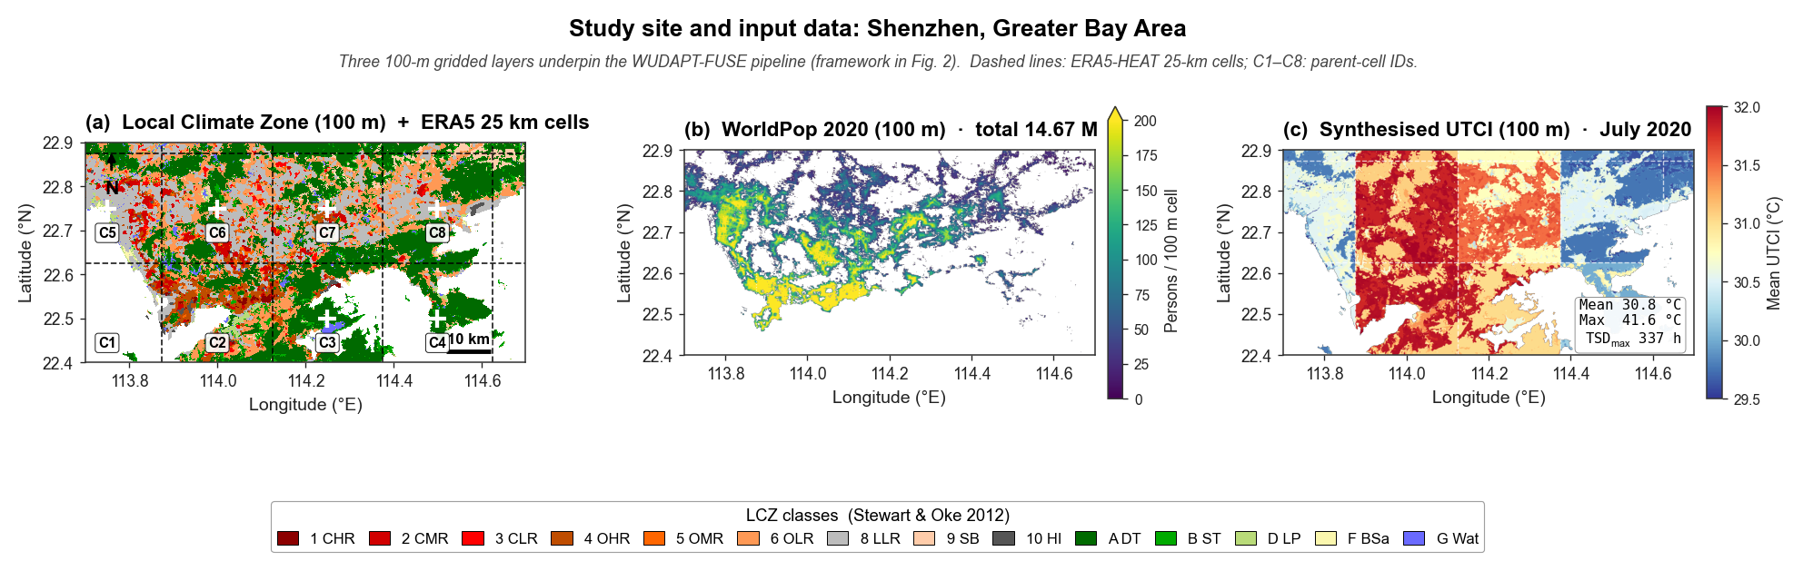
Three 100-m gridded layers underpin the WUDAPT-FUSE pipeline (framework shown in Fig. 2). Dashed lines mark ERA5-HEAT 25-km parent cells (C1–C8). (a) Demuzere et al. (2022) Local Climate Zone map at 100 m, overlaid with eight ERA5-HEAT 25-km cells; LCZ class colors follow the Stewart–Oke (2012) standard. (b) WorldPop 2020 gridded population at 100 m (constrained product); city total 14.67 million. (c) Synthesized 100-m UTCI mean for July 2020 produced by the deviation-injection method (Methods §2.3); range 21.6–41.6 °C, population-weighted mean 30.84 °C, max strong-heat- stress duration 337 h. Panels (a)–(c) are Shenzhen examples; Guangzhou and Dongguan, processed with identical inputs, are analyzed in Section 3.12 and Figure 12.

Figure 2. WUDAPT-FUSE framework: research logic chain.
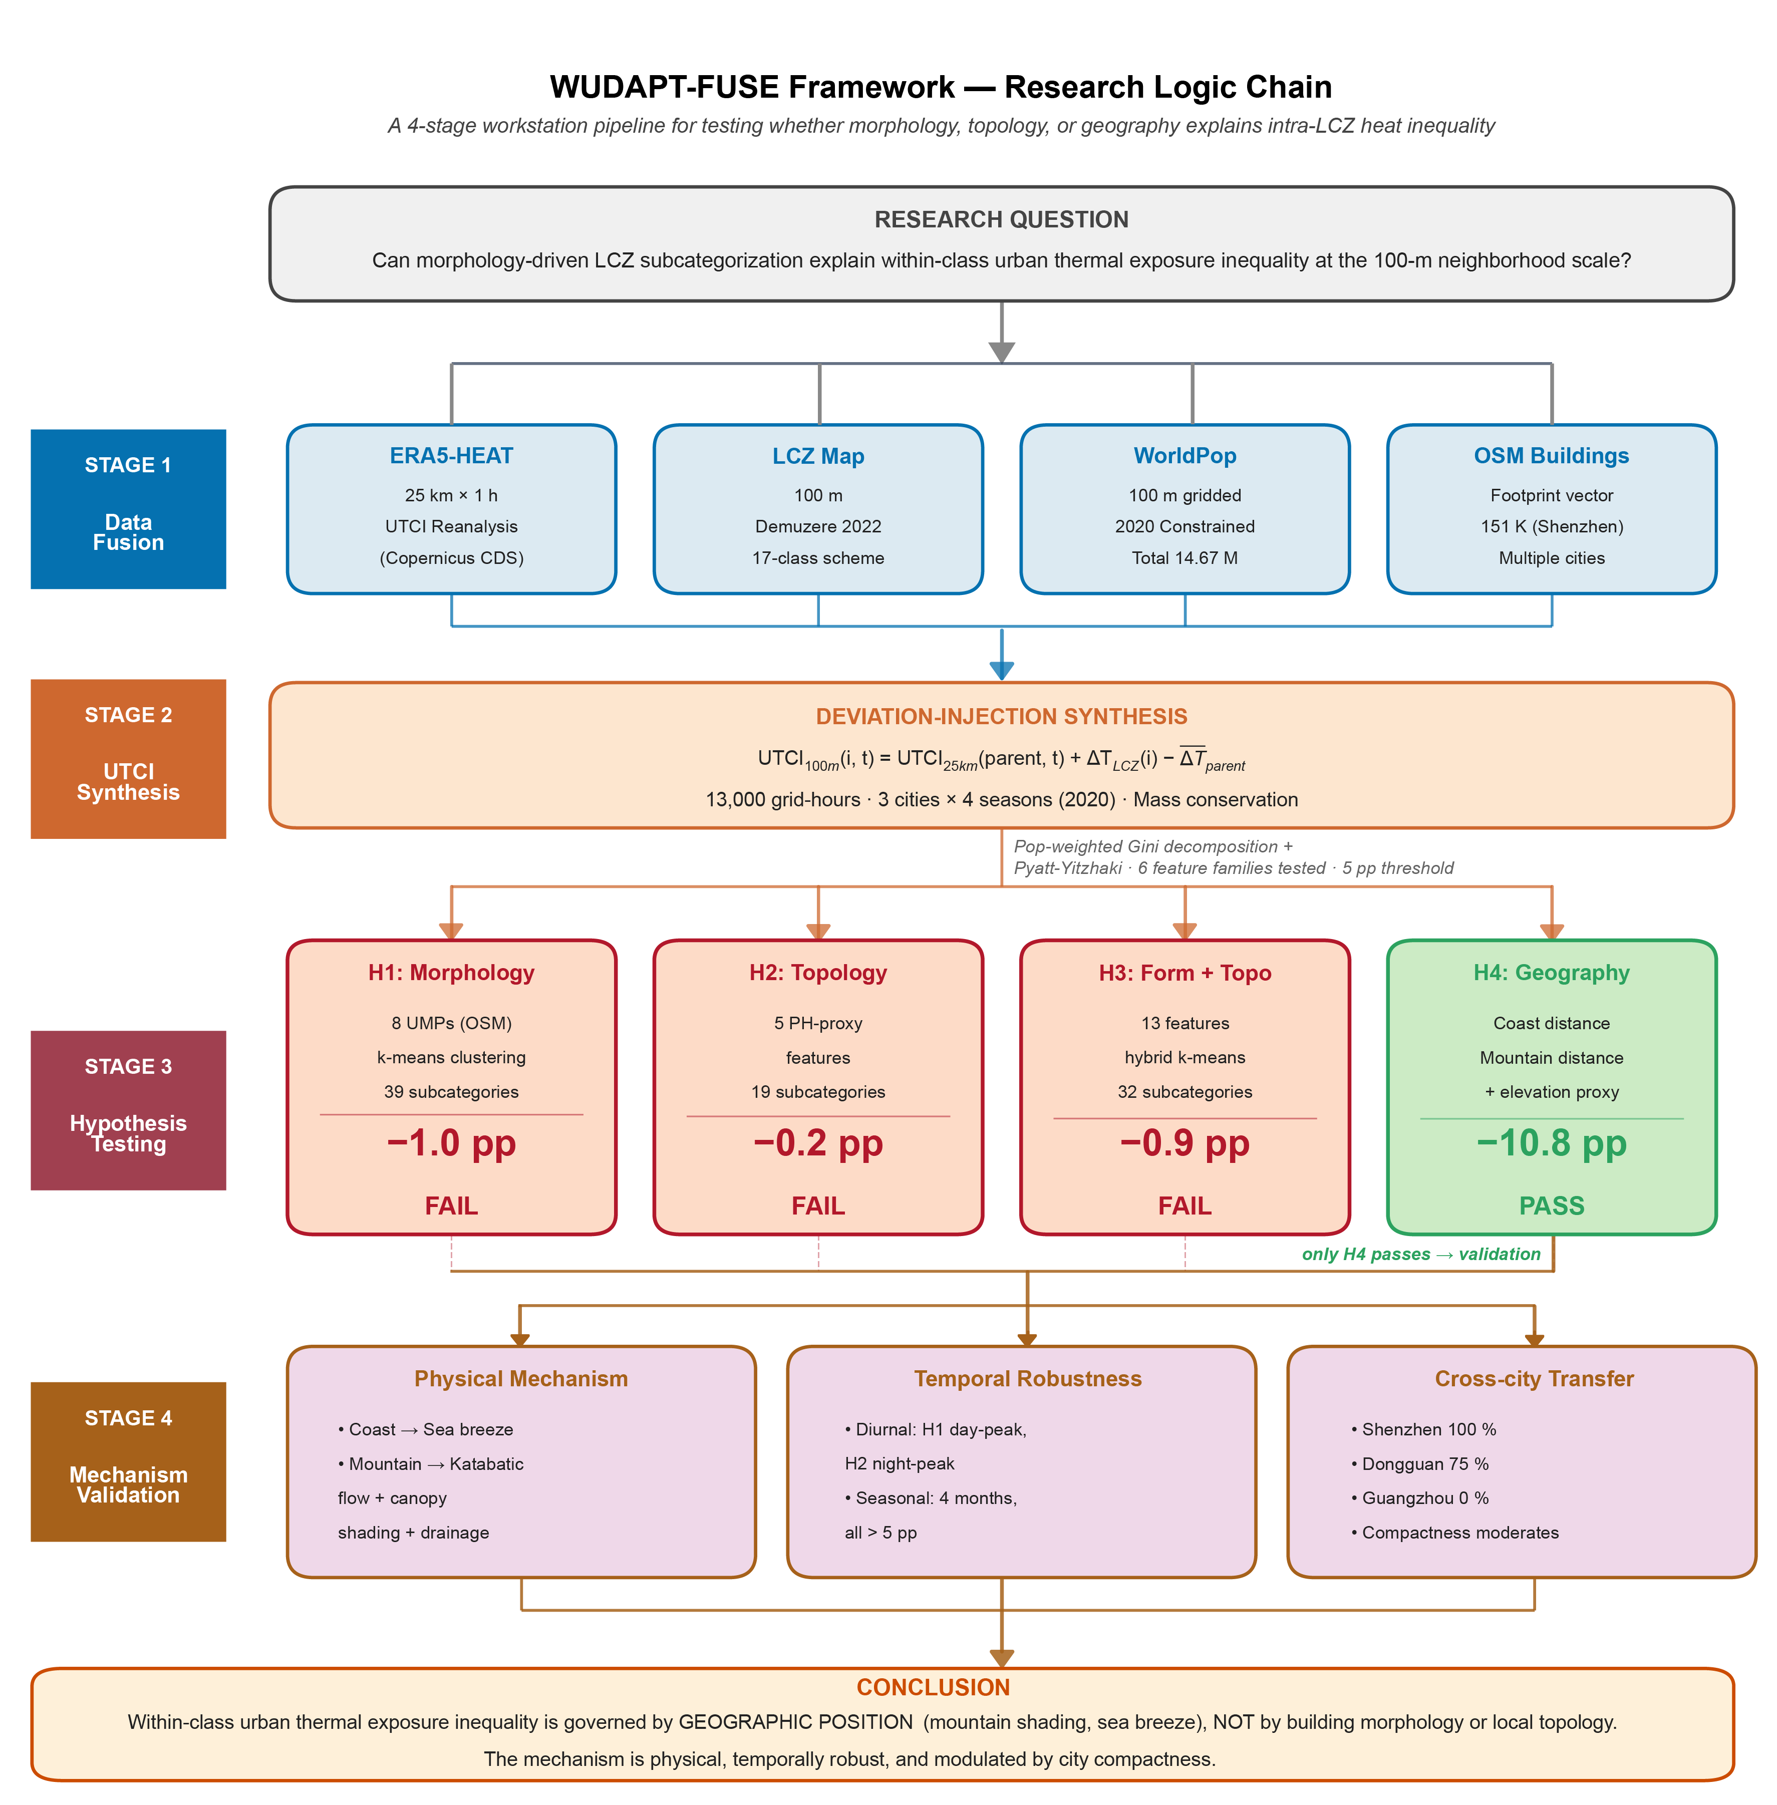
Four-stage analytical pipeline integrating data fusion, UTCI synthesis, hypothesis testing, and mechanism validation. Stage 1 fuses four open data sources—ERA5-HEAT (25 km × 1 h reanalysis), Demuzere LCZ map (100 m), WorldPop 2020 (100 m), and OpenStreetMap building footprints. Stage 2 synthesizes hourly 100-m UTCI for three GBA cities (Shenzhen, Guangzhou, Dongguan) across four seasons of 2020 (~13,000 grid-hour combinations) through a deviation-injection method that preserves both city-mean ERA5 dynamics and LCZ-class spatial heterogeneity. Stage 3 computes population-weighted Gini coefficients with Pyatt–Yitzhaki decomposition and tests four independent feature families: H1 morphology (8 OSM-derived UMPs, 39 subcategories, −1.0 pp), H2 topology (5 PH-proxy features, 19 subcategories, −0.2 pp), H3 form + topology hybrid (13 features, 32 subcategories, −0.9 pp), and H4 geography (coast + mountain distance + elevation proxy, −10.8 pp; the only family exceeding the 5 pp threshold). Stage 4 validates the geographic mechanism through three dimensions: physical (sea breeze + katabatic flow + canopy shading), temporal (diurnal split + four seasons of 2020), and spatial (cross-city transfer to Guangzhou and Dongguan). Conclusion: at the population-weighted scale and under the deviation-injection identification structure, geographic proxies are the most efficient indicators of within-LCZ heat exposure heterogeneity, dominating morphological and topological subcategorization; the pattern is consistent with sea-breeze and katabatic-flow signatures, temporally robust, and city-compactness- modulated.

Figure 3. UTCI dataset and baseline inequality.
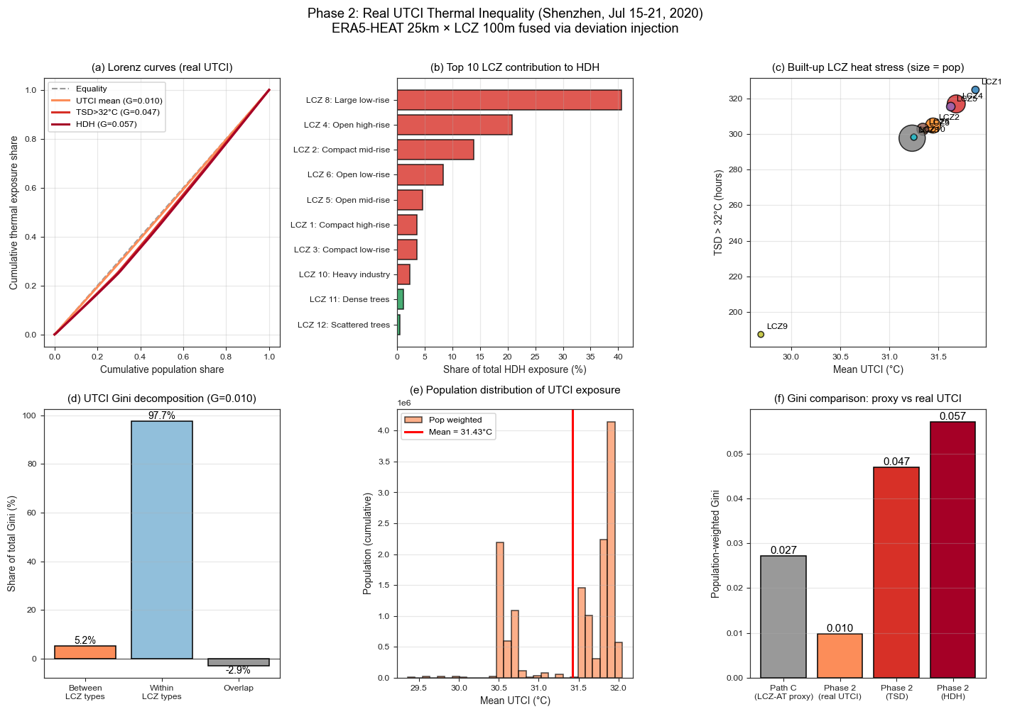
- Lorenz curves for three exposure metrics. The hottest 10% of population bears 11.0% of HDH burden. (b) Top 10 LCZ classes by HDH exposure share. LCZ 8 carries 40.6% of the city’s HDH burden. (c) Built-up LCZ thermal phase space: UTCI mean vs TSD. (d) Gini decomposition by LCZ-type grouping: within-group dominates. (e) Population-weighted distribution of UTCI mean. (f) Method comparison: real UTCI gives Gini values 2–6 times higher than the LCZ-AT proxy.

Figure 4. LCZ subcategories from morphology.
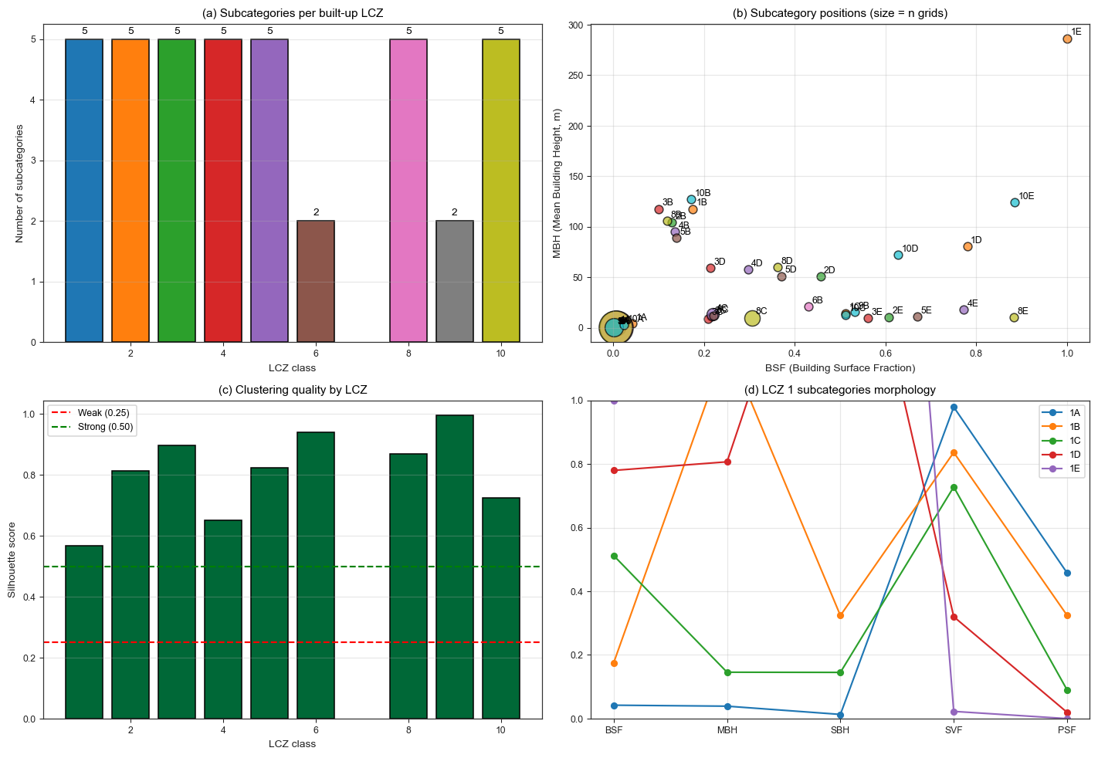
- Number of subcategories per built-up LCZ class (range 2–5; total 39). (b) Subcategory positions in BSF-MBH phase space; marker size proportional to grid count. (c) Silhouette coefficients per LCZ; all values exceed 0.5. (d) Radar chart of normalized UMPs (BSF, MBH, SBH, SVF, PSF) for the five LCZ 1 subcategories.

Figure 12. Cross-city validation in three GBA cities (Phase 8).
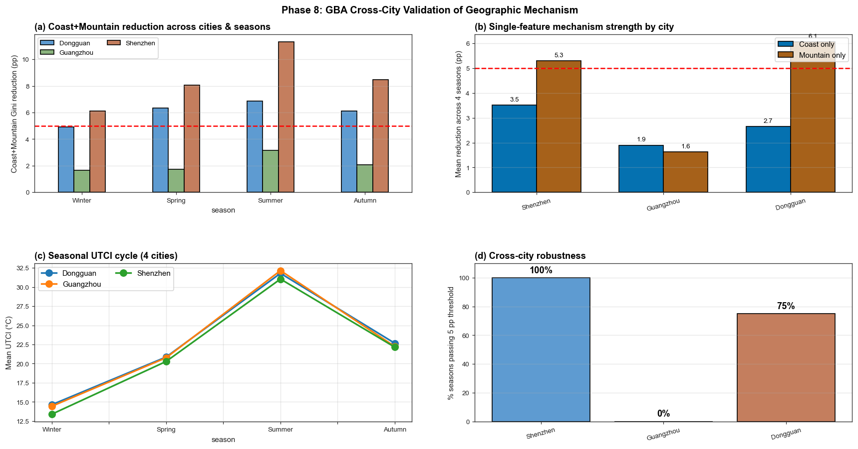
Three GBA cities (Shenzhen, Guangzhou, Dongguan) processed with the same WUDAPT-FUSE pipeline, four seasons each. (a) Coast + Mountain Gini reduction by city and season. The 5 pp threshold (red dashed) is exceeded in all 4 Shenzhen seasons, 3 of 4 Dongguan seasons, and none of Guangzhou’s. (b) Mean single-feature strength (Coast only and Mountain only, averaged across 4 seasons) per city. Mountain dominates Coast in Shenzhen and Dongguan but not Guangzhou. (c) Seasonal UTCI cycle by city; the three cities have nearly identical baseline temperatures, so differences in geographic mechanism strength are not driven by temperature differences. (d) Cross-city robustness: % seasons passing the 5 pp threshold (Shenzhen 100 %, Dongguan 75 %, Guangzhou 0 %).
The figure provides direct evidence that the geographic mechanism generalises to compact GBA cities (Shenzhen, Dongguan) but not to the sprawling case (Guangzhou). City compactness, not raw mountain or coast coverage, is the key moderator.

Figure 11. Seasonal robustness of geographic mechanism (Phase 7 L2).
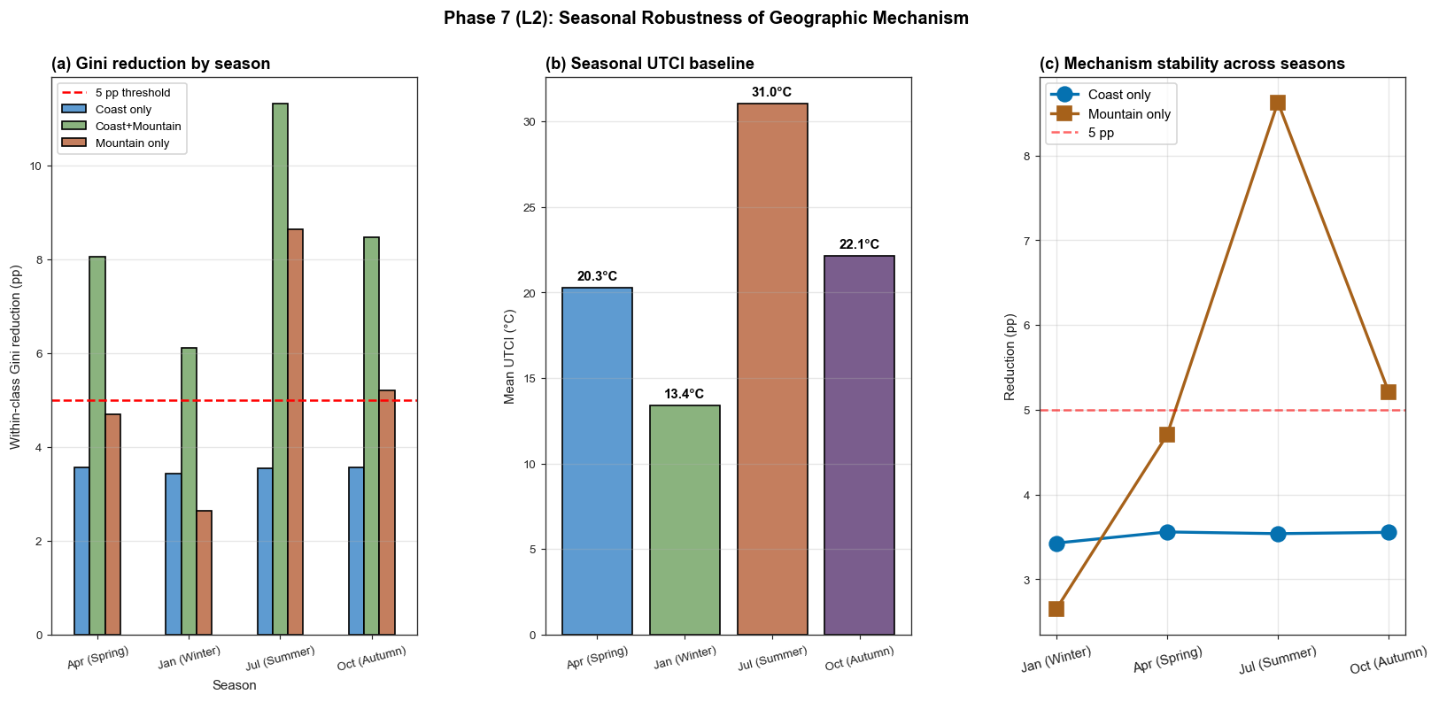
Four months of 2020 (January, April, July, October) were synthesized as 100-m UTCI and re-analyzed with the Coast/Mountain Gini decomposition. (a) Within-class Gini reduction by season for three feature schemes (Coast only, Mountain only, Coast+Mountain). The combined scheme exceeds the 5 pp threshold (red dashed) in every season. (b) Mean UTCI baseline by season, ranging from 13.4 °C (winter) to 31.0 °C (summer). (c) Stability of the two single- feature mechanisms across seasons: Coast contribution is nearly flat (~3.5 pp year-round), while Mountain contribution scales sharply with summer warmth (winter +2.65, summer +8.63 pp).
The figure provides direct evidence that the geographic dominance over morphology (Phase 6) is not a summer-only result and that the two distance features capture physically distinct processes with different seasonal signatures.

Figure 10. Diurnal validation of physical mechanism (Phase 7 L1).
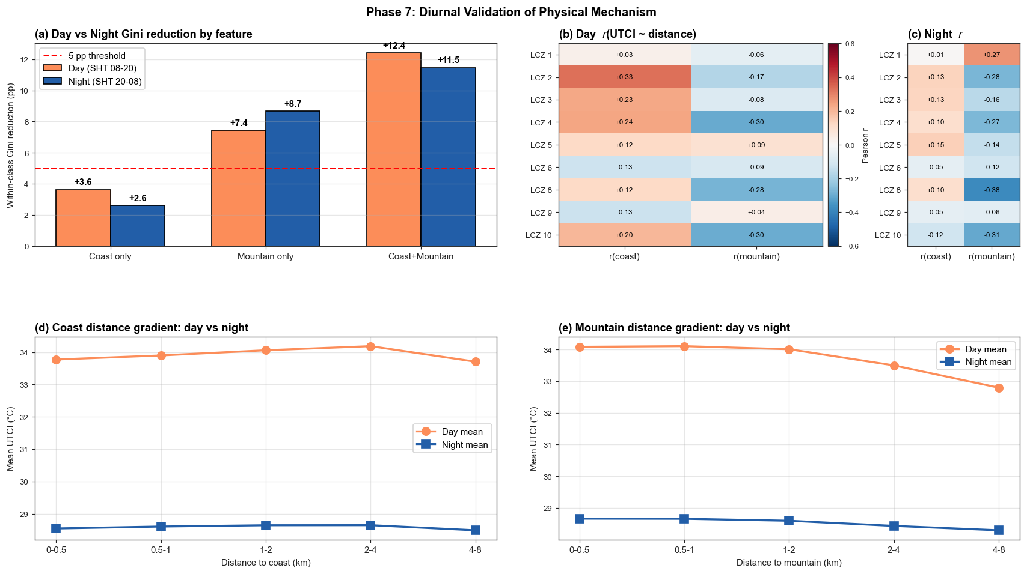
- Day vs night Gini reduction for three feature schemes. Coast effect is 39 % larger during the day (sea breeze daytime peak); the mountain effect is 17 % larger at night (katabatic flow). The combined coast+mountain scheme is high in both periods. (b) Within- LCZ Pearson $r$ for daytime UTCI vs distance to coast/mountain. (c) Same for nighttime. (d) Mean UTCI as a function of distance to coast, separated by day (orange) and night (blue). The day curve shows a more pronounced inland-warming gradient. (e) Mean UTCI as a function of distance to mountain. Both day and night show cooling near mountains, but the night gradient is sharper.
The figure demonstrates that the geographic Gini breakthrough in Phase 6 is mechanistically grounded in two well-known mesoscale processes that operate on different timescales: daytime sea breeze and nighttime katabatic drainage.

Figure 9. Physical mechanism — coast and mountain drive within-class heat inequality.
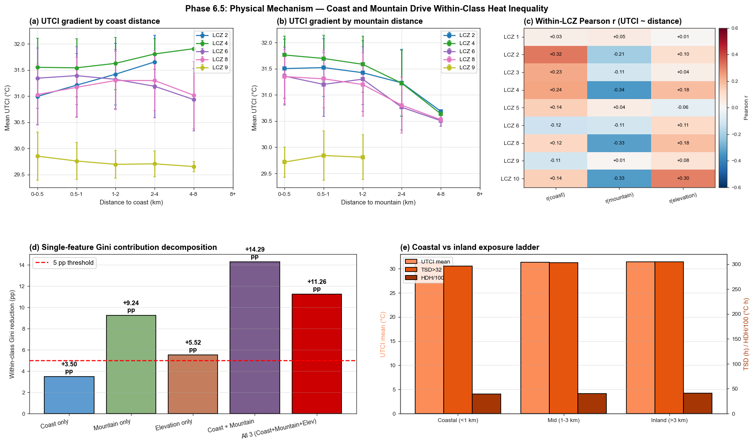
Phase 6.5 decomposes the Phase 6 geography reduction into its physical components. (a) Mean UTCI as a function of distance to the nearest water body, stratified by major built-up LCZ classes (LCZ 2, 4, 6, 8, 9). UTCI rises by 0.2–0.5 °C from the coast inland in most LCZ classes. (b) Mean UTCI as a function of distance to the nearest mountain (LCZ 11/12 dense forest patches). In several built- up LCZ classes, cells closer to the mountain belt are 0.3–0.5 °C cooler than cells far from it. (c) Within-LCZ Pearson $r$ heatmap of UTCI against distance to coast, mountain, and the elevation proxy. Negative $r$ for mountain in LCZ 4, 8, and 10 ($r=−0.32$ to $−0.34$) confirms a strong shading and katabatic-flow effect. (d) Single-feature Gini decomposition. Mountain alone reaches +9.24 pp (above the 5 pp red threshold); Coast + Mountain peaks at +14.29 pp. Adding elevation as a third feature reduces the result to +11.26 pp, an early dimensionality penalty. (e) UTCI, TSD, and HDH for three coast-distance bins. The coast-to-inland step is ~0.2 °C in mean UTCI and ~150 °C·h in HDH, confirming a real but modest sea- breeze relief signal.
The figure provides physically grounded evidence that within-class heat inequality is mediated by mesoscale processes (sea breeze and mountain shading) rather than by neighborhood-scale building form.

Figure 8. Geographic position breaks the 5 pp barrier (Phase 6).
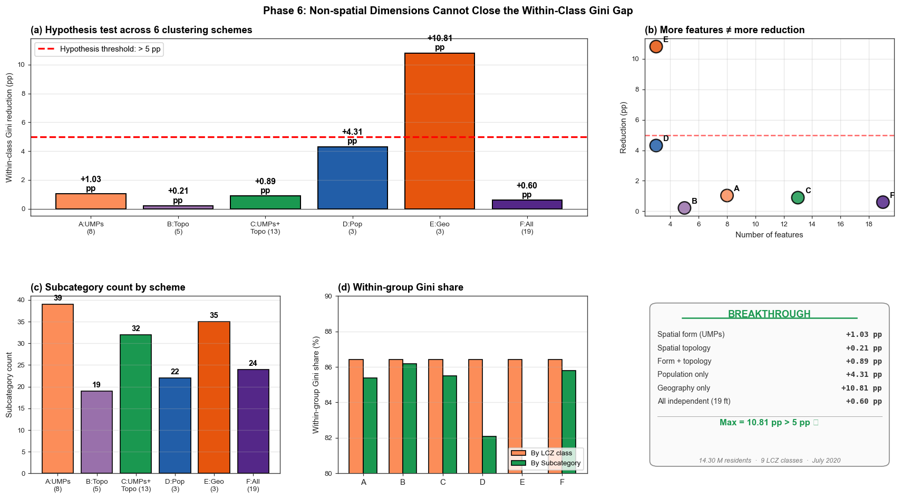
Six clustering schemes A-F using UTCI-independent features only. (a) Within-class Gini reduction for each scheme. The dashed red line marks the hypothesized 5 pp threshold. Schemes A-C (spatial geometry, 8–13 features) and F (all 19 features combined) fall below 1 pp. Scheme D (population, 3 features) reaches 4.31 pp. Scheme E (geography, 3 features) reaches +10.81 pp, exceeding the 5 pp threshold by a factor of two. (b) Reduction vs. number of features. More features do not equal more reduction; small focused feature sets (D, E) outperform high-dimensional combinations (F). (c) Subcategory count per scheme. (d) Within-group Gini share by LCZ-class vs subcategory grouping for each scheme. (e) Summary panel showing the central finding: geographic position alone (coast/mountain distance) absorbs more within-class inequality than all 19 features combined—evidence of curse of dimensionality and of geography’s role as the dominant non-geometric driver.

Figure 7. Hybrid morphology + topology subcategorization fails to close the within-class Gini gap.
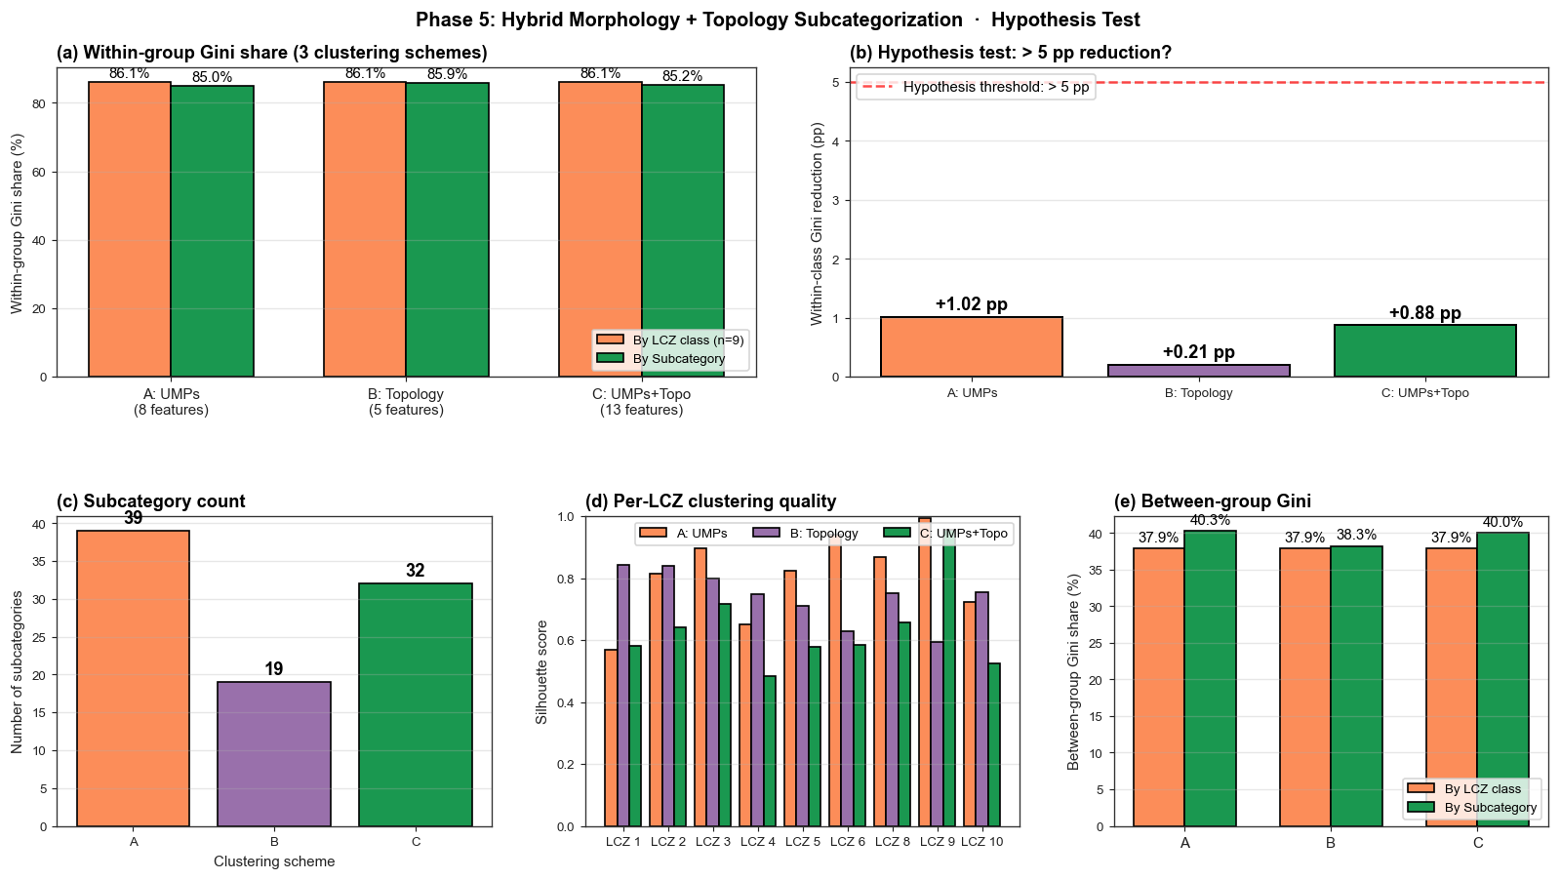
Phase 5 controlled experiment with three k-means clustering schemes: A (UMPs only, 8 features), B (Topology only, 5 local geometric features as PH proxies), and C (UMPs + Topology, 13 features). (a) Within-group Gini share for each scheme, comparing LCZ class (orange) and subcategory (green) groupings. All schemes show near-identical within-class share (85.0–85.9%). (b) Hypothesis test: within-class Gini reduction (pp). The dashed red line marks the hypothesized threshold of 5 pp. All three schemes fall far below the threshold, with the hybrid scheme (0.88 pp) actually slightly worse than UMPs alone (1.02 pp). (c) Number of subcategories generated by each scheme (39, 19, 32). (d) Per-LCZ Silhouette clustering quality—values exceed 0.5 for most classes, confirming that the lack of Gini reduction is not due to poor clustering. (e) Between-group Gini share, with small complementary changes.
The figure provides the central empirical evidence on the question whether topology can complement morphology under our identification structure: it cannot, at least at the explanatory-efficiency level the within-class Gini decomposition can resolve.

Figure 6. Topological data analysis of the 100-m UTCI field.
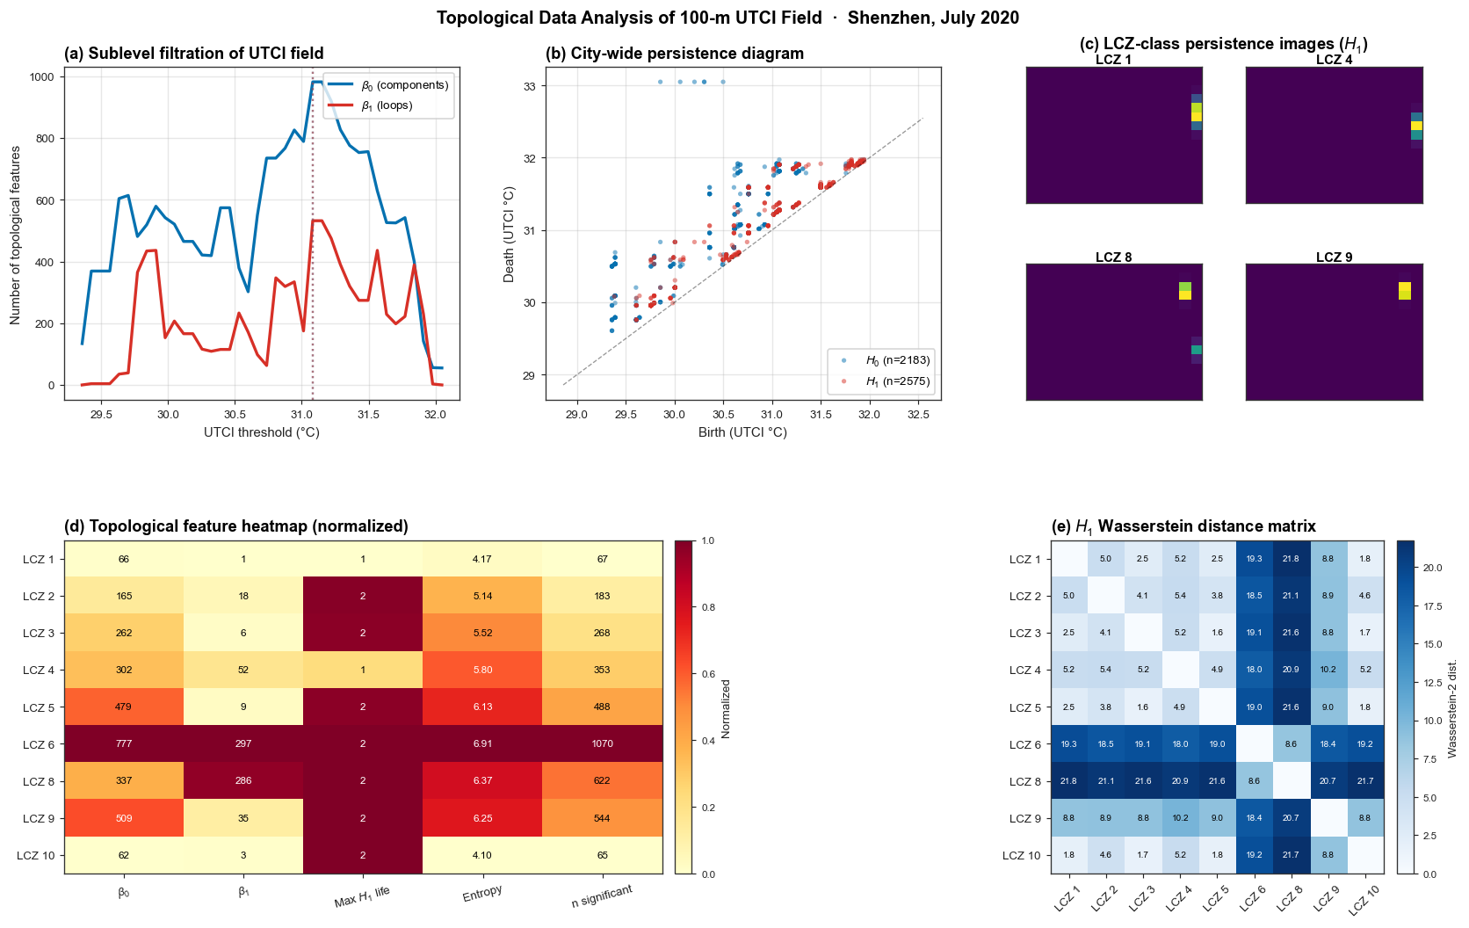
- Sublevel filtration of the city-wide UTCI field. $β_{0}$ (blue, connected components) and $β_{1}$ (red, holes) both peak at UTCI = 31.08 °C—the topological transition point at which Shenzhen’s heat island network is most fragmented. (b) City-wide persistence diagram. The diagram shows 2,183 $H_{0}$ and 2,575 $H_{1}$ features, with persistence entropy = 8.06. Off-diagonal points are robust topological features; the diagonal corresponds to noise. (c) Persistence images of four representative LCZ classes (1, 4, 8, 9) at $H_{1}$ resolution, revealing distinct geometric signatures. (d) Topological feature heatmap: nine built-up LCZ classes × five features (column-normalized). LCZ 6 (Open low-rise) stands out with the highest $β_{1}$ (297 holes) and entropy (6.91). (e) Pairwise $H_{1}$ Wasserstein-2 distances between LCZ classes, ranging from 1.55 to 21.76—a 14× dynamic range that far exceeds the per-class mean UTCI spread of only 2.2 K.

Figure 5. Subcategorization fails to absorb within-class inequality (key result).
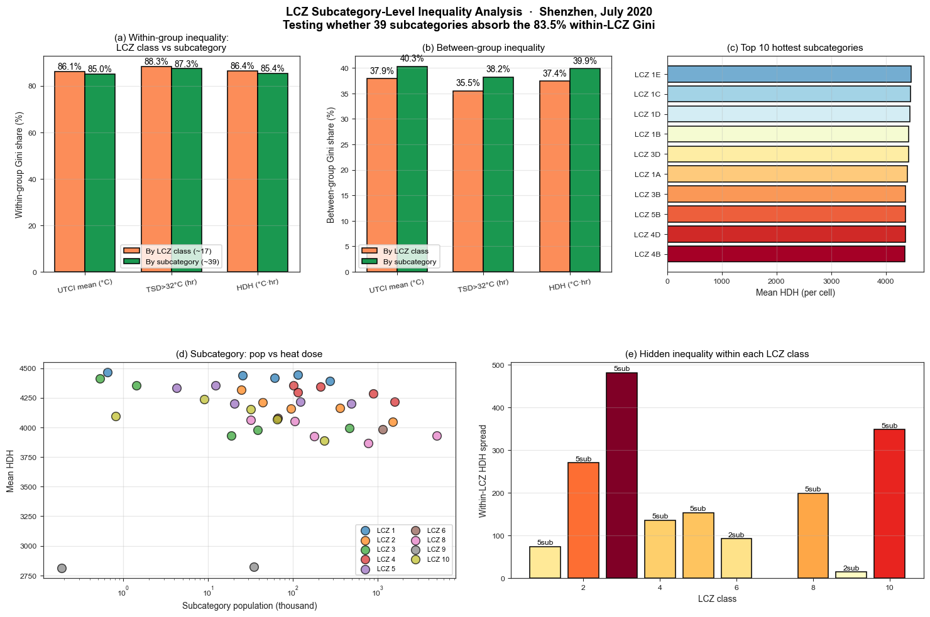
- Within-group Gini share by grouping level: LCZ class (9 groups, orange) vs LCZ subcategory (39 groups, green). Across all three metrics (UTCI mean, TSD, HDH), the within-group share falls by only 1.0–1.1 percentage points despite a 4.3-fold increase in group count.
- Between-group Gini share, showing a small complementary increase under finer grouping. (c) Top 10 hottest subcategories ranked by mean HDH, dominated by LCZ 1 (Compact high-rise) variants. (d) Subcategory population vs mean HDH on a log x-scale, colored by parent LCZ class.
- Within-LCZ HDH spread (max minus min subcategory) per LCZ class. LCZ 3 ($Δ=481$) and LCZ 10 ($Δ=348$) carry the largest hidden inequality, redirecting adaptation priorities away from the visible high-rise CBD.

