Instructions to Working with Scanning Tool in Docker Container

1/ Deployment and Running

* Clone the project from GitHub Repo
* Open the project directory
* Run the command below to build and run container:
  + docker composes run scantools

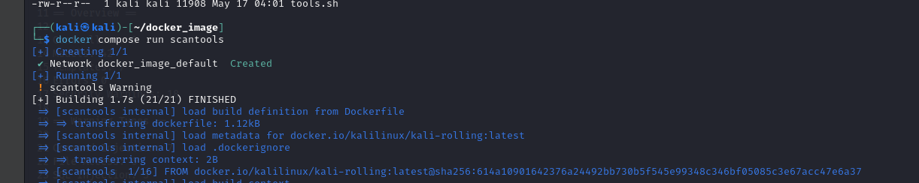

* The building process finishes when the menu selection appears:

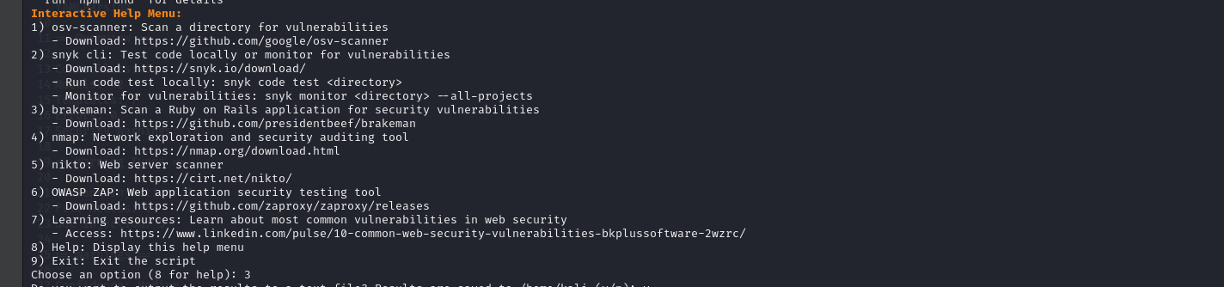

* Enter the number to select the tool

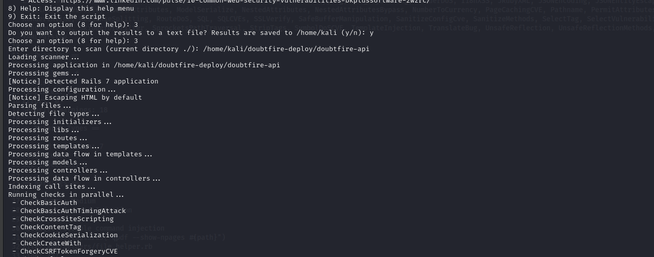

* Note 1: I made the fallback in case some bugs happen, and you don’t see the menu selection appear just run the command below
  + scan1

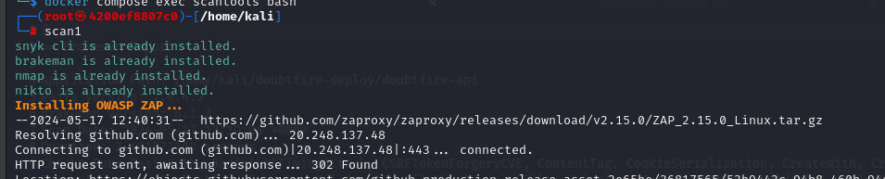

* To exit enter: 10

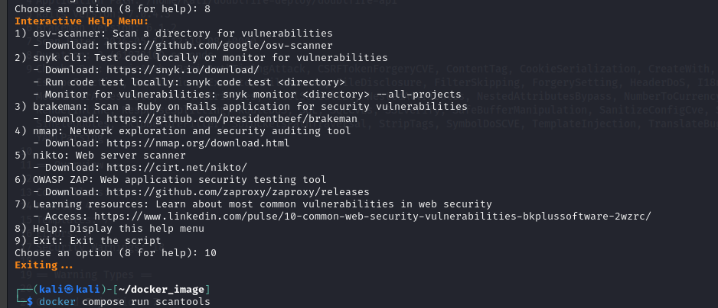

2/ Clean Up

If the build process is not successful or during running errors appear you can try to clean up and re-run again

* To clean up run the commands below:
  + docker compose down
  + docker image rm -f scantools:1.0

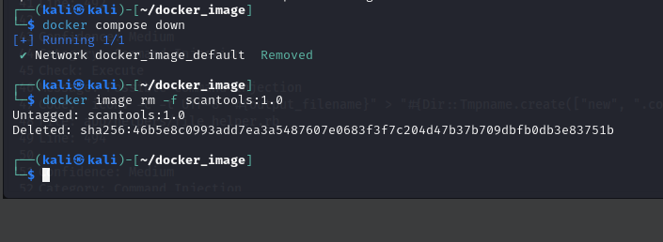

3/ Know Issue

* During the build process, you may see stuck in the error that some URL or repository cannot be connected
  + You can try Disable the firewall or Internet protection setting of your security/Anti-virus Software
  + This docker image is built based on Kali Linux and Script install vulnerability scanning tools. Some Security Software may consider it unsafe and block the network connection.