How Smishing Attacks Work and Why They’re Effective

# 1. Introduction

Smishing, a portmanteau of “SMS” and “phishing,” is a cyberattack method where attackers use text messages to trick individuals into revealing sensitive information or clicking malicious links. While the concept might seem simplistic, smishing continues to be remarkably effective. This report explores how smishing works, the psychological principles it exploits, and why even basic tactics remain successful in today's digital landscape.

# 2. What is Smishing?

Smishing is a form of social engineering where attackers impersonate trusted organizations or individuals to lure recipients into performing actions that compromise their data or security. These messages often contain:  
  
- Malicious links leading to fake websites  
- Phone numbers that connect to scammers  
- Requests for personal data such as bank credentials or OTPs  
  
Common examples include fake package delivery updates, fraudulent bank alerts, or impersonated messages from government agencies.

# 3. The Mechanics of a Smishing Attack

Below is the Step-by-step Breakdown of a Smishing attack using the example :  
  
1. Message Delivery: The attacker sends a text designed to look official or urgent.

2. Social Engineering Hook: The message includes emotional triggers—fear, urgency, curiosity, or reward.

3. Call-to-Action (CTA): The victim is encouraged to click a link or call a number.

4. Payload Delivery:  
 - A phishing site harvests credentials.  
 - Malware may be downloaded (especially on Android).  
 - Personal data is extracted through conversation or fake forms.

5. Exploitation: Stolen information is used for fraud, identity theft, or access to secure systems.

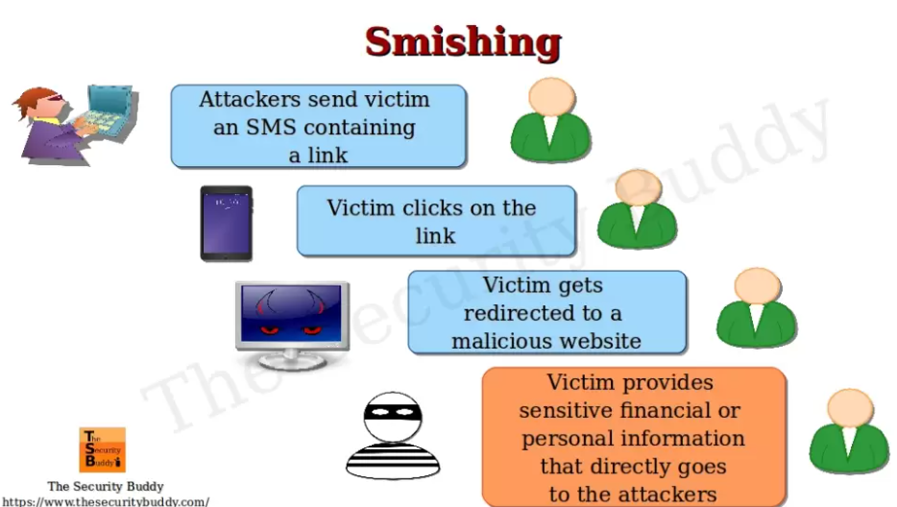

Figure 1: Working of the example of a Smishing attack

The above figure shows a example of the working of one Smishing attack. Firstly, the attacker sends victim an SMS containing a link, afterwards, the victim clicks on the link and victim is getting redirected to a website that is malicious. Finally, the victim provides his sensitive information that goes to the attackers.

# 4. Why Smishing is So Effective

Smishing attacks are highly effective due to their ability to exploit psychological vulnerabilities and mobile environment weaknesses, leading to major consequences for individuals and organizations. Smishing utilizes SMS messages to lure victims into revealing sensitive information or downloading malicious software, [according to IBM](https://www.ibm.com/think/topics/smishing) and [Kaspersky](https://www.kaspersky.com/resource-center/threats/what-is-smishing-and-how-to-defend-against-it).

Below is a breakdown of the working of triggers used in smishing used and its effects:

**- Urgency:** Messages often create a sense of immediate threat or time-limited action, for instance “Your account will be locked unless you verify now!” This prompts users to act quickly without thinking critically.

**- Authority:** Attackers impersonate banks, government bodies, or company IT departments to leverage trust and obedience. Users are more likely to comply with instructions from a figure of authority.

**- Scarcity:** Fake promotions or exclusive deals with short deadlines trick users into prioritizing the offer over caution, e.g., “Only 2 hours left to claim your reward!”

**- Fear or Panic:** Tactics include messages about suspicious account activity or fines, pressuring users to resolve the issue urgently. Example: “We’ve detected a login attempt. Reset your password now!”

**B. Mobile Environment Vulnerabilities:**

**- Small Screens:** Mobile devices display shortened URLs and limited message previews, reducing the ability to inspect links or detect suspicious content.  
**- Immediate Access:** Phones are often checked instantly upon receiving a message. The casual and quick nature of text response habits makes users less skeptical.

**- Lack of Security Tools:** SMS apps don’t provide phishing detection features like email platforms or browsers. Users receive raw messages without filters, and mobile antivirus protection is often minimal or absent.

**- App Permissions & Downloads:** Some smishing messages link to APK files or apps disguised as legitimate tools. On Android, sideloaded apps can install malware if users are tricked into granting permissions.

These combined factors make smishing an especially potent threat. The simplicity of the attack—just a text—belies its potential damage, particularly when users are unprepared or unaware.

# 5. The Simple and Common Patterns that Still Work

Despite growing awareness, basic smishing tactics remain effective due to:  
  
**- Human error:** Not everyone recognizes red flags.  
**- Broad reach:** Attackers can send thousands of messages at low cost.  
**- Lack of verification:** SMS lacks built-in sender authentication.  
**- Mobile habits:** People often multitask and respond without careful analysis.

Figure 2: The common source of data breach involves the human error by around 25%

**Example:**  
"Your package is awaiting delivery. Please confirm your address: https://track-now.xyz/ABC123"  
  
Even if poorly written, such messages still yield results, especially during peak times like holidays or sales events.

# 6. Real-World Impact

The below are the real-world impacts of the smishing detection-

* **Financial Loss:** A successful smishing attack can lead to the theft of bank account details, credit card information, and other sensitive financial data, resulting in unauthorized transactions and significant financial loss for the victim.
* **Identity Theft:** Cybercriminals can use stolen information to open fraudulent accounts, incur debt in the victim's name, and damage their credit score, leading to long-term financial and reputational harm.
* **Mental Wellbeing:** Being a victim of a smishing attack can be incredibly distressing, leading to feelings of anxiety, stress, and even depression.
* **Compromised Accounts:** Smishing can lead to the compromise of various online accounts, including email, social media, and banking accounts, exposing sensitive data and potentially leading to further cybercrime.
* **Data Breaches:** Smishing attacks can be a gateway for cybercriminals to access sensitive data stored on mobile devices or through compromised accounts, potentially leading to large-scale data breaches.
* **Business Impacts:** Businesses that rely on mobile communication can be targeted by smishing, leading to financial loss, damage to reputation, and disruptions to business operations.
* **Public Communication Interference:** Smishing can disrupt public announcement systems, potentially undermining the public's trust and faith in important communication channels.
* **Social Engineering:** Smishing often relies on social engineering techniques, where attackers use deception to manipulate victims into disclosing information or clicking on malicious links.
* **Malware Installation:** Smishing can be used to install malware on a victim's device, allowing cybercriminals to monitor their activity, steal data, or gain remote access to the device.
* **Reputation Damage:** Being a victim of smishing can damage a person's reputation, especially if their personal information is leaked or used to commit fraudulent activities.

# 7. Mitigation Strategies

The below are some of the strategies to reduce the smishing attacks-

**For Individuals:**  
  
- Never click on suspicious links from unknown senders.  
- Verify with the institution directly using official contact details.  
- Use SMS spam blockers or mobile antivirus apps.  
  
**For Organizations:**  
  
- Educate users through awareness campaigns.  
- Implement SMS filtering and firewalls.  
- Use multi-factor authentication to reduce impact.

# 8. Conclusion

Smishing attacks continue to thrive not because they are technically complex, but because they exploit fundamental aspects of human psychology and digital habits. In a mobile-first world, where convenience often outweighs caution, the effectiveness of smishing lies in its simplicity. Combating it requires a mix of technological defenses and human awareness, reinforcing the timeless cybersecurity principle: people are the first line of defense.

# 9. References-

1. IBM Security, 2021. Smishing Attacks Are on the Rise. [online] Security Intelligence. Available at: <https://securityintelligence.com> [Accessed 14 May 2025].
2. Kaspersky, 2023. What is Smishing? [online] Available at: <https://www.kaspersky.com/resource-center/threats/smishing> [Accessed 14 May 2025].
3. Australian Cyber Security Centre (ACSC), 2023. Protect Yourself from Scams and Smishing. [online] Available at: <https://www.cyber.gov.au> [Accessed 14 May 2025].
4. Federal Trade Commission (FTC), 2022. How to Recognize and Avoid Phishing Scams. [online] Available at: <https://consumer.ftc.gov> [Accessed 14 May 2025].
5. Verizon, 2023. Data Breach Investigations Report. [online] Available at: <https://www.verizon.com/business/resources/reports/dbir/> [Accessed 14 May 2025].
6. Norton, 2022. What is Smishing? SMS Phishing Explained. [online] Available at: <https://us.norton.com/internetsecurity-online-scams-what-is-smishing.html> [Accessed 14 May 2025].
7. Google, 2025. Google Search. [online] Available at: <https://www.google.com> [Accessed 14 May 2025].