Project/Case Study
  - Deadline: Phase-1: Sunday 26/07/2026 @ 23:59 Phase-2: Sunday 09/08/2026 @ 23:59
[Total Mark is 20]

Network Management
IT363

Student Details: CRN:
Name:  Name:  Name:  Name: |  | ID:  ID:  ID:  ID:

Instructions:
- You must submit two separate copies (one Word file and one PDF file) using the Assignment Template on Blackboard via the allocated folder. These files must not be in compressed format.
- It is your responsibility to check and make sure that you have uploaded both the correct files.
- Zero mark will be given if you try to bypass the SafeAssign (e.g., misspell words, remove spaces between words, hide characters, use different character sets, convert text into image or languages other than English or any kind of manipulation).
- Email submission will not be accepted.
- You are advised to make your work clear and well-presented. This includes filling your information on the cover page.
- You must use this template, failing which will result in zero mark.
- You MUST show all your work, and text must not be converted into an image, unless specified otherwise by the question.
- Late submission will result in ZERO mark.
- The work should be your own, copying from students or other resources will result in ZERO mark.
- Use Times New Roman font for all your answers.

Project Instruction
Project Objective:
This activity is an opportunity for you to practice your knowledge, enhance your skills, and learn from experience to work on network management in terms of network tools, configurations, protocols, and troubleshooting.
Total Marks = 20
- Group Size = 3-4 Members.
- One group member (group leader/coordinator) must submit all files on blackboard. Marks will be given based on your submission and quality of the contents.
Project Report
- Each Report will be evaluated according to the marking criteria.
- Screenshots are required only for the practical monitoring tools question.
- The report must be clear, well-presented, and written in English.
- The report must include a short reflection and contribution table.
- Copying from other students or external sources without proper citation may result in zero.
Required Student Report Structure
- Cover page with student names, IDs, CRN, and group number.
- Table of contents.
- Answers to Question 1 to Question 5.
- Screenshots for Question 4.
- References, if external sources were used.

Question # | Criteria | Marks
Q1-A | Clear explanation of the need for network management | 1
Q1-B | Correct simple diagram showing NMS and managed devices | 2
Q1-C | Four relevant parameters to monitor | 1
Q2-A | Comparison of OSI/CMIP, SNMP/Internet, and TMN | 1.5
Q2-B | Justification for using SNMP | 1
Q2-C | Explanation of the four management models | 1.5
Q3-A | SNMP manager-agent diagram | 1
Q3-B | Correct explanation of five SNMP messages | 1
Q3-C | Five managed objects correctly classified | 1
Q3-D | Simple MIT/MIB tree diagram | 1
Q4-A | Ping test with screenshot and explanation | 1
Q4-B | nslookup/dig test with screenshot and explanation | 1
Q4-C | Wireshark capture/filter screenshot | 1
Q4-D | Clear interpretation of results | 1
Q5-A | Correct comparison between wired and wireless broadband access | 1
Q5-B | Clear recommendation with justification | 1
Reflection | Please red “Project submission requirements and instruction” file | 2
 | Total | 20
Marking Criteria

Question One
4 Marks
Learning Outcome(s):
Describe network management issues, standards and architecture.

Consider the following scenario and answer the questions,

A small university computer lab has the following network:
- 1 router connected to the Internet.
- 2 switches.
- 1 file server.
- 1 printer.
- 20 student PCs.
- 1 network administrator PC used as the Network Management System (NMS).
For the given lab network:
- Explain why network management is needed in this lab network.
- Draw a simple network management diagram showing the NMS, router, switches, server, printer, and PCs.
- Identify and briefly explain at least four network parameters that the administrator should monitor, such as availability, packet loss, delay, throughput, or interface status.

ANSWER:
A-
Network administration is essential in the university computer lab in order to ensure that all of the devices and services that are connected to the network operate in an efficient and appropriate manner. The network administrator uses the Network Management System (NMS) to keep an eye on everything from the router and switches to the file server and printer, as well as the PCs used by the students. With the help of network management, it is possible to discover a variety of issues, including failures in connection, loss of packets, devices that are not accessible, and slow network performance. Additionally, it helps the administrator to quickly fix problems, eliminate service outages, manage network security, and ensure that students have continuous access to the Internet, shared files, and printing services. All of these benefits are made possible by the system.
B-
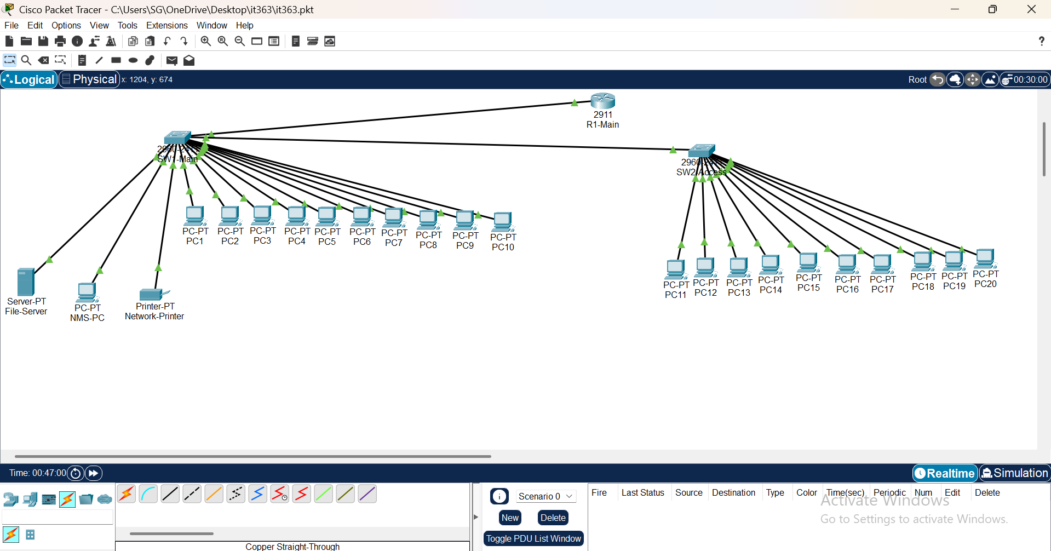

C-
The network administrator should monitor several important network parameters:

1. Availability: This shows whether a network device or service is operating and reachable. The administrator should monitor the router, switches, file server, printer, and student computers to identify any device that becomes unavailable.

2. Packet Loss: Packet loss occurs when some data packets do not reach their destination. High packet loss may cause slow communication, interrupted access, and poor network performance.

3. Delay: Delay measures the time required for data to travel from the source to the destination. High delay can make Internet access, file transfers, and other network services slower.

4. Throughput: Throughput represents the amount of data successfully transferred through the network during a specific period. Monitoring throughput helps the administrator identify congestion or insufficient network capacity.

5. Interface Status: Interface status shows whether the ports on routers and switches are active or inactive. Monitoring interface status helps identify disconnected cables, disabled ports, or hardware problems.

Question Two
4 Marks
Learning Outcome(s):
Describe network management issues, standards and architecture)..

- Briefly compare OSI/CMIP, SNMP/Internet, and TMN as network management standards.
- Explain why SNMP is commonly used in practical network management.
- Using the OSI/SNMP network management model, briefly describe the organizational model, information model, communication model, and functional model.

ANSWER:
A-
OSI/CMIP, SNMP/Internet, and TMN are three different approaches to network management that include differing degrees of complexity and may be used in a variety of contexts. Despite the fact that OSI/CMIP provides a comprehensive management framework that is packed with advanced capabilities, it is difficult to use and requires a significant amount of processing and implementation capacity. There is support for SNMP/Internet across all types of network equipment, including routers, switches, servers, and other network devices. This protocol is simpler and easier to configure. Managing and monitoring networks that are based on IP is the primary application for it. Technology administration Network (TMN) was initially created for use in telecommunications networks, and its primary emphasis is on the administration of big, structured communication systems via several management layers. Because it is practical, lightweight, and easy to use, Special Network Management Protocol (SNMP) is typically better suited for use in smaller university labs.

B-
It is extensively used in practical network administration due to the fact that Simple Network administration Protocol (SNMP) is simple to use, lightweight, and widely supported by a variety of network devices. Through the use of a centralized Network Management System, the administrator of the network is able to monitor many devices, including routers, switches, servers, printers, and numerous more. A manager-agent architecture is used by SNMP. This design allows for the management to send requests, while the agents are responsible for providing data on the performance and state of the devices. In addition, it has the capability to automatically deliver Trap messages if a big event or problem occurs. Compared to more intricate management protocols, Simple Network Management Protocol (SNMP) is easier to set up and maintain, and it use less resources. Therefore, it is suitable for use in both large IP-based networks as well as smaller networks, such as the one found at the university lab.
C-

1. Organizational Model: This model defines the relationship between the network management system and the managed devices. The NMS acts as the manager, while routers, switches, servers, and printers contain agents that collect and provide management information.

2. Information Model: This model defines the management information that can be monitored or controlled. The information is stored as managed objects in the Management Information Base (MIB), such as interface status, IP address, CPU utilization, and system name.

3. Communication Model: This model explains how the manager and agents exchange management messages. SNMP uses messages such as Get-Request, Get-Next-Request, Set-Request, Get-Response, and Trap.

4. Functional Model: This model describes the main network management functions. These functions include fault management, configuration management, accounting management, performance management, and security management.

Question Three
4 Marks
Learning Outcome(s)
Illustrate different variations of Simple Network Management Protocol (SNMP).

For the lab network scenario:
- Draw a simple SNMP Manager-Agent architecture for the given lab network, clearly labeling the SNMP Manager (NMS), SNMP Agents, and the communication between them.
- Explain the purpose of Get-Request, Get-Next-Request, Set-Request, Get-Response, and Trap.
- Identify five examples of SNMP managed objects (MIB objects) relevant to the lab network (e.g., interface status, system name, IP address, CPU utilization, printer status), and classify each as hardware, software, or administrative information.
- Draw a simple Management Information Tree (MIT) for the lab network. Do not write a full MIB module.

A-
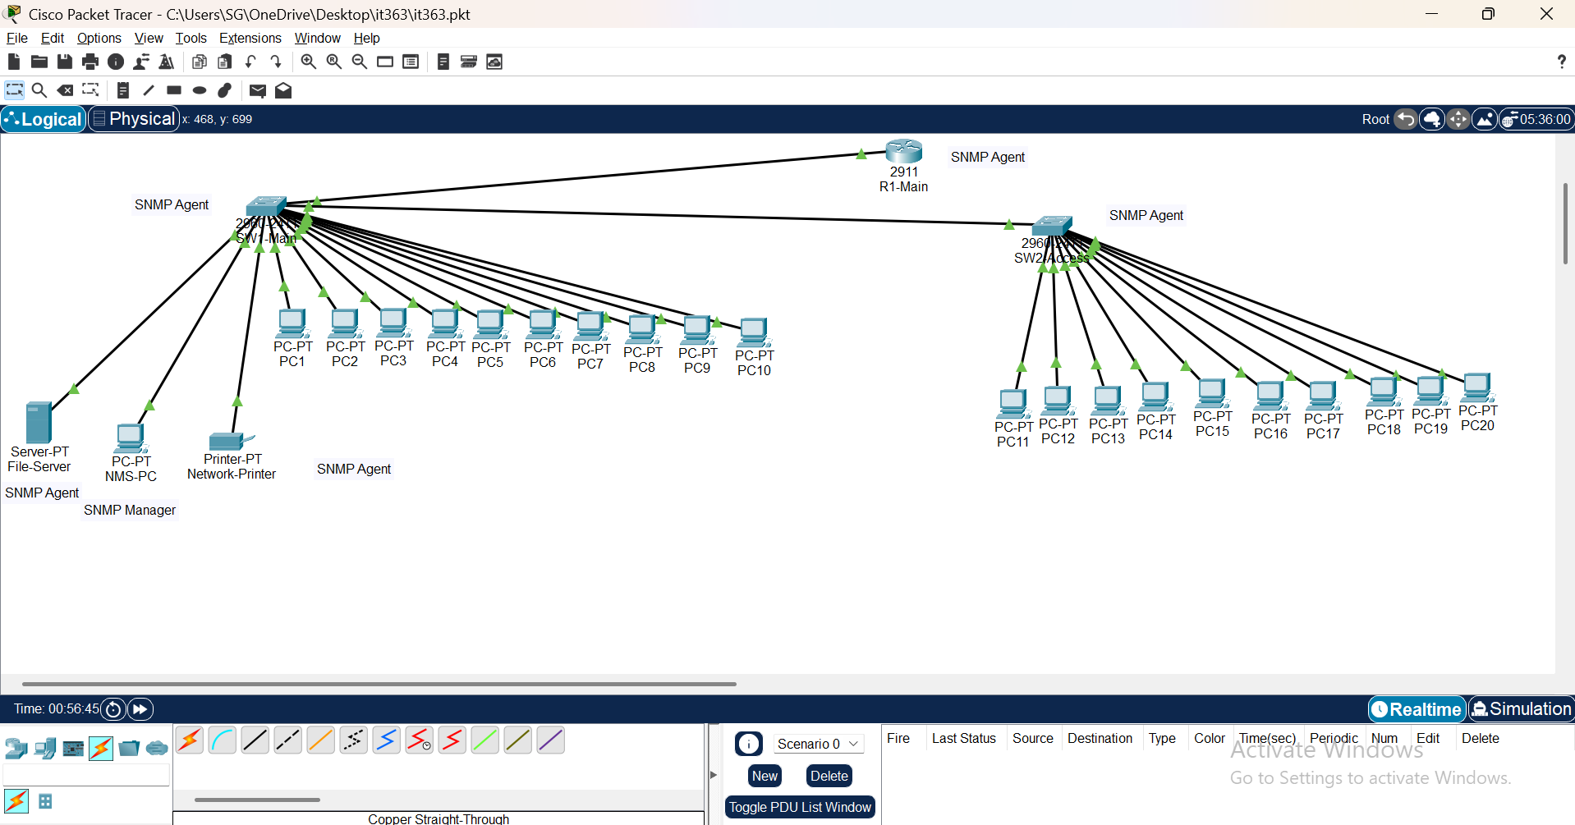
In this architecture, the NMS-PC acts as the SNMP Manager. The router, switches, file server, and network printer act as SNMP Agents. The manager sends SNMP requests to the agents to collect management information, and the agents return responses. Agents can also send Trap messages automatically to the NMS when a fault or important event occurs.
B-
Get-Request: This message is sent by the SNMP Manager to an agent to request the value of a specific managed object, such as interface status or CPU utilization.

Get-Next-Request: This message is used by the SNMP Manager to retrieve the next managed object in the MIB. It is useful when the manager wants to read several related objects in sequence.

Set-Request: This message is sent by the SNMP Manager to change the value of a managed object on a device, such as modifying a device name or configuration setting.

Get-Response: This message is sent by the SNMP Agent to the Manager as a reply to Get-Request, Get-Next-Request, or Set-Request. It contains the requested value or an error message.

Trap: This message is sent automatically by an SNMP Agent to the Manager when an important event occurs, such as an interface failure, device restart, or high CPU utilization.

C-
Managed Object | Example in the Lab Network | Classification
Interface Status | Shows whether a router or switch port is up or down. | Hardware Information
System Name | Stores the configured name of a device, such as R1-Main or SW1-Main. | Administrative Information
IP Address | Shows the IP address assigned to a network device. | Administrative Information
CPU Utilization | Shows the percentage of processor usage on the router, switch, or server. | Software Information
Printer Status | Shows whether the network printer is ready, busy, offline, or has an error. | Hardware Information

D-
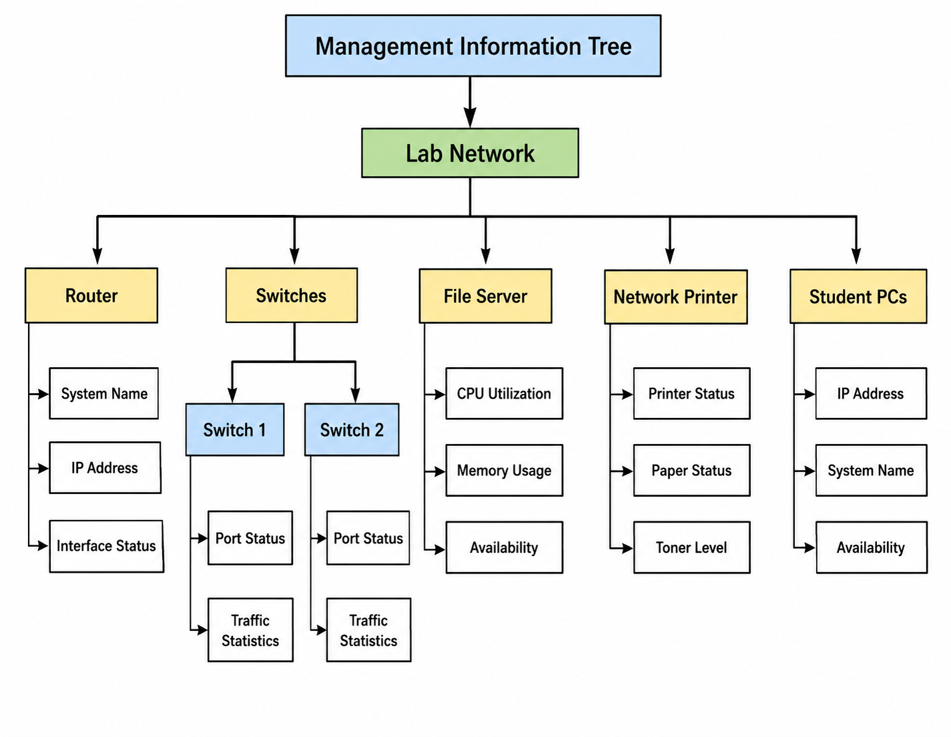

Question Four
4 Marks
Learning Outcome(s)
Evaluate different SNMP tools, network statistics tools, and protocol analyzer for network management.

Each group should use a PC and perform the following simple monitoring tasks:
- Use ping to test connectivity to the default gateway and one reachable public website (e.g., www.google.com).
- Use nslookup or dig to resolve the IP address of one public domain name (e.g., www.google.com).
- Use Wireshark to capture traffic for 2-3 minutes and apply one simple display filter such as icmp, dns, or tcp.
- Add screenshots and briefly explain the purpose of each command and interpret the obtained results. Screenshots must clearly show the executed command and the corresponding output.

1-
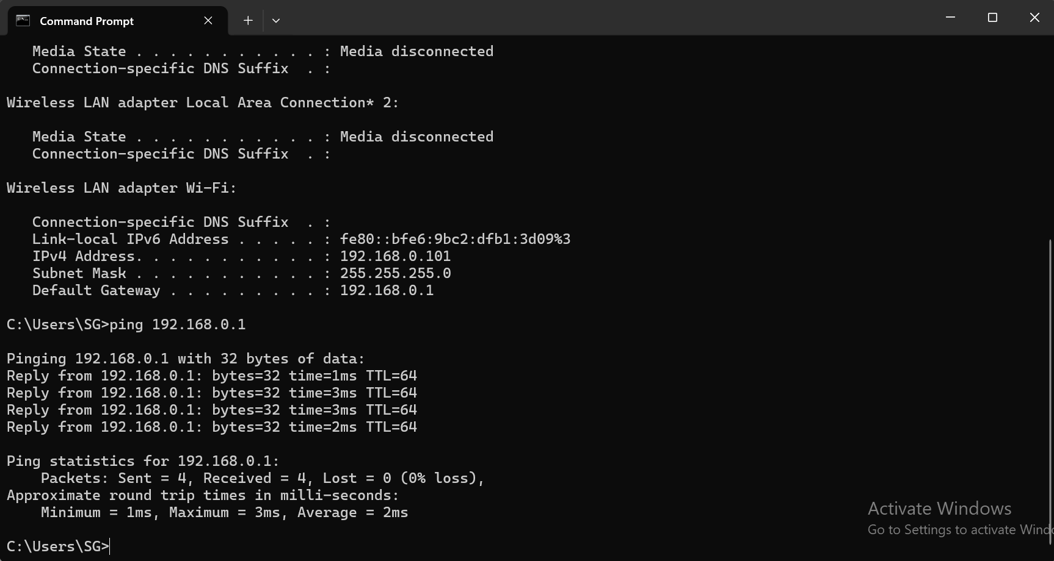
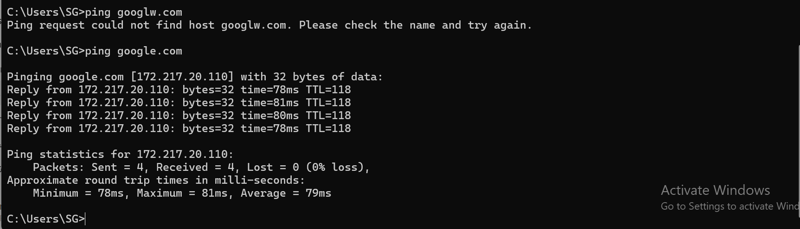
The ping command was used to test connectivity between the computer and the default gateway. The successful reply messages show that the local network connection and the router were reachable. The packet statistics also indicate whether any packets were lost during the test.
2-
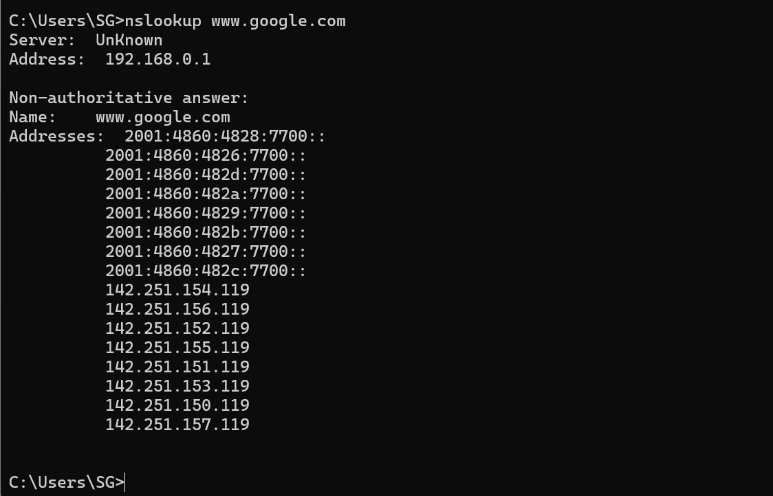
The nslookup command was used to resolve the domain name www.google.com into one or more IP addresses. The result shows the DNS server used by the computer and the IP address associated with the selected public domain.
3-
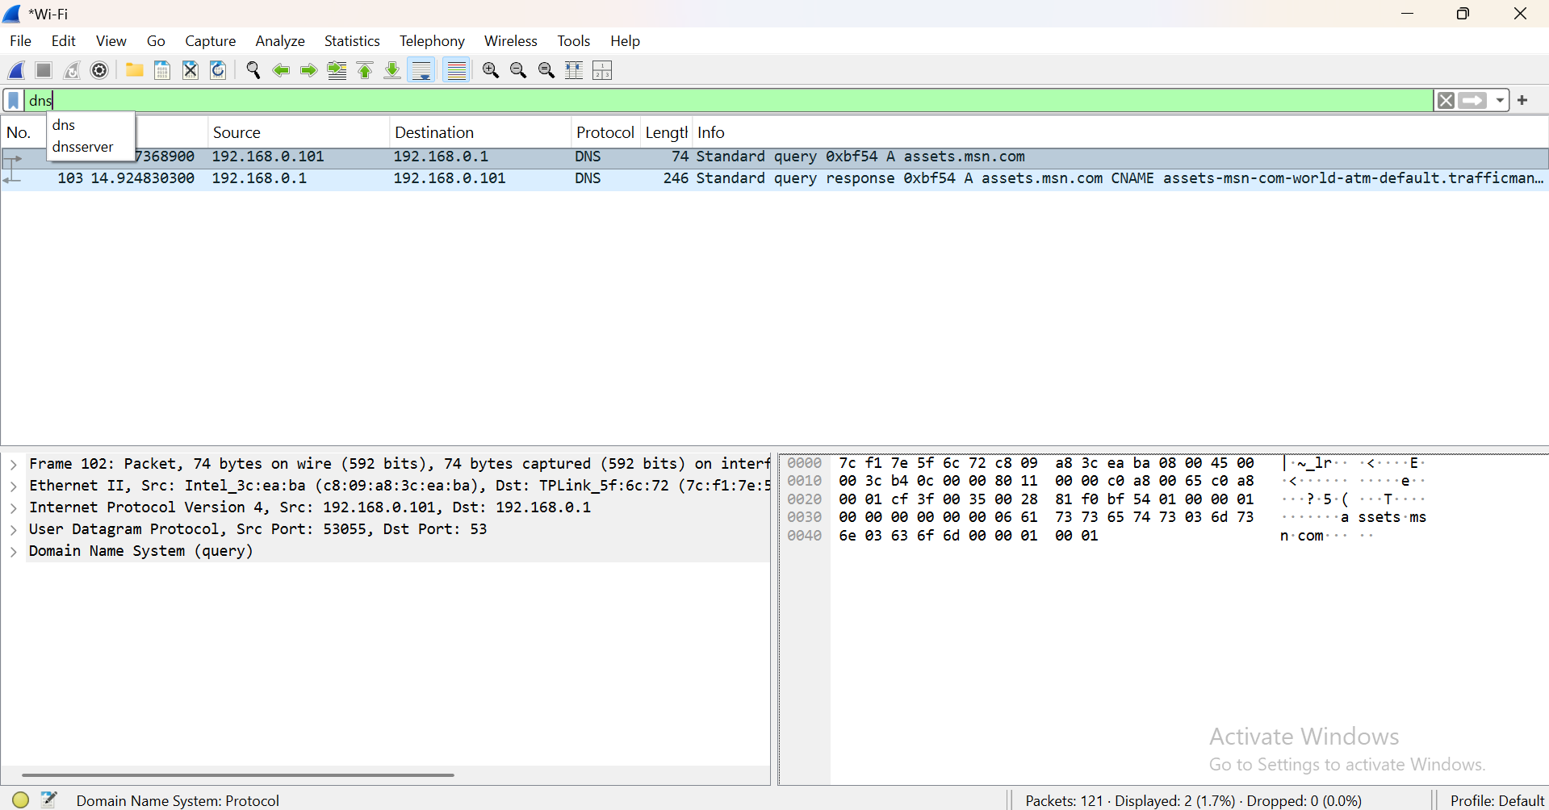

Wireshark was used to capture network traffic for approximately two to three minutes. The ICMP display filter was applied to show only ICMP packets. The captured packets show the source and destination addresses and confirm that ICMP traffic was generated during the ping test.

Question Five
2 Marks
A small branch office needs Internet access for 10 employees. Compare one wired broadband access technique and one wireless broadband access technique, then recommend the better option for the branch.
Your answer should include one wired option such as DSL, HFC, or PON; one wireless option; and a short recommendation based on reliability, cost, and suitability.

Answer:
A small branch office would benefit greatly from fiber-to-the-premises, or PON, wired broadband. High speed, constant performance, and minimal latency are all features it offers. Connectivity for up to 10 employees, file sharing, cloud apps, video conferencing, and the Internet are all within its capabilities. The installation fee, however, can be more or less depending on the company providing the service.

When looking for a wireless internet solution, 5G fixed wireless connection is a great choice. Easy to set up and doesn't need extensive wiring. The initial installation cost can be lower as well. Some factors that could affect how well it works include the intensity of the signal, the distance from the base station, network congestion, and environmental or architectural factors.

This branch office is best served by PON when it is available. It guarantees continuous speed, boosts dependability, and enhances flexibility for day-to-day company operations. Despite the potential speed and ease of setup of 5G, PON remains the superior choice for a primary Internet connection. It is possible to use a wireless connection as a fallback in case the wired connection fails.

Reflection
2 Marks

