User Testing Report — Camera+
Module: Mobile Applications (UFCF7H-15-3) Student Name: Ali Nabhan Aboobakuru
App Title: Camera+
Gitlab Link: https://gitlab.uwe.ac.uk/an3-aboobakuru/mobiledev
Demonstration Link: https://www.youtube.com/watch?v=t9BUl6QXPNo
Word Count: ≈ 1,250 words

Overview
The mobile application Camera+ runs on Expo Go and React Native platforms to deliver its functionality. The application enables students to take clear photos which receive basic visual tints and edits before the enhanced images become available for device gallery export to the gallery. The report presents findings from a small usability test which involved four participants and it now matches the application's current structure and functionality.

Testing Design & Methodology

2.1 Objectives

Check whether first-time users can perform a complete capture to edit and export process without any form of assistance.

Identify usability issues in the Camera+, Album, and Editor screens that could prevent users from advancing or cause frustration.

Validating design changes implemented for better export feedback should help users understand their saved image status better.

Collect qualitative user feedback which would help determine the most important development priorities for functionality

2.2 Test Environment
- Devices: Android/IOS phones running Expo Go.
- OS / Framework: React Native 0.81, Expo SDK 54, running from Metro bundler.
- Location: Online and inside Villa College Classroom WW202.
- Sessions: Around 1 hour per participant including briefing and debrief.
- Participants: 4 users (classmates).

2.3 User Personas
Name | Age / Occupation | Tech Familiarity | Goal | Pain Points
P1: Student | 21, CS student | High | Capture, tint and export an image using Camera+. | Album browsing feels underused/unclear; not obvious how to review older captures from inside the app instead of just relying on the device gallery.
P2: Student | 22, CS student | Medium | Keep consistent tint settings for default capture. | Login/register feels unnecessary for this kind of app; would prefer persistence demonstrated through Settings/configurations rather than accounts.
P3: Student | 22, CS student | Medium | Use Camera+’s Camera screen easily. | No safe areas around the bottom and top edges, capture button and camera notch area feel cramped.
P4: Student | 55, CS student | Low | Give feedback on the Colors and UI of the application. | Gets confused if too many options are hidden or not demonstrated (e.g. Album browsing not shown properly), wants the UI to stay clean and obvious.

Test Scenarios and Tasks
Scenario | Expected Outcome | Result
Capture a selfie photo (T1) | User opens Camera+, grants camera permission if needed, and captures a readable image. | All four participants completed this successfully, one hesitated briefly at the permission prompt, and another noted the capture area felt close to the phone’s navigation, suggesting better safe areas.
Locate the captured image in Album and open it (T2) | New capture appears immediately in a “Viewer” section or application album screen. | All participants eventually succeeded, but two first checked the phone’s system gallery before noticing the Album tab. One classmate commented that “you didn’t show the album browsing properly.”
Apply an effect and export an improved copy (T3) | User applies night/thermal/tint, taps Export, and sees clear confirmation that the image is saved to the gallery. | All participants exported successfully, but three watched the spinner progress button and asked if the app had frozen before the success toast appeared, highlighting the need for faster feedback.
Change default effect in Settings and verify it (T4) | User changes default tint strength in Settings, returns to Camera+, and sees the new defaults applied to the live preview in Camera screen. | All participants completed this with no major difficulty and described the behavior as sensible. One classmate said Settings are a better way to show persistent storage than a login/register screen for this kind of app.

Execution & Evidence
Sessions were run together and one‑to‑one. I monitored participants during their scenario execution while documenting their points of confusion and their requests for assistance and their final task achievement results. I took screenshots to display the export progress button and Album layout and export toast and Settings sliders. The four participants finished all T1–T4 tasks but the evidence shows their experience with minor UX problems.

4.1 Key Observations
- The participants successfully finished the core capture to edit and export sequence which demonstrates that the fundamental navigation system and tab structure operates correctly.
- A research participant suggested that the application should eliminate its login/register system because users could access storage functions by navigating to the Settings menu and configuration options.
- The participants expressed confusion about Album browsing because the session did not demonstrate its functionality properly so they needed to access older captures through their phone gallery.
- The design of safe areas in devices with gesture navigation and camera notches led to problems because the capture button and top camera feed reached the system UI boundary.
- The participants found the navigation tabs easy to use because they were simple and they appreciated the multiple settings which showed persistence and the application interface had a clean and organized design.

Analysis & Findings
Issue Identified | User Feedback | Proposed Solution
Login/sign up feels unnecessary for this app (U1) | “You should show the persistent storage using the settings of the app by the user instead of a login that you can’t justify for an app like this.” | Keep the local email/password system in code, but emphasize persistence by demonstrating Settings and stored preferences during testing instead of focusing on accounts automatically logging in. For future iterations, consider removing login/register from the main flow if it is not required for the app’s purpose.
Album usage and browsing not shown clearly (U2) | “You didn’t show the album browsing properly.” Users were unsure how to review older captures from inside Camera+ itself. | Spend more time demonstrating the Album tab during user testing, including how the section and device album images work together. Add a short on-screen hint or empty-state message explaining that this is where users can browse previous photos saved by the app.
Safe areas around navigation and notch (U3) | “There should be safe areas as it will cause discomfort for the user trying to use the phone’s navigation in contingent with the app’s navigation, also the top camera notch.” | Ensure the layout respects safe-area insets at the top and bottom so the capture button and content are not too close to gesture navigation or the camera notch. Test on multiple devices with different cut-outs and navigation styles to confirm that it feels comfortable.
Export button and feedback timing (U4) | On one device, a participant watched the button and asked if the app had frozen before the success toast appeared. | Disable the export button during image baking, bound the button with a spinner timeout, and make sure the success toast appears quickly when the export completes. This gives users clear confirmation that the app is working and prevents repeat taps due to uncertainty during initial image capture.

Reflection & Recommendations

6.1 What I Learned
- The system gallery check by multiple users led to the discovery of the Album tab during the testing session.
- The stability and trustworthiness of an application depends on export button placement and other small timing and layout decisions.
- The application will become more user-friendly through basic feedback elements which include toasts and labels and helper text that can be implemented using simple code modifications.
- The brief formative assessment with four users showed particular issues which will direct the development of the upcoming version.

6.2 Recommendations
- Run a second testing cycle that includes the History tab functionality and image re-editing capabilities to confirm its advanced features.
- Participants need to finish T3 tasks within a specified time period while answering five usability questions to assess the effectiveness of their changes.
- Do a standalone build instead of only Expo Go.
- Implement basic editing tools which include crop and straighten functions and markup capabilities because the application runs at its current speed.

Structure & Presentation
The findings from camera+ testing sessions appear in this report and in the Camera+ source code modifications. The document follows my lecturer’s sample structure and uses clear headings and tables and maintains brief language to help markers understand the test design and evidence collection and their impact on the final application.
Overall, the test confirmed that the core capture/edit/export flow works for first-time users, but highlighted improvements around album discoverability, safe areas, and export feedback. These findings will guide the next development iteration.

Appendix A

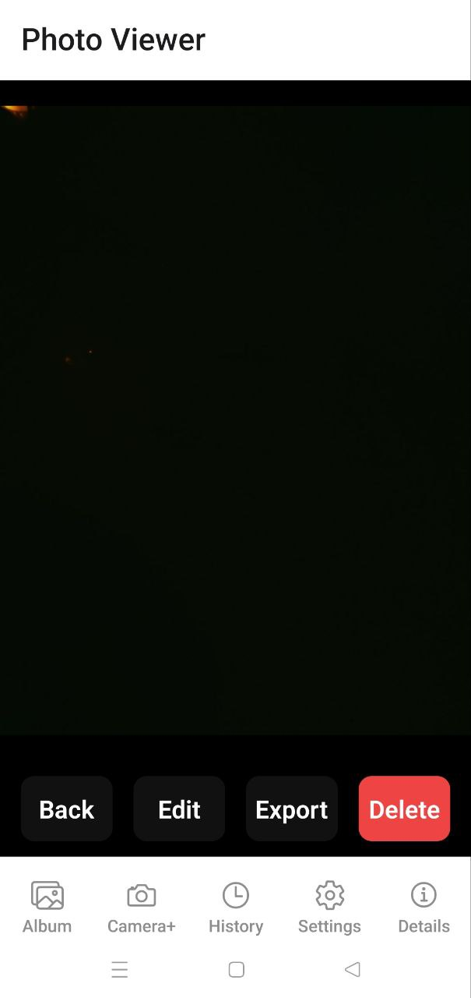
Screenshot 1: Camera+ Viewer with export button visible after pressing the capturing button.
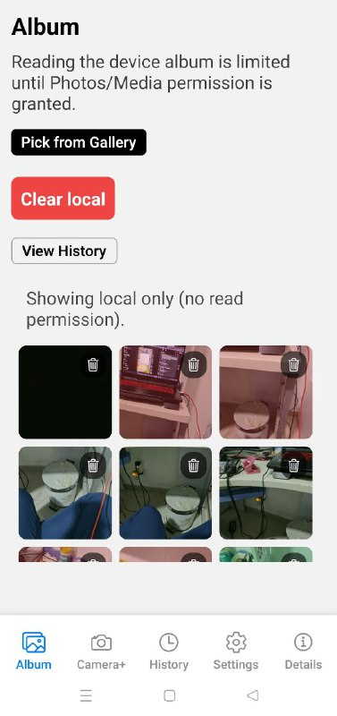
Screenshot 2: Album screen showing device photos plus the labelled recent‑captures section.

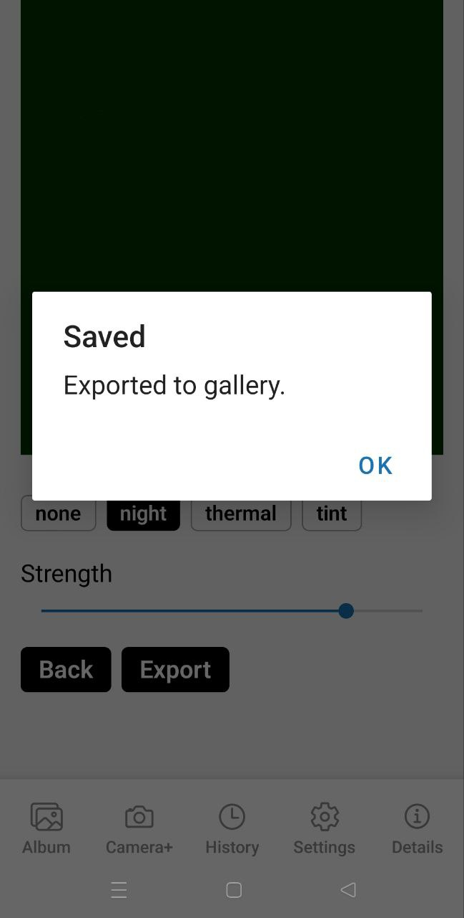
Screenshot 3: Photo Editor export success toast confirming that the baked image has been saved.

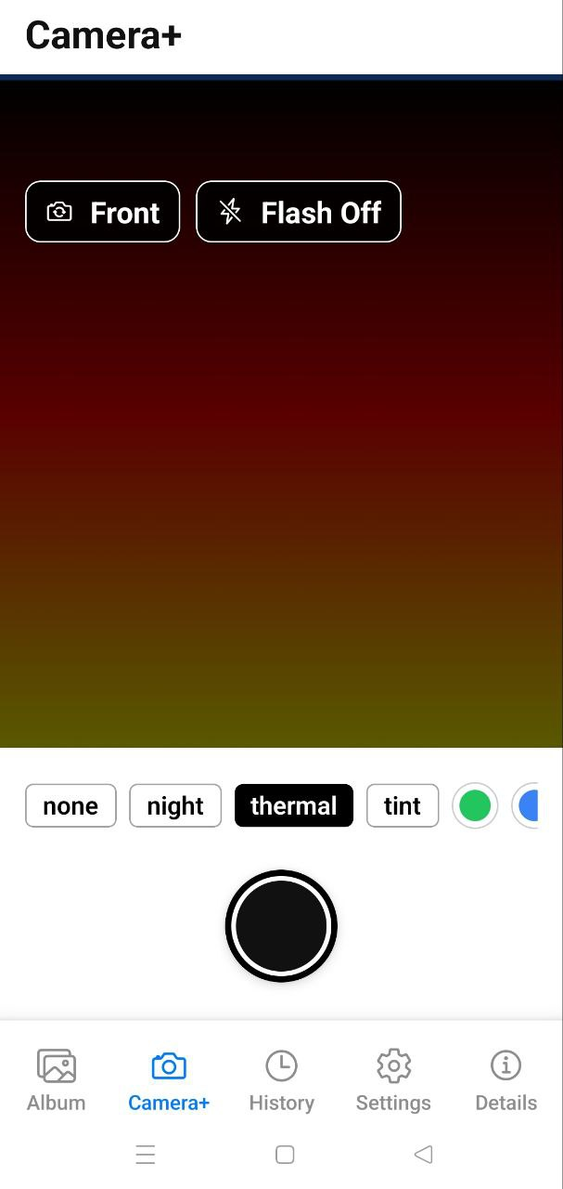 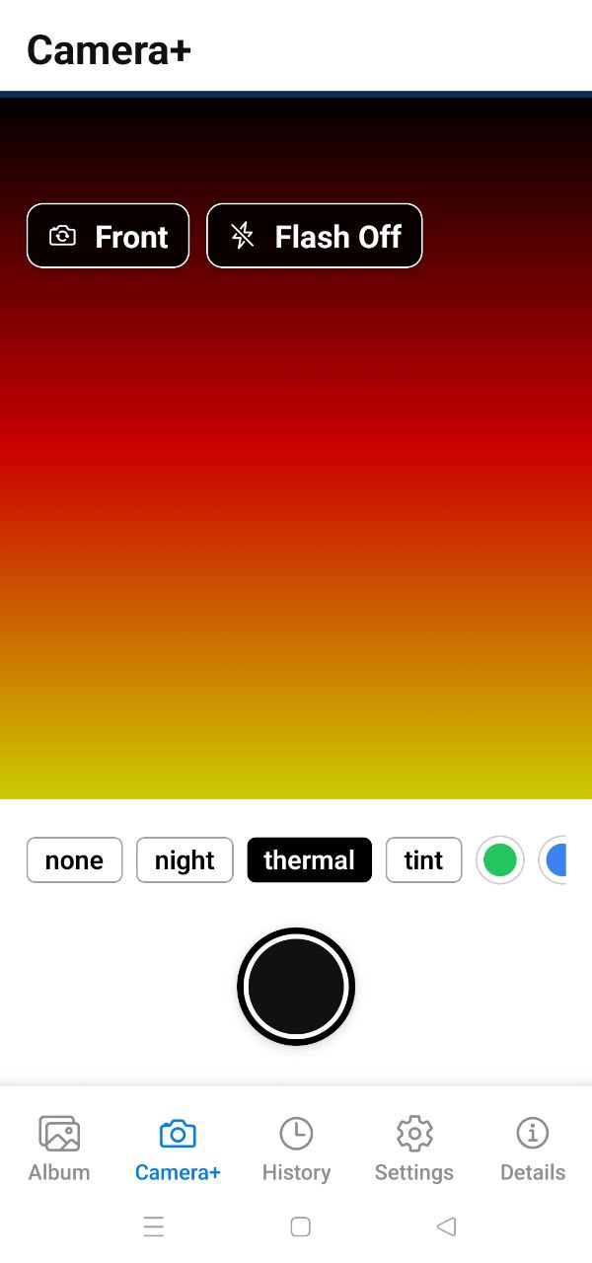
Screenshot 4: Settings screen with default look and intensity sliders before and after changes.

