Install & Use
Use these steps to configure Camera+ on Windows or macOS before launching Expo Go.
Prerequisites
- Node.js 18+ (verify with `node --version`)
- Yarn 1.22+ (verify with `yarn --version`)
- Expo CLI (install with `npm install -g expo-cli`)
- Optional: Xcode/iOS Simulator or Android Studio emulator for local testing
Install & Run
1. Clone or download the repo, then run `yarn install`.
2. (Optional) Run `expo login` if you plan to push dev builds or use EAS.
3. Start Metro with `yarn start` and press `i`, `a`, or `w` for iOS, Android, or web.
Camera dependencies (one-time)
Run `npx expo install expo-camera expo-media-library expo-haptics expo-linear-gradient react-native-view-shot` so native modules match Expo SDK 54.
When the QR code appears, scan it with Expo Go (Android) or the iOS Camera app to open Camera+.
Appendix: Developer Setup (optional)
Legacy rn-new bootstrapping notes are retained below for reference.
Once you are inside the folder in command prompt, simply write these words: npx rn-new@latest

To start with I had to do:
npm uninstall -D @dev-plugins/react-query
rd /s /q node_modules
del package-lock.json
del yarn.lock
npm install expo@~54.0.20
npm install
npx expo install react-native
npx expo start
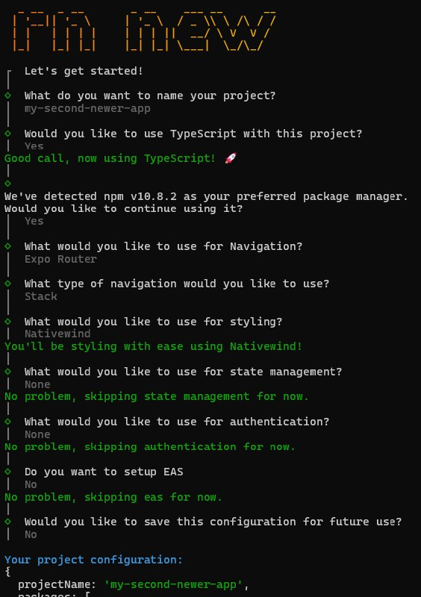
Some yellow words will show up in your command prompt alongwith a bunch of questions and answers. Sir showed us exactly what to say yes toand what to say no to. So I copied sir as seen here.

now do cd into the project you had named, it should have created a project that you had named
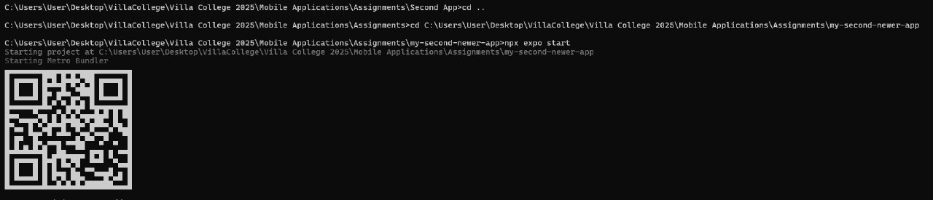
This is me going into mine. After doing cd to go inside the project, write the words: npx expo start a qr code should appear
You can scan it on the Expo Go App easily if you had an android, ios people had trouble
Something similar to the default page of django should appear on your phone, but instead it will be React
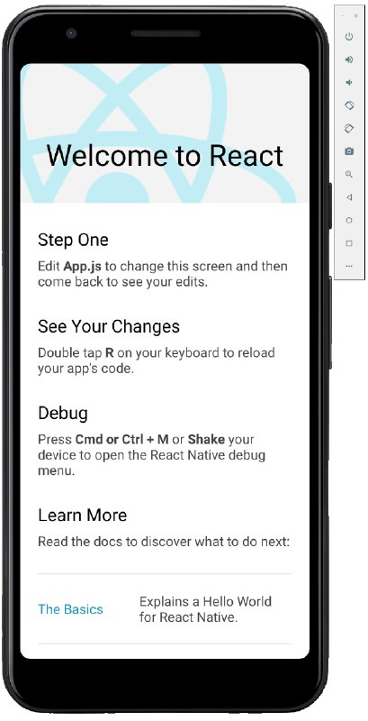
like this
you can copy sir's code from github and replace the default code with it to get what was shown in the Mobile Application group like Ayaan showed.

