Title:
Phase-based greedy optimization of wind turbine placement in offshore wind farms
Scope
Background and Motivation
The transition toward renewable energy has accelerated significantly in recent years, making wind energy one of the most important sources of sustainable power generation. Denmark is among the leading countries in offshore wind energy, where large-scale wind farms play a crucial role in the energy transition.
While wind turbine technology continues to improve, another important aspect of wind farm performance lies in the optimal placement of turbines within the wind farm. The layout of turbines directly affects wake interactions between turbines and therefore has a significant impact on the Annual Energy Production (AEP) of the wind farm.
Optimizing wind turbine placement is therefore a key step in improving wind farm efficiency without changing the turbine technology itself.
Research Questions
Primary research question: what is the question about the world your thesis will try to help answer?
How can wind turbine placement in offshore wind farms be optimized in order to maximize the Annual Energy Production (AEP)?
Secondary research questions: what are the smaller questions that you will answer (in sequence) to build up to the bigger research question
How effective is a phase-based greedy heuristic for wind farm layout optimization?
How effective is a gradient-based for optimization for a wind farm?
How do the different methods compare, and which is the most effective?
Learning Objectives
The objective of this project is to:
- Apply wind farm modelling tools such as PyWake and TopFarm
- Understand wake interactions and their impact on AEP
- Implement and evaluate optimization algorithms
- Compare heuristic and gradient-based optimization methods

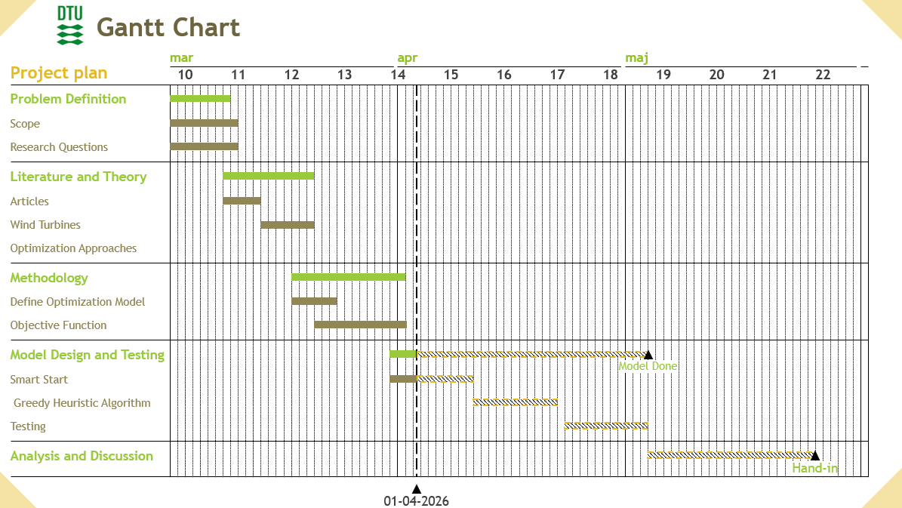
Project plan

