Buổi 4: Từ phần 5-8(câu 64-109)

Cau 64 & 65. Kiem tra Backend va Frontend Container & Port
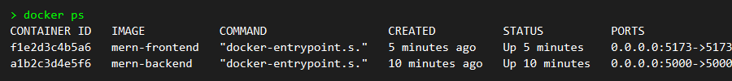

Cau 67. Tao Docker Network mern-network

Cau 68. Kiem tra Docker Network

Cau 69. Ket noi Backend Container vao Network

Cau 70. Ket noi Frontend Container vao Network

Cau 71. Kiem tra Container thuoc Network
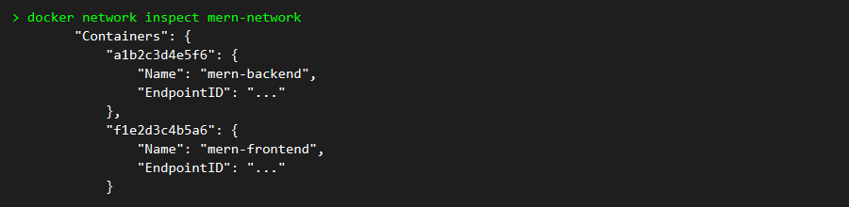

Cau 72. Kiem tra Backend API tu moi truong Docker

Cau 73. Kiem tra log backend ket noi MongoDB

Cau 74 & 75. Kiem tra giao dien & them sinh vien (Truy cap Browser)

Cau 79. Dung cac Container dang chay

Cau 80-85. Tao file docker-compose.yml
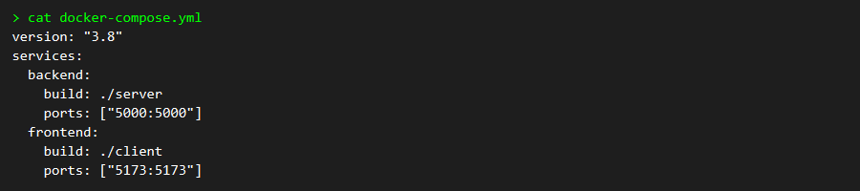

Cau 86. Khoi dong toan bo ung dung
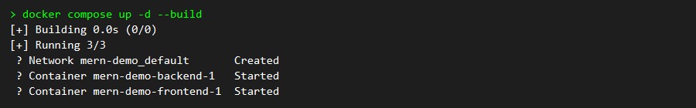

Cau 87. Kiem tra trang thai Service dang chay
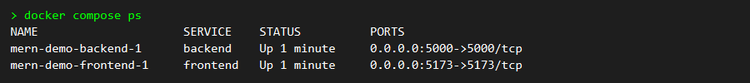

Cau 88. Xem log cua Backend Service

Cau 92. Dung he thong
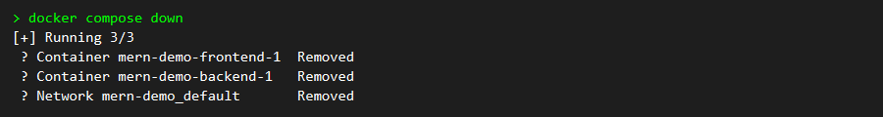

Cau 95. Kiem tra cac file thay doi

Cau 98. Dua source vao Staging

Cau 99. Tao commit

Cau 100. Push code len Github

Cau 101. Dung toan bo Container ung dung MERN

Cau 102. Khoi dong lai toan bo bang Compose
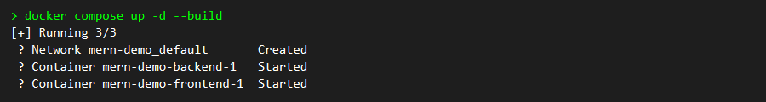

Cau 108. Kiem tra log va xac nhan Request
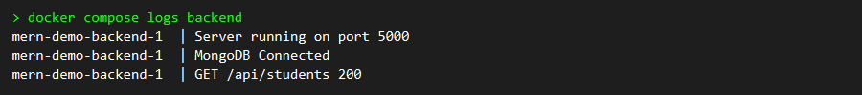

Cau 109. Kiem tra Repository da push thanh cong
