
SHUTE UNIVERSITY
樹德科技大學
824高雄市燕巢區橫山路59號

Department of Information Management

“Artificial Intelligence: A New Era of Intelligence”


About The Author
Gladys Erika Ermac Orillo (孝佳麗), born on October 14, 2006, in the Philippines, is the eldest of three siblings. Raised in Bulasa, Argao, Cebu, she developed a strong sense of responsibility and perseverance from a young age, always striving to set a positive example for her younger brothers. A naturally curious individual, S24101303@stu.edu.tw
Gladys may not have always been the top student, but she is consistently determined to learn, grow, and give her best in every endeavor. Her dedication and passion for knowledge led her to become an international student scholar at Shute University. Fascinated by technology and innovation, she is particularly interested in artificial intelligence and its transformative impact on society, exploring how AI continues to shape the way we live, work, and interact in the modern world.

Abstract
Today, almost every activity is related in some way to the use of computer technology. The application of advanced technologies such as Artificial Intelligence (AI) opens up new possibilities, potentials, and challenges in educational practice. With the help of AI, Which simulates human intelligence in making conclusions or predictions. Computer systems can provide personalized guidance, support, and feedback to both students and teachers in the educational process.
Introduction
Artificial Intelligence (AI) has become one of the most influential and transformative technologies of the 21st century. From virtual assistants like Siri and Alexa to advanced medical diagnostic systems, AI is now integrated into nearly every aspect of daily life. It is no longer just a concept from science fiction but a reality that continues to evolve and shape how people live, learn, and work. The growing capabilities of AI have not only enhanced convenience but also sparked discussions about its potential benefits, challenges, and ethical implications.
The development of AI began with the goal of creating machines that could think and learn like humans. Over time, this idea has grown into a wide field that combines computer science, mathematics, psychology, linguistics, and data science. These disciplines work together to design intelligent systems capable of performing complex tasks such as image recognition, speech translation, and decision-making. The rapid growth of AI has made it a crucial tool for innovation and problem-solving in education, healthcare, business, and beyond.
However, as AI becomes more advanced, it also raises important questions about how society can balance progress with responsibility. Issues such as data privacy, job displacement, and algorithmic bias remind us that technology must be developed and used ethically. Therefore, understanding the role of AI, its applications, and its limitations is essential for ensuring that this technology continues to benefit humanity rather than harm it.
This article provides an overview of Artificial Intelligence — explaining how it works, where it is applied, and how it continues to shape the modern world. By exploring both the opportunities and challenges that AI presents, we can better appreciate its role in creating a smarter, more connected future.
This paper aims to identify the impact of Artificial Intelligence on education, present some of its major applications in the field, and highlight the perceived benefits of its implementation.
Content
Definition
The beginning of modern Artificial Intelligence (AI) research can be traced back to John McCarthy, who coined the term “artificial intelligence” during a conference at Dartmouth College in 1956. This event is widely regarded as the birth of AI as a scientific discipline. In the years that followed, progress was remarkable, as many scientists and researchers focused on automated reasoning and the application of AI to mathematical problem-solving. One notable example is Logic Theorist, a computer program developed by Allen Newell, Herbert A. Simon, and Cliff Shaw, which successfully proved 38 of the first 52 theorems in Principia Mathematica and even offered more elegant proofs for some. These achievements fueled great optimism among early AI pioneers, many of whom believed that the creation of fully intelligent machines was imminent. (Yongjun Xu,1,35,42 etc., October 28, 2021)
Artificial Intelligence (AI) is the simulation of human intelligence by machines, particularly computer systems. It involves key processes such as learning (acquiring knowledge and improving performance), reasoning (using logic and rules to reach conclusions), and self-correction. AI systems are designed to perform tasks that typically require human cognition—such as understanding language, recognizing speech and images, making decisions, and solving problems. Unlike traditional computer programs, AI systems can learn from data and experiences, allowing them to adapt and improve over time. (Xin Liu,5,35,42 Xin Cao,10,42 etc., October 28, 2021)
Preface
In today’s fast-changing world, Artificial Intelligence (AI) is one of the most groundbreaking innovations. AI is already being used in many areas like education, healthcare, business, and more. This article will explore how AI is affecting these fields, why it’s so impactful, and the ethical concerns we must consider as we continue to develop and use AI in our everyday lives. Understanding AI is key to ensuring that we use this powerful technology responsibly and for the benefit of society. (Yongjun Xu,1,35,42 Xin Liu,5,35,42 Xin Cao,10,42 etc., October 28, 2021)

Theoretical Framework
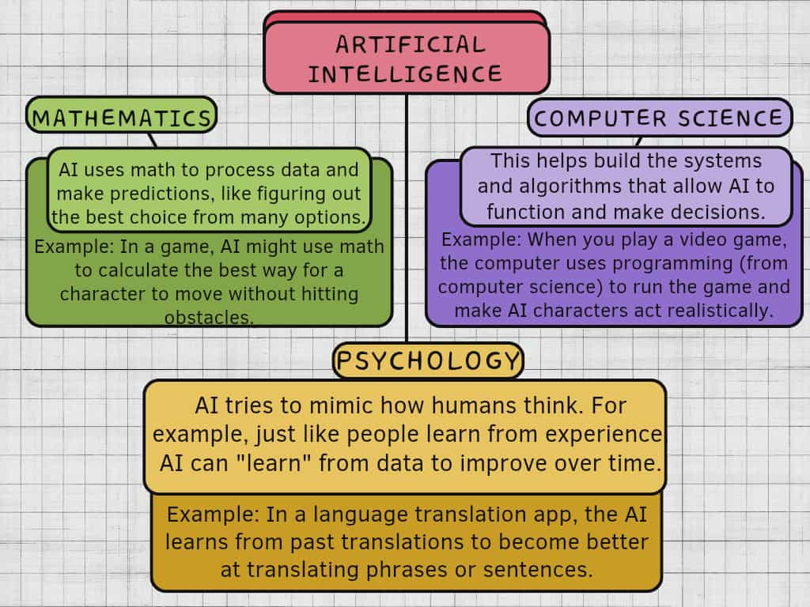
Artificial Intelligence (AI) works by using complex algorithms (rules that help make decisions) and a lot of data. AI looks at this data, finds patterns, and makes decisions based on what it has learned. The more data AI gets, the better it becomes at making decisions. (Wentao Su , Jian Wu , Huiyu Xu, etc. October 28, 2021)
AI is based on ideas from different fields:
AI systems use machine learning to get smarter. Machine learning means that AI looks at data, finds patterns, and improves its decisions without needing to be told exactly what to do each time. Deep learning is a more advanced version of machine learning that uses a lot of data to make even more complex decisions, like recognizing faces in pictures or understanding speech.
- Example of machine learning: A recommendation system (like Netflix or YouTube) watches what you watch and suggests movies or videos based on your past choices. (Davidson et al., 2010; Gomez-Uribe and Hunt, 2016).
- Example of deep learning: In apps like Google Photos, AI can recognize your face in photos because it learns from thousands of pictures and understands what you look like. (Maad M. Mijwil, Karan Aggarwal, Sonia Sonia, Abdel Hameed Al-Mistarehi, etc. January 2022)
The key thing about AI is that it can improve over time by learning from new data and experiences. This ability to adapt and learn is what makes AI so useful for solving difficult problems and handling complex tasks.
- Example: Siri or Google Assistant gets better over time at understanding your voice and answering questions more accurately because it learns from each interaction. Malodia, S., Islam, N., Kaur, P., & Dhir, A. (2021).

Practical Hands-On Exercise
To illustrate Artificial Intelligence (AI) in practice, this section presents several real-life applications that demonstrate how AI operates across various fields. These examples show that AI is not just a concept but an active part of everyday life, improving efficiency, accuracy, and convenience in different areas of society.
AI in Education
Artificial Intelligence has become a valuable partner in modern classrooms and online learning platforms. Educational tools powered by AI help personalize lessons, making them more suitable for each student’s level and learning style. For example, learning applications like Duolingo and Grammarly use AI algorithms to detect mistakes and offer corrections or hints, allowing learners to improve continuously. AI can also suggest activities or topics depending on what students need to strengthen.
Teachers, on the other hand, benefit from AI systems that assist with grading exams, tracking student performance, and identifying those who may need extra help. Intelligent tutoring systems (ITS) and adaptive learning platforms can adjust questions and materials based on a learner’s previous responses. This individualized approach helps both students and teachers save time while improving the quality of education.
In some schools, AI-powered robots or chatbots are even used as teaching assistants. They can answer students’ questions, translate lessons into different languages, or give instant feedback. Through these tools, education becomes more interactive, accessible, and inclusive—especially for students with special needs or language barriers. (Shan Wang a 1, Fang Wang b2, Zhen Zhu c 3, Jingxuan Wang etc. 15 October 2024)

AI in Healthcare
The healthcare industry is one of the biggest beneficiaries of Artificial Intelligence. AI technologies are used to analyze massive amounts of medical data, helping doctors detect diseases faster and more accurately. For example, AI algorithms can examine X-rays, CT scans, and MRI results to identify tumors or fractures that may be difficult for the human eye to spot. This leads to earlier diagnosis and better treatment plans.
AI also supports hospital operations. Intelligent systems can schedule appointments, manage patient records, and even predict future health risks. For instance, AI programs can forecast potential heart problems by studying patterns in a patient’s heartbeat or lifestyle data. Virtual nurses and chatbots are also being developed to remind patients to take their medicine or guide them through recovery steps after surgery.
Moreover, AI contributes to medical research by analyzing data from clinical trials. This speeds up the discovery of new medicines and treatments. During the COVID-19 pandemic, AI helped scientists model virus transmission and develop vaccines more efficiently. As AI continues to evolve, it is expected to play an even greater role in global healthcare improvement. (Anthony Wilson1orcid logoemail,Haroon Saeed2,Catherine Pringle3 4, etc. 29 July 2021)

AI in Daily Life
Artificial Intelligence is not only found in industries or research—it is also part of our daily routines. Voice assistants like Siri, Alexa, and Google Assistant use AI to understand and respond to spoken commands. They can set alarms, play music, or control smart home devices with just a voice command, making daily tasks faster and easier.
Navigation apps such as Google Maps and Waze rely on AI to analyze real-time traffic conditions and suggest the quickest routes. Streaming platforms like Netflix, YouTube, and Spotify also use AI to recommend movies, videos, and songs based on users’ viewing or listening habits. Even the facial recognition feature on smartphones uses AI to unlock devices securely.
AI also plays a big role in online shopping and social media. Websites like Amazon and Shopee use AI to recommend products you might like, while social media platforms use AI to filter content, detect spam, and enhance security. These AI-driven experiences show how technology has become an invisible assistant that simplifies modern life. (Colleen Mc., Brian Ke., Jeffrey Go., Monica An., Giancarlo Pa., April 3, 2025)

AI in Business and Industry
In business, Artificial Intelligence improves efficiency, productivity, and customer service. Companies use AI to automate repetitive tasks such as data entry, inventory management, and responding to customer inquiries. Chatbots powered by AI can handle multiple customer questions at once, providing instant and accurate support.
In manufacturing, AI-powered robots are used in factories to assemble products with precision and consistency. These robots can detect errors, monitor equipment conditions, and even predict when machines might fail—saving both time and costs. Businesses also use AI to study market trends, analyze customer feedback, and plan marketing strategies. This helps them make smarter decisions and improve their products or services.
In finance, AI detects fraudulent transactions by monitoring spending patterns. It also assists banks in providing personalized financial advice and automating credit scoring. Overall, AI has transformed how industries operate by reducing errors, cutting costs, and increasing innovation. (Palani Velu,January 2020)

AI in Environmental Protection
Another powerful use of AI is in protecting the environment. AI systems can analyze satellite images and predict natural disasters like floods, earthquakes, or forest fires before they happen. They can also track pollution levels and monitor endangered species, helping scientists make data-driven decisions to protect ecosystems.
For example, AI drones can scan forests to detect illegal logging activities or monitor coral reefs underwater to assess their health. Smart farming systems use AI to analyze soil conditions, predict crop yields, and suggest the best times for planting and harvesting. These innovations show that AI can be used not only for human convenience but also for the sustainability of the planet. (Yukai Qi, May 2024)
Summary
From classrooms to hospitals, from smartphones to factories, and even in protecting nature, Artificial Intelligence continues to expand its impact on the world. Each of these examples demonstrates how AI is helping people solve real-life problems, save time, and make better decisions. The more we explore and apply AI responsibly, the more we can use its power to improve lives and create a smarter, more sustainable future for everyone.
Conclusion
Artificial Intelligence (AI) has become one of the greatest innovations shaping the modern world. Its influence reaches every aspect of life — from education and healthcare to business, communication, and even environmental protection. Through its ability to process information, recognize patterns, and make intelligent decisions, AI has made daily tasks easier, improved efficiency, and opened new opportunities for innovation.
However, while the advantages of AI are remarkable, its rapid development also presents important challenges. Ethical concerns such as data privacy, job replacement, and the potential misuse of technology remind us that AI must be used responsibly. Society must find a balance between technological progress and moral responsibility to ensure that AI continues to serve humanity in a positive way.
In education, AI provides personalized learning experiences and helps teachers manage time more effectively. In healthcare, it assists doctors in detecting diseases earlier and improving treatment accuracy. In industries, it automates processes and increases productivity, while in the environment, it helps predict natural disasters and promote sustainable living. These applications show that AI is not only a tool for progress but also a partner in solving real-world problems.
In conclusion, Artificial Intelligence represents both the present and the future of human advancement. Its success depends on how people choose to develop and apply it. By combining innovation with ethics, and technology with empathy, AI can continue to improve lives, connect communities, and build a smarter, safer, and more sustainable world for generations to come.
References
(Davidson et al., 2010; Gomez-Uribe and Hunt, 2016) https://pmc.ncbi.nlm.nih.gov/articles/PMC10642507/#B27
(Yongjun Xu,1,35,42 Xin Liu,5,35,42 Xin Cao,10,42 etc., October 28, 2021) https://pdf.sciencedirectassets.com/777800/1-s2.0-S2666675821X00045/1-s2.0-
(Maad M. Mijwil, Karan Aggarwal, Sonia Sonia, Abdel Hameed Al-Mistarehi, etc. https://ijcsm.researchcommons.org/cgi/viewcontent.cgi?
Malodia, S., Islam, N., Kaur, P., & Dhir, A. (2021).
https://www.researchgate.net/publication/356826452_Why_Do_People_Use_Artificial_Intelligence_AI-Enabled_Voice_Assistants
Shan Wang a 1, Fang Wang b2, Zhen Zhu c 3, Jingxuan Wang etc. 15 October 2024
https://www.sciencedirect.com/science/article/pii/S0957417424010339
(Anthony Wilson1orcid logoemail,Haroon Saeed2,Catherine Pringle3 4, etc. 29 July 2021)
https://informatics.bmj.com/content/28/1/e100323?utm_source=google&utm_medium=cpc&utm_campaign=submissions&utm_content
(Colleen Mc., Brian Ke., Jeffrey Go., Monica An., Giancarlo Pa., April 3, 2025)
https://www.pewresearch.org/internet/2025/04/03/artificial-intelligence-in-daily-life-views-and-experiences/
(Palani Velu,January 2020)
https://www.researchgate.net/publication/345304894_ROLE_OF_ARTIFICIAL_INTELLIGENCE_IN_BUSINESS_TRANSFORMATION
(Yukai Qi, May 2024)
https://www.researchgate.net/publication/381545012_The_Impact_of_Artificial_Intelligence_on_Environmental_Protection

