Home Appliance / AGD Store

s26816 David Condratiuc
s31766 Maksymilian Kozub
s27559 Kacper Tkacz
s30165 Mert Altinbas
Table of Contents
User Requirements 3
Use Case Diagram 4
Class Diagram 5
Class Diagram – Description 5
Use Case Scenario: “Make Payment” 6
Activity Diagram: “Make Payment” 7
Activity diagram "Make Payment" – Description 7
Use Case Scenario: “Request Leave” 9
Activity Diagram: “Request Leave” 10
Activity diagram "Request Leave" – Description 10
Use Case Scenario: “Add product to cart and Create Order” 11
Activity Diagram: “Add product to cart and Create Order” 12
Activity diagram " Add product to cart and Create Order" – Description 13
Use Case Scenario: “Assign Shift” 14
Activity Diagram: “Assign Shift” 15
Activity diagram "Assign Shift " - Description 16
Use Case Scenario: “Add Product” 17
Activity Diagram: “Add Product” 18
Activity diagram " Add Product" - Description 19
Use Case Scenario: “Add Category” 19
Activity Diagram: “Add Category” 20
Activity diagram "Add Category" - Description 21
Use Case Scenario: “Create Sale” 21
Activity Diagram: “Create Sale” 22
Activity diagram "Create Sale" - Description 23
State Diagram – Order Class 23
State Diagram – Description 23
State Diagram – Employee Class 25
Dynamic Analysis 26
Changes to the Class Diagram after dynamic analysis 27
Class diagram changes - Description 27
Design Decisions 28
Data persistance 28
Data validation 28
Multi-Value Attributes 28
Derived Attributes 28
Optional Attributes 28
Types Used For Numbers 28
Data Encapsulation 28
Any Type 28
Design Diagram 29

User Requirements

Home Appliances Store System supports the daily operations of a retail business selling both new and used products. It integrates all essential business processes such as managing product information, handling customer orders, monitoring employee work and leave records and maintaining store operations including opening hours and deliveries.

Customer can browse and purchase or sell products, create orders and pay or get paid though multiple methods.

Products in the system contain detailed data such as name, description, model number, brand, warranty period, related products, weight and available stock for both new and used items and products currently in repair. Each product can have multiple custom properties such as color or material limited by the category it is in, which may be part of a hierarchical structure of parent and subcategories. A product can be a freestanding product that have a movement cost and/or an integrated product that require assembly and have an integration cost. Some integrated products must be installed by the store.

Customers can place buy/sell orders containing one or more products. The system stores the order date and automatically calculates the total cost based on product prices and quantities and for sell orders amount paid can be reduced based on its state. Each order is linked to a specific customer. Products included in an buy order must be available in stock before the order can be confirmed. Orders can include a delivery which specifies the sending and receiving dates, delivery company, cost, tracking number and whether the order has been received.

The payment module supports multiple payment methods: card, BLIK, PayPal or cash. Each payment type includes specific information which must be included for it, such as card number and CVV for Card payments, a transaction ID for Blik and a paypal account ID for PayPal.

Customer data includes name, middle name, surname, date of birth and address. Customers accumulate loyalty points that can be used in purchases. The customer's age is automatically calculated based on the date of birth.

Employees are connected to roles through employment contracts which define start and end dates and store the contract duration as a derived value. Each employee can have multiple leave entries categorized as sick, paid, unpaid. They are also given shifts for specific days of the week or holidays, they may be given a bonus for working during a specific shift.

Store record includes its name, E-mail, phone number and address. System also records working hours of the store. Store can also be marked as closed for specific periods such as renovations or holidays.

Use Case Diagram
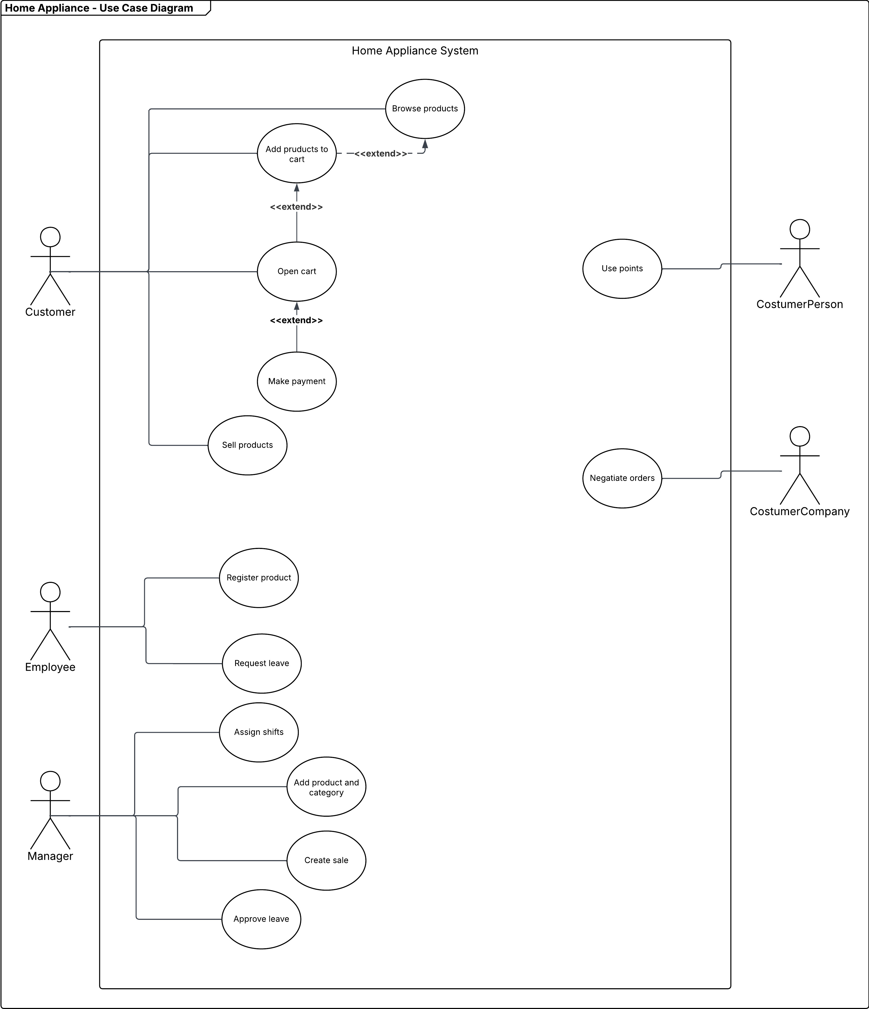

Class Diagram

Class Diagram – Description

The class diagram is of a Home Appliances Store System which includes customers, employees, products, orders, deliveries, and payments. It defines how employees manage stores, contracts, shifts, and leaves, and how customers place orders and earn loyalty points. Products are categorized, can be new or used, and include freestanding and built-in products with their extended attributes. Different payment methods (Card, Blik, PayPal) and deliveries are accepted. Some details, like the Role class and ProductStatus function, are not clearly defined in the diagram.

Use Case Scenario: “Make Payment”
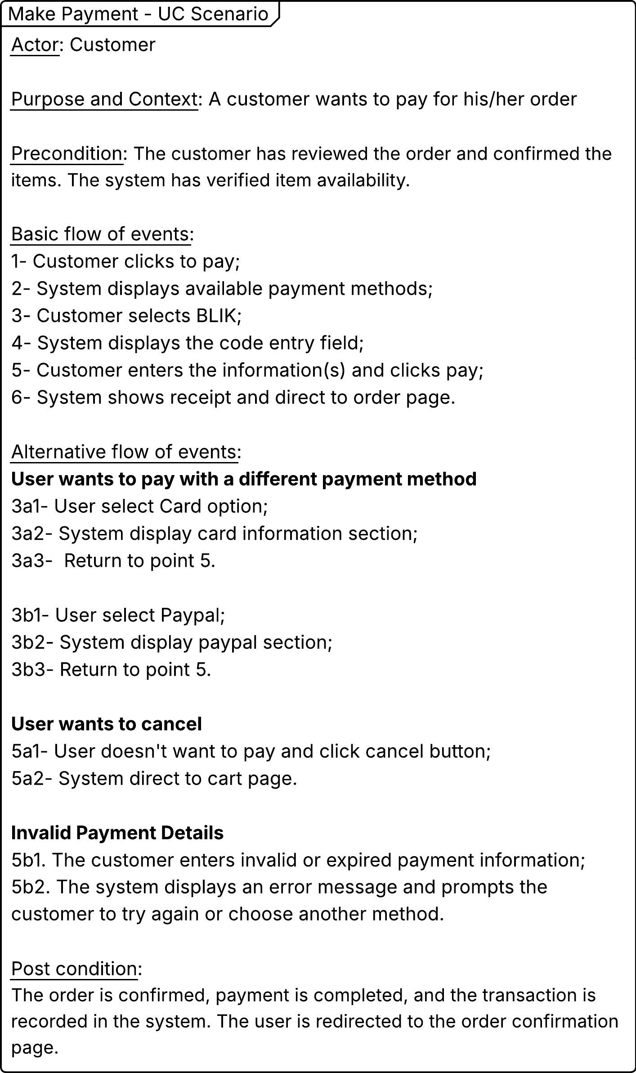

Activity Diagram: “Make Payment”
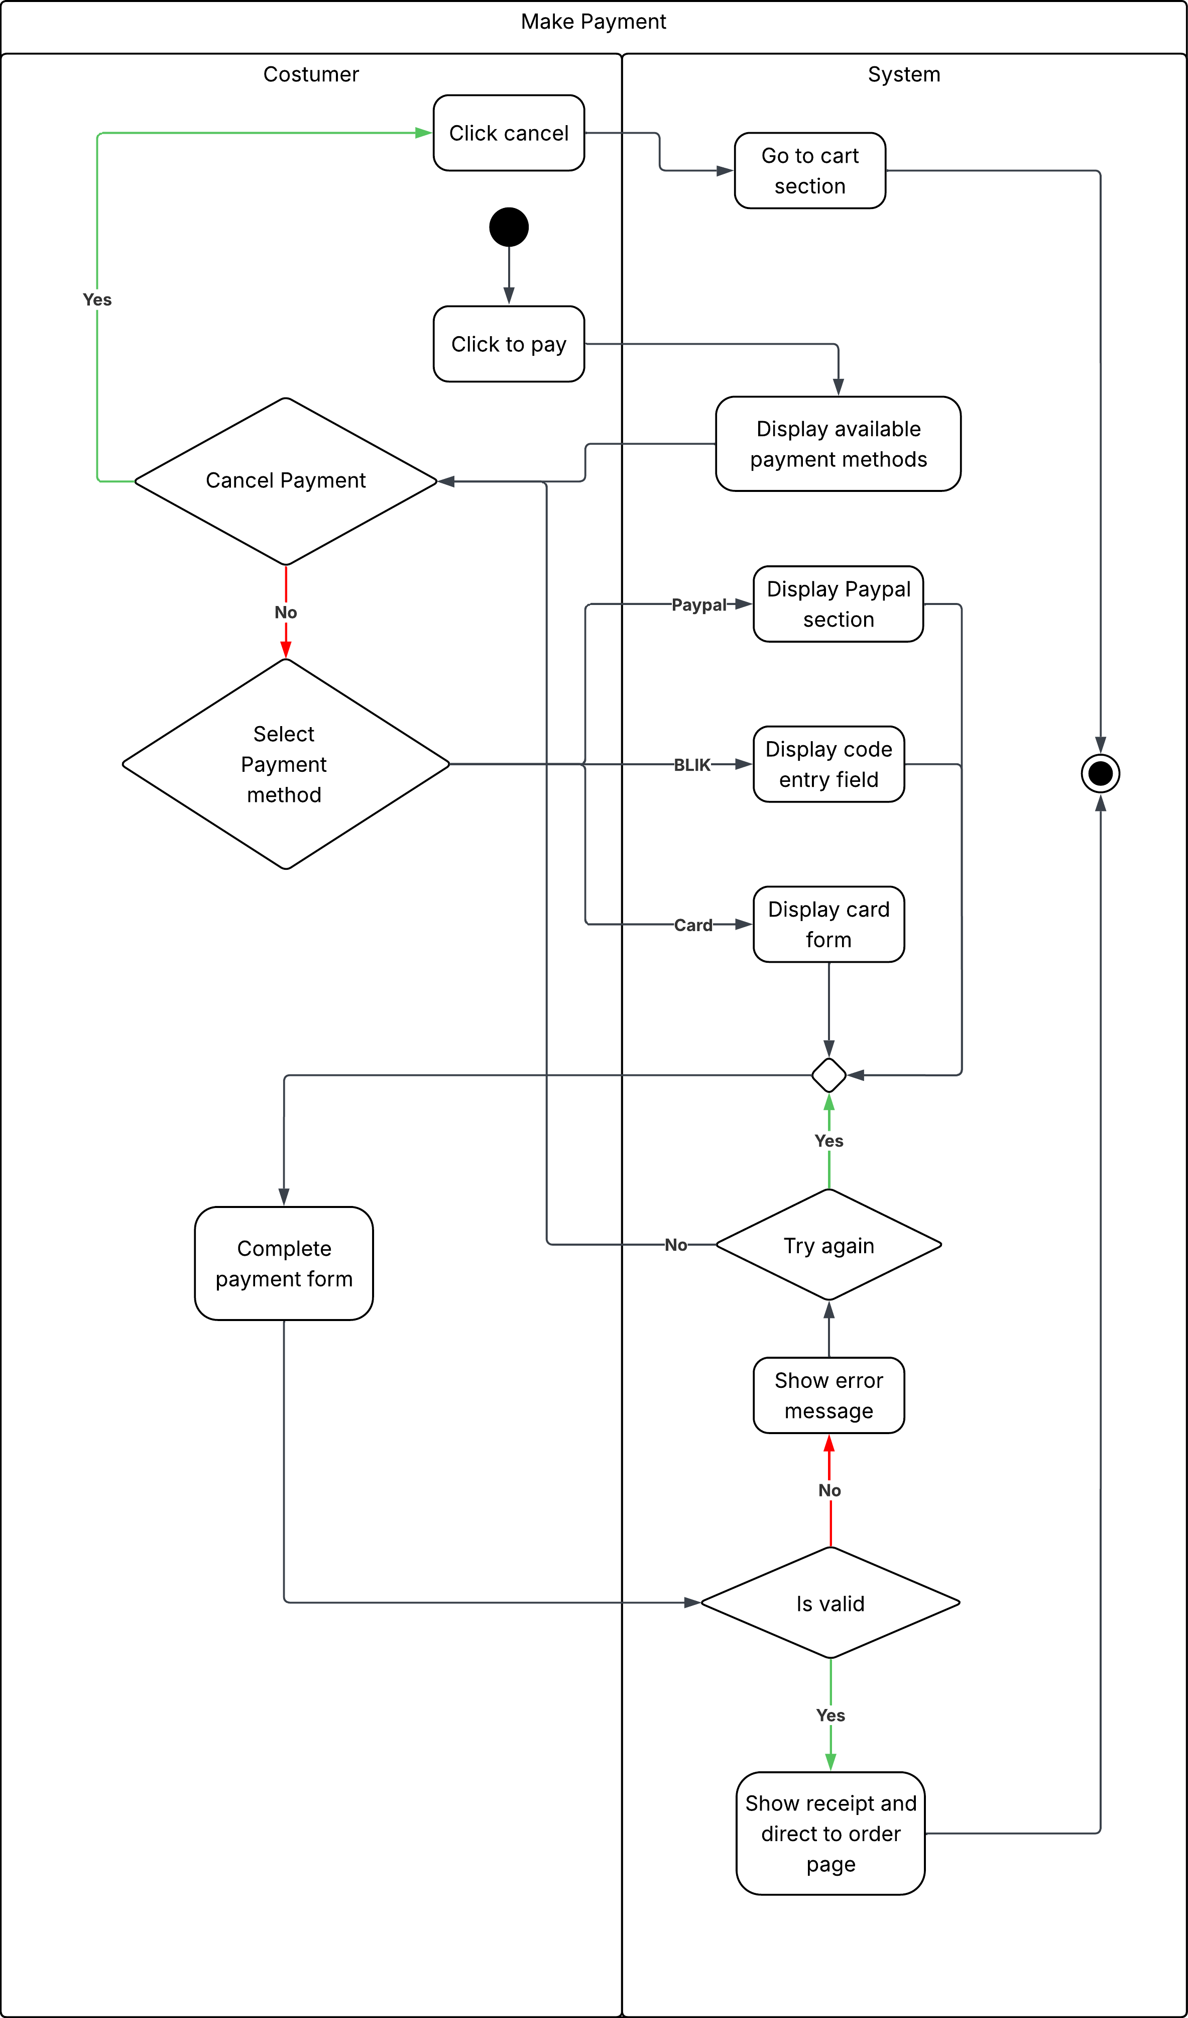

Activity diagram "Make Payment" – Description
This activity diagram represents the process of making a payment by a customer. The customer begins by clicking "Click to pay" after which the system displays available payment methods. The customer may choose to cancel the payment or proceed by selecting a payment method such as PayPal, BLIK or card. Depending on the chosen method the system displays the corresponding payment form. The customer then completes the payment form and the system verifies its validity. If the information is invalid an error message is shown and the customer can try again. Once the payment is validated the system shows the receipt and redirects the customer to the order page completing the transaction.

Use Case Scenario: “Request Leave”
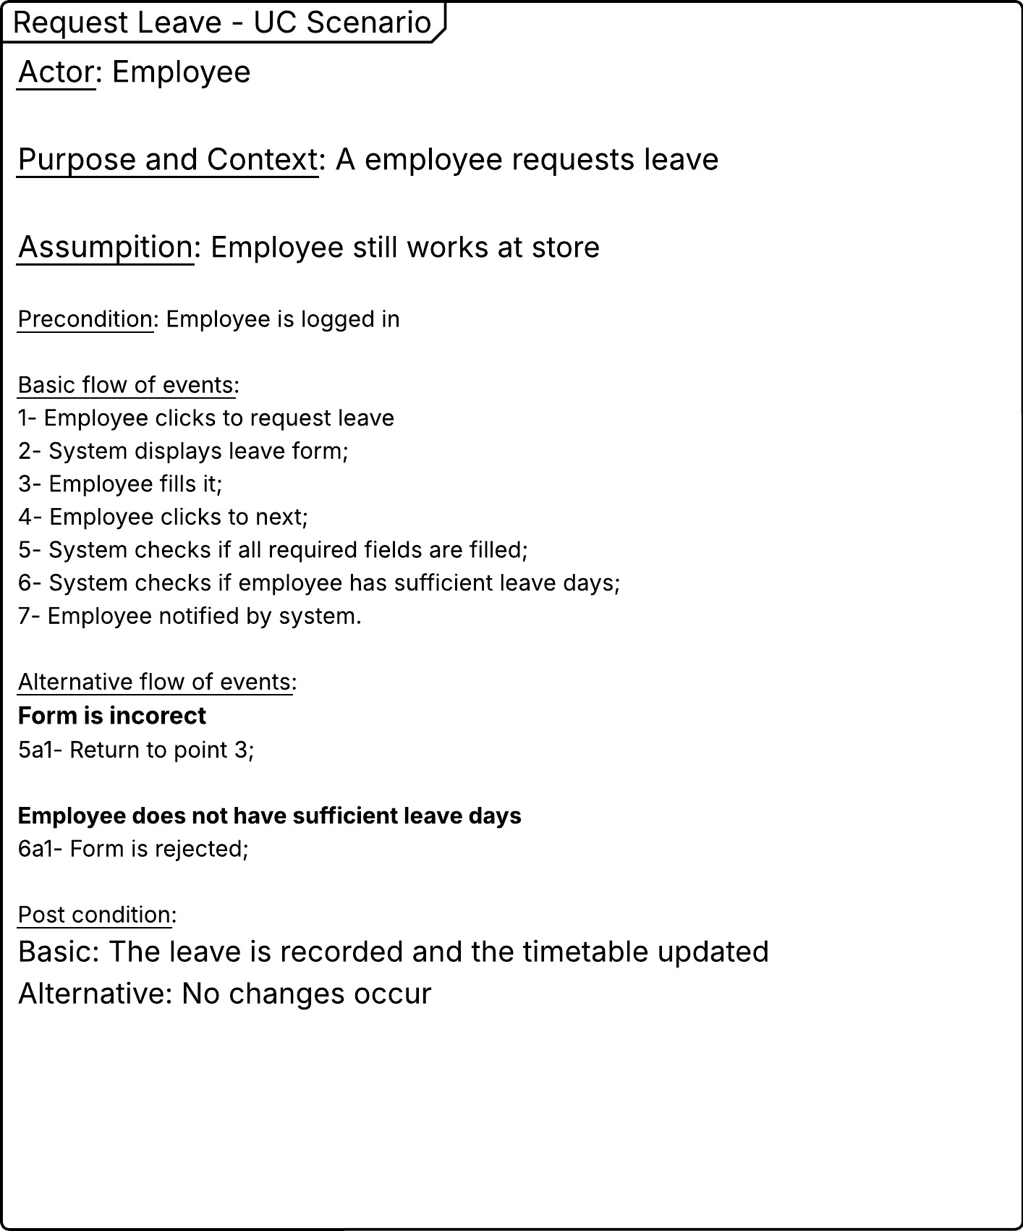

Activity Diagram: “Request Leave”
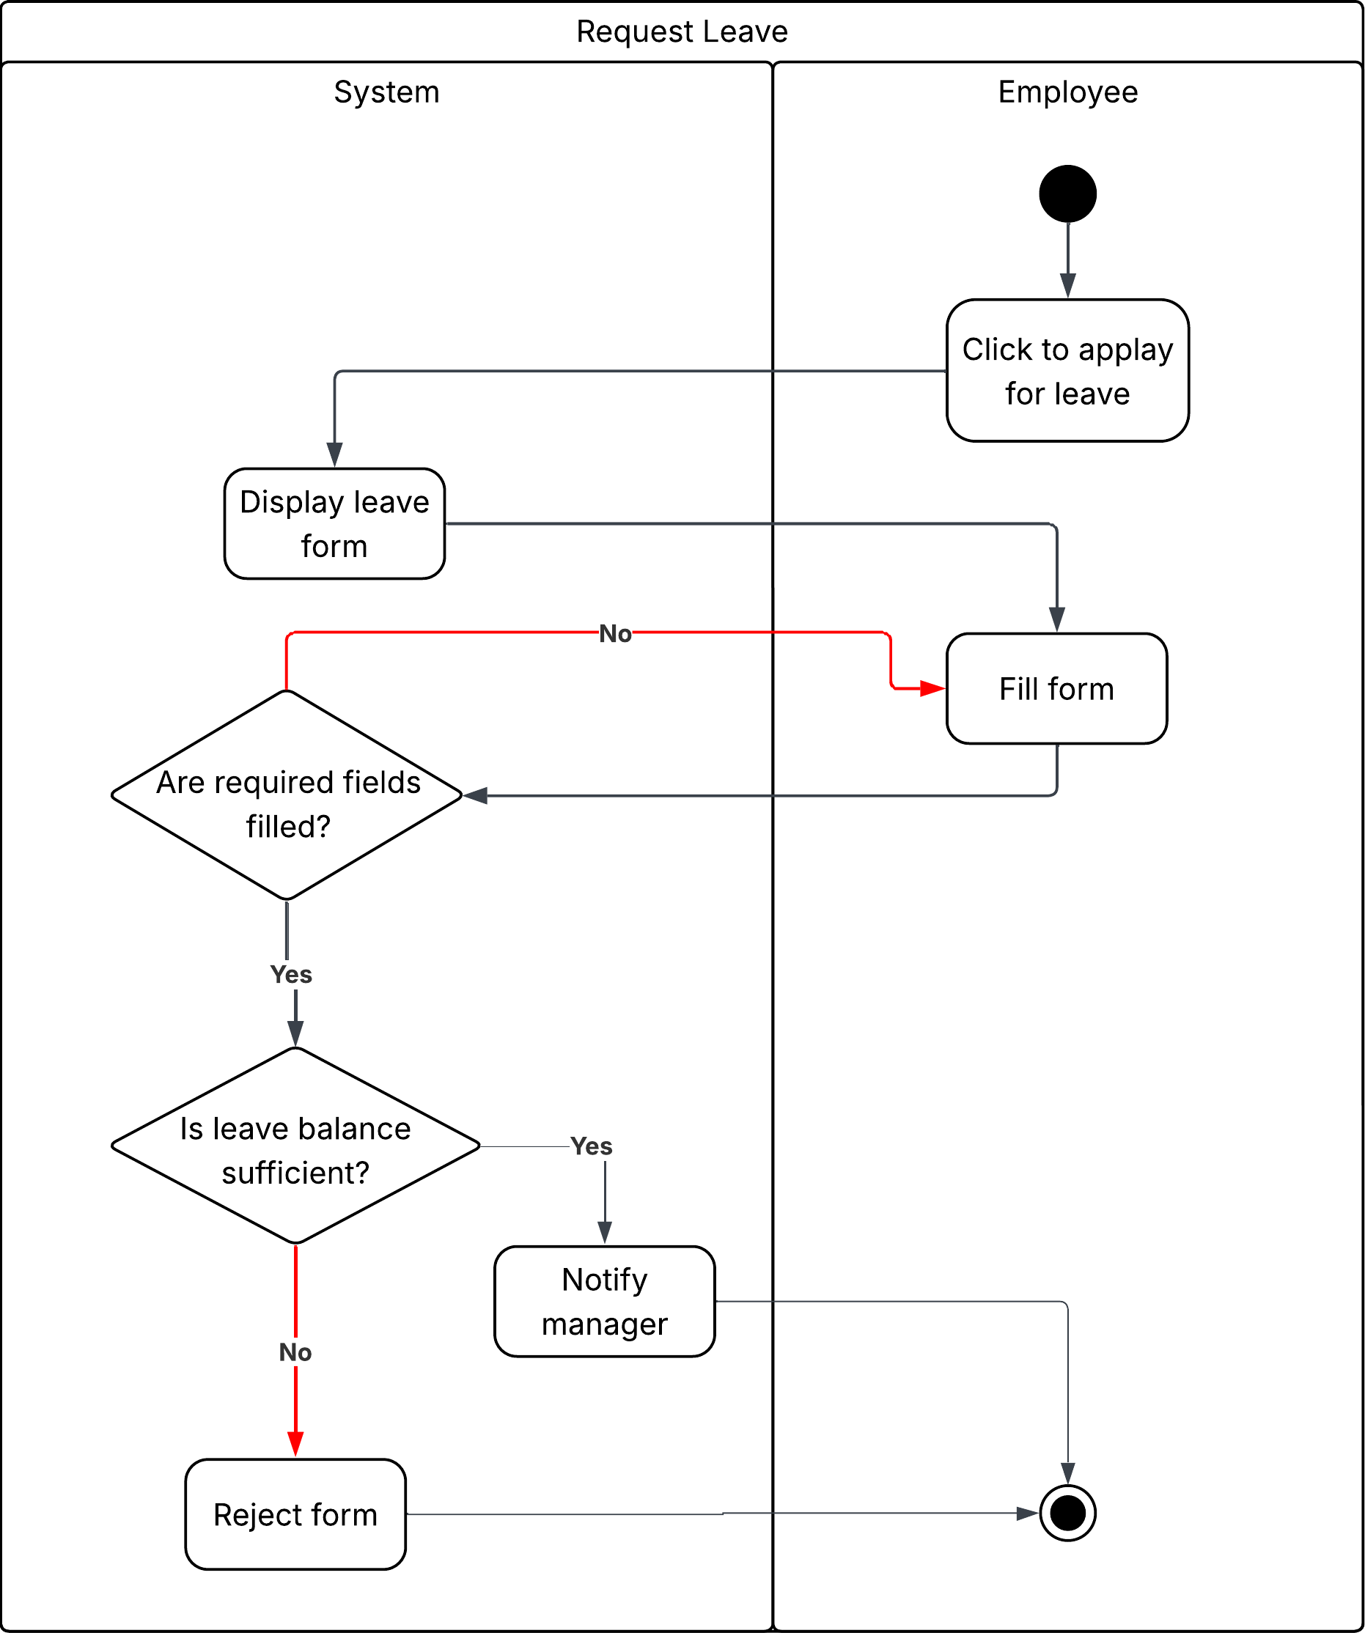

Activity diagram "Request Leave" – Description
This activity diagram illustrates the leave request process between an employee, the system and a manager. The employee initiates the process by clicking to apply for leave and filling out the form. The system then checks whether all required fields are filled and if the employee's leave balance is sufficient. If either check fails the form is rejected and the employee is notified. If both checks pass the request is sent to the manager for approval. The manager can either approve or reject the request. If approved the system updates the shifts table and notifies the employee. If rejected the employee receives a rejection notification.

Use Case Scenario: “Add product to cart and Create Order”
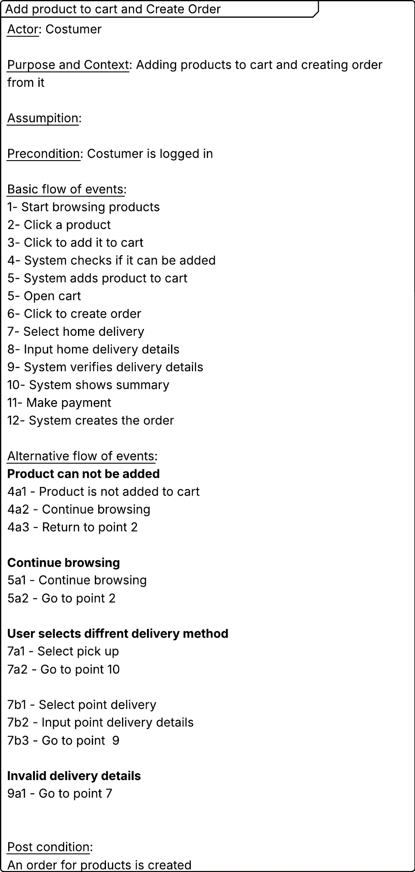

Activity Diagram: “Add product to cart and Create Order”
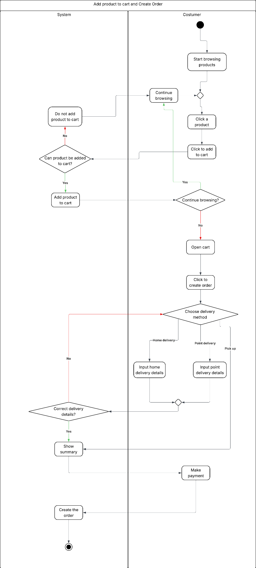

Activity diagram " Add product to cart and Create Order" – Description
This activity diagram illustrates the process of adding products to the cart and creating an order. The customer begins by browsing products and selecting items to add to the cart. The system checks whether the selected product can be added. If valid it is added to the cart. Once the customer finishes browsing they open the cart and proceed to create an order. The customer then chooses a delivery method either home delivery or point pickup and provides the necessary delivery details. The system verifies the entered information, displays an order summary and the customer makes the payment. After successful payment the system finalizes and creates the order.

Use Case Scenario: “Assign Shift”
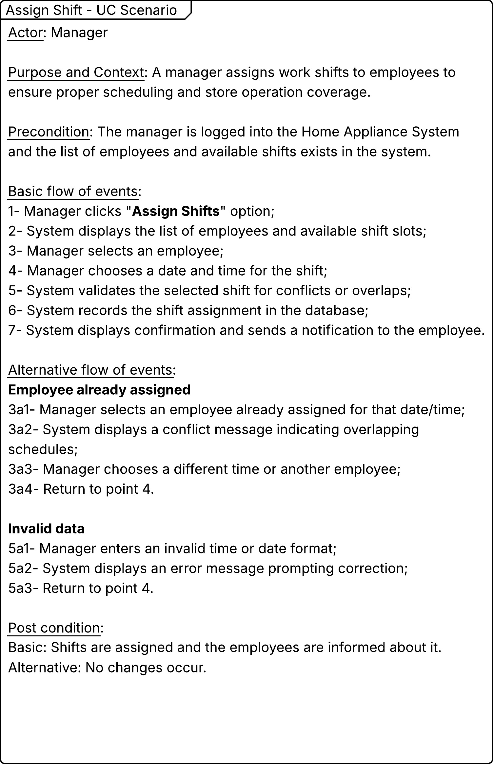

Activity Diagram: “Assign Shift”
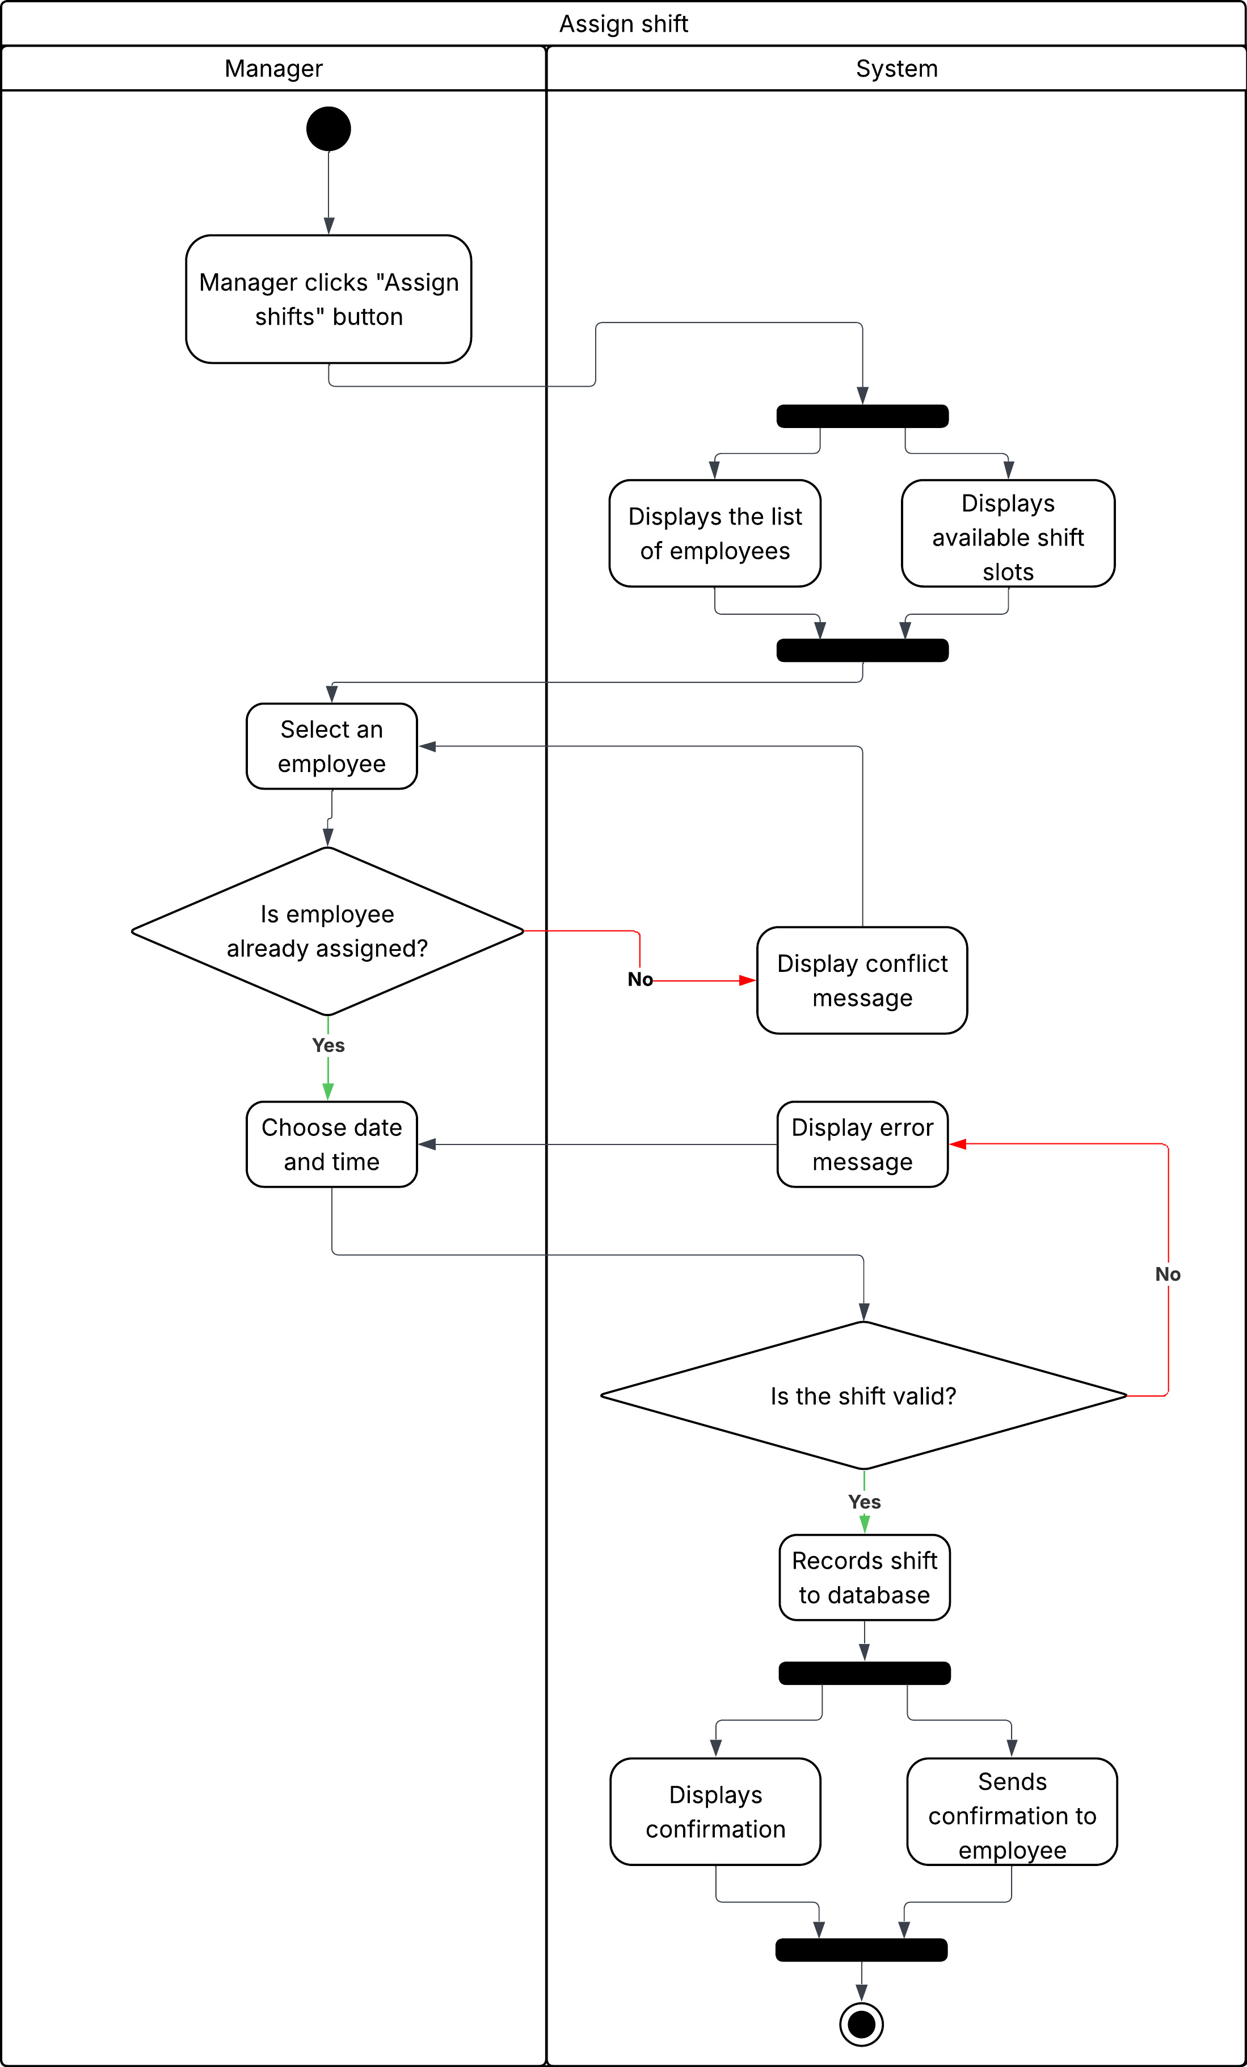

Activity diagram "Assign Shift " - Description
This activity diagram illustrates how a manager assigns work shifts to employees. The process starts when the manager clicks the "Assign Shifts" button after which the system displays available employees and shift slots. The manager selects an employee, chooses a date and time and the system checks for scheduling conflicts or invalid inputs. If no issues are found the shift is recorded in the database and both confirmation and notification are sent to the manager and employee respectively.

Use Case Scenario: “Add Product”
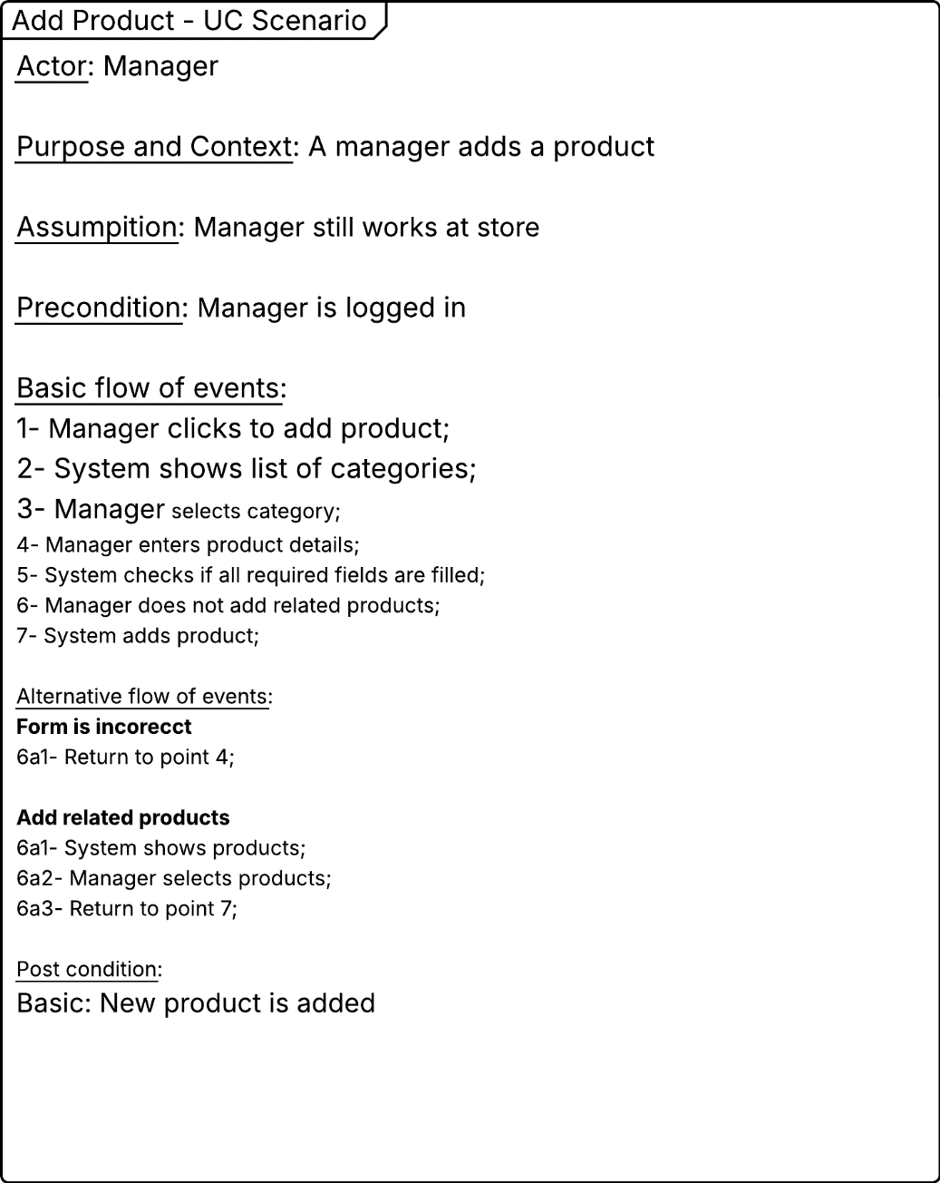

Activity Diagram: “Add Product”
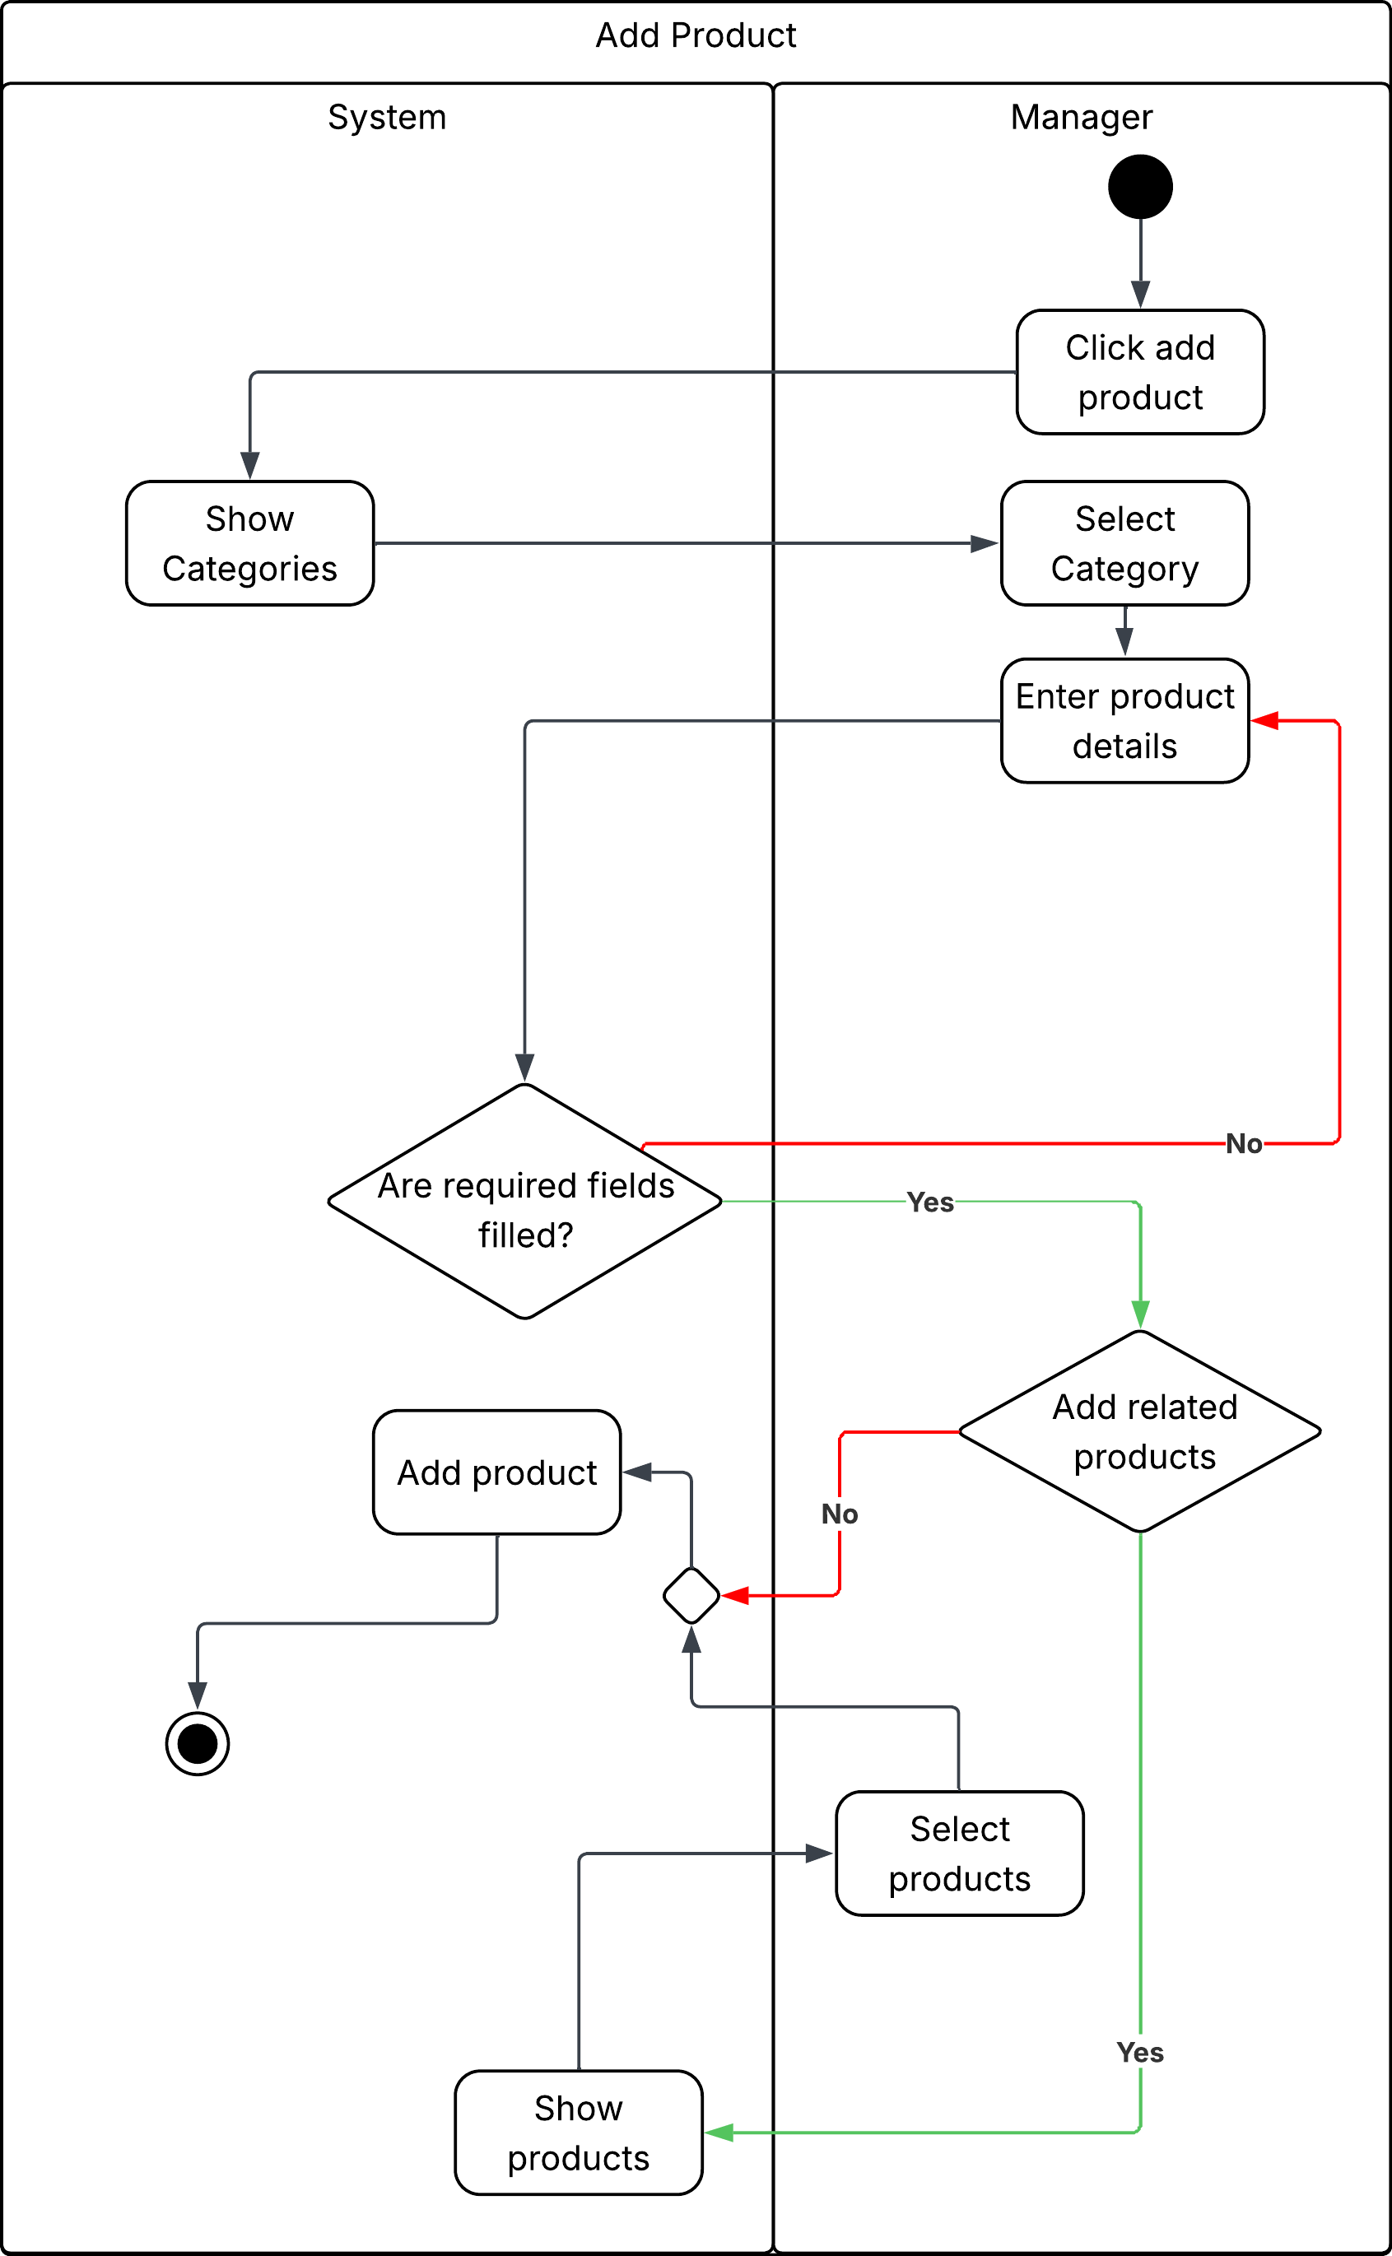

Activity diagram " Add Product" - Description
This activity diagram shows the process of adding a new product by a manager. The manager starts by clicking “Add product” then selects a category and enters product details. The system checks whether all required fields are filled. If not the manager must complete the missing information. Once the form is correctly filled the manager can choose to add related products. If there are no related products the system proceeds to add the product directly. After the product is successfully added the manager can select products to view and the system displays them in the product list.

Use Case Scenario: “Add Category”
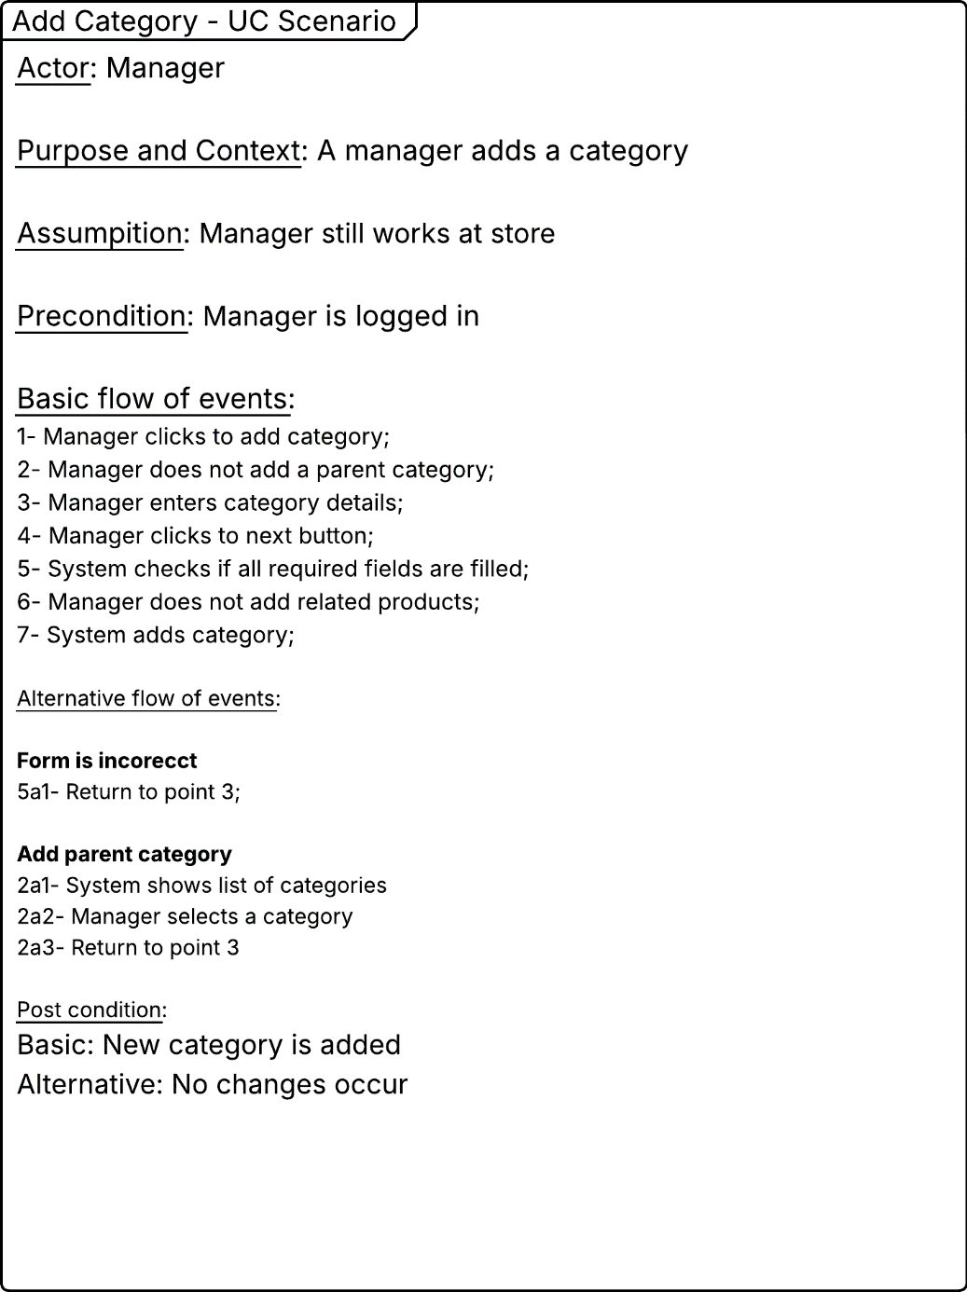

Activity Diagram: “Add Category”
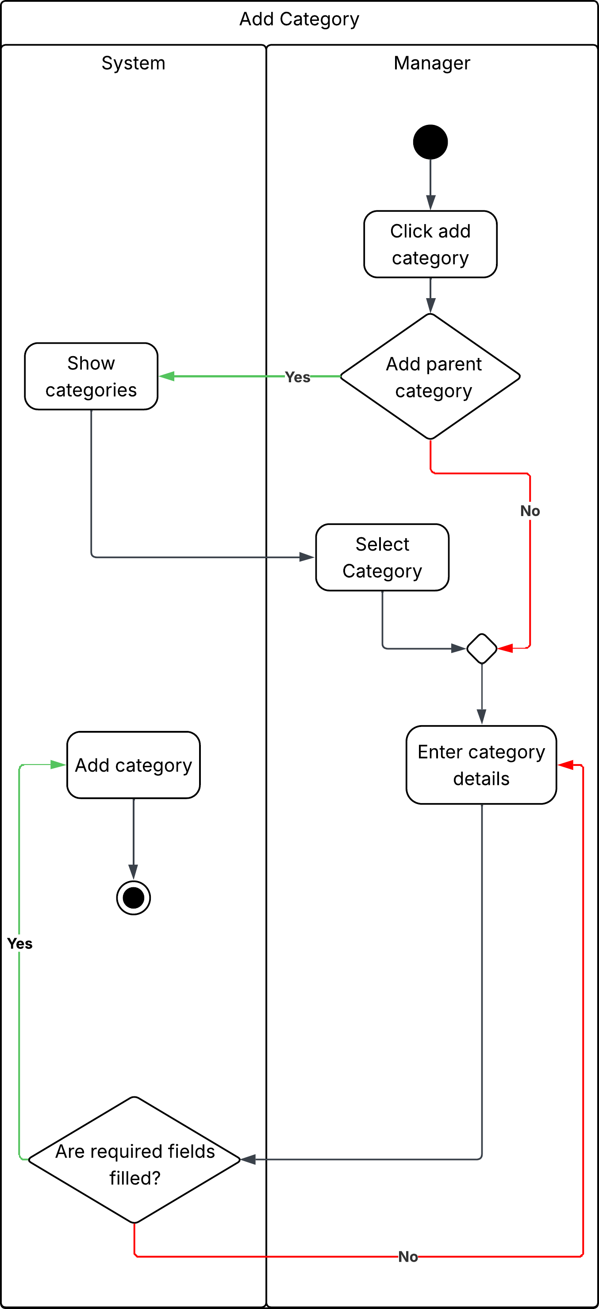

Activity diagram "Add Category" - Description
This activity diagram represents the process of adding a new category by a manager. The process begins when the manager clicks "Add Category". The manager then decides whether to add a parent category. If yes the system displays existing categories to choose from. If no parent category is needed the manager proceeds to enter category details. The system verifies that all required fields are filled. If any field is missing the manager is prompted to complete the information. Once all details are correctly provided the system adds the new category and completes the process.

Use Case Scenario: “Create Sale”
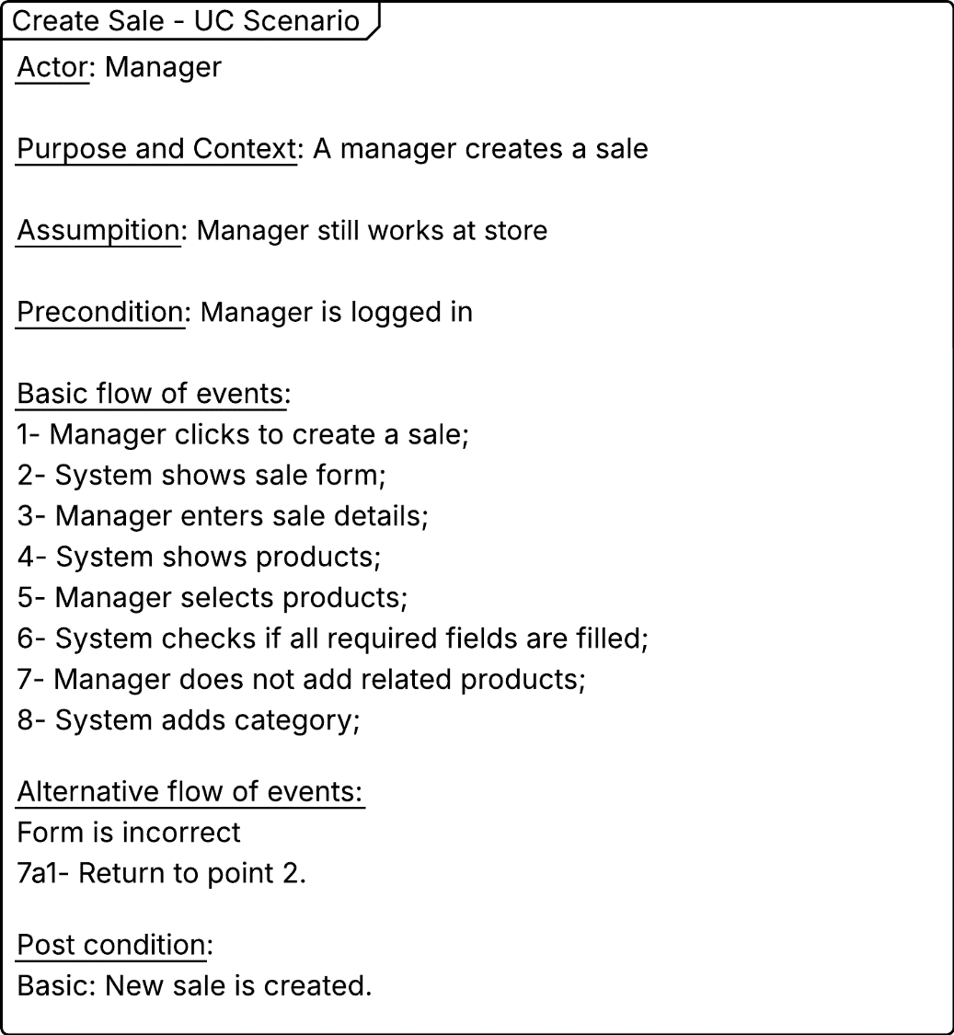

Activity Diagram: “Create Sale”
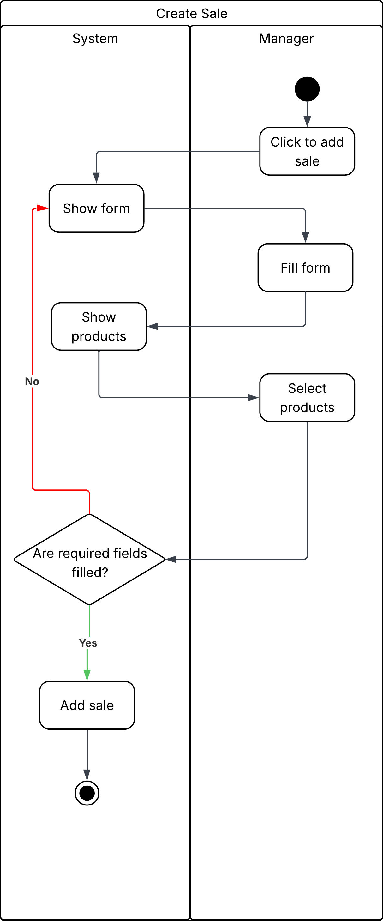

Activity diagram "Create Sale" - Description
This activity diagram illustrates the process of creating a sale by a manager. The process starts when the manager clicks "Add Sale". The system then displays the sale form and the manager proceeds to fill in the required information and select products for the sale. Once the details are entered the system checks whether all required fields are filled. If any information is missing the manager is prompted to complete the form. When the form is correctly filled out the system adds the sale and the process is successfully completed.

State Diagram – Order Class

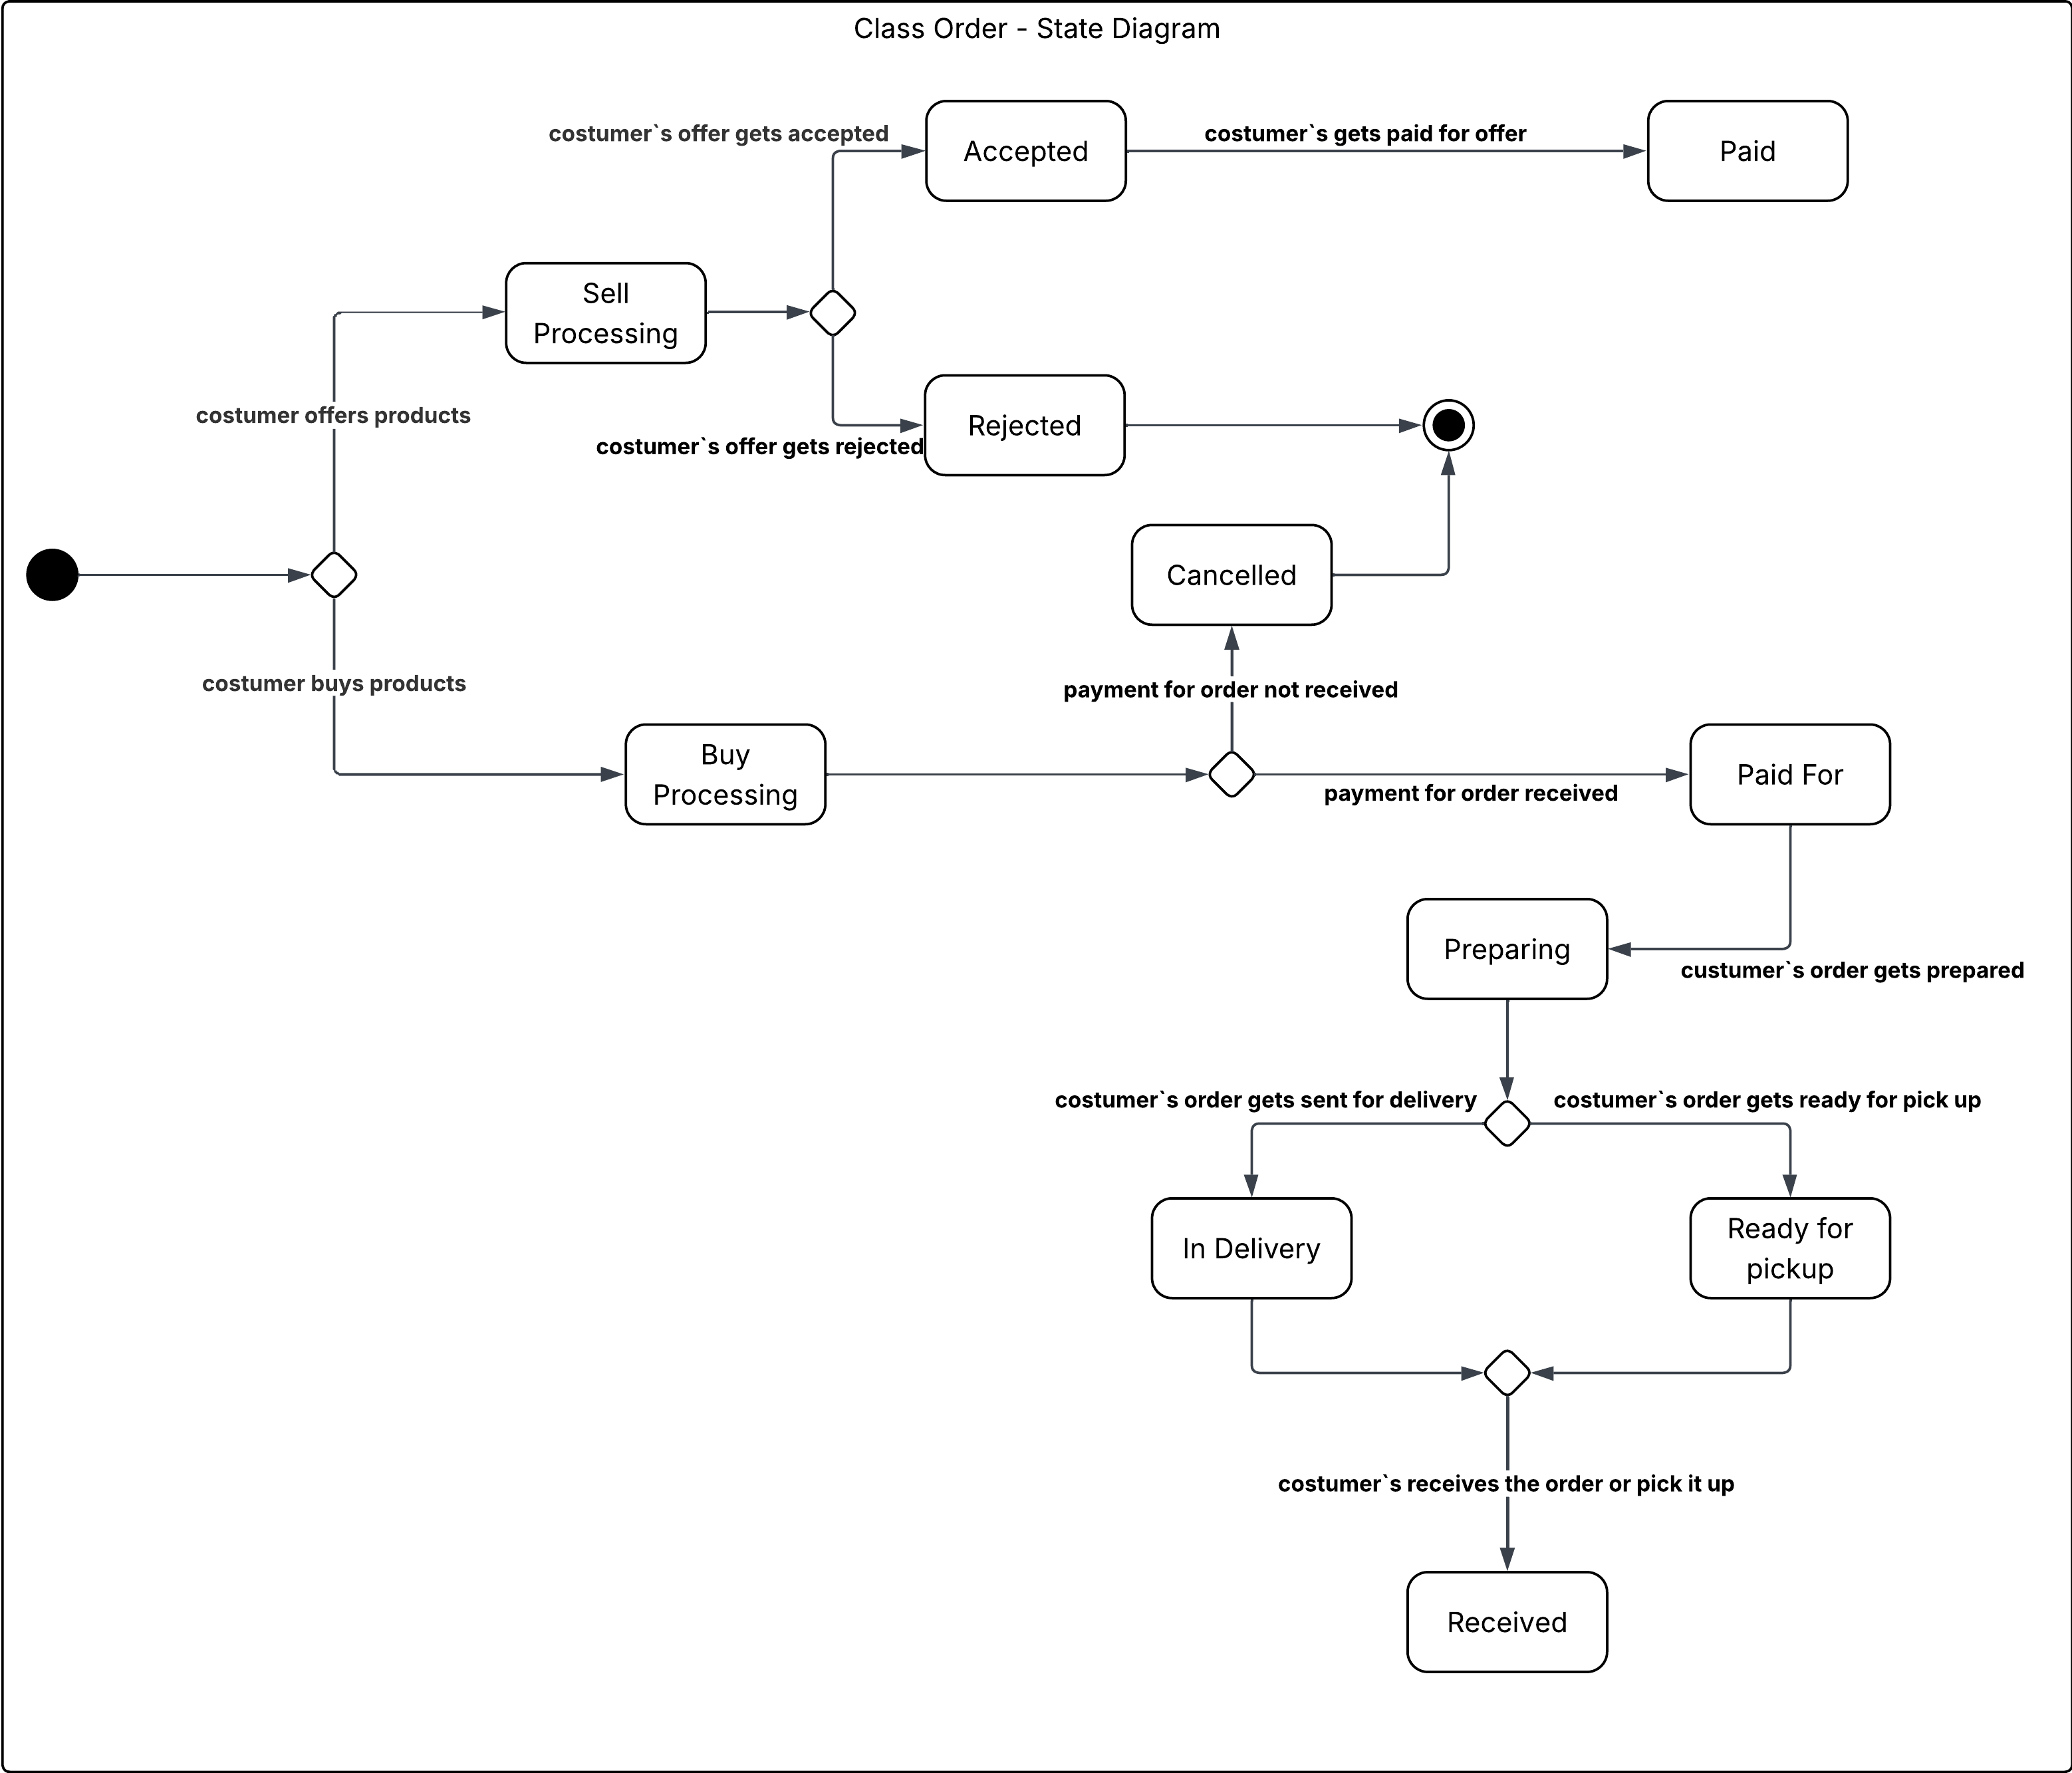
State Diagram – Description
The state diagram represents the different stages of an Order. An order can be created when a customer either offer products for sale or buys products.
Depending on the outcome of the actions and payment processing the order can go through several states.
"Sell processing" - this state occurs when the customer offers products. The order moves to:
"Accepted" if the offer is approved.
"Rejected" if the offer is declined.
2. "Accepted" - when the customer’s offer is accepted the order proceeds to the "Paid" state after successful payment.
3. "Paid" - indicates that the customer has received payment for their offer.
4. "Buy Processing" - this state occurs when the customer buys products. After processing:
If payment is received the order moves to "Paid For".
If payment fails the order transitions to "Cancelled".
5. "Paid For" - once payment is confirmed the order enters "Preparing" where the store prepares the products.
6. "Preparing" - during preparation, the order can move to:
"In Delivery" if the order is shipped to the customer.
"Ready for Pickup" if the order is available for collection.
7. "In Delivery" and "Ready for Pickup" - these states represent the order being on its way or waiting for the customer.
Once the customer receives or picks up the order, it transitions to "Received".
8. "Received" - the final state meaning the customer has obtained the order successfully.
9. "Canceled" - the order is terminated due to a failed payment or rejection. This is also a possible end state.
The object lifecycle can thus end in two ways:
"Received" – when the order is successfully completed.
"Cancelled" – when the process fails due to rejection or payment issues.

State Diagram – Employee Class
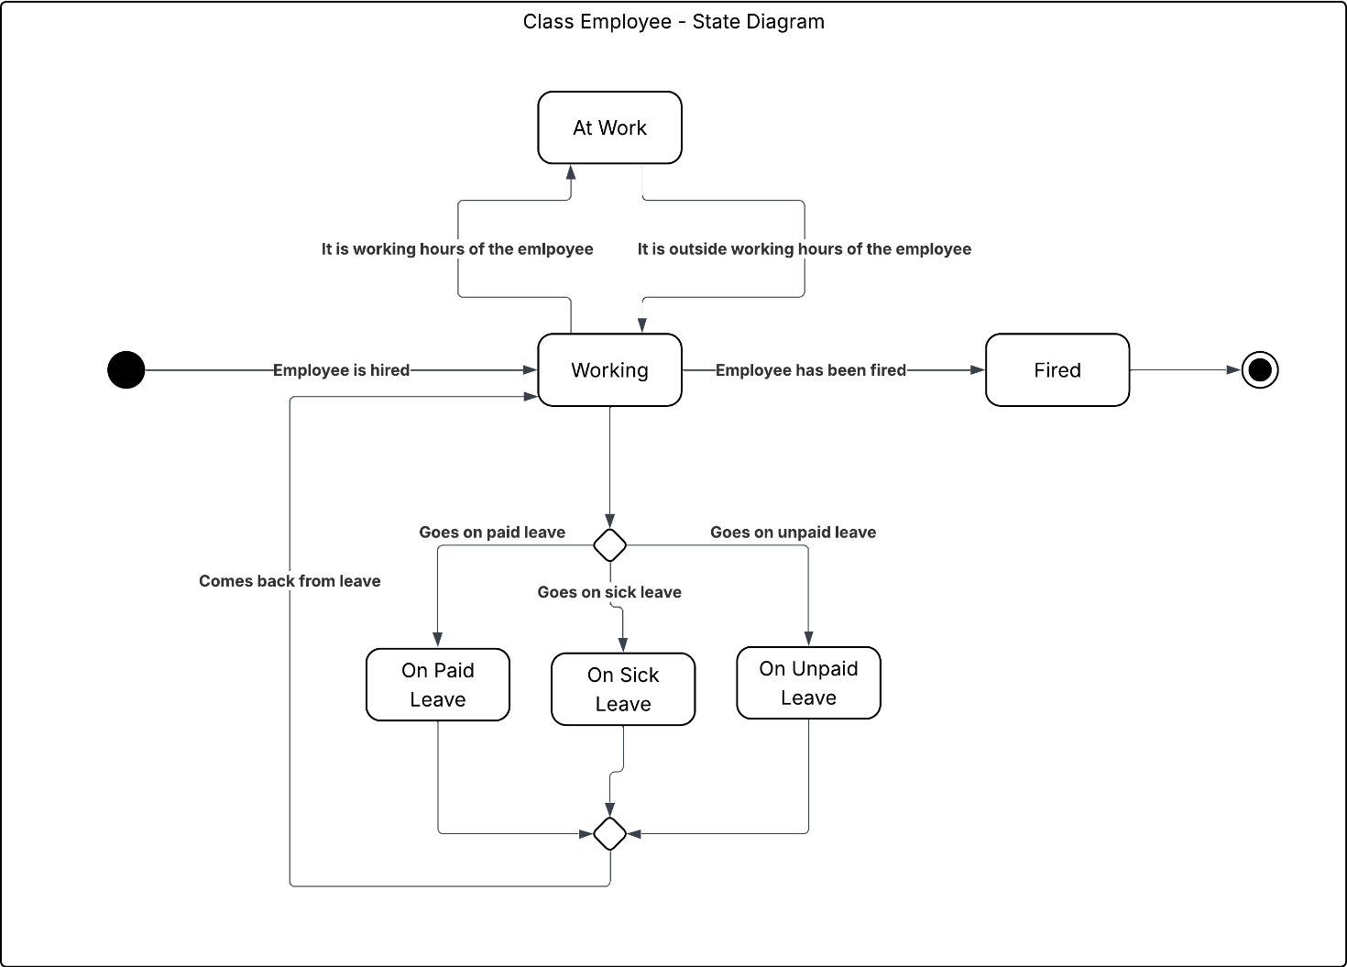

Dynamic Analysis
In the Use Case Scenario when a Customer is selling a product to the store he has to accept the price that the employee proposes to him in order to make the sell final. We could implement this function in our class diagram to know that the employee has the final decision in this process.
In the Use Case Scenario when a Manager is adding a product he has to input all the information about it. That's why we could introduce a method for the Manager called enterProductDetails(). This method would be used when his adding the product but maybe in the future it could have some more use cases like maybe automating the inventory management.

Changes to the Class Diagram after dynamic analysis

Class diagram changes - Description
We added methods for the Manager like: createSale(), addProduct(), addCategory(), approveLeave() and assignShifts().
For the Employee: checkProductStatus() and also enterProductDetails().
For the Customer class we introduced: openCart(), makePayment(), makeOrder(), sellProduct() and acceptPrice().

Design Decisions

Data persistance
Each class which needs to be saved implements Extent, in which the logic what handels saving and loading of master lists and also getting a immutable master list, and they store a master list of all objects of that class in memory. That list is saved each time a new object is removed and/or created also it is saved on each change to an object of that class. It is also loaded once on class initialization.

Data validation
Data is validated during setters and constructors. When data is invalid an appropriate Exception is thrown.

Multi-Value Attributes
They are represented by a ArrayList of a appropriate type.

Derived Attributes
They are represented by making a getter which calculates that attribute.

Optional Attributes
The getters of those attributes return the value wrapped in Optional class.

Types Used For Numbers
For real numbers we use BigDecimal to avoid floating point errors, because we work with money. For natural numbers we use long, because they can represent bigger numbers.

Data Encapsulation
Every attribute is private, but they have public getters and setters. This for data validation and saving.

Any Type
For any type we use generic classes and specify that a type must be serializable.

Assosiations

Basic Assosiations
They are represneted by attributes in their resprective classes. Most classes store each side of the association, aka there is a lot of doubling of data (If they are not present they are just null or empty). Groups of objects are represeented by ArrayList or Sets. ArrayLists are supposed to be checked and add data to the collection only once.
AddMethods either add an object to a collection or create a new object
RemoveMethods either delete the object remove it from a collection and/or sett attributes to null
ChangeMethods are done using setters
Present reverse connections store data on one side of the connection and one side has less assosiation methods.
Deletion happens in the delete() method.

Errors and Validating Assosiations
They are supposed to throw propper exceptions, while setting them.

Agreggate Assosiations
Are those present in the cunstructor but not in the delete method.

Composition Assosiations
Are those present in the constructor and there are present in delete() methods of the assosiation.

Qualified Assosiations
The qualified assosiation got absorbed into a class assosiation of Conrtact.

Class Assosiations
They link one instance of a class with another. They either are stored on one side and have the other as attribute or have both as an attribute.

Reflex Assosiations
They sorted in the instance of object of the class and are mostly and are mostly treated like normal assosiatioins.

Design Diagram

