

Faculty of Computer Science

IT Department

Databases (A_BD)

Thesis author
S28786

WooF1
F1 Fantasy Web Application with AI Integrations

Thesis type: BSc

Thesis supervisor
Piotr Gago

Technical supervisor
Piotr Kojalowicz

Warsaw, 25.10.2024

Contents
1. Introduction 3
2. Glossary 4
3. Aims and Objectives 5
3.1 Aims 5
3.2 Objectives 6
4. Context 8
4.1 About the sports industry 8
4.2 Early days of fantasy sports 9
4.3 The modern version of fantasy sports 11
4.4 Rising popularity and relation to gamble 12
4.5 Fantasy Formula One and its gap 14
4.6 Artificial Intelligence overview 15
4.6 Artificial Intelligence in sport industry 16
5. Functional Requirements 22
5.1. Must-Have Requirements: 22
5.2. Performance Requirements 23
5.3. Excitement Requirements 24
5.4. Indifferent Requirements 25
5.5. Reserve Requirements 25
Machine Learning implementation 26
Machine Learning Model testing (yet to be written) 27
Bibliography 28

1. Introduction
2. Glossary

- F1: Formula One

- MVP: Most valuable player - the man or woman judged to be the outstanding player in a sport during a particular season or championship.

- API: Application Programming Interface - a software intermediary that allows two applications to talk to each other. APIs are an accessible way to extract and share data within and across organizations.

- OAuth: open authorization, - a widely adopted authorization framework that allows you to consent to an application interacting with another on your behalf without having to reveal your password.

- PostgreSQL: an advanced, enterprise-class open-source relational database that supports both SQL (relational) and JSON (non-relational) querying

- DBMS: Database Management System - a software system that is designed to manage and organize data in a structured manner

- DNF: Did not finish – in this project means occasion when a driver did not finish their race
3. Aims and Objectives

3.1 Aims

The main aim of this project is to utilize machine learning models to support better predictions for F1 related content; by building an F1 Fantasy web app with AI driven predictions and analytics so users can make decisions when picking and managing their fantasy teams with access to AI predictions. The project will increase user engagement and decision-making accuracy by providing personalized insights from historical and real time F1 data.

Specifically, the app will aim to increase fantasy team selection predictions accuracy using AI to give users recommendations based on past performance and driver stats.
Increase user engagement and post launch with an easy-to-use, data rich interface and interactive features, thus creating a community for people who are interested in the sport.

Simplify F1 performance metrics so fantasy sports are accessible to casual fans and experienced users. Encourage competitive community engagement with leaderboards, performance tracking and interactive forums.

The project addresses some of the key issues faced by F1 Fantasy players, which are too many unusable data, not enough tools to predict and no personalized insights. By providing a modern AI powered solution the app will deliver tangible benefits to the user and an active fantasy sports community.

3.2 Objectives

1. Market and User Needs Analysis

a) Conduct research among F1 enthusiasts to understand the preferences and expectations of F1 fans for applications related to the sport.

b) Keep track of existing fantasy sports platforms, recognizing the strengths, weaknesses, and what left to be desired.

c) Review historical F1 data sets to understand the factors influencing driver and team performance, which will result in a well-rounded understanding of the sport for future machine learning implementation.

2. Application Design

a) Develop a prototype for the web application based on research discoveries and best UX/UI practices.

b) Design the AI prediction model, indicating the key performance indicators that will be used for the predictions.

c) Gather feedback on the prototype from potential users and make any necessary adjustments

3. Application Implementation

a) Select appropriate technologies for building the application.

b) Train the AI prediction model in a dataset that contains historical F1 data.
c) Program the application's core functionalities with security and performance into consideration.

d) Conduct initial testing to search for easy to replicate bugs, as well as having a first look at usability

4. Deployment and Evaluation

a) Release a beta version for a selected group of users, including casual fans, competitive players, and F1 enthusiasts.

b) Collect feedback on:
- The accuracy and usefulness of AI predictions.
- Overall user experience and design of the app.
- Community features and engagement tools.

c) Analyze user behavior data as an evaluation to the application.

d) Improve the application according to the feedback given, concentrating more on the most requested features or major issues.

e) Measure success against the project’s aims using specific KPIs such as:
- Prediction accuracy: Comparison of AI-driven recommendations to actual race outcomes.
- Engagement rates: Track how many people use the app daily and the number of hours they spend on it.
- User retention: Percentage of users still using the app after specific periods of time.
4. Context

4.1 About the sports industry

These days, sports are a concept that everyone is aware of. The definition of it exists in all modern dictionaries, which basically can be understood as a game, competition, or activity needing physical effort and skill played or done according to rules, for enjoyment and/or as a job [1]. Sport has existed in human society since recorded history, with editions of Omlypic in ancient Greece, which researchers figured dated back to 776 BC when it was initially held as a sports festival in honor of local heroes [2].

Following the development of mankind, sports evolved into a global industry with multiple branches, along with their own businesses, players, and fans. Sports investments have become increasingly common due to the fact that the income and marketing value of sports teams in general are worth a lot more than ever before. Proofs of them have been shown in multiple reports, examples being the $4.351 billion enterprise value worth of Manchester City football club in the England Premier League, with multiple other clubs being worth more than $1 billion and recording double-digit percentage growth since the previous year according to a 2023 report [3].

With peak growth recently, the sports industry being in the technology era has undergone multiple transformations on the consumption of its audiences, which has shifted dramatically from traditional stadium attendance to digital platforms. Ultrahigh-definition services and over-the-top media have become central to the viewing experience, allowing fans to engage with content in more interactive ways [4]. The COVID-19 pandemic accelerated this shift, with a decline in physical gatherings and a surge in online participation, such as co-watching and online discussions. Platforms like YouTube have also played a significant role in this digital transformation, offering new ways to experience sports mega-events [5].

With that, sports fans now have additional interest in data, whether for their own team or as a sport in general. Data analytics has become increasingly integral to sports analysis, influencing both player performance and fan engagement. The use of wearable technology, big data analytics, and sensor technology has revolutionized how sports are played and analyzed [6]. Fans now seek new ways to interact with the sport that they enjoy, which for example are interactive experiences like fantasy sports, e-sports, and betting platforms. Along with that happening, taking into account the fact that sports are built on the idea of competition, having teams and players rivalry, their fans also compete in multiple ways, which includes fantasy sports.

4.2 Early days of fantasy sports

The fantasy sport idea is easy to grasp, as the name suggests, it is an imaginary situation concept based on a real-life sport. When the fans get more engaged with the sport they follow, these people might start to create situations, and cases that did not actually happen, and discuss theories about those events. For example, what would happen if we put the football team Manchester United in their European championship-winning season of 1998 - 1999 versus the formation of Real Madrid in their own European champions season of 2023 - 2024? Or what would happen if Formula 1 driver Max Verstappen started his journey in the highest tier of F1 as a Mercedes AMG Petronas driver instead of Red Bull Racing? From this concept, fantasy sports started to exist in the form of tabletop and board games.

The roots of fantasy sports stretch to the mid-19th century with the creation of the earliest manufactured in-home games using a pinball-like
design as Richard G. Lomax wrote in the Handbook of Sports and Media [7]: “In Francis Sebring’s 1866 Parlor Base-Ball
game, a coin (representing a baseball) would be propelled along a
flat wooden surface by a coiled spring (the pitcher) toward a
movable flipper (the batter). The batter would then hit the coin into
one of several open slots on the playing surface and create a specific
outcome of the game-player’s at-bat.”
This format of the board game allowed the player to use their imagination and make up a game somewhat similar to a real-life baseball game, with players being whomever the player wants to assign to, which makes the player more attached to their real-life baseball player references.

Since then, there have been multiple types of fantasy sports that have been played. The first version is mentioned above, with the implementation of a board game or in tabletop format.

Another version use a computer system to simulate the actual game. In this version, all the stats for each player are created by the players and utilized by the computer, for example, speed, agility, technique, etc, to generate a lot of information only for a single game. Taking into account a basketball match, the computer can use the stats set for the players in the NBA and create fantasy information regarding a match, such as 3-pointer throws, number of blocks, final MVP, and more. In theory, if the stats imported to the players are relatively close to their actual performance in real life, the computer will generate a more likely result between them. This type of fantasy is implemented in sports games nowadays. Games like FC 25, F1 Manager, and Football manager use this system to simulate matches between so-called AI in career mode. Every sport that exists can have a fantasy gaming platform implemented in cyberspace.

4.3 The modern version of fantasy sports

After years of refinement, the current version of fantasy sport coming into one's mind whenever it gets mentioned will most likely contain some form of a player being a ‘manager’. In general, the player will take on the role of a general manager and manipulate a team of players with limited slots. The core gameplay consists of users picking their players for the team whose real-world performances after some time can generate points.

The main flow of the game is usually defined as follows: the game starts with a player draft. This is when each person, acting as a team owner, picks real-life players from a professional league to build their fantasy team. These team owners can then compete against others in multiple fantasy leagues. The owners earn points based on how well the players on their team perform in actual games. The points add up over time, and the fantasy owner with the most points accumulated after the sports season finishes wins. Different leagues use different scoring systems, and other fantasy sports host may have their unique twist to it. For example, in the Fantasy Premier League, players get 1 point for playing up to 60 minutes, while a goalkeeper specifically gets 5 points for each penalty save in a match.

For sports with their own league, for example: football, basketball, or F1, the fantasy sport host can set their own special rules and conditions for the gameplay.

One of the most common aspects of this is a deadline and transfer window. Between each league sports game or period, the players will enter a period called a transfer window, which allows the gamers to replace (or can be called a transfer) their current players to some others that they think are more likely to give better performance next match. Usually, each transfer window will have a limit of free transfers – transfers that do not reduce points, if users replace several players above that limit, then the fantasy score will have a deduction based on the number of rule-violated transfers that were redeemed. The transfer window will close at the deadline, which in general is set to be right before the next matches begin.

Another important gameplay element in fantasy sports nowadays is power-ups. Powerups are items that give special effects when they are used during a transfer window, which can dramatically reshape the dynamic of that window. For example: a powerup that can eliminate all transfer violation deductions for a single week, or triple the point gain for a specific player in their next match. Fantasy hosts commonly implement powerups to only be available with a limited number of usage for the whole season.

At the end of the season, the host will usually give out prizes to the determined winners, or top players of the league as stated in the rulebook before the players enter. This applies mostly to the leagues that are hosted by the publishers, while people from the community can give out prizes for their own league, or just play in friends’ league for the purpose of entertainment.

4.4 Rising popularity and relation to gamble

This gameplay of fantasy sports thus gained the high interest of sports fans, data enthusiasts, and many others, given the gameplay is highly centered around data and prediction. The industry has seen significant growth, with millions of participants worldwide and a turnover in billions of dollars, which was measured to be approximately $4 billion in economic impact in 2011 [8]. The game has grown to 59.3 million North American participants and has seen tremendous growth over the past three decades according to studies [9].

It is also worth noting that while many players prefer free leagues, P2P fantasy sports contests are growing, with nearly half of the players paying league participation fees. This trend has led to many citizens classifying fantasy sports as a form of gambling due to the occasional entry fees, uncertain outcomes, and cash prizes [10]. Wether this type of game is a form of gambling or not is still up for debate. There are researches with similar finidngs as fantasy sports participation among college students is associated with increased risk of gambling-related problems [11]. However there are other studies that stated that fantasy sports is infact not really a form of gamble as legislators in the United States believe it is a game of skill or gambling, and defining it as either is misguided; instead, harm minimization strategies should be implemented [12]. Additionally, there are studies that claimed fantasy sports are not games of chance and should not be considered gambling [13].

As stated in the previous section, fantasy sports has evolved into a multi-billion dollars industry, with fantasy sports acting as a form of media along with traditional channels like television or social media. Research has pointed out that sports games presented on television receive more viewers who also play fantasy genes [14]. Therefore, fantasy sports can be counted as a form of complement to the existing televised sports events, which allows cross-marketing between the internet and television sports matches. Social media helps fans connect with their different interests and personalities, making fantasy sports a bigger part of their daily lives.

4.5 Fantasy Formula One and its gap

As stated in the title of this thesis document, Formula One will be the target of the application. Being the pinnacle of motorsport, Formula One has been gaining popularity with wide media coverage, streaming services, and detailed content such as Drive to Survive. Moreover, this is a great sport to have a fantasy sport instance, due to the unique combination of strategy. Statistics and excitement of the races. Each race in the Formula One calendar is at least one week apart from other races, which gives the perfect period for a transfer window. While in other sports, points generated from players might need to be calculated based on vague performance metrics, here each race gives a wealth of data points which is discrete, thus making it much easier to give out points to drivers. For example, the race leaderboard after the race finishes gives out the distinct placement that each driver finished at, along with the fastest lap data and starting grid position can provide players with diverse ways to earn points while still making it great to implement logic behind.

Formula One itself already has a fantasy game on its website, where participants can select a team of five drivers and two constructors, balancing their picks within a budget. This adds a layer of strategic depth, as fans must analyze track conditions, team form, and driver consistency to make informed predictions. It utilizes the fact that the app is an official product from the F1 branding, which mean there is no requirement for a lisence for images right or official data from. However, even with those data in place, F1 can still bring surprise results from a wide range of mid-season car upgrades and unpredictable races, which gives out entertainment throughout the season. The combination of technology and teamwork makes the sport natural for fans who enjoy both motor racing and competitive strategy games involving heavy data usage.

On the other hand, the official Formula One Fantasy is only a web application. Aside from the game content, the page only has one more section dedicated to data with graphs and numbers on various statistics of the current F1 season, which alongside minimal advertisement for the product, makes few people interested. The app missed out on the usefulness of artificial intelligence or machine learning model implementation, which this project aims to improve on to make it stand out. The integration of a system for AI-based prediction in this project will give users an edge over others and strengthen their interaction with the platform.
4.6 Artificial Intelligence overview

From the early work of Alan Turing in the 1930s, AI has been rapidly developing, further cementing its position in multiple branches of human life nowadays. Artificial Intelligence is commonly referred to the ability of a computer or a robot to perform tasks commonly associated with intelligent beings like humans and other animals. Google stated on their website about AI being “a broad field that encompasses many different disciplines, including computer science, data analytics and statistics, hardware and software engineering, linguistics, neuroscience, and even philosophy and psychology.”

In computer science world, four stages of AI development are commonly recognized. The first one is reactive machines, which are Limited AI that only react to commands or similar based on rulesets that are already programmed into them by developers from before. This version does not use memory and with that cannot learn with new data. One of the earlier uses of this AI version was IBM’s Deep Blue that beat chess champion Garry Kasparov in 1997. The second stage of AI is called limited memory, which includes most modern AIs. The AIs in this stage can use some form of memory to improve their performance over time by training with new data. The training methods are done with neural networks or other models. The industry considered deep learning, a subset of machine learning, to be in this state of AI. The third stage is theory of mind, which does not currently exist, although there are researches being done at the moment to discover the possibilities. In this stage the AI model can emulate the human mind has can make decisions with reasonings like an actual human, as well as recognize and remember emotion and react to social situations just like a human. Above the mind AI is the final stage which is Self-Aware. The step describes a mythical machine that is aware of its own existence and has the intellectual and emotional capabilities of a human. Like the third stage, this stage of AI does not exist yet. With the idea of this project, the use of AI’s second stage would be ideal since we have lots of data from F1.

Research has been showing that AI has the potential to revolutionize industries and society, however, the clear roadmap for its future is not there yet. There are huge benifits of AI, as well as the risk of not using the correctly or using them for the wrong purposes of implementations. Nevertheless, the challenges and research agendas must be addressed to ensure its successful implementation and future impact [15].

4.7 Artificial Intelligence in sport industry

AI has been implemented in sports since as early as the late 1990s, with the use of computer vision algorithms to automatically track football players, working with the club in the England Premier League Derby County in 1997. From then on, the use of AI in sports started to span multiple branches.

AI techniques can automatically assess exercise technique and provide athletes with appropriate feedback in training when being implemented in sportswear, enhancing performance and providing sportsmen with prompt advice, or generally helping sports researchers analyze data at a faster rate. This has proven to be the case in some research, particularly with weight training. In the study, they recorded data from cable force sensors which had already attached to weight (figure 1). This data then got fed to the AI for training, therefore the model was allowed to check the correctness of training techniques and output them back to the athletes in a timely manner. The artificial neural networks used for the analysis of the training data showed good performance and high classification rates (figure 2) [16].With that, AI can help with analyzing sports metrics with exercise selection and assist with distributing workload as well.

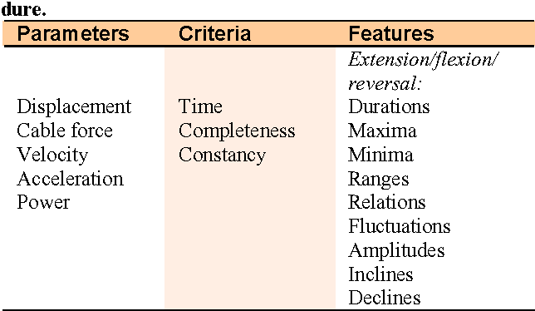
Figure 1: Gathered parameters, main criteria and exemplary features derived for the applied pattern recognition procedure. (from the research [16])
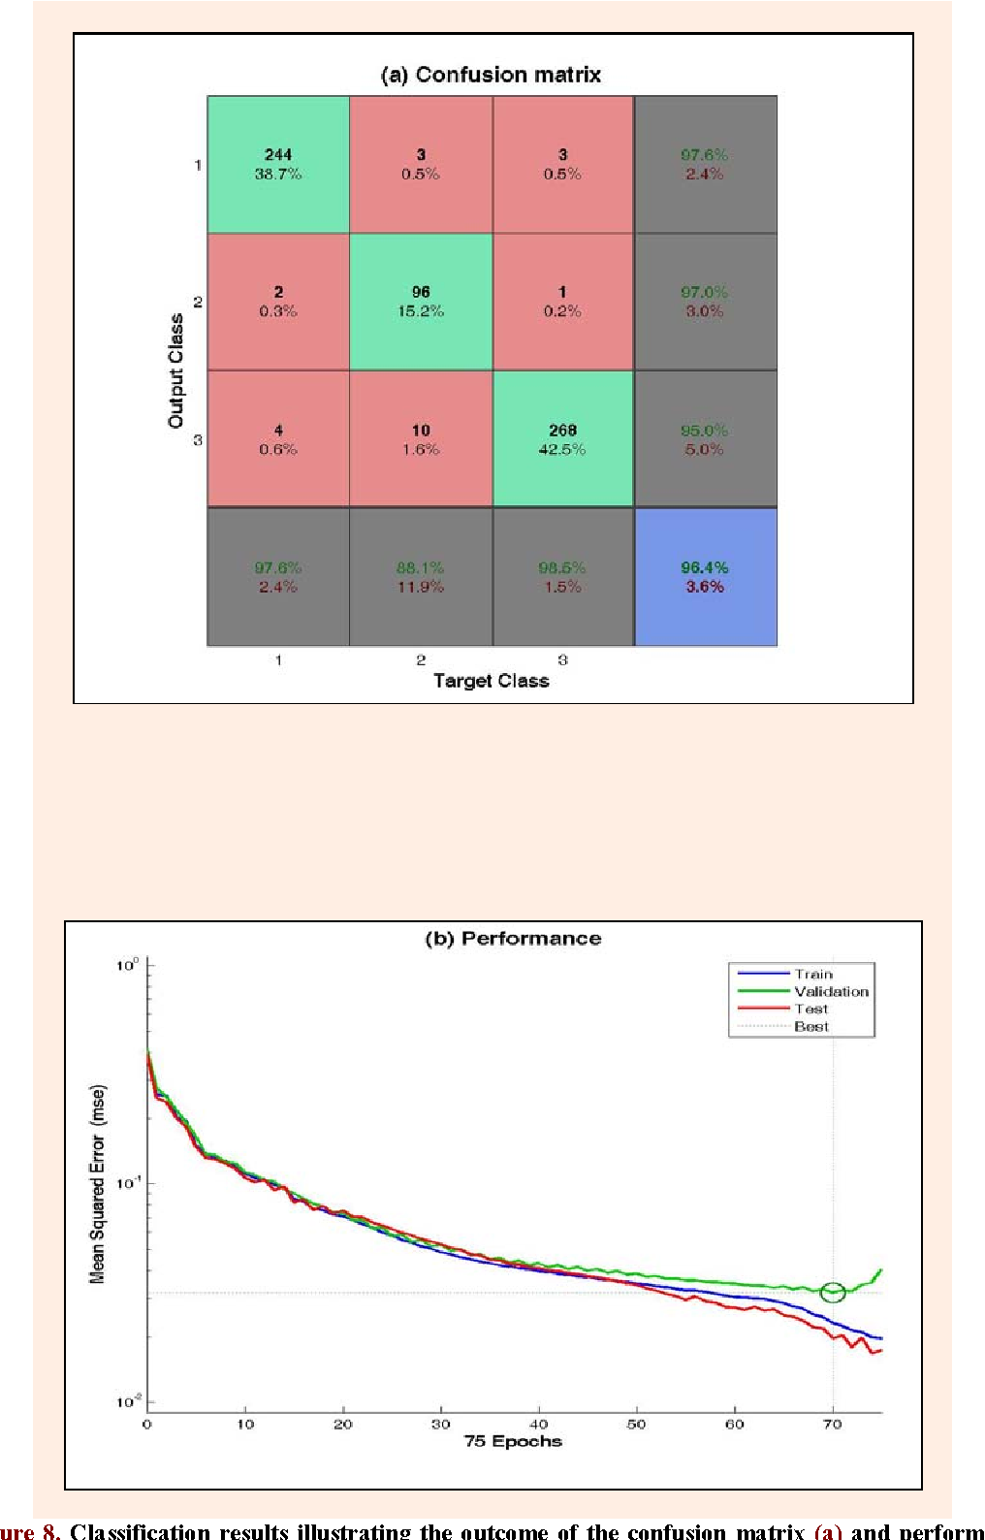
Figure 2: Classification results illustrating the outcome of the confusion matrix (a) and performance curves (b) for the trained ANN in respect to characteristics regarding the constancy of the executions. (from research [16])

In various occurrences, AI algorithms are used to analyze data collected from athletes’ sportswear, such as heart rate, and training intensity, to perhaps predict the percentage of how likely an injury can happen, and if so, what kind of injury will it be, how will it affect the future performance of that specific player. Radiology AI in sports medicine after training with datasets has been stated in studies to be able to identify patterns and make decisions without input from human, which can potentially uplift diagnosis and treatment by a lot [17]. Another case of AI usage in sports to enhance performance is by collecting data about player gameplay, for example, in football, the data of pass completion rate, movement heat map, running distance, etc. from each game can be collected for the AI to suggest in what area the player should focus on in training, to maximize gameplay outcomes.

Multiple models of AI have been used for this purpose, with multiple studies done on current approaches. A systematic review of these studies had been conducted which figured out there was significant usage of artificial neural network, decision tree classifier, Markov process, and support vector machine in basketball, soccer, and volleyball [18]. These models are also being used for injury risk assessment in multiple sports. The application of AI in sports has potential to grow into a much bigger thing in the future.

Ai usage is also found significant in media side of sport, with studies finding that “progressively customized encounters increasingly accommodating robotized connections may well mean more fan devotion and commitment after some time.” [19] Aritificial intelligence is found to be setting up another creative way to enjoy sports for die-hard sportspersons, supporters and even casual fans, with a continuing influx of game insights which can provide help for the player to pick the correct system. With these stepups of AI in recent years, it would make sense for this proposed project to have an implementation in place.
4.8 Data provider – Ergast API

To utilize the use of AI in the application for prediction, data will be a must have. As the option of F1 official data is blocked behind a paywall, the decision is set to be using a community made API, called jolpica-f1. The project is open source and available on GitHub under Apache License 2.0 which basically allows extensive usage. The project is an API to query F1 related data, using Python as the main language with Django as web framework, and PostgreSQL as the DBMS to manage the database. Information about the project can be found in the GitHub link: GitHub: jolpica-f1. This project consists of multiple endpoints to gather F1 data and return JSON response, which can be called online or to the local links if the user decides to use the project locally, having a clear database structure (figure 3) and documentation for querying data.

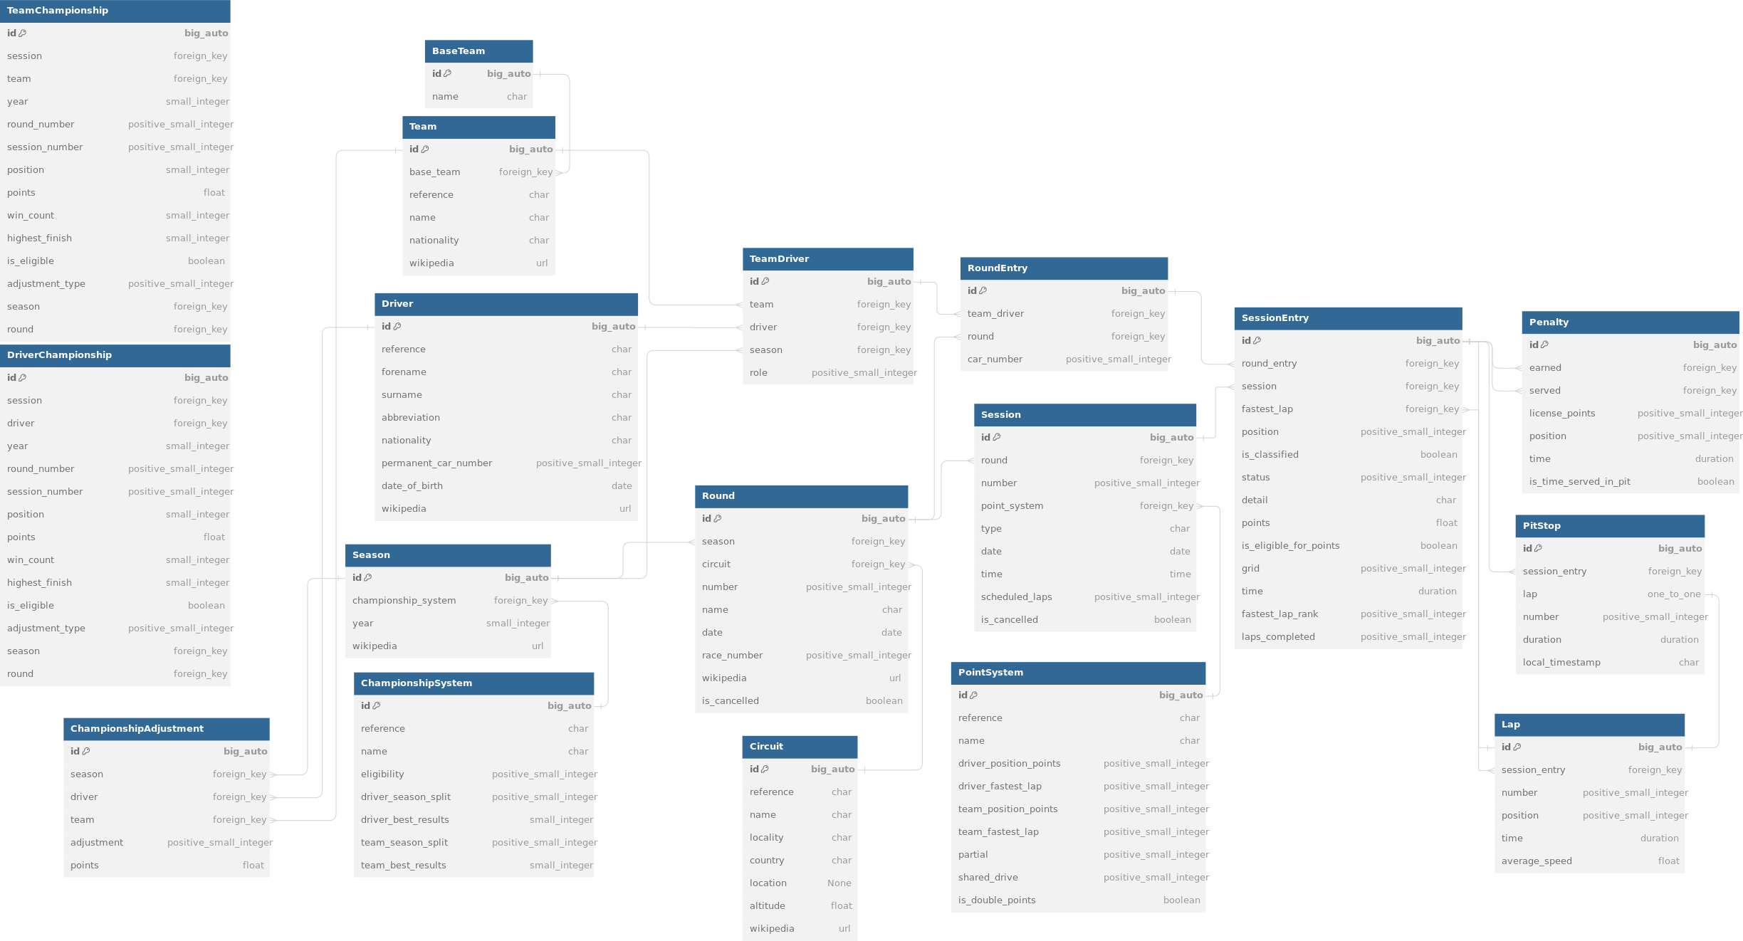
Figure 3: jolpica-f1 database schema
Jolpica-f1 is great to gather data since if the project is cloned and run locally, the database will be available to use immediately. The PostgreSQL local database then allows gathering data easily as it’s a relational database management system. The database consists of multiple relational mapped tables with information about each season of F1, with each driver, constructor, race, circuit, etc. This will open the door for further research in the future, like getting data to train AI models.

The new data in this API get added after each race result got published, so it would work perfectly inline with the idea of a fantasy game, with the logic of calculating points after each race. For databases, the races and championships are stored as far as since the 1950s, except for the new data of pitstops in F1 are only available from the 2010s onward, and the lap times are only recorded since the late 1990s.

5. Functional Requirements
5.1. Authentication and authorization:

For authentication and authorization, the web application should enable secure sign-up and login using username, email, password, or social media accounts (OAuth). With that it needs to also support account recovery, and password reset functionality. With that the authorization will separate functionality via different roles, with the user can be a normal player or an admin. The sign up and login functionality should be implemented with a separate view from the rest of the app.
The admins, players, and normal users will have different allowed functionalities, which will be discussed throughout other sections here.

Daily Login Rewards

The web application will implement a system to record daily login, which can give players rewards based on how many days of non-interrupted login the current player has. The milestones for these rewards will be discussed in core gameplay section

5.2. Gameplay

Core Gameplay
Each logged in user will have a squad of 5 drivers and 2 constructors, which should allow the user to create and maintain their team. The user can select drivers and constructors from the current F1 roster of that season. The squad will have a cap value of 100$, with each driver and constructor having their own price tag, for example: Max Verstappen (driver) – 32$, Mercedes (constructor) – 17$. The current squad summed price will have to be below or equal to the cap value to be allowed to save in user account. Each squad will be attached to the main race that will happen next in the season, with a deadline of 1 hour before the qualifying session starts to lock the squad, not allowing players to edit any more.

After the main race ends and the data from it gets updated from the API, the system will have to calculate points gathered from drivers and constructors, the result is based on grid start positions from drivers, and final positions of drivers and constructor.

The game point calculation logic only considers the main race, all other sessions such as qualifiers, free practices or sprint races are irrelevant.

For each main race, the squad attached to it will be compared to the squad of the previous week (providing if the race is not the first race in the calendar). The system then counts how many drivers and constructors in the new lineup are not present in the last race lineup. In game play logic, this is called transfer, and there will be 2 free transfers available each race, which allows player to change driver or constructor freely. If the number of transfers exceeds the max amount for the week, points are modified as follows:

Exceeding transfer point deduction - for each transfer (excluding the 2 free transfers)

Exceeding transfer | Deduction Point
One transfer | 10 points

Point gain for grid start for each driver – a driver can only receive one of the following:

Grid starting position – driver | Point
1st place – Pole position | 10 points
2nd place | 9 points
3rd place | 8 points
4th place | 7 points
5th place | 6 points
6th place | 5 points
7th place | 4 points
8th place | 3 points
9th place | 2 points
10th place | 1 point
11th place and below | 0 point

Point gain for final position for each driver – a driver can only receive one of the following:

Final position – driver | Point
1st place – Pole position | 25 points
2nd place | 18 points
3rd place | 15 points
4th place | 12 points
5th place | 10 points
6th place | 8 points
7th place | 6 points
8th place | 4 points
9th place | 2 points
10th place | 1 point
11th place and below | 0 point
Status of “Withdrew” / “Accident” | -20 points
Status of “Disqualified” | -25 points

Point gain for constructor performance in qualifying – a constructor can only receive one of the following:

Constructor point gain | Point
Neither driver reaches top 10 | -1 point
One driver reaches top 10 | 1 point
Both drivers reach top 10 | 3 points
One driver reaches top 3 | 5 points
Both drivers reach top 3 | 10 points

Additional point gain for each driver – a driver can receive multiple point gain of the following:

Additional point gain | Point
1 Position Gained | 1 point
1 Position Lost | -1 point
Fastest Lap | 3 points

Positions Gained or Position Lost is calculated to be the result of absolute value after the starting grid position gets subtracted from the final position of the driver. Additionally, Fastest Lap is only given to a single driver from each race.

The initial point gain of a race weekend from a driver is calculated as follows:

Driver’s initial point gain = Grid starting position point gain + Final position point + Additional point gain (if applicable)

The initial points gain of a race weekend are calculated as follows:

Race’s initial points gain = Each driver’s initial point gain + Point gain for each constructor – Exceeding free transfer deductions

Given this is only initial point gain, the final point gain may be different due to various usages of powerup or unique circumstances happening.

A player can see their total score for the season, as well as the result of their lineup for each finished race.

League system

League is a group that consists of at least one account. A league allows the players to have a place where they can compare line ups and see the result of other players in the league. A league will have a leaderboard of total points gained in the current season, as well as leaderboards for each finished race, which includes all the players in the league. This information of private leagues is only available to see for league members, while for public leagues even non-users can see them.

Players can search for them of a league that they want to join, while popular leagues are also listed as featured leagues. These users can also choose to leave their league, following the league’s ruleset. These are divided into 2 types: private leagues and public leagues.

A private league can be created by one player; thus, its existence is directly tied to its own creator. A player can create maximum 3 leagues, which can also be deleted by themselves, or admins. Only the creators of the league have an option to generate invitations to other players to join, and the option to kick out players. In addition, the creators can specify passwords for players to join the league without an official invitation sent. A player can only join at most 5 private leagues for their account.

A public league can only be created by admins, which means the leagues of this type are not tied to any user, and only admins can delete them. Players can freely join and leave the public leagues, as well as admins can remove them from the leagues. A player can only join at most 5 public leagues for their account.

Powerups

Powerups are race specific boosts with logic applied to the core gameplay. With them being seasonal, there will be a limit of how many times a powerup can be used for a single player in a single game and season, which is usually 1 time per season. The usage limit of each powerup is reset after each season finished, with admins allowed to change them. Only one powerup can be used per race for the lineup, which gives various types of advantage to the player, usually to boost the lineup score for the race that is applied to by modifying the race’s initial points gain discussed above. A player can choose not to apply any powerup for the race, which will preserve the use of the remaining powerup for the latter race, providing it is not the last race of the season.

The power up will have unique names and their own description of usage, such as:

- DRS Enabled

This powerup allows users to double their score for a chosen driver in the next race. With this powerup enabled, the formula for the final race will be calculated as the initial formula with some modifier:

Final race’s points gain = Race’s initial points gain + Chosen driver’s initial point gain

This ensures the point gain of the chosen driver is considered twice from that same race, which can give players more points if the initial driver’s point is positive, however, deducing the point if the chosen driver got negative points after the race finished.

- Free transfer week

This powerup allows users to negate their penalty score for exceeding free transfers limit in the next race. With this powerup enabled, the formula for the final race will be calculated as the initial formula with some modifier:

Final race’s points gain = Race’s initial points gain + Exceeding free transfer deductions

This ensures the penalty deduction points from transferring drivers get negated from that single race, which means the players can change as much as the whole lineup without getting the penalty.

- Escapist

This powerup allows users to negate their score for every driver in the next race if the driver accumulates negative points. With this powerup enabled, the formula for the final race will be calculated as the initial formula with some modifier:

Final race’s points gain = Race’s initial points gain – Driver’s initial points gain (below 0)

This ensures the point gained from all drivers is only considered if it is more than 0 from that same race, which can give players more points if there exist drivers in the lineup which scored negatively after race finished.

…
Ask WooF1 AI

Each player will have a few AI usage times assigned to them, which will be reset to 0 at the start of each season. With this, the application will implement an AI model as a reward for daily logins. For each 14 days of consecutive daily login, the number of AI usage will be increased by 1. Using AI for each option will consume 1 attempt of AI usage.

The machine learning model will be implemented and trained through the data from jolpica-f1, thus can provide prediction service for getting the result of next qualification and main race. When using the AI, the player will have options to predict the qualification or the main race. Each option can only be used once for each race; thus, a single race can only have at max 1 qualification prediction and 1 main race prediction used by one player.
For the qualification option, the player will be presented with a prediction grid of how the starting grid might look like for the next race, with all drivers and their position.

If the player chooses the main race prediction, the application will require an input of starting grid position for each driver. This input can be used automatically from the qualification option, providing the user already used the qualification prediction from before, however, the user will have to manually give out the starting grid as input. This option will present a prediction of how the final race result might look like for the next race, with all drivers, their positions, and race time.

The implementation of this AI model will be discussed later in this document.

5.3. Achievements

The application should implement some forms of achievements. Achievements in this project are great accomplishments, something in the game that are achieved with great effort or skill. Each achievement has an unique requirement to reach for the player, which after they accomplish, the system will assign these achievements to them. Achievements come with it’s own graphic, usually a badge.

Achievements can be implemented as concreete achievements, which the user can get qualified for them as any time as long as they are players. In addition, there can be event achievements for time-limited events, in which these specify achievements can only be gotten providing the player surpass the conditions during the timeframe of the event.

The user after gaining these achievements can choose to show the achievement bage on their profile page, with the maximum capacity of 5 featured badges per player.

5.4. Chat system

The application also implements a real-time chat system directly between player and a group chat dedicated to each private league. The group chat need to be implemented with inappropriate word filter.

5.5. Statistic board

In addition to the gameplay, the application should allow all users to access an universal statistic page. The statistic page will have all information relating the fantasy or the real F1 data. The fantasy data will be displayed in different leaderboards, divide by 3 big categories: for drivers, for constructors and for fantasy players.

For all categories, there will be general leaderboards of total point gathered this season and average point gain per race. The drivers will be assigned with leaderboards of the number of fastest laps driven, DNF races amount, average fantasy point scored, etc. The drivers will be assigned with leaderboards of total point gathered this season, the number of top 10s, the number of top 3s, average fantasy point scored etc. Finally, for fantasy player section there will be a leaderboard for top 10 players’ total points globally.

With real F1 data, the application will implement charts to track the position change of each drivers and constructers, as well as a map model to check circuit position and information in the calendar. The current official Formula One driver and vonstructor leaderboard will be available as well as past race results.

5.6. Friends and chat

A logged in user will have the ability to send friend request to another player. These 2 users can have the status as friend only if the other player accept the request. Then each user can access their friend list to for further functionalities regarding friends. An user can choose to unfriend another user giving that both are already connected as friend, while also has option to block other user from sending new friend request to their account. An user can only have maximum 30 friends.

The application will implement a chat system for an user to each of their accepted friend, which can be access via accessing friend while browsing the friend list. Other chat system will also be applied to leagues, as a group chat will be initiated for each private league. If a league get deleted, the group chat is also deleted, as well as if an user choose to unfriend, the friend chat will also be deleted.

5.7. Favorites

A logged in user can choose at max 1 constructor and 2 drivers of the current season to be their favorite. The system will take the statistic of the favorite chosens and display them on a separate page on the user’s profile. Satistic such as the position of the drivers/constructor on the leaderboard will be displayed with the user’s data, while the favorites will be highlighted in the statistic board to get user’s attention. The favorite constructor and drivers will be reset at the start of each new Formula One season.
6. Non Functional Requirements

Enhanced Team Management

- The web application shall be implemented with an intuitive drag and drop interface to select, swap players and constructors.

Views Optimization

- The web application shall ensure that the views are responsive between computers and mobile devices.

5.3. Excitement Requirements

Social Engagement

- The web application shall add a community chat feature for private leagues or between users

User Experience

- The web application shall allow users to save their favorite drivers and teams

- The web application shall allow users to enable notification related to their favorite drivers, teams and other key events.

5.4. Indifferent Requirements

Customizable Themes

- The web application shall allow users to change the app’s color scheme or layout.

Offline Mode

- The web application shall offer a way to view past performance and leaderboards offline.

5.5. Reserve Requirements

- Making scoring too detailed or unintuitive might discourage casual users.

- Overly complicated processes or too many features can overwhelm users, leading to frustration.

C4 model system diagram
Machine Learning implementation

The idea is to use machine learning predictions as a bonus for the gameplay, which sits in a different field from powerup from previous discussions of fantasy sports. The ‘ticket’ to use the prediction system is handed over to players in multiple events each season. After a period of dates yet to be decided, if the user successfully logs in to the game in all those days, then they will get to use the AI prediction one time. The ‘ticket’ to use the prediction remains for four race weeks before getting deleted even if the user has not used it.

The open source project jolpica-f1 stated above also allows to have a database initiated in local PostgreSQL server with F1 data from the 1950s until now. The database currently has interesting f1 data that makes it able to train machine learning models effectively. With the objective of predicting the final position of the whole grid, these parameters are taken into account:

Driver: driver reference is crucial since different drivers have varying skill levels, driving styles, and experience that can significantly affect times.

Birthday: birthday is used to calculate another variable of drivers’ ages when the race happened. Knowing age can lead to a better understanding of the maturity of each driver.

Team: teams can have different car setups, technologies, and strategies in each race that can affect final times. This will apply to the variation of performance of drivers.

Circuit: each circuit has different lengths, track layouts, and unique features (e.g. the elevation change at Circuit of Spa-Francorchamps and, the tightness of Circuit de Monaco) that influence lap times. This field helps the model account for these variations.

Session status: this field accounts for the status of the race session from each driver, which can vary from Finished to Did Not Finished, which can cut short the race time.

Starting Grid Position: this field can influence a driver’s strategy and performance in the early laps, potentially affecting lap times

Race Date: the race date is used to get the race year, in which the race is done. This can affect the times since each year brings different regulations and technology advancements. Race date is also used to calculate the number of years of experience from a driver, which determines how long it has been since the driver's first race in F1.

All of these fields are connected to the lap times, which contains lap time of each driver collected from the late 1990s in each race, which is summed up to obtain the drivers’ final race time during the specific race. The machine learning model will train on these data with the result to predict the final time for each driver, given all the fields are filled.

During a prediction session, all the drivers and the data are put into the models, and with the output of predicted time, the application will sort the race times to prepare a final leaderboard base on the prediction result and send it back to the user.

Machine Learning Model testing (yet to be written)

Bibliography

[1] | J. Swaddling, The Ancient Olympic Games, University of Texas Press, 1999.
[2] | Cambridge University Press & Assessment, Cambridge University Press & Assessment, [Online]. Available: https://dictionary.cambridge.org/dictionary/english/sport.
[3] | A. SARTORI, „Football Clubs' Valuation: The European Elite 2023,” Football Benchmark, 2023.
[4] | A. P. A. D. Kirti Mahajan, „Revolutionizing Fan Engagement: Adopting Trends and Technologies in The Vibrant Indian Sports Landscape,” International Journal of Management Thinking, 2023.
[5] | G. B. É. M. A. &. R.-Ó. K. Ráthonyi, „How Digital Technologies Are Changing Sport?.,” Applied Studies in Agribusiness and Commerce , 2018.
[6] | J. A. &. P.-W. R. Lee Ludvigsen, „From television to YouTube: digitalised sport mega-events in the platform society,” Leisure Studies, p. 615–632, 2022.
[7] | R. G. Lomax, „Fantasy Sports: History, Game Types, and Research,” w Handbook of Sports and Media, New York, 2006, pp. 383-392.
[8] | B. &. C. J. Ruihley, „Just a Fantasy? Examining Fantasy Sport in a Time Without Sport,” International Journal of Sport Communication, 2020.
[9] | R. H. K. &. P. R. Burton, „The Historical Development and Marketing of Fantasy Sports Leagues,” The Journal of SPORT, tom 2, 2013.
[10] | D. M. B. &. N. E. Houghton, „Fantasy Sports and Gambling: A Comparison of Antecedent Traits and Motivations,” w Celebrating America’s Pastimes: Baseball, Hot Dogs, Apple Pie and Marketing?, Springer International Publishing, 2016, pp. 601-605.
[11] | R. &. N. S. Martin, „Fantasy sports, real money: Exploration of the relationship between fantasy sports participation and gambling-related problems,” Addictive Behaviors, 2014.
[12] | D. B. A. H. M. &. K. B. Pickering, „Fantasy Sports: Skill, Gambling, or Are These Irrelevant Issues?,” Current Addiction Reports, tom 3, p. 307–313, 2016.
[13] | T. &. N. S. Easton, „Are daily fantasy sports gambling?,” Journal of Sports Analytics, tom 5, nr 1, 2018.
[14] | T. &. K. K. Nesbit, „The Impact of Fantasy Sports on Television Viewership,” Journal of Media Economics, pp. 23 - 41, 2010.
[15] | Dwivedi i e. al., „Artificial Intelligence (AI): Multidisciplinary perspectives on emerging challenges, opportunities, and agenda for research, practice and policy,” International Journal of Information Management, 2019.
[16] | H. &. B. A. Novatchkov, „Artificial intelligence in sports on the example of weight training.,” Journal of sports science & medicine, tom 12, nr 1, pp. 27-37, 2013.
[17] | W. &. F. B. Parker, „Artificial intelligence in sports medicine radiology: what’s coming?,” British Journal of Sports Medicine, tom 53, pp. 1201 - 1202, 2018.
[18] | R. R. Nadikattu, „Implementation of New Ways of Artificial Intelligence in Sports,” Journal of Xidian University, tom 14, nr 5, pp. 5983 - 5997, 2020.
[19] | J. D. O. C. D. D. S. T. S. J. P. A. &. N. G. Claudino, „Current Approaches to the Use of Artificial Intelligence for Injury Risk Assessment and Performance Prediction in Team Sports: a Systematic Review,” Sports Medicine - Open, 2019.

