**Practical: 2.4**

**Aim: Add a new Server in 2.3 to read the data from the database and display it on output screen of client.**

**Description:**

Same as previous 2.3 program but we are creating two servers of different services with remote interface respectively. We are also implementing these two servers with different abstract method. One is for inserting and other one is for displaying the data.

**Program code:**

**Client.java**

**import** java**.**rmi**.*;**

**import** java**.**io**.*;**

**import** java**.**util**.*;**

public class Client**{**

public static void main**(**String args**[]){**

**try{**

String ip**=**"rmi://localhost/SERVICEI"**;**

String ip1**=**"rmi://localhost/SERVICEI1"**;**

RemoteInsert s1**=(**RemoteInsert**)**Naming**.**lookup**(**ip**);**

RemoteInsert1 s2**=(**RemoteInsert1**)**Naming**.**lookup**(**ip1**);**

Scanner sc**=new** Scanner**(**System**.**in**);**

System**.**out**.**print**(**"number of insertion:"**);**

int i**=**sc**.**nextInt**();**

**while(**i**!=**0**){**

System**.**out**.**print**(**"number Id:"**);**

int id**=**sc**.**nextInt**();**

System**.**out**.**print**(**"number name:"**);**

String name**=**sc**.**next**();**

s1**.**insert**(**id**,**name**);**

i**--;**

**}**

System**.**out**.**println**(**"data inserted :"**);**

s2**.**display**();**

**}**

**catch(**Exception e**){**

System**.**out**.**println**(**e**.**getMessage**());**

e**.**printStackTrace**();**

**}**

**}**

**}**

**Server1.java**

**import** java**.**rmi**.*;**

**import** java**.**net**.*;**

public class Server1

**{**

public static void main**(**String args**[])**

**{**

**try**

**{**

ServerInsert s**=new** ServerInsert**();**

Naming**.**rebind**(**"SERVICEI"**,**s**);**

System**.**out**.**println**(**"Server Started "**);**

**}**

**catch(**Exception e**)**

**{**

System**.**out**.**println**(**e**.**getMessage**());**

**}**

**}**

**}**

**Server2.java**

**import** java**.**rmi**.*;**

**import** java**.**net**.*;**

public class Server2

**{**

public static void main**(**String args**[])**

**{**

**try**

**{**

ServerInsert1 s**=new** ServerInsert1**();**

Naming**.**rebind**(**"SERVICEI1"**,**s**);**

System**.**out**.**println**(**"Server Started "**);**

**}**

**catch(**Exception e**)**

**{**

System**.**out**.**println**(**e**.**getMessage**());**

**}**

**}**

**}**

**RemoteInsert.java**

**import** java**.**rmi**.*;**

public interface RemoteInsert **extends** Remote**{**

void insert**(**int id**,** String name**)throws** Exception**;**

**}**

**RemoteInsert1.java**

**import** java**.**rmi**.*;**

public interface RemoteInsert1 **extends** Remote**{**

void display**()throws** Exception**;**

**}**

**ServerInsert.java**

**import** java**.**rmi**.*;**

**import** java**.**rmi**.**server**.*;**

**import** java**.**lang**.**String**;**

**import** java**.**sql**.*;**

**import** java**.**util**.*;**

public class ServerInsert **extends**

UnicastRemoteObject **implements** RemoteInsert**{**

public ServerInsert**()throws** Exception**{**

**super();**

**}**

public void insert**(**int id**,**String name**){**

Connection c**=null;**

Statement s**=null;**

Scanner sc**=new** Scanner**(**System**.**in**);**

**try{**

Class**.**forName**(**"org.postgresql.Driver"**);**

c**=**DriverManager**.**getConnection**(**"jdbc:postgresql://localhost:5432/s2a130050131070"**,**"postgres"**,**"krishna"**);**

s**=**c**.**createStatement**();**

String query**=**"insert into student values("**+**id**+**",'"**+**name**+**"');"**;**

s**.**executeUpdate**(**query**);**

System**.**out**.**println**(**"Date Inserted"**);**

**}**

**catch(**Exception e**){**

System**.**out**.**println**(**e**.**getMessage**());**

**}**

**}**

**}**

**ServerInsert1.java**

**import** java**.**rmi**.*;**

**import** java**.**rmi**.**server**.*;**

**import** java**.**lang**.**String**;**

**import** java**.**sql**.*;**

**import** java**.**util**.*;**

public class ServerInsert1 **extends**

UnicastRemoteObject **implements** RemoteInsert1**{**

public ServerInsert1**()throws** Exception**{**

**super();**

**}**

public void display**(){**

Connection c**=null;**

Statement s**=null;**

Scanner sc**=new** Scanner**(**System**.**in**);**

**try{**

Class**.**forName**(**"org.postgresql.Driver"**);**

c**=**DriverManager**.**getConnection**(**"jdbc:postgresql://localhost:5432/s2a130050131070"**,**"postgres"**,**"krishna"**);**

s**=**c**.**createStatement**();**

String query**=**"select * from student"**;**

ResultSet rs **=** s**.**executeQuery**(**query**);**

**while(**rs**.**next**())**

**{**

int id**=**rs**.**getInt**(**"id"**);**

String name**=**rs**.**getString**(**"name"**);**

System**.**out**.**println**(**id**);**

System**.**out**.**println**(**name**);**

**}**

rs**.**close**();**

**}**

**catch(**Exception e**){**

System**.**out**.**println**(**e**.**getMessage**());**

**}**

**}**

**}**

**Output:**

Client

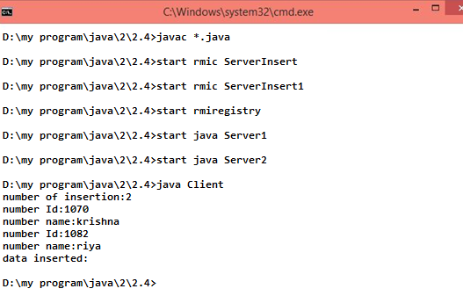

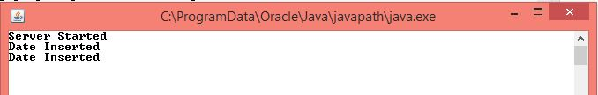

server