**DialogFlow (API.AI)**

Dialogflow comes in 2 editions

Standard Edition is free and while Enterprise Edition offers paid enterprise support.

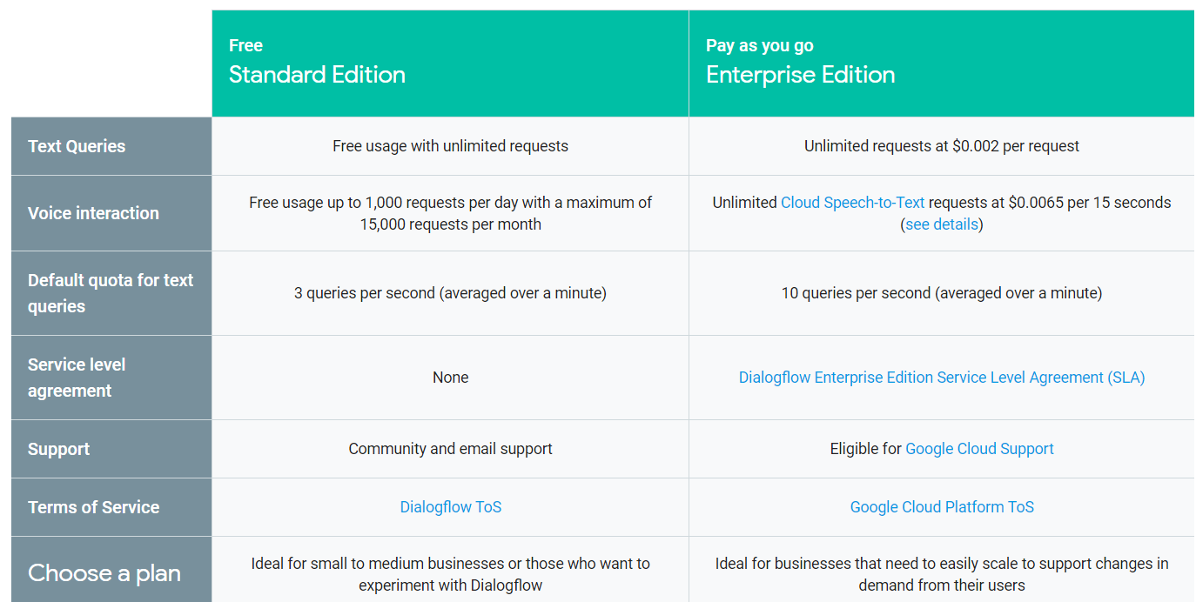

Also provides built in Templates that we can import our [customizable Prebuilt Agents](https://dialogflow.com/docs/prebuilt-agents) that cover a variety of verticals (ie travel, food, retail, entertainment) and use cases.

This is mostly an NLP engine. It does a good job of that. It does not have a visual designer.

Pros:

* NLP is great
* Lots of pre-built domains (super easy to activate)
* Easy to build simple, non-linear bots quickly
* API is good.
* Integration with FB, Twilio and other platforms is easy.

Cons:

* Lack of a visual representation of the bot’s flow makes building complex bots hard. They force you think think in terms of their own model - intents, entities etc. Not intuitive if you have a mix of linear and non-linear flows.
* Poor documentation
* Email and chat support is ok, especially if you upgrade the plan.
* If you want to integrate with FB, you must do some legwork (create fb app, get approval etc.) but not hard. There is no one click deployment to FB.
* Complicated and annoying to construct loops, subroutines, branches

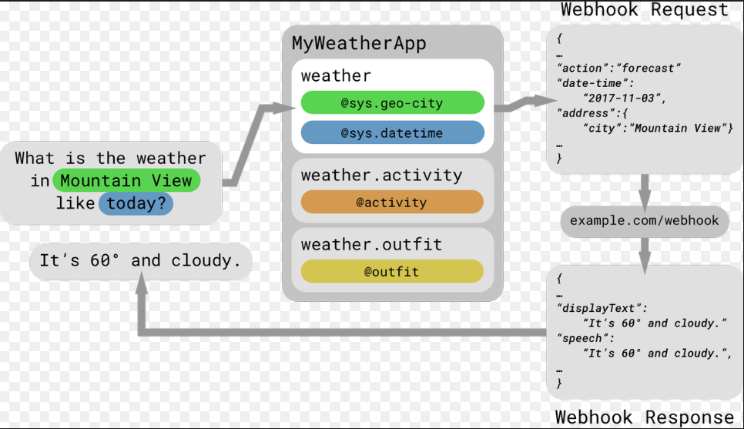

**Microsoft Azure Bot Service**

Microsoft Bot Framework is a SDK allowing you as a developer to create conversational chatbots with ease. Using the bot framework, you can create your own bots with SDK’s available in C#, Node.JS and using REST requests.

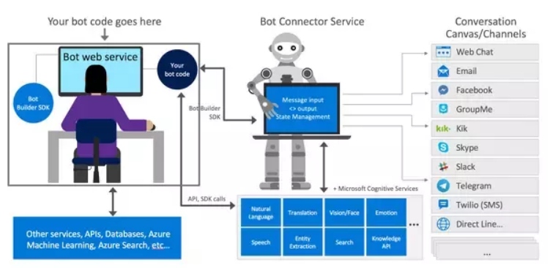

* Each series of conversations is called a Dialog, like a conversation between the bot and the user.
* The user may say “I want to book a flight to Delhi” and the bot responds back with some conversation like: “May I know from where you want to board the flight, what day would you like to travel?”
* The user input is called the Utterance, the user may give his/her utterance via any of the channels (Skype, Facebook Messenger, Telegram, Web Chat)
* Now after taking the input of the user, we must parse the utterance for finding out what the user means by what he says. So, we make use of a Machine Learning Web Service called the LUIS (Language Understanding Intelligent Service).

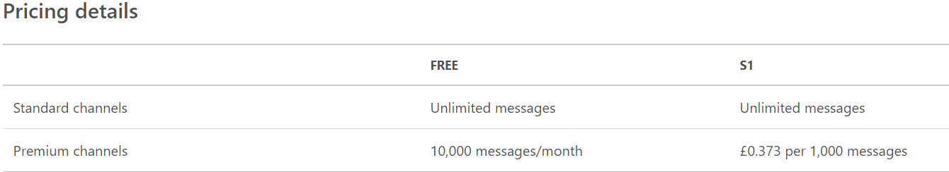

To make sure your agent matches user input as often as possible, it’s important to provide your agent with enough data. The greater the number of natural language examples in the **Training Phrases** section of [**Intents**](https://dialogflow.com/docs/intents), the better the classification accuracy