Homework 2

CS498daf, Spring 2016

Varun Somani, David Young and Cybelle Smith

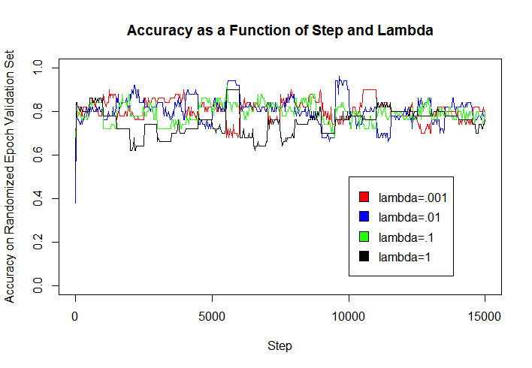

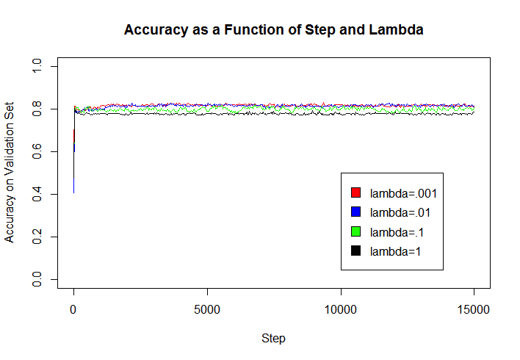

Figure 1: accuracy of the model on the randomly selected epoch validation set (top), as well as the overall validation set (bottom) as a function of increasing step number and the regularization constant lambda.

a. The regularization constant does not affect model accuracy (particularly on the test set) much considering the scale at which it varies (factor of 1000). High lambda values (.1 and 1), however, led to loss of accuracy on the validation set, because they allowed for more examples to be misclassified or fall within the margin. Apparently, small lambda values can improve accuracy on the training examples but decrease the model’s ability to generalize to new data.

b. Our estimate of the accuracy of the best classifier on the held out (test) data is .814, the mean of 5 different runs on our algorithm.