**Practical 5**

**5.15 Aim:- Java Action Tags**Write individual programs to demonstrate the use of following action tags.   
    <jsp:forward>, <jsp:include>, <jsp:usebean>

**usebean.java**

**public class usebean {**

**private String message = "No message specified";**

**public String getMessage() {**

**return(message); }**

**public void setMessage(String message) {**

**this.message = message; } }**

**usebean1.jsp**

**<head>**

**<title>Using JavaBeans in JSP</title>**

**</head>**

**<body><center><h2>Using JavaBeans in JSP</h2>**

**<jsp:useBean id="test" class="action.usebean" />**

**<jsp:setProperty name="test"**

**property="message"**

**value="Hello JSP..." />**

**<p>Got message....</p>**

**<jsp:getProperty name="test" property="message" />**

**</center></body></html>**

**output:**

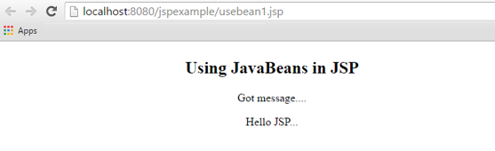

**forward1.jsp**

**<%@page contentType="text/html" pageEncoding="UTF-8"%>**

**<!DOCTYPE html>**

**<html>**

**<head>**

**<meta http-equiv="Content-Type" content="text/html; charset=UTF-8"><title>JSP Page</title></head>**

**<body><p>**

**Today's date: <%= (new java.util.Date()).toString()%></p>**

**</body></html>**

**forward2.jsp**

**<html>**

**<head><title>The include Action Example</title></head>**

**<body><h2>The include action Example</h2>**

**<jsp:forward page="date.jsp" /></body></html>**

**output**

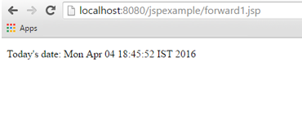

**include1.jsp**

**<html>**

**<head><title>The include Action Example</title></head>**

**<body><h2>The include action Example</h2>**

**<jsp:forward page="date.jsp" /></body></html>**

**include2.jsp**

**<html>**

**<head><title>The include Action Example</title></head>**

**<body><h2>The include action Example</h2>**

**<jsp:include page="date.jsp" flush="true" /></body></html>**

**Output:**

