**Practical: 3.6**

**Aim:** Consider Bank Table with attributes AccountNo, Customer Name, Balance, Phone and Address. Write a JDBC Program which allows insertion, updation and deletion of record in Bank Table. Print values of all customers whose balance is greater then specified amount.

**Program code:**

//STEP 1. Import required packages

**import** java**.**sql**.*;**

**import** java**.**util**.*;**

public class bankinfo **{**

// JDBC driver name and database URL

static final String JDBC_DRIVER **=** "org.postgresql.Driver"**;**

static final String DB_URL **=** "jdbc:postgresql://127.0.0.1:5432/s2c130050131090"**;**

// Database credentials

static final String USER **=** "postgres"**;**

static final String PASS **=** "12345"**;**

public static void main**(**String**[]** args**)** **{**

Connection con **=** **null;**

PreparedStatement stmt **=** **null;**

Statement stmt1 **=** **null;**

Double ph**,**acno**;**

String name**,**add**;**

Double bal**;**

int i**=**0**;**

**try{**

//STEP 2: Register JDBC driver

Class**.**forName**(**JDBC_DRIVER**);**

//STEP 3: Open a connnection

System**.**out**.**println**(**" \n Connecting to a s2C130050131090 database"**);**

con **=** DriverManager**.**getConnection**(**DB_URL**,** USER**,** PASS**);**

System**.**out**.**println**(**"Connected database successfully"**);**

Scanner sc**=new** Scanner**(**System**.**in**);**

**while(**i**!=**1**){**

System**.**out**.**println**(**"\n Enter the operation to be performed:\n \t1.Insert \n \t 2.Update \n \t 3.Delete\n \t4. display values of all customers whose balance is greater then \n \t5.Exit"**);**

int ch**=**sc**.**nextInt**();**

**switch(**ch**){**

**case** 1**:**

stmt**=**con**.**prepareStatement**(**"insert into Bank values(?,?,?,?,?)"**);**

System**.**out**.**print**(**"Enter Account No:"**);**

acno**=**sc**.**nextDouble**();**

System**.**out**.**print**(**"Enter Customer Name:"**);**

name**=**sc**.**next**();**

System**.**out**.**print**(**"Enter balance:"**);**

bal**=**sc**.**nextDouble**();**

System**.**out**.**print**(**"Enter Phone No:"**);**

ph**=**sc**.**nextDouble**();**

System**.**out**.**print**(**"Enter Address:"**);**

add**=**sc**.**next**();**

stmt**.**setDouble**(**1**,**acno**);**

stmt**.**setString**(**2**,**name**);**

stmt**.**setDouble**(**3**,**bal**);**

stmt**.**setDouble**(**4**,**ph**);**

stmt**.**setString**(**5**,**add**);**

stmt**.**executeUpdate**();**

System**.**out**.**println**(**"Data inserted successfully."**);**

**break;**

**case** 2**:**

stmt**=**con**.**prepareStatement**(**"update Bank set balance=? where acc_no= ?"**);**

System**.**out**.**print**(**"Enter Account No:"**);**

acno**=**sc**.**nextDouble**();**

System**.**out**.**print**(**"Enter balance:"**);**

bal**=**sc**.**nextDouble**();**

stmt**.**setDouble**(**2**,**acno**);**

stmt**.**setDouble**(**1**,**bal**);**

stmt**.**executeUpdate**();**

System**.**out**.**print**(**"Data Updated successfully"**);**

**break;**

**case** 3**:**

stmt**=**con**.**prepareStatement**(**"delete from Bank where acc_no=?"**);**

System**.**out**.**print**(**"Enter Account No:"**);**

acno**=**sc**.**nextDouble**();**

stmt**.**setDouble**(**1**,**acno**);**

stmt**.**executeUpdate**();**

System**.**out**.**println**(**"Data Deleted successfully"**);**

**break;**

**case** 4**:**

System**.**out**.**println**(**"enter amount "**);**

int Amount **=** sc**.**nextInt**();**

stmt1 **=** con**.**createStatement**();**

String sql **=** "select * from bank where balance > "**+**Amount**+**""**;**

stmt1**.**executeQuery**(**sql**);**

ResultSet rs **=** stmt1**.**executeQuery**(**sql**);**

**while(**rs**.**next**())**

**{**

acno**=**rs**.**getDouble**(**"acc_no"**);**

name**=**rs**.**getString**(**"name"**);**

bal**=**rs**.**getDouble**(**"balance"**);**

ph**=**rs**.**getDouble**(**"ph_no"**);**

System**.**out**.**println**(**"Account number:"**+**acno**);**

System**.**out**.**println**(**"Account Name:"**+**name **);**

System**.**out**.**println**(**"Account Balance:"**+**bal**);**

System**.**out**.**println**(**"Contact Number:"**+**ph**);**

System**.**out**.**println**();**

**}**

**break;**

**case** 5**:**

i**=**1**;**

**break;**

**default:**

System**.**out**.**println**(**"Invalid choice"**);**

**break;**

**}**

**}**

**}catch(**SQLException se**){**

//Handle errors for JDBC

se**.**printStackTrace**();**

**}catch(**Exception e**){**

//Handle errors for Class.forName

e**.**printStackTrace**();**

**}** **finally{**

//finally block used to close resources

**try{**

**if(**stmt**!=null)**

con**.**close**();**

**}catch(**SQLException se**){**

**}**// do nothing

**try{**

**if(**con**!=null)**

con**.**close**();**

**}catch(**SQLException se**){**

se**.**printStackTrace**();**

**}**//end finally try

**}**//end try

System**.**out**.**println**(**"program complited"**);**

**}**//end main

**}**//end

**Input Output:** INSERT

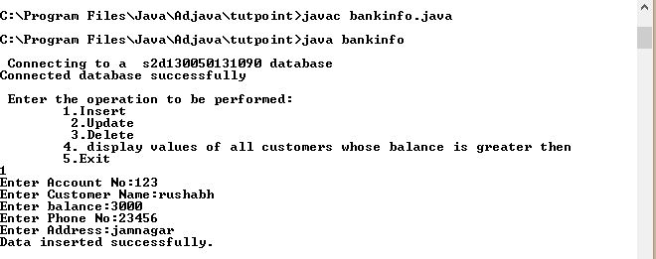

**Update:**

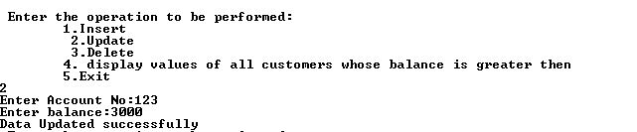

**Display:**

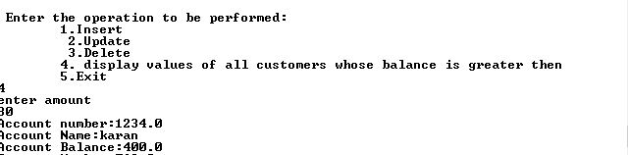

**Delete:**

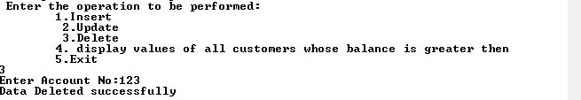

Exit:

