B10415040(杜佳謙)：加密

B10415039(曾柏誠)：解密

Python

IDE：VS code

Caesar(key：int , text：string[a-zA-Z]+)

Ex：key = 7,text = nevergiveup

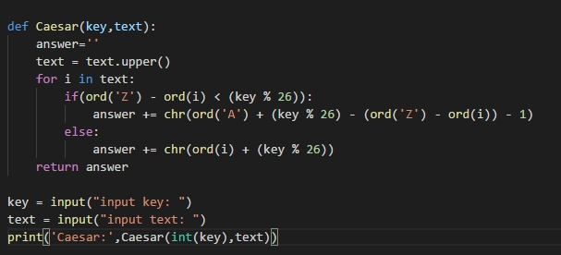

Monoalphabetic(key1：string[a-zA-Z]+ , key2：string[a-zA-Z]+ , text：string[a-zA-Z]+)

Ex：key1 = abcd…,key2 = MNBV…,text = nevergiveup

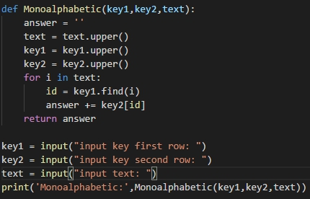

Playfair(key：string[a-zA-Z]+ , text：string[a-zA-Z]+)

Ex：key=ALT,text = nevergiveup

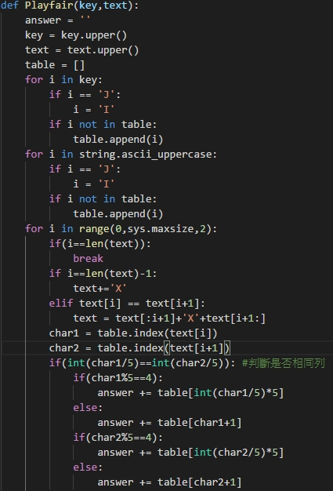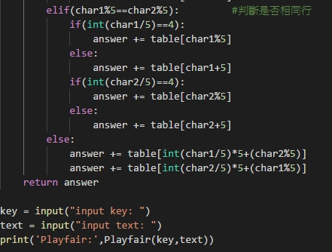

Vernam(key：string[a-zA-Z]+ , text：string[a-zA-Z]+)

Ex：key=ALT,text = nevergiveup

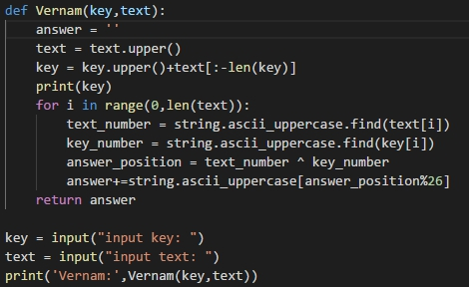

Row_transposition(key：string[a-zA-Z]+ , text：string[a-zA-Z]+)

Ex：key=123456,text = nevergiveup

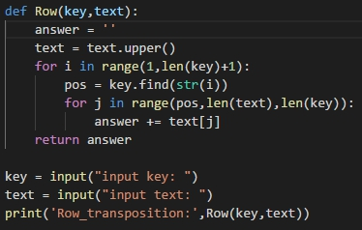

Product(key：int , transport： int , text：string[a-zA-Z]+)

Ex：key1=1 2 3 4 5 6 7…,key2=4 5 6 7 8 9…,text = nevergiveup

