Lab2

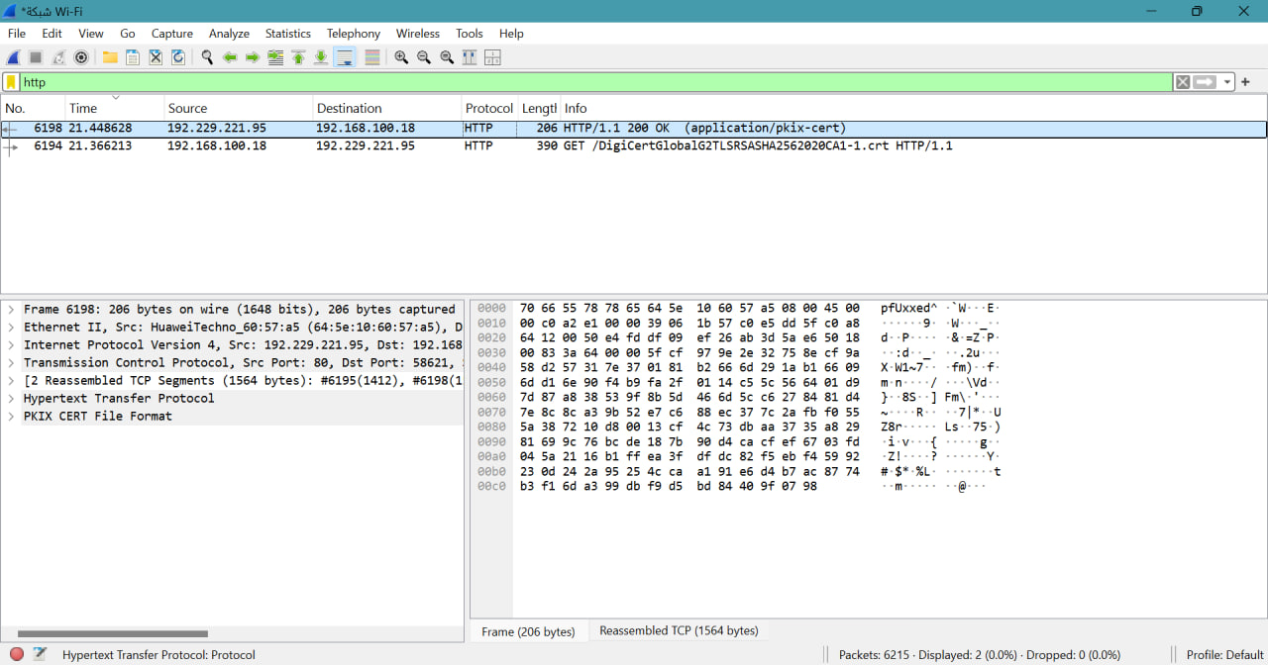

• Source IP: 192.168.100.18 (appears multiple times)
• Destination IP: 152.199.19.161, 216.58.198.67, 192.168.100.18 (varies per request)
• Protocol: HTTP
• Request Type: GET
• Response Code: 200 OK

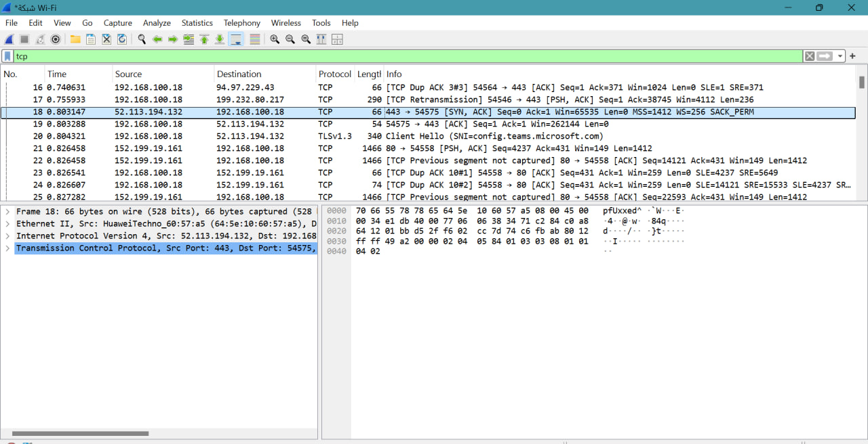

The image shows a Wireshark capture, and the selected packet (No. 19) contains a TCP segment with the SYN-ACK flags. This indicates that the packet is part of the TCP three-way handshake process.
• Flags: SYN, ACK
• SYN: Synchronize sequence numbers (request to establish a connection).
• ACK: Acknowledgment of a SYN received from the client.
This means that the server is responding to the initial connection request (SYN) from the client with a SYN-ACK packet, completing the second step of the three-way handshake.

UDP

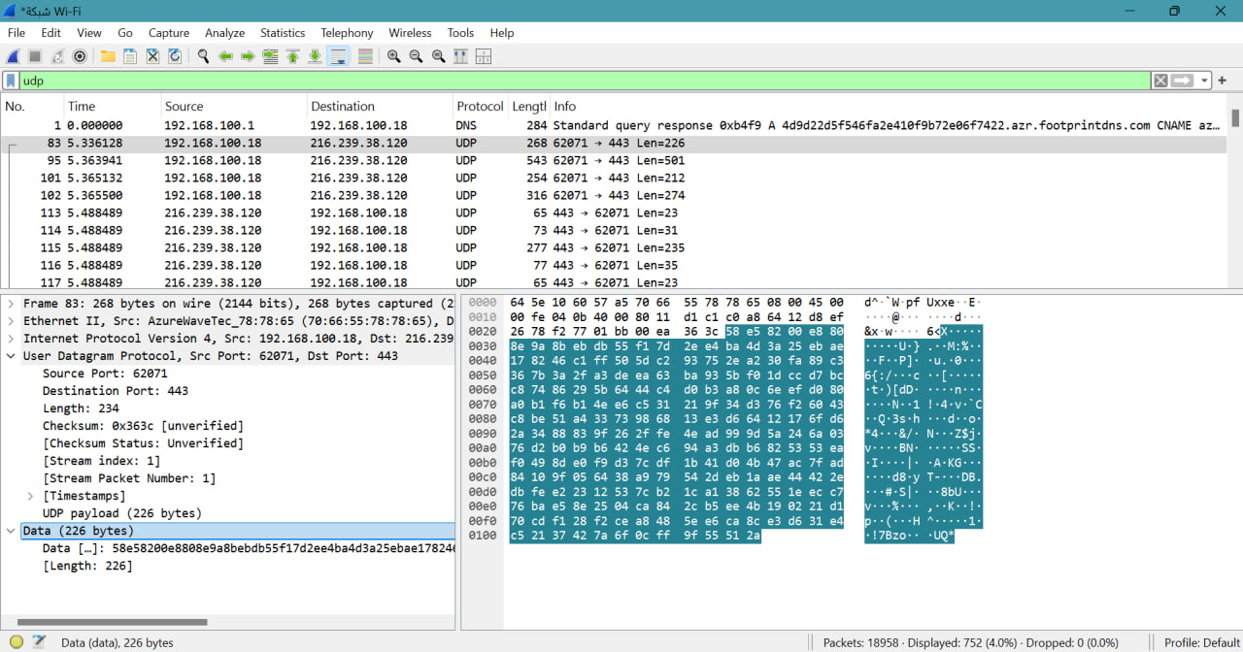
• Protocol: UDP (User Datagram Protocol)
• Length: 268 bytes (total packet size)
• UDP Payload: 226 bytes (the actual data being transmitted)

Task 1 :
Reasons | TCP or UDP
is a connection-oriented protocol, meaning that before any data is transferred, a three-way handshake (SYN, SYN-ACK, ACK) is used to establish a connection. By doing this, it is ensured that the sender and the recipient are prepared to share data. Furthermore, TCP ensures dependability by retransmitting missing packets, acknowledging (ACK) received packets, error-checking, and controlling flow to guarantee that data arrives intact, in the right order, and without duplication. | TCP | Reliability and Connection Establishment
TCP ensures data integrity by implementing error-checking, flow control, and sequencing, making sure that data packets are received in the correct order. | TCP | Data Integrity and Ordering
Task 2:
UDP | TCP
When streaming media (video or audio), a little packet loss is tolerable; faster delivery is more crucial than flawless dependability.  - Online gaming: Even with minimal packet loss, low latency is essential.  VoIP, or voice over IP, is a real-time communication method in which packet loss is worse than latency. DNS queries are quick, connectionless transactions; if retransmission is required, it is handled by the application layer. | -Web browsing (HTTP/HTTPS): For web pages to load properly, dependable delivery is required.  - File Transfers (SFTP, FTP): Guarantees a successful file transfer.  - Email (SMTP, IMAP, POP3): Complete and dependable data delivery is necessary.  - Remote Access (SSH, Telnet): Ensuring the orderly and comprehensive flow of data is crucial. | Use cases
- Faster since there is less overhead: UDP performs better and has reduced latency in time-sensitive applications because it doesn't require a connection, packet acknowledgment, or error correction.  - Lightweight: Requires less resources because it does not require data integrity checks or connection management. | - Slower because of connection setup and dependability mechanisms: In high-latency contexts, it is slower because of increased overhead from packet acknowledgment, error recovery, and handshaking.  - High resource consumption: To monitor connections and guarantee accurate information, more CPU and memory resources are needed. | Performance

