TASKFLOW
Project Output Screenshots
Visual evidence of all implemented features
Screenshot 1 Swagger API Documentation

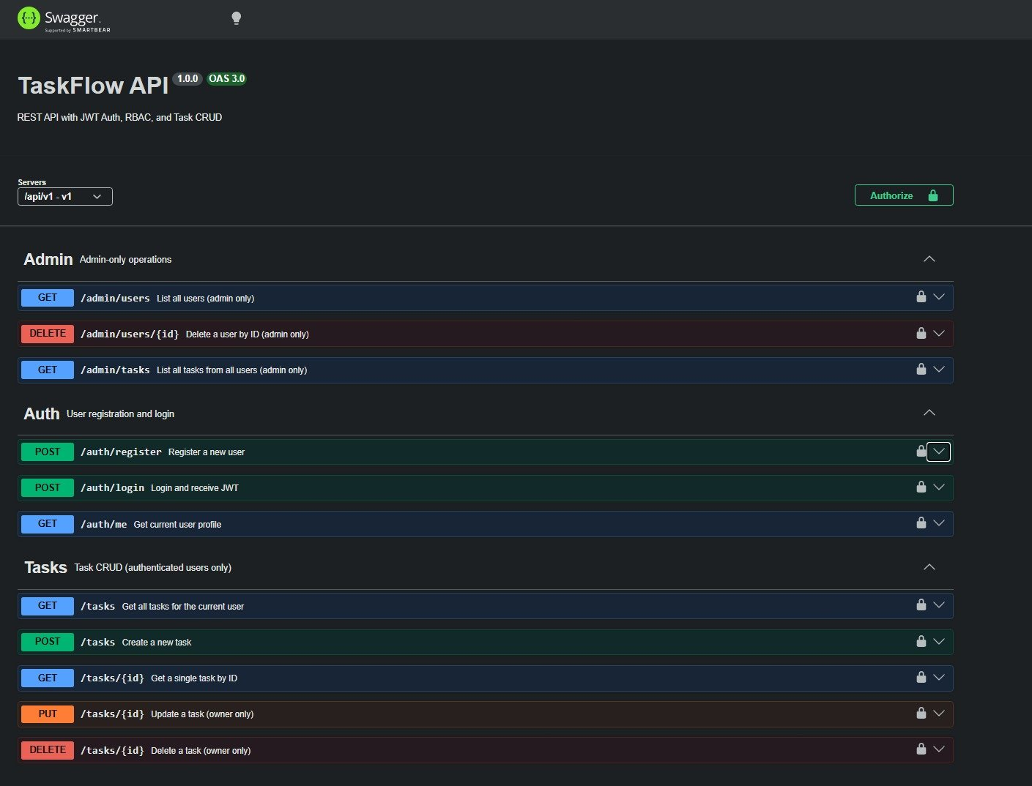
Figure 1: Swagger UI at /api/v1/docs showing all 11 API endpoints across Admin, Auth, and Tasks groups

Screenshot 2 Login Page (Frontend UI)
React frontend authentication interface

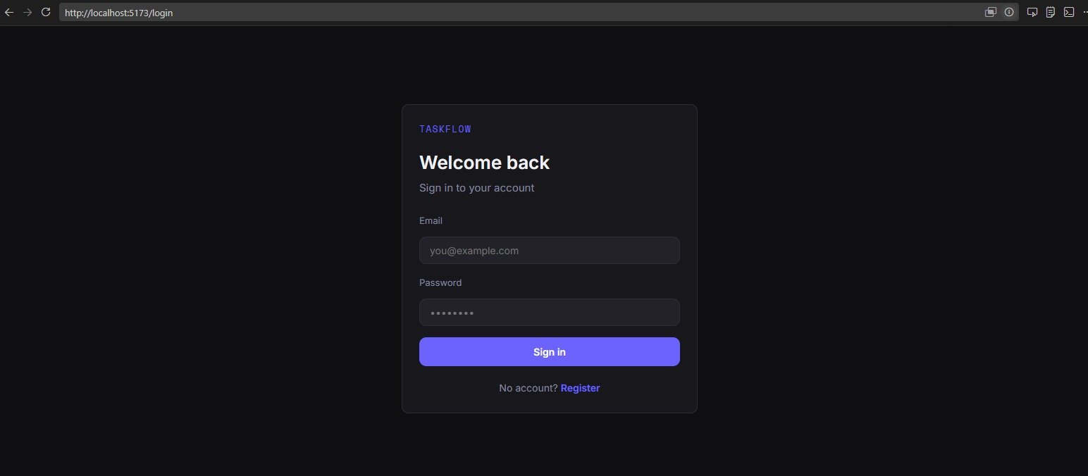
Figure 2: Login page at localhost:5173/login React frontend with JWT-based authentication
Screenshot 3 Dashboard with Task CRUD
What this shows: Protected dashboard with full CRUD functionality

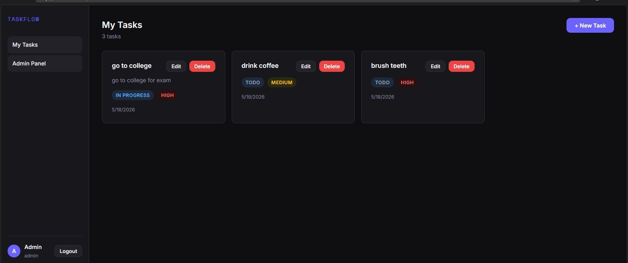
Figure 3: Dashboard at /dashboard task cards with status/priority badges, sidebar with admin navigation

Screenshot 4 Swagger Login API Response (200 OK)
What this shows: Live API response proving authentication works end-to-end
This is the Swagger UI response after executing POST /api/v1/auth/login with valid credentials. This screenshot is significant for several reasons:
- Code 200 confirms the endpoint is live, correctly routing, and responding the full backend stack (Express → Service → Sequelize → PostgreSQL) is operational

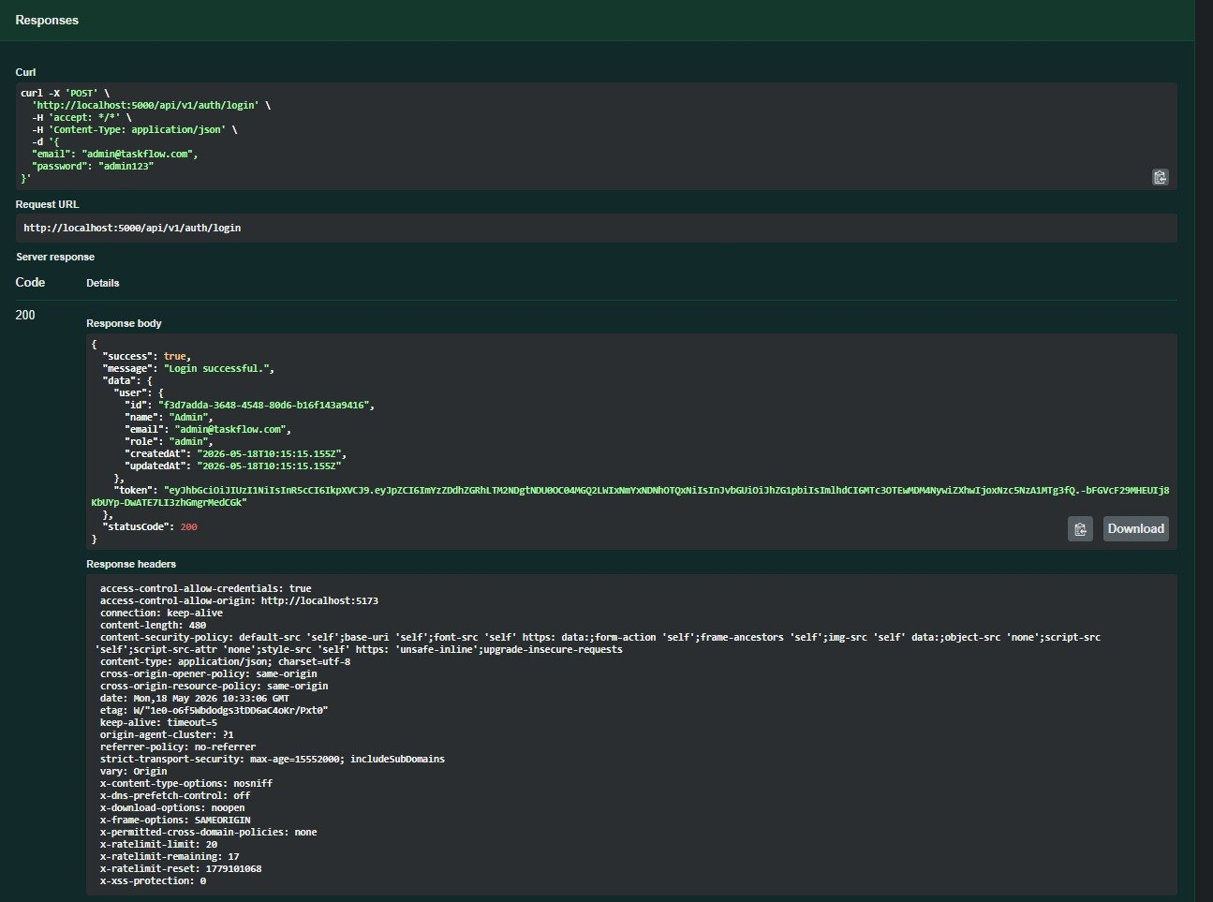
Figure 4: Swagger POST /auth/login response 200 OK with JWT token and Helmet security headers visible

Screenshot 5 Admin Panel (Role-Based Access Control)
What this shows: Admin-only view proving RBAC is fully implemented
This is the Admin Panel at /admin, accessible only to users with role: admin. A regular user attempting to visit this route is redirected to /dashboard by the ProtectedRoute component (adminOnly prop). The panel demonstrates:
- All registered users listed in a table in this case two users: arjun kumar (role: USER) and Admin (role: ADMIN)

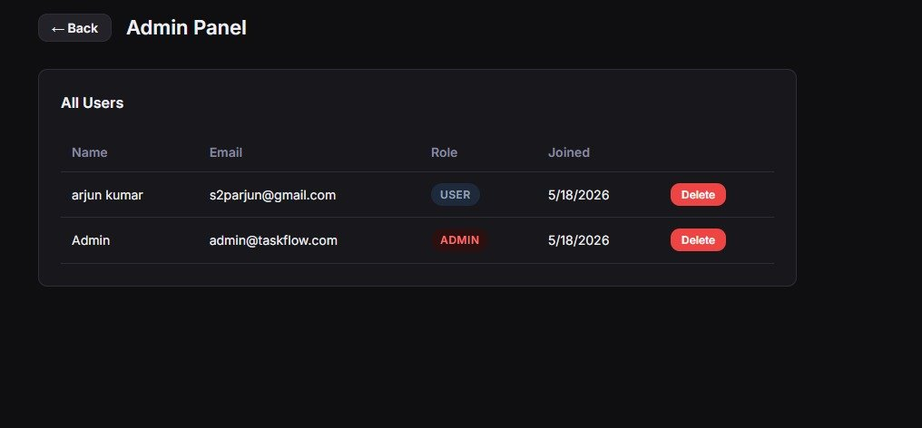
Figure 5: Admin Panel at /admin : user management table with role badges, accessible only to admin-role accounts

