**Amrita School of Engineering, Amritapuri Campus,**

**Amrita Vishwa Vidyapeetham**

**Amrita Centre for Wireless Networks & Applications**

**15CSE379: Connected Internet of Things Devices (3-0-0-3)   
Elective, S5 B.Tech CSE**

**Tutorial No: 1**

Smart Ecosystem

Aim: Implement an IoT system for weather monitoring using Waspmote.

Description:

A tea plantation company in Assam is setting up a new weather monitoring station in their plantation area. In that station, they are setting up an IoT system using several sensors like rain gauges, wind sensor, temperature sensors, etc. You are asked to implement a part of this system using rain gauge sensor including the functionalities such as data collection, processing, storage, communication and visualization.

Please implement the below steps to achieve this.

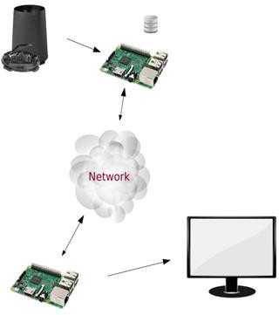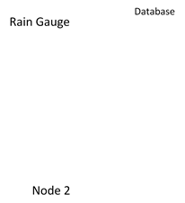

Steps:

1. State the design methodology that you adopted for this application.
2. Collect the data from the given rain gauge sensor at a suitable sampling frequency using waspmote node 1.
3. Process and store the data in the SD card within Node 1.
4. Client Node 2 should request Node1 for the processed data.
5. Node 2 receiving the data packets from Node1.
6. Upon successful reception of this data, Node 2 to send acknowledgment to Node1.
7. Visualize the processed rain gauge data on your monitor using any high level programming language.
8. Also, pass the data onto the central node for centralized processing.

**Solution:**

Hardware connection

Node 1

* Connect the Rainguage to Node 1
  + Connect the sensor out of rain gauge to PIN no 14 of sensor I/O of waspmote.( i.e ANALOG1 Pin)
  + Connect Vcc of raingauge to PIN no 31 of sensor I/O of waspmote.
  + Connect GND of raingauge to PIN no 27 of sensor I/O of waspmote.
* Connect LoRa module to socket 0 and wifi module to socket 1 of waspmote

Node 2

* Connect waspmote to a PC/Laptop using UART cable
* Connect LoRa module to socket 0 and wifi module to socket 1 of waspmote

Software

Algorithm for node 1

Void setup()

{

Initialize lora ;

Initialize WiFi ;

Create file to log data ;

}

Void loop()

{

dataAcquisition() ;

if (rcvPkt == SUCCESS)

{

If( pktType == REQ)

{

sendData() ;

}

}

}

Void dataAcquisition()

{

Val = read data from ANALOG1;

Rain = convertToRain(Val) ;

Write timestamp and rain to file1 in SD card

}

Void sendData()

{

Fp = isData(File1) ;

While ( Fp == TRUE)

{

Read data from file ;

Make packet ;

Send packet using Lora ;

Send packet using WiFi ;

}

}

Algorithm for Node 2

Void setup()

{

}

Void loop()

{

Send REQ for node 1

If(rcvPkt == Data)

{

Read data from packet ;

Send ACK to node 1 using Lora;

Write the data to serial port ;

Send data to network using WiFi

}

}