**Amrita School of Engineering, Amritapuri Campus,**

**Amrita Vishwa Vidyapeetham**

**Amrita Centre for Wireless Networks & Applications**

**15CSE379: Connected Internet of Things Devices (3-0-0-3)   
Elective, S5 B.Tech CSE**

**Tutorial No: 1**

Smart Ecosystem

Aim: Implement an IoT system for weather monitoring using Waspmote.

Description:

A tea plantation company in Assam is setting up a new weather monitoring station in their plantation area. In that station, they are setting up an IoT system using several sensors like rain gauges, wind sensor, temperature sensors, etc. You are asked to implement a part of this system using rain gauge sensor including the functionalities such as data collection, processing, storage, communication and visualization.

Please implement the below steps to achieve this.

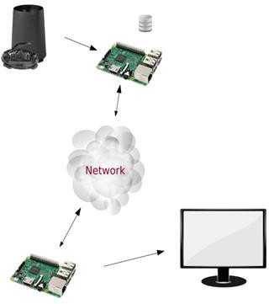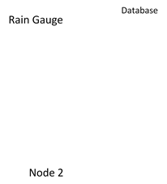

Steps:

1. State the design methodology that you adopted for this application.
2. Collect the data from the given rain gauge sensor at a suitable sampling frequency using waspmote node 1.
3. Process and store the data in the SD card within Node 1.
4. Client Node 2 should request Node1 for the processed data.
5. Node 2 receiving the data packets from Node1.
6. Upon successful reception of this data, Node 2 to send acknowledgment to Node1.
7. Visualize the processed rain gauge data on your monitor using any high level programming language.
8. Also, pass the data onto the central node for centralized processing.