**Amrita School of Engineering, Amritapuri Campus,**

**Amrita Vishwa Vidyapeetham**

**Amrita Centre for Wireless Networks & Applications**

**15CSE379: Connected Internet of Things Devices (3-0-0-3)   
Elective, S5 B.Tech CSE**

**Tutorial No: 1**

Smart Ecosystem

Aim: Implement an IoT system for weather monitoring using Waspmote.

Description:

A tea plantation company in Assam is setting up a new weather monitoring station in their plantation area. In that station, they are setting up an IoT system using several sensors like rain gauges, wind sensor, temperature sensors, etc. You are asked to implement a part of this system using rain gauge sensor including the functionalities such as data collection, processing, storage, communication and visualization.

Please implement the below steps to achieve this.

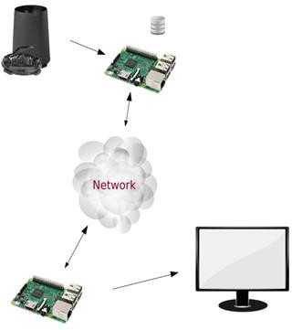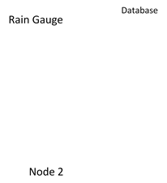

Steps:

1. State the design methodology that you adopted for this application.
2. Collect the data from the given rain gauge sensor using waspmote node 1. The sampling interval is given as Train.
3. Collect the data from the given wind sensor using waspmote node 1. The sampling interval is given as Twind.
4. Process and store the data in the SD card within Node 1.
5. Define threshold values for both the sensors
6. If the sensor data is greater than respective thresholds, send the data to Node2.
7. Send the collected data after every Tmax interval regardless of the threshold.
8. Please note that Train> Twind> Tmax
9. Upon successful reception of this data, Node 2 to send acknowledgment to Node1.
10. Visualize the data on your monitor using any high level programming language.
11. Also, pass the data onto the central node for centralized processing.