Read My Novel - An Online Reading and Writing Platform

- Project description
The most important thing for any writers is not how much money their book makes, but how many people have read it and truly enjoyed their work. If you are trying to write a novel and would like some unofficial "beta" readers or if you have published a short story, it is not a bad idea to post your work on a website that has a devoted readership. Reading and writing communities can be a great way to get feedback on your writing. They often have various criteria to evaluate each writing in order to find the most popular one, which are then publicized. For example, some of the large sites such as Wattpad and Authonomy have cooperative links with social media, publishers, or in the case of WEbook, there is a service that helps writers contact directly to agents. Each community offers different things, however, they all have in common is to provide an online platform for writer’s works to get closer to the public, make them available to thousands, if not millions, of readers.
This project aims at developing an online reading and writing platform, called Read My Novel. Through this website, authors can write books by posting chapters and choose to publish their writing to public community. Each user can read some book for free or buy each chapter of a book to read if he/she is interested. Moreover, users can write book reviews, comment on chapters or vote for their favorite books.

- Member assignment
- Lê Minh Hải Phong:
- Lê Hổng Minh:
- Nguyễn Bình Long:
- Usecase diagram
  - General usecase diagram
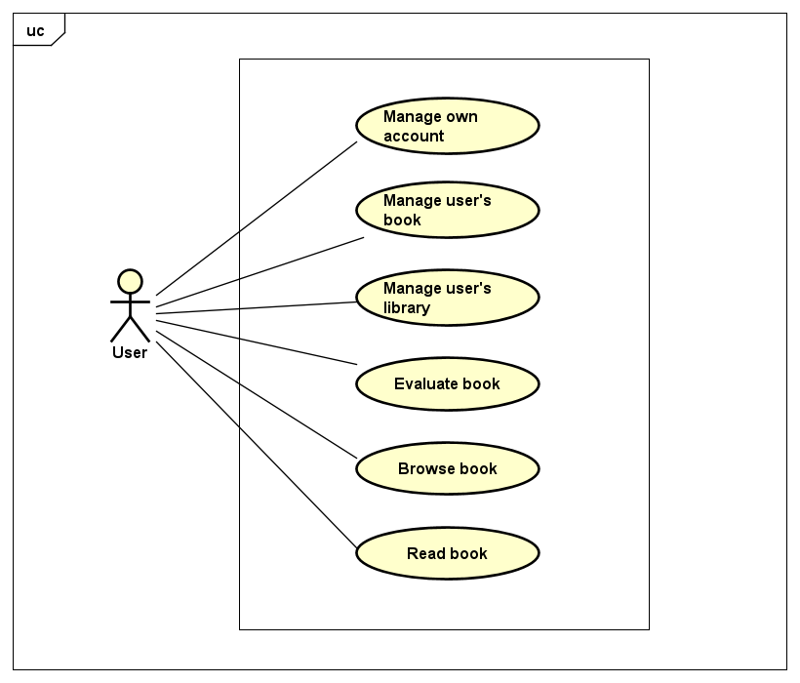
Figure 1: General usecase
  - Manage own account
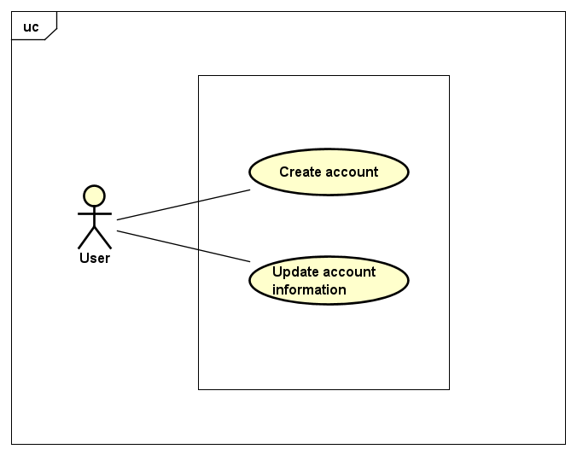
Figure 2: Manage own account usecase
  - Manage user’s book
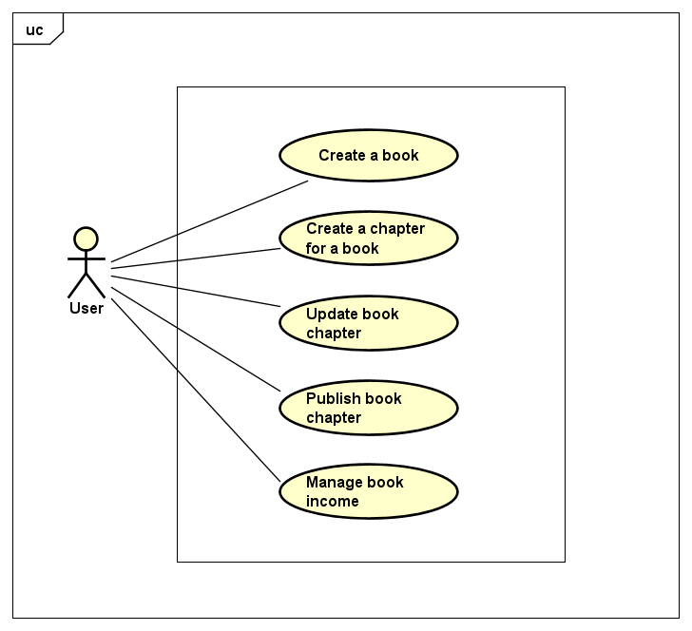
Figure 3: Manage user's book usecase
  - Manage user’s library
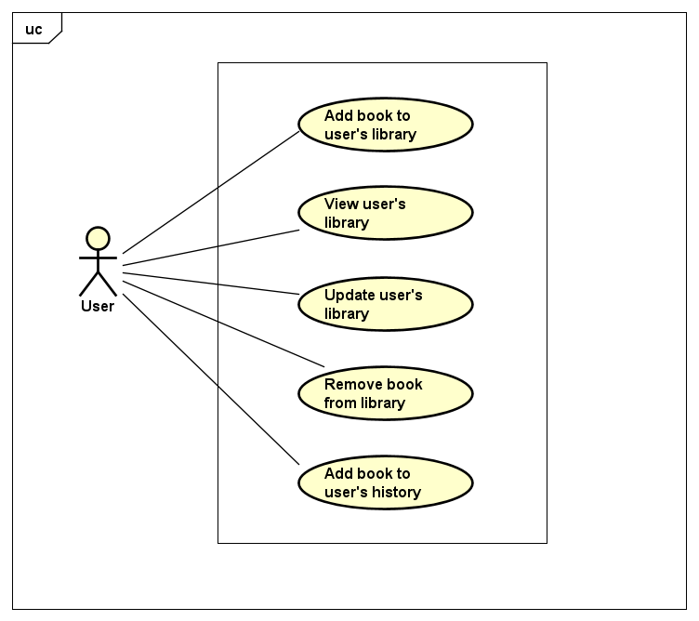
Figure 4: Manage user's library usecase
  - Read book
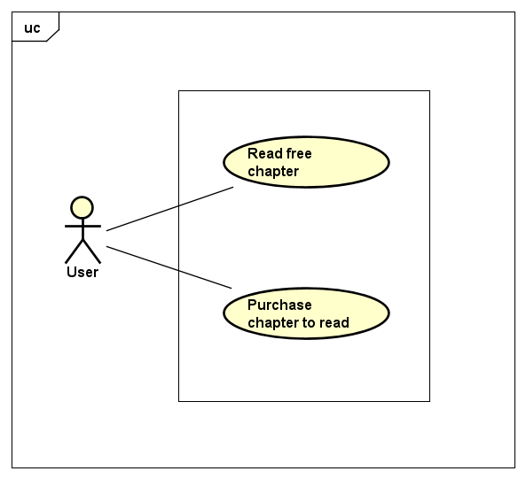
Figure 5: Read book usecase
  - Browse book
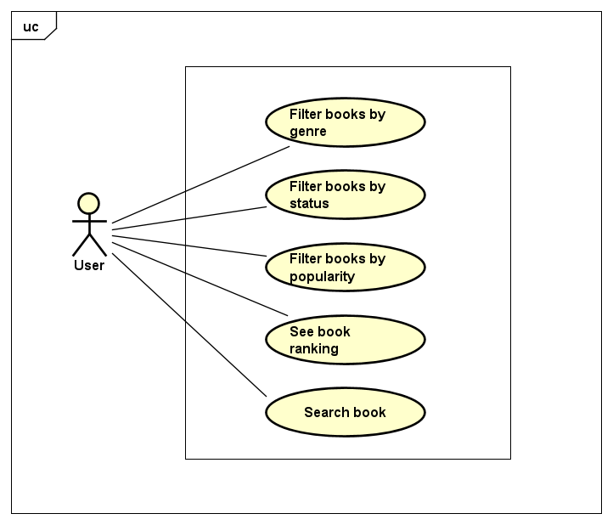
Figure 6: Browse book usecase

  - Evaluate book
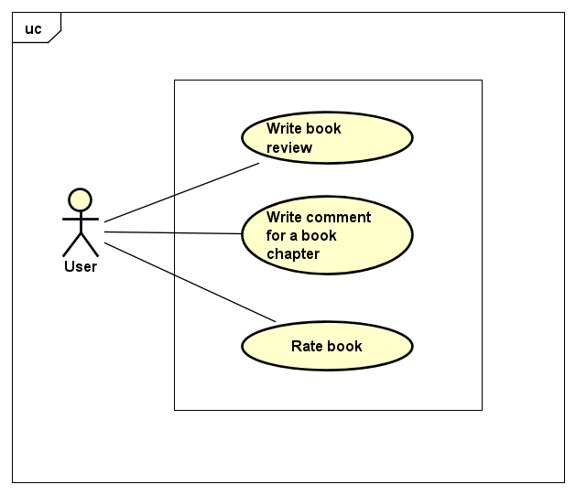
Figure 7: Evaluate book usecase

- UI design
- The website is responsive, which can run on desktop screen (screens equal to or greater than 1200px wide) and display well on mobile screens (screens less than 768px wide)
- The UI of homepage with header, footer is as follows:
….
- The design of UI is based on https://www.webnovel.com/

- Database design
- Relational Schema:
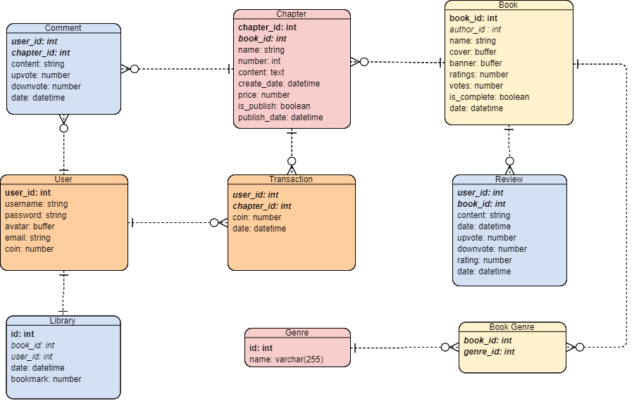
Figure 8: Database Relational Schema
- Database management system used: MongoDB, which is an open-source, document database designed for ease of development and scaling. Mongoose is a client API for node.js which makes it easy to access our database from our Express application.
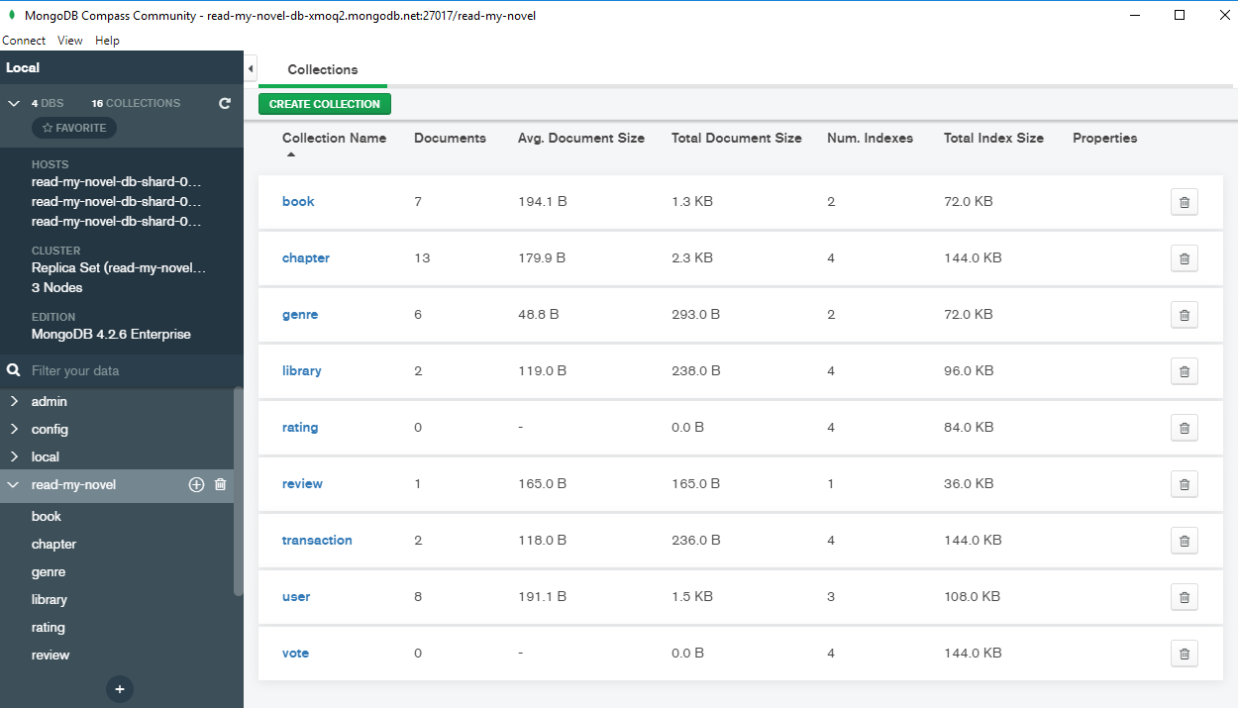
- Technology stacks
  - React
- React is a JavaScript library that aims to simplify development of visual interfaces. Developed by Facebook and released to the world in 2013, it drives some of the most widely used code in the world, powering Facebook and Instagram among many, many other software companies. Its primary goal is to make it easy to reason about an interface and its state in any point in time, by dividing the UI into a collection of components. React is used to build single-page web applications, among with many other libraries and frameworks that were available before React came into life.
- React is really popular nowadays and has taken the frontend web development world by storm. Firstly, React is less complex than other alternatives. At the time when React was announced, Ember.js and Angular 1.x were the predominant choices as a framework. Both these imposed too many conventions on the code that porting an existing app was not convenient at all. React made a choice to be very easy to integrate into an existing project, because that’s how they had to do it at Facebook in order to introduce it to the existing codebase. Also, those 2 frameworks brought too much to the table, while React only chose to implement the View layer instead of the full MVC stack. React encourages the creation of reusable UI components, which present data that changes over time. React abstracts away the DOM from you, offering a simpler programming model and better performance. React can also render on the server using Node, and it can power native apps using React Native. React implements one-way reactive data flow, which reduces the boilerplate and is easier to reason about than traditional data binding

- Popularity of React:
According to the 2019 Stack Overflow Report, JS is used by 67.8% of developers with “Big Three” of JS frameworks in 2019: React, Angular and Vue.
- GitHub Stars
The JavaScript Rising Stars report, which tracks the number of stars added on GitHub, listed Vue, React and Angular as the most popular JS frameworks in 2018, outpacing the other frameworks by a lot:
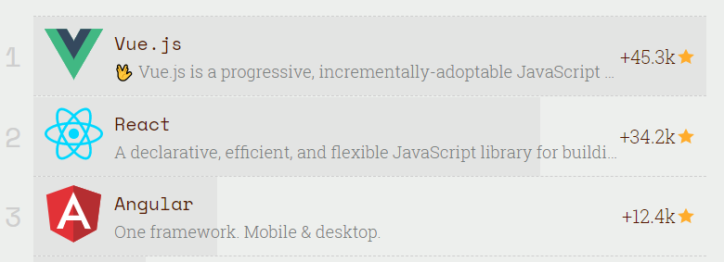
- Program Downloads
Unlike GitHub stars, the number of downloads show React in the lead in terms of sheer bulk of use. These downloads are a good indicator of what developers are actually using, instead of hot trends. The most surprising part of this data? Vue comes in last, after React and Angular:
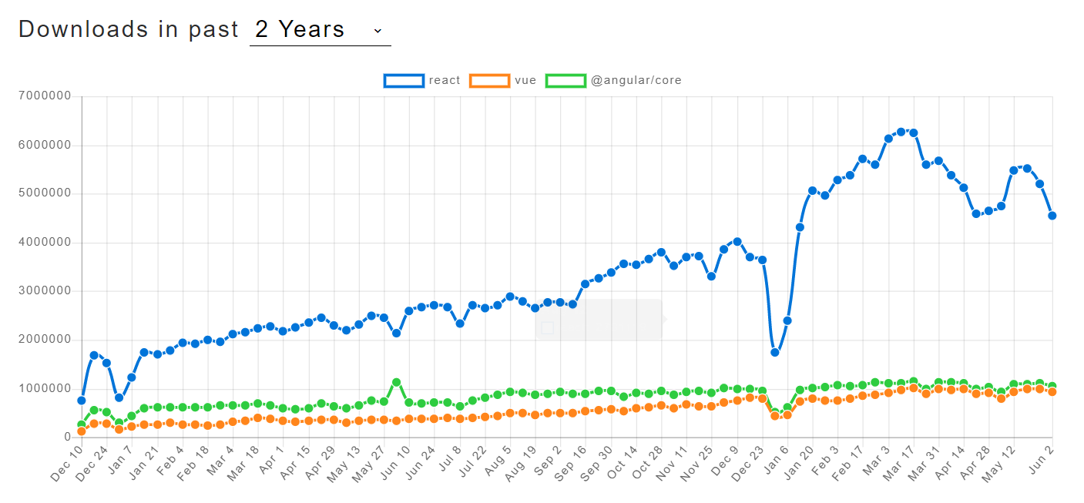
- Most Loved and Wanted Frameworks
The 2019 Stack Overflow Developer Survey also measured what frameworks developers love versus which are most wanted. Like GitHub stars, this shows how developers feel about these frameworks. The results aren’t too surprising:
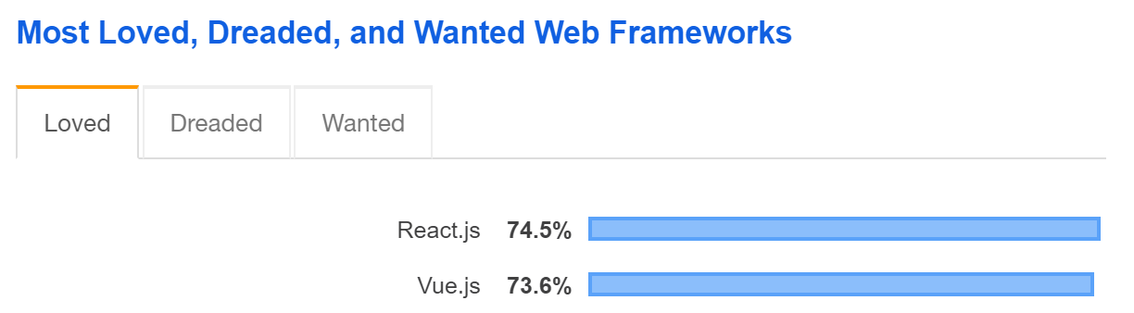
React and Vue were head-to-head in the most loved category, while all three appeared in the top most wanted frameworks, with React in the lead with 21.5%.
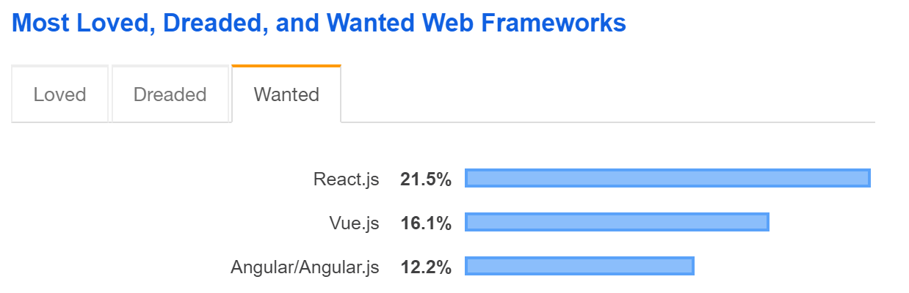

- React Features:
- JSX − JSX is JavaScript syntax extension. It isn't necessary to use JSX in React development, but it is recommended.
- Components − React is all about components. You need to think of everything as a component. This will help you maintain the code when working on larger scale projects.
- Unidirectional data flow and Flux − React implements one-way data flow which makes it easy to reason about your app. Flux is a pattern that helps keeping your data unidirectional.
- License − React is licensed under the Facebook Inc. Documentation is licensed under CC BY 4.0.

- React Advantages:
- Uses virtual DOM which is a JavaScript object. This will improve apps performance, since JavaScript virtual DOM is faster than the regular DOM.
- Can be used on client and server side as well as with other frameworks.
- Component and data patterns improve readability, which helps to maintain larger apps.
- React Limitations:
- Covers only the view layer of the app, hence you still need to choose other technologies to get a complete tooling set for development.
- Uses inline templating and JSX, which might seem awkward to some developers.

  - Redux
- Redux is a predictable state container for JavaScript apps. As the application grows, it becomes difficult to keep it organized and maintain data flow. Redux solves this problem by managing application’s state with a single global object called Store. Redux fundamental principles help in maintaining consistency throughout your application, which makes debugging and testing easier. More importantly, it gives you live code editing combined with a time-travelling debugger. It is flexible to go with any view layer such as React, Angular, Vue, etc.
- Principles of Redux: Predictability of Redux is determined by three most important principles as given below
- Single Source of Truth: The state of your whole application is stored in an object tree within a single store. As whole application state is stored in a single tree, it makes debugging easy, and development faster.
- State is Read-only: The only way to change the state is to emit an action, an object describing what happened. This means nobody can directly change the state of your application.
- Changes are made with pure functions: To specify how the state tree is transformed by actions, you write pure reducers. A reducer is a central place where state modification takes place. Reducer is a function which takes state and action as arguments, and returns a newly updated state

  - Express
- ExpressJS is a web application framework that provides you with a simple API to build websites, web apps and back ends. Express is a minimalist and extensible web framework built for the Node.js ecosystem. It enables you to create a web server that is more readable, flexible, and maintainable than you would be able to create using only the Node HTTP library, which can get verbose and complicated for even the most basic web servers. With ExpressJS, you need not worry about low level protocols, processes, etc. Express is going to make creating a web server much easier!
- Express provides a minimal interface to build our applications. It provides us the tools that are required to build our app. It is flexible as there are numerous modules available on npm, which can be directly plugged into Express. Express was developed by TJ Holowaychuk and is maintained by the Node.js foundation and numerous open source contributors.
- Setup
- Make a new directory to hold this project, and then change into that directory. As most Node projects begin, open your terminal and start with initializing NPM to create a package.json file. Then install Express as a dependency.
npm init --yes
npm install --save express
- We’ll start with the classic “hello world” example, explain that, and then build from there. First, create a new file called server.js that will hold the code for, you guessed it, our Express server. In this file, write the following code:
const express = require('express');
const app = express();
app.get('/', (request, response) => {
response.send('hello world');
});
app.listen(3000, () => {
console.log('Express intro running on localhost:3000');
});
- In your terminal, start the server using the command:
node server.js
- Then head on over to localhost:3000 in your browser, and you should see:
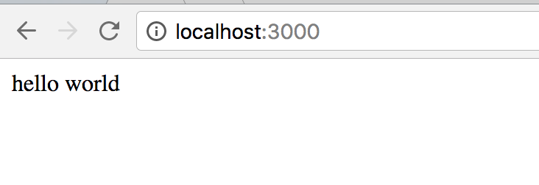
- Project structure
This project contains 6 folders/packages with the functionality of each folder is as follows:
- Models: to store all model of the database

- Config: to store all configurations of the project such as database connenction, etc.
- Middlewares:
- Express middleware are functions that run after a request is received but before the route handler function. Middleware functions have access to the request object, response object, and a function called next to pass control to the next middleware function or to the route handler.
- The “middlewares” folder contains 3 file: admin.js, auth.js and book.js
- Node modules:
- Route: contains all API of the project. The API tree of the project can be illustrated as:
routes
|____ api
|____ auth (GET)
|____ users (POST)
|____ books (GET, POST)
| |_____ :bookid (GET, PUT, DELETE)
| |____ chapters (GET, POST)
| | |_____ :chapid (GET, PUT, DELETE)
| | |____ comments
| | |____ :commentid
| |____ reviews (GET, POST)
| |_____ :reviewid (GET, PUT, DELETE)
| |____ upvote
| |____ downvote
|____ genres (GET)
|____ library (GET, POST, PUT, DELETE)
|____ ratings (GET, PUT)
|____ votes (GET, POST, DELETE)
|____ transactions (GET, POST)

- Client
- Actions:
- Components:
- Reducers
REDUX STATE SHAPE:
state : {
auth: {
token:
isAuthenticated: Boolean
loading: Boolean
user: {
_id,
name,
email,
admin,
createdAt,
updatedAt
}
}
alert: [],
genres: [],
}

- Individual report
- Le Minh Hai Phong
- Le Hong Minh
- Nguyen Binh Long

