npm install -g @vue/cli

# OR

yarn global add @vue/cli

cd work

yarn install

# OR

npm install

vue ui

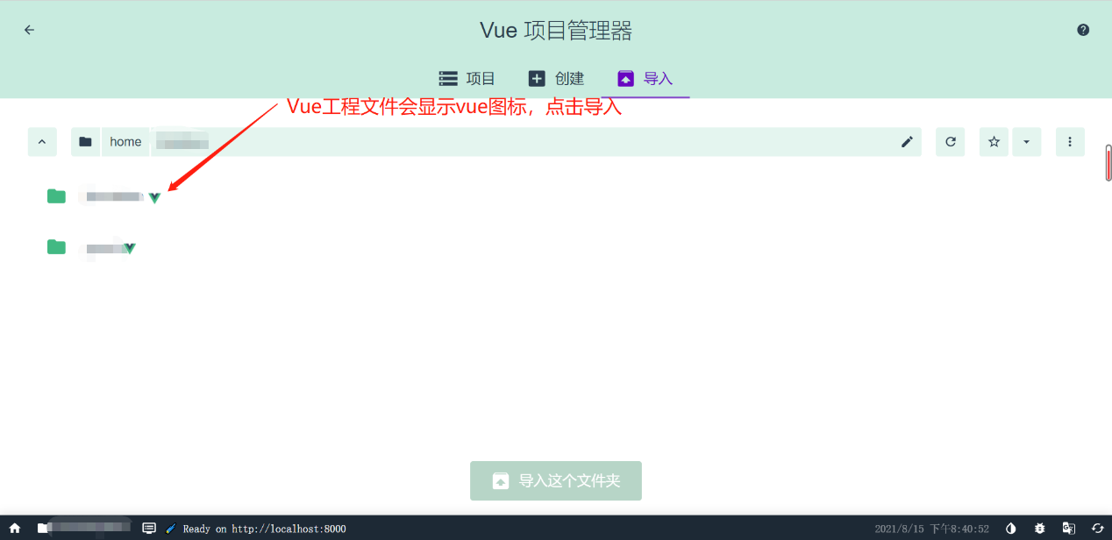

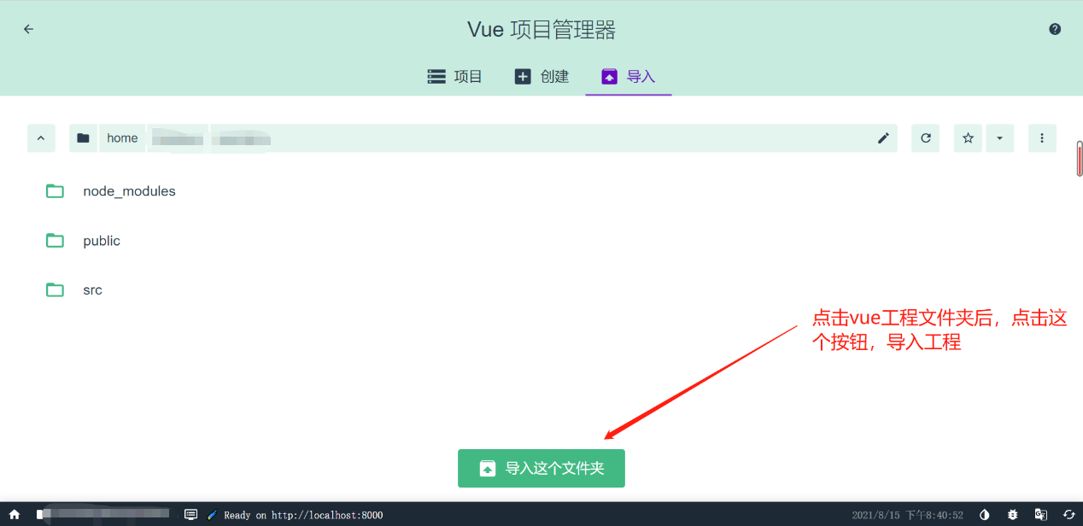

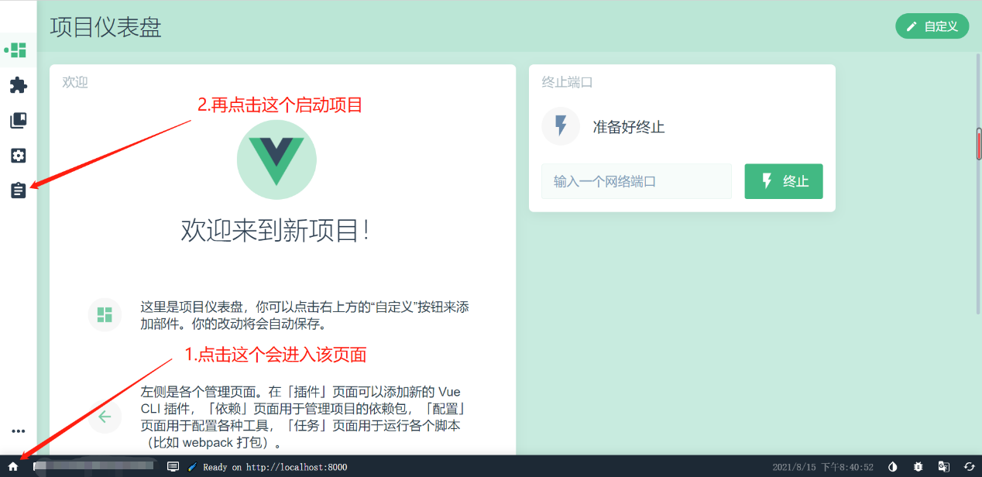

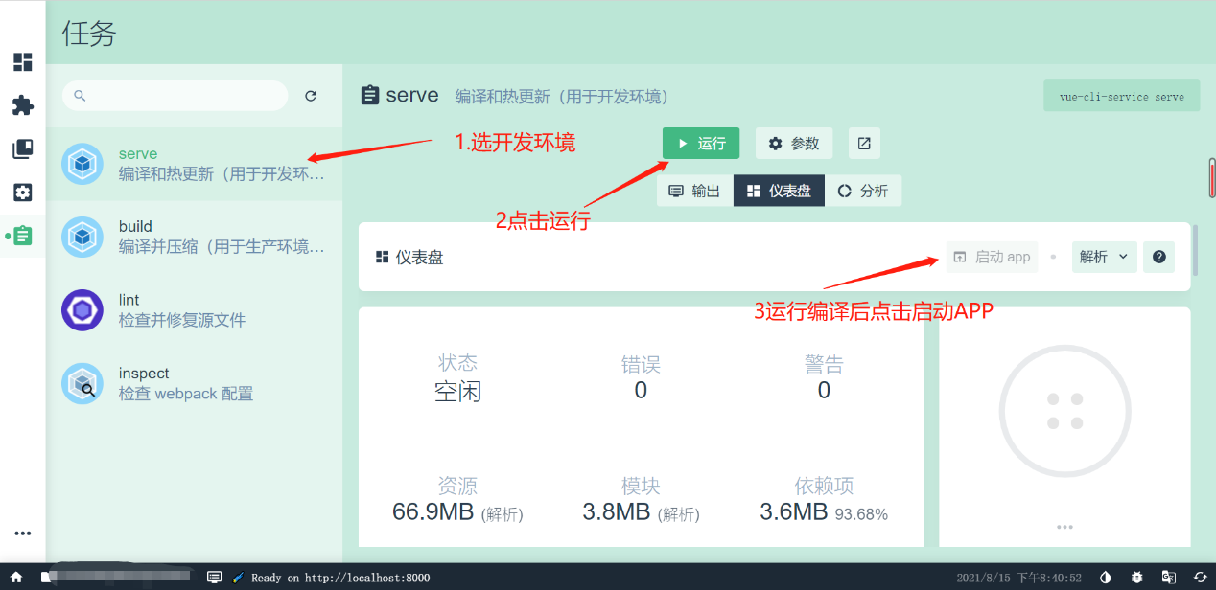

或者使用yarn serve OR npm run serve

登录 /login

注册 /register

/registeruser

/registerpost