Part 1 design

Class Diagram Format

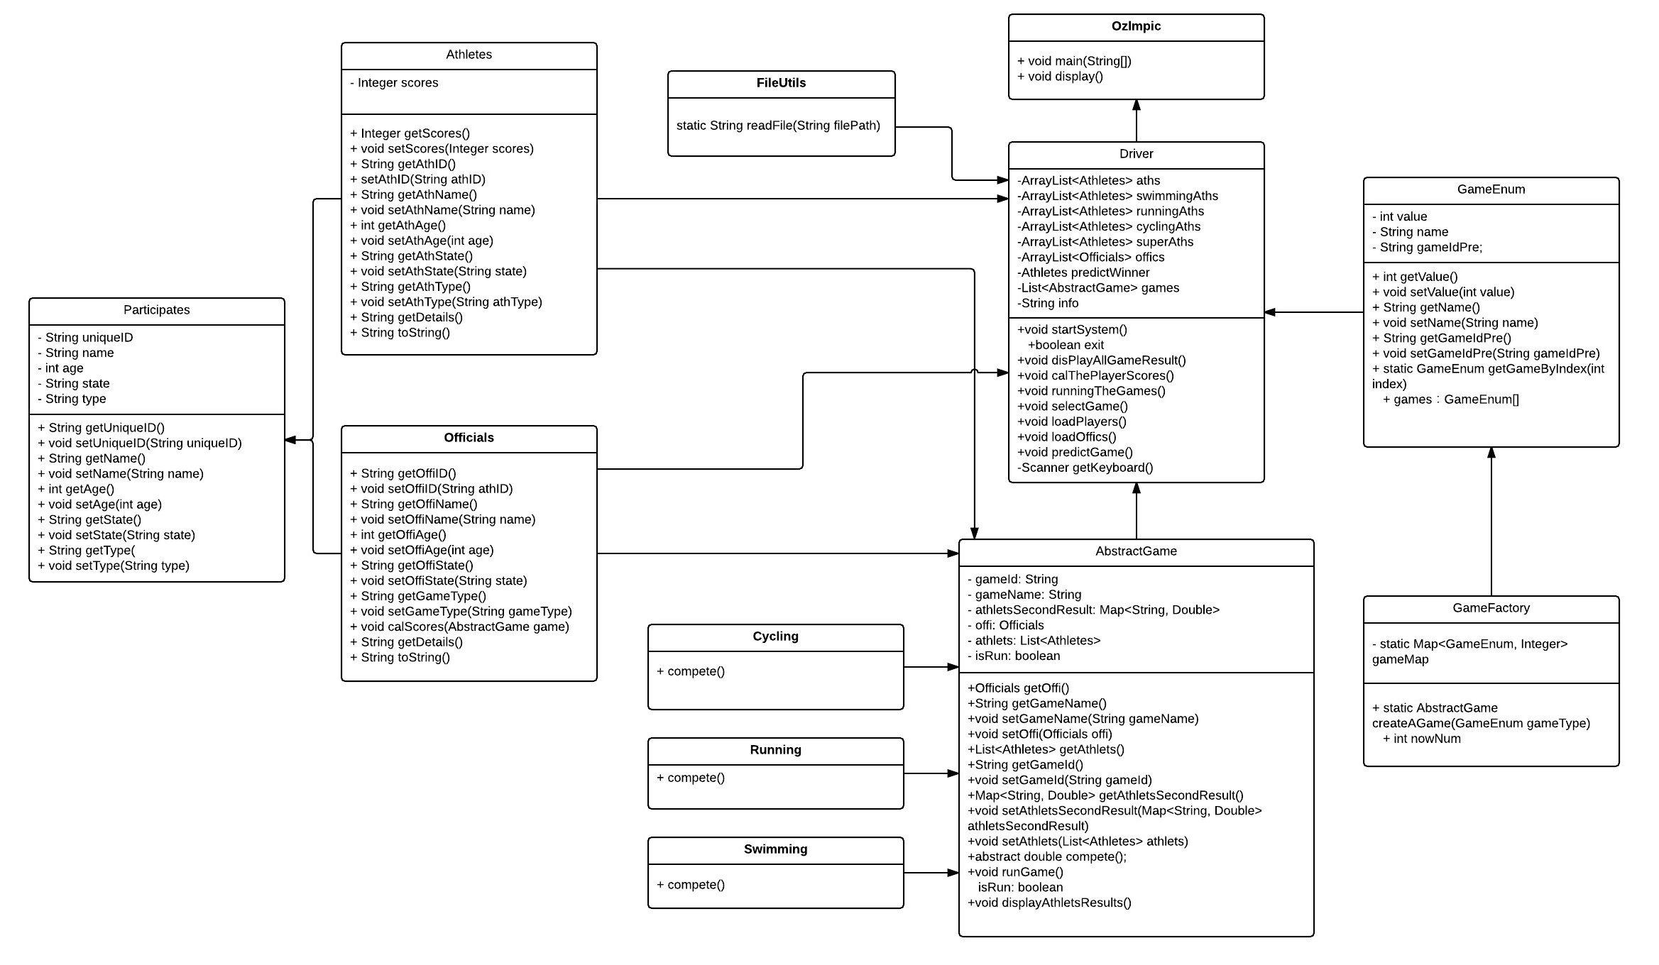

1. Explain how your design will be able to store the information of games, athletes and user predictions.

I use ArrayList and HashMap to store athletes and officials information in two text files.

1. Explain how your class hierarchy will forbid a user from creating a “generic” type of participant (i.e. not a athlete nor an official)

I make the participant class to be the Super class of Athletes class and officials class, and the concrete method call the Athletes and officials class respectively and both athletes and officials information store in different text files. So users could not create a “generic” type by themselves.

1. Explain the process by which your program will maintain a game and give correct score to athletes according to their performance.

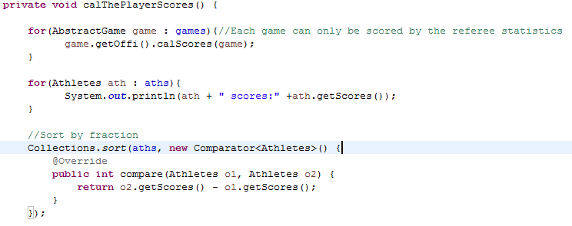

Compare the athletes score, if former athlete seconds less than latter athlete seconds, it will return 1 , if equal , it will return 0,else it will return -1. Use Sort method to order them.

4. Explain how a user prediction can be checked with the actual game results.

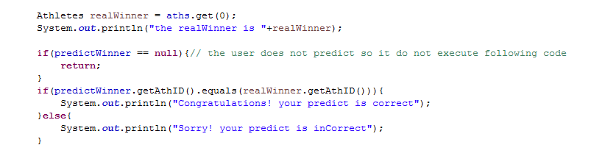

If the result is null ,means user does not predict, so jump out method and do not execute the predict method. I use equal to judge the input and real results whether are the same, If the result is same, return congratulation message, otherwise return incorrect message.