Project Sprint Planning Notes

**Team**: Group 13

**Sprint**: Sprint 1

**Date**: 22 August 2020

**Attended:**

**Scrum Master**: Shiyu Chen

**Product Owner**: Noureddine Dib

**Scrum team**: Shiyu Chen,QingZhao Liu, Jerome Youssef, Hanwu Yu, HaoMing Tian

1. Goal

*What is the aim that you are trying to achieve by running this sprint?*

*The main goal of this sprint is that to analysis the requirement and design the first two features before the development. In order to allow the group to save the time on find out requirements and make change. Otherwise just do development straight might cause change all things after they done the development.*

1. Duration of the sprint

*2 weeks*

1. What is the team’s vision for this sprint?

*Which items of the product backlog will be committed to sprint backlog and why?*

*What will the potentially shippable product look like in the end? What features will it have in its working form?*

*The items that is we planning to do it but doesn’t require or doesn’t have time to do it in this Sprint will put it on product backlog, because we were limited time to do the development and design the whole product, the whole product will be a big plan for a group only for five people,therefore is a good idea to do it step by step, to do the things ahead first and then planning others later.*

*In the final performance of the product, it will have basic six features for Customer page, and there will be five feature for Admin page.*

*For Customers they maybe allow to do:*

* *Fitness tracking including workout per day, wheight, program progress.*
* *Manage favourites of their fitness.*
* *Adding comments about thier experience.*
* *Manage thier personal profile*
* *Asking for custom programs*
* *Share with others by screenshots or in the website.*

*For Admin they maybe allow to do:*

* *Manage Workouts for themselves*
* *Manage training program for Customers then customers can follow the instructions.*
* *Manage Recipes for Customers.*
* *Manage Medals for Customers.*
* *Promete new workouts and programs in the website.*

*The final product will be performance in a HTML website that allow users to access and use it easily, which means it should be a simple design that allows all users to use it. Also it should make a space in the HTML website to let the Admin do promete the new workouts and programs.*

1. Estimation in story points

*Team to estimate story points for each of the items. Provide some sort of justification.*

*We start our working at 13 August.*

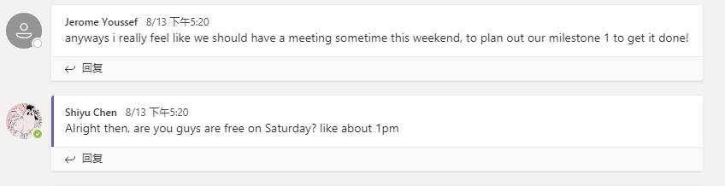

*Then we have a meeting at 15 August at 1pm (We have time differences)*



Shiyu:



Hanwu are going to do the backlog which is C6.

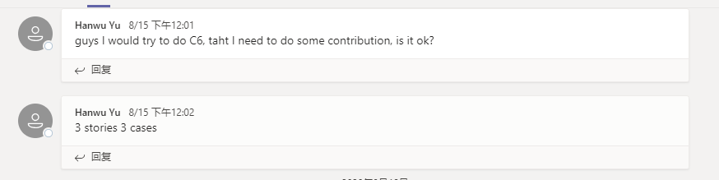

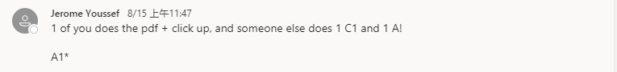

And QingZhao was talking about he is going to do one of the C1. After a few days till 19 August, all of our members were upload their works on the Microsoft Team to let the others to check if there is anything wrong.

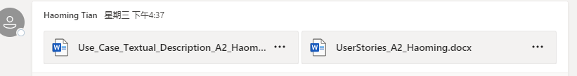

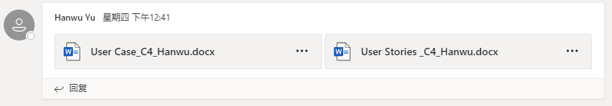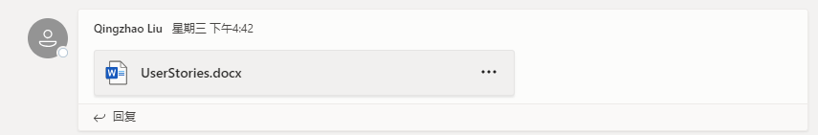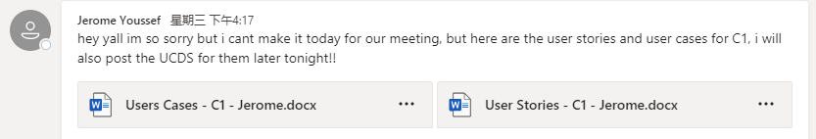

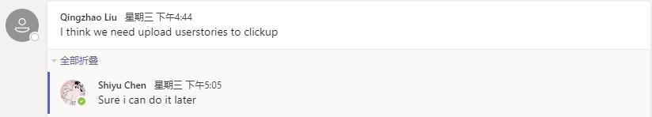

Then about the User Case Diagram, Shiyu has suggest all members work together on LucidChart.

