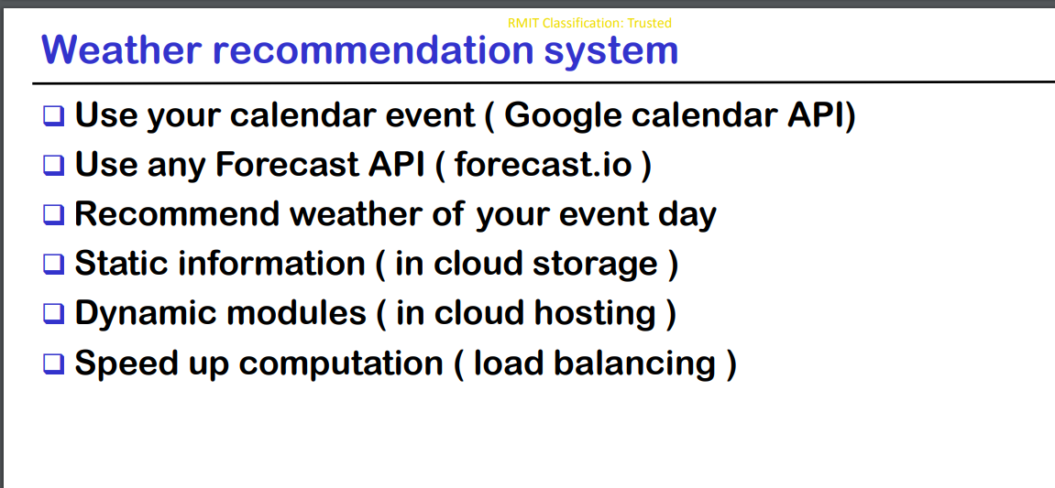

Google Calender API: https://developers.google.com/calendar/quickstart/python
Forecase API: https://www.weatherbit.io/api
Static Info - Google Datastore: https://cloud.google.com/datastore/docs/reference/libraries#client-libraries-install-python
Dynamic Modules: TODO…
Speed up computation: TODO…

