Overview of the problem
The purpose of this task is to construct a credit rating classification model based on existing data from banks, such as loan quantity, number of delayed payments, etc. After receiving user personal data, users are divided into pre-set different credit risk levels. This is a supervised learning task, where the training data has a known label, namely Credit_Score, and the label is discrete, making it a classification problem.
This task is interesting and has practical significance. Credit scoring is widely used in banks and other financial institutions. By constructing a classification model for credit scoring, it can effectively improve classification efficiency and reduce labor costs. When dealing with large amounts of lending data, this model will be particularly effective. At the same time, the model also improves the standardization of classification, ensuring the accuracy and objectivity of credit ratings, which helps credit ratings be accepted by consumers. From a technical perspective, building an efficient and accurate scoring model poses many challenges, including data cleaning, feature selection, model optimization, and so on. This task can help beginners master the basic knowledge of data science, understand the advantages and disadvantages of different models, and explore how to improve the performance of models. This is both a challenge and an interesting research process.

Dataset description
The dataset contains 100000 samples and 28 feature columns[1]. Among these features, 16 columns represent numerical data and 12 columns represent categorical data. Among them, it should be noted that due to data entry or issues with outliers, some numerical information is saved in char format and needs to be cleaned and formatted, such as in the Num of Loan column. The column names and data types are shown in the following figure:
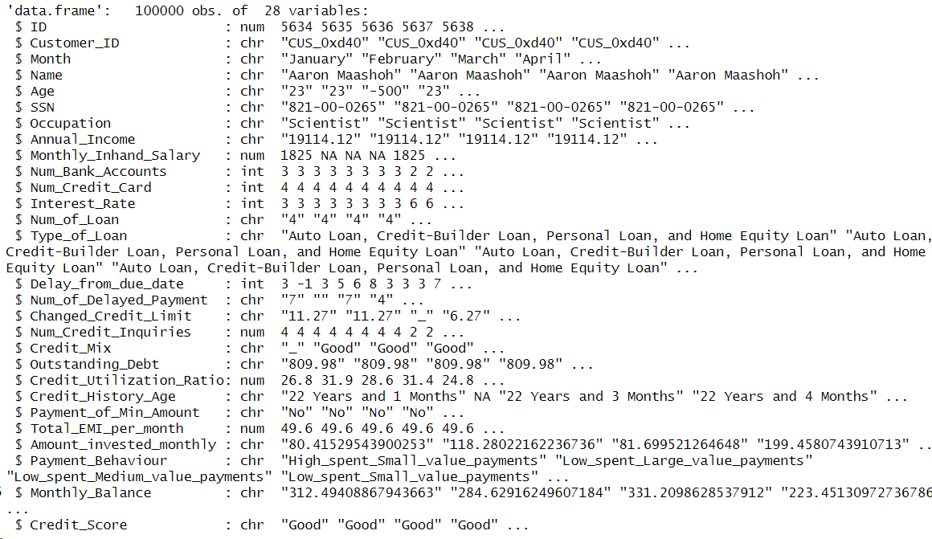
Figure 1:Column names and data types
In this task, the dataset contains 100000 samples, with a large number of missing values that need to be supplemented in different ways. Filling in a large number of missing values will be a challenge. At the same time, it is necessary to handle various types of erroneous values during research, such as underline, values that clearly exceed the normal range, etc. This will involve a series of tasks such as data cleaning and data type conversion. Meanwhile, the model needs to solve a Multi class classification problem, which is also a challenge.

[1] Rohan Paris. (2022). Credit score classification [dataset]. Kaggle. https://www.kaggle.com/datasets/parisrohan/credit-score-classification

