

**COSC2440: Software Architecture: Design and Implements**

**Assignment 1**

**Date: April 13th, 2021**

**STUDENT ENROLLMENT SYSTEM**

**Name: Bui Duc Huy**

**ID: s3817842**

**Course: COSC2440**

1. **Use Cases Diagram**

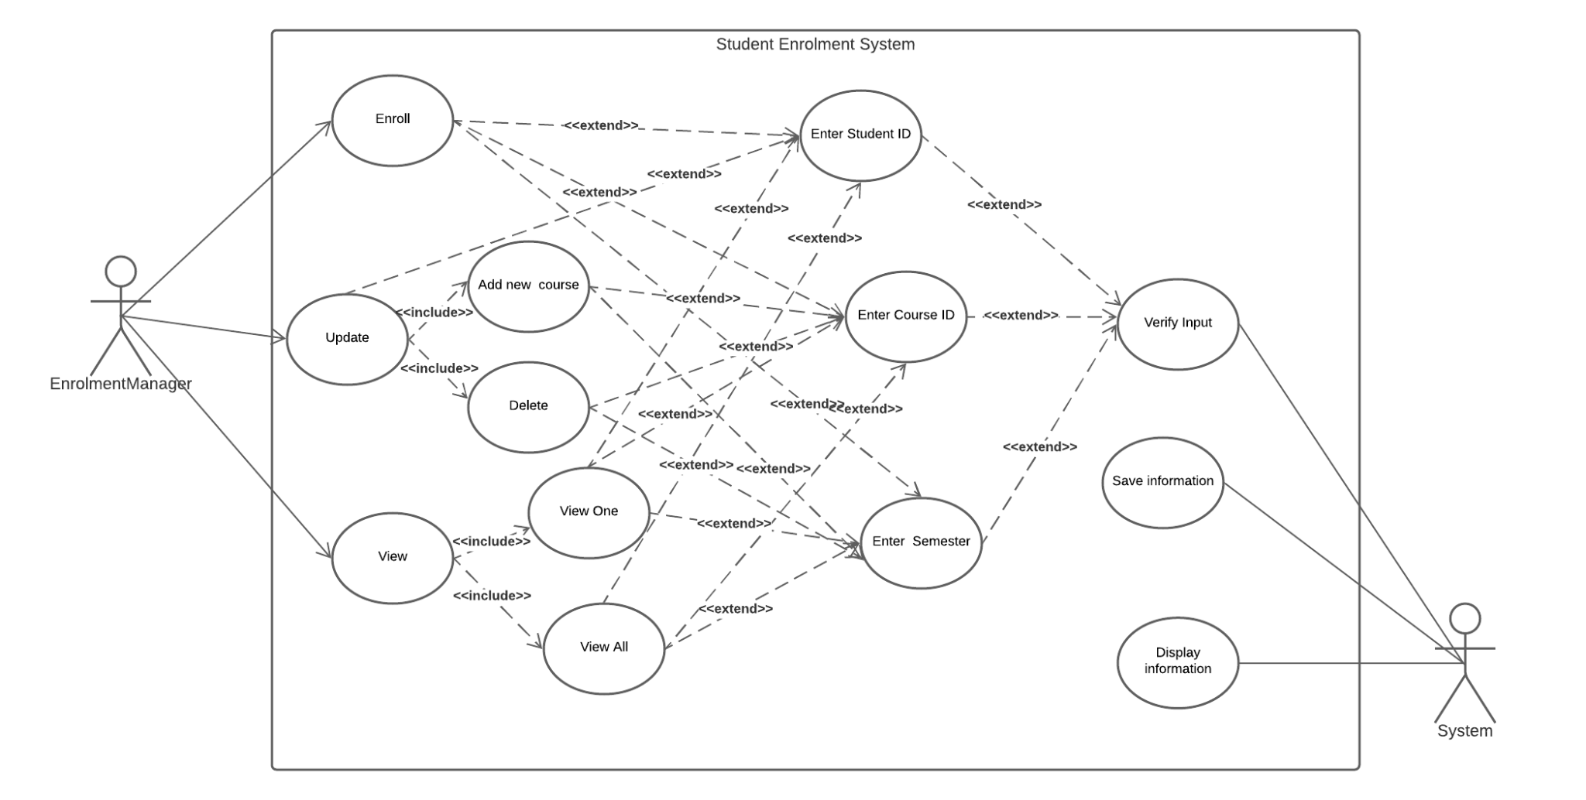

**Figure 1: Student Enrolment System Use Cases Diagram**

In the enrolment system, users are able to choose one of three main functions of the system including enrolling, updating, and viewing. If the enrollment manager chooses an update, they would have to choose to add a new course or delete the enrollment, the same as view since they had to choose view one (students, courses, enrolments) or view all information. After that, users have to enter a student, course, or semester ID based on their previous option. The system would be responsible for saving the enrollment, verifying the input, and displaying the information that users want to see on the screen.

1. **Class Diagram**

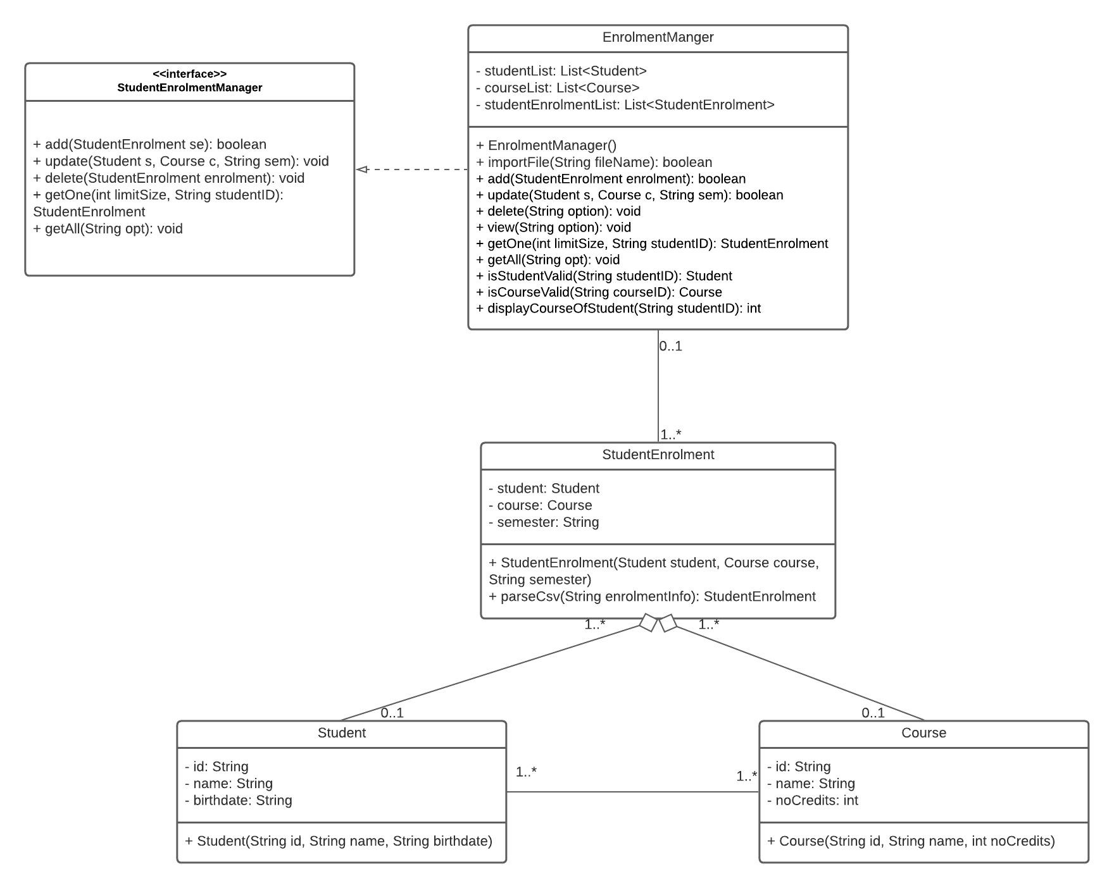

**Figure 2: Student Enrolment System Class Diagram**

The class diagram represents the relationship between each class in the system. Based on that, Student and Course class would be an important part of StudentEnrolment class since, without them, the StudentEnrolment class would be broken. Moreover, there is also an interface that is implemented by the EnrolmentManager Class which plays an important role in managing the enrolment list.

1. **Activity Diagram**

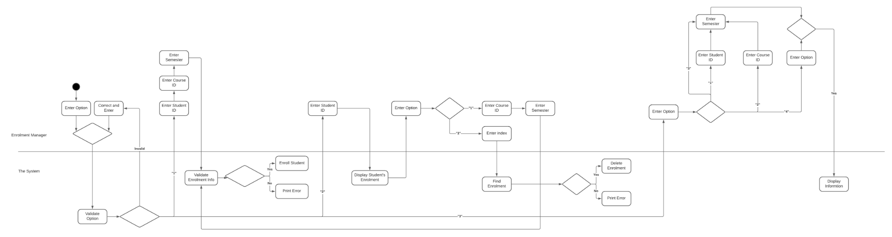

**Figure 3: Student Enrolment System Activity Diagram**

The diagram has displayed the whole process of the system including the enrolment manager’s task and the system’s task. First of all, the enrolment manager should enter the option from 1 to 4 to enrol, update, view or exit the system, after that, the system would be responsible for verifying and processing the input option of users, it would be the same for each time users’ input. If users choose 1, the system would ask for providing enrolment information including student ID, course ID, and the semester that users want to add to the system. In the case of 2, users have to provide the student ID so the system would display all courses of that student, after that, users are able to add or delete information of a student. Adding would be the same as the enrol function, on the other hand, delete would ask users to choose the information that they want to delete by entering the index of the displayed information. The third option would mainly show users some reports in the database such as show all students in a course of a semester, show all courses of a student in a semester, show all courses offered in the semester, or show all enrolments/ students/ courses or all of them.

1. **Appendix**

<https://lucid.app/lucidchart/invitations/accept/inv_ce1ab63f-3b2a-475c-b106-6311e762dfc8?viewport_loc=345%2C-503%2C1707%2C823%2C0_0>