IT Profile

Personal Information

Hi, I am Nghia, a Vietnamese currently studying at RMIT University Vietnam. My student ID is s3818269 and my email is s3818269@rmit.edu.vn. Before studying here, I finished my study at Banking University of Ho Chi Minh in 2017. At present, I have a part time job as an English tutor for some primary and secondary school students. In my free time, I usually read novels, play computer games or watch films. My favorite genre of movies is horror, especially films from Asian countries such as Japan and Korea. I love dogs, in fact I have a pug at home. His name is Thit Vien due to his chubby body and big appetite. Whenever he sees chicken legs which are his favorite food, he will be so excited and happy that he will dance and jump around the food before enjoying it.

Interest in IT

When I was a kid, I loved to watch science - fiction movies with my brother. There was a movie in 1995 called Hackers which had Angelina Jolie as the actress. It was about a young boy and his friends - the protagonists - accidentally found out a plot to spread the dangerous computer virus in order to get money, and they had to use their computer skills to find the evidence while being chases by the police and the antagonist. As a child, I was very impressive by the skills that the group of hackers had, such as being able to remember and write command lines promptly without looking the keyboard. At that time, I really want to have an computer. The idea of spending all day surfing the Internet just to satisfy my curiosity makes me excited. I got my first computer for studying in secondary when I was 12. It was the prize of my father for my achievement of being rank first in second semester. I remembered how happy and cheerful I was when I saw it in my room. My brother bought all the computer components and I helped him build the case. He instructed me how to place the motherboard and RAM properly, showed me some basic advice about cable management and maintenance. From that PC, I have learned may interesting things, such as Pascal when I was in high school.

I chose to study at RMIT because I can achieve an internationally recognized degree and be immerse in a friendly, professional and challenging life. Technology always changes immensely fast, and in order to keep pace with it, I need a lot of information and practices, from basic to advance. At RMIT, I will be able to learn from experts of their fields as well as gain benefits from a wide range of courses providing useful and practical knowledge.   
 When studying in RMIT, I expect to study some popular programming languages such as Python, C# and Java, and relevant courses about programming which can help me gain sufficient knowledge to apply for a good position. In addition, I want to improve my communication skills as well as teamwork, because in real life, people have to work together to finish their given tasks.

Ideal Job

<https://itviec.com/it-jobs/application-developer-net-c-java-global-insurance-corporation-3507>

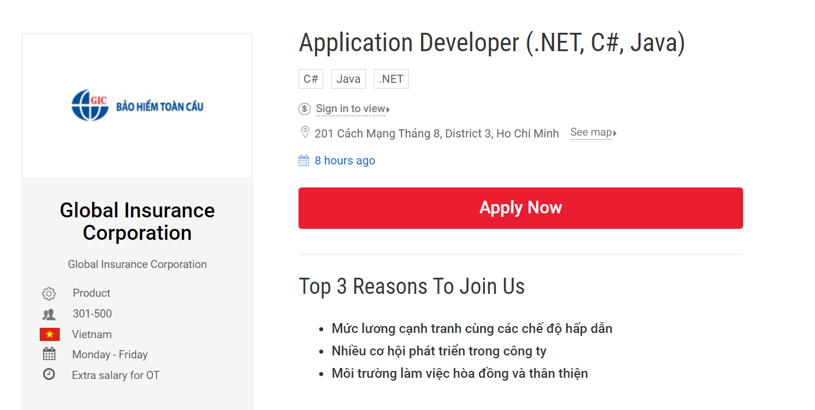

Application Developers are responsible for developing and modifying the source code for software applications for the company. They also have to analyze the given business tasks and then come up with software solutions. In addition, they will test other developers’ working progress to find out any errors and handle them properly. They are expected to be able to address any problems and fix them without causing additional issues. Working as a team, they will provide their updates of tasks planned, tasks completed and tasks on progress as well as any issues that can impact the time to complete or the quality of work. This job caught my eyes because I am interested in software engineering and I used to work in the bank field, which will provide me useful experience to finish my work thoroughly.

Software Developers require some crucial qualifications. Firstly, Bachelor’s degree in business, computer science or related fields, or equivalent experience is needed. Secondly, the candidates are required to have at least 2 years of experience in Software engineering before applying for this position. If the candidates used to work in insurance or bank field, they will be prioritized. Moreover, they need to have experience in Web developing and a variety of programming languages. Finally, the candidates are required to have great soft skills, such as communication skills, problem solving and crisis management skills, analytical skills as well as critical thinking and working effectively as a member of a team.

Currently, I have the Bachelor’s degree in Banking and I also worked for BIDV for 2 years before enrolling at RMIT, which gives me some advantages when applying for this position. Due to having a job previously, my soft skills and ability to work in a group are good. I am able to express my ideas clearly, work under high pressure condition and find solutions to resolve the issues.

At moment, I am lacking knowledge about Information Technology field, particularly the study of programming language as well as web developing MVC. I also need the Bachelor’s Degree of Information Technology, which I will get in 2022. At school, beside enrolling in programming language courses, I will also attend classes for web designing and database MySQL. I can gain working experience from becoming an intern, which will allow me to meet real life situation and how to handle it.

Personal Profile

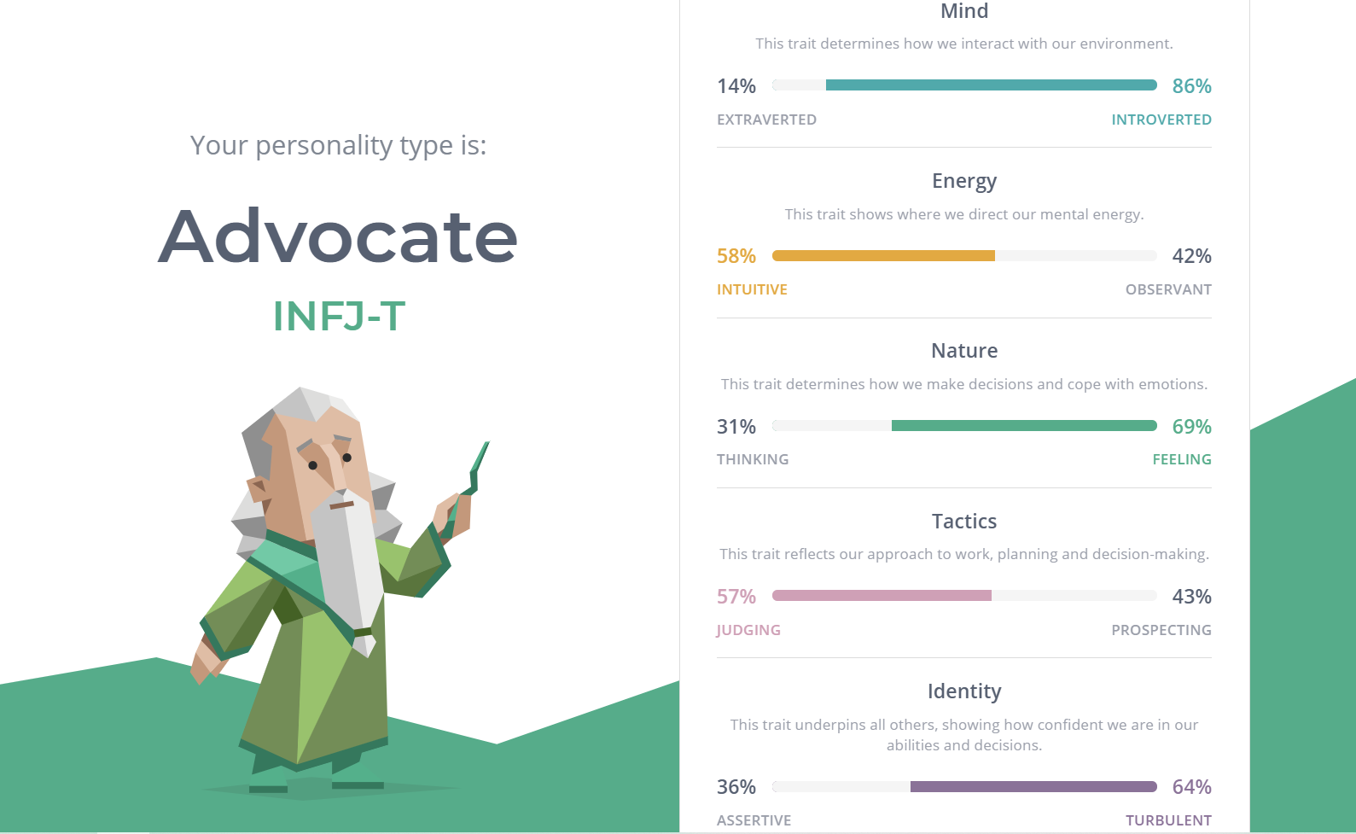

The result of Myers - Briggs Types Indicator test shows that I will focus more on internal thoughts, moods and feelings rather than on external sources of stimulation. I also have some plans for the future, but they can be influenced by the suddenly changed feelings and other people’s criticism. These can heavily affected to my behavior in a team. I usually have thoughts and ideas but I do not express them to other teammates unless being asked. Sometimes I am also distracted to do other works before completing the current ones. Therefore, when discussing in a team, I would like my team leader to ask every members to talk about their own works every week, so I and other members are motivated and pushed to work.

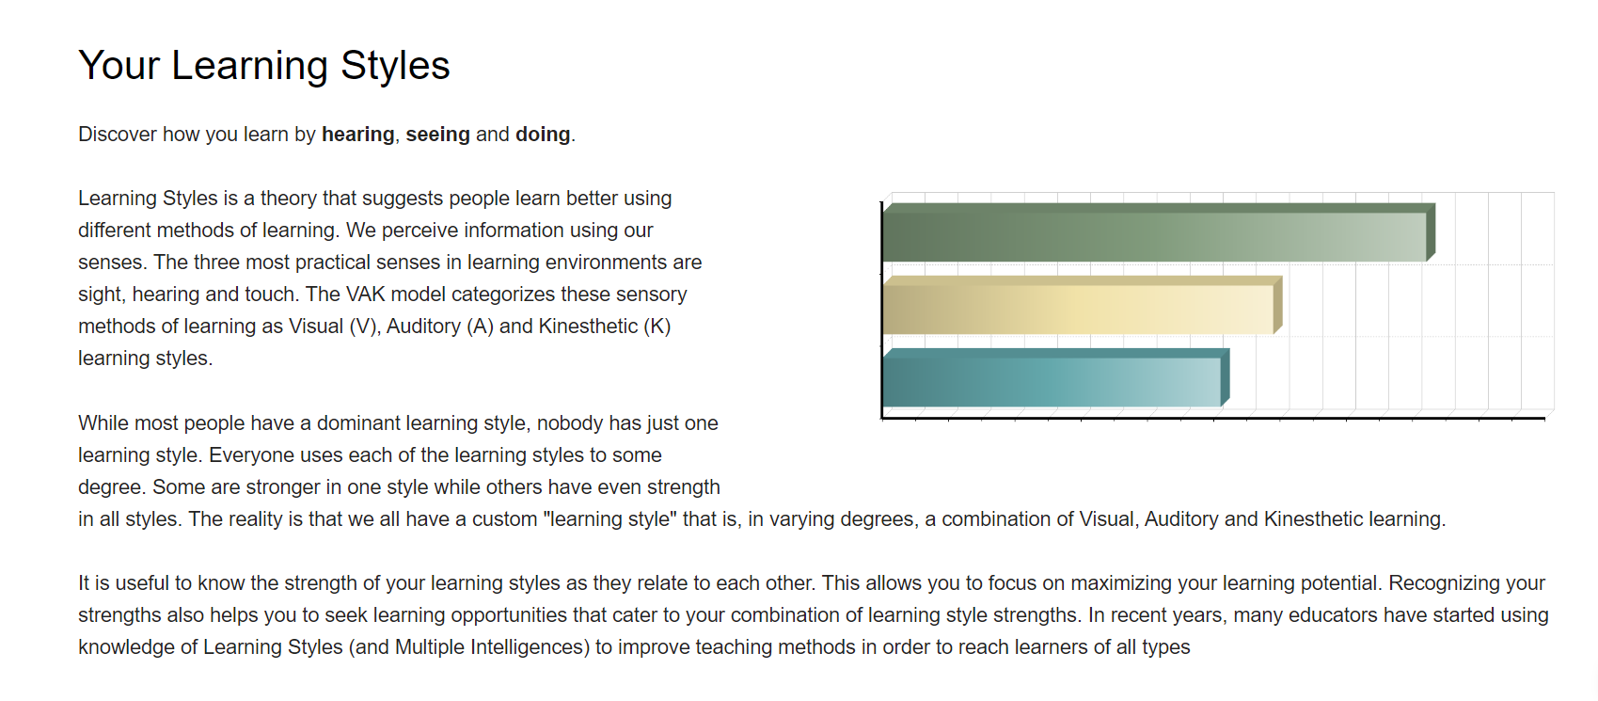

The result of Learning style test shows that I am good at learning through hands - on experience and watching other people’s work. By doing work repeatedly, I can gain experience from mistakes and be better. On the other hands, my least preferred learning style is auditory. This can be very bad when working in a team. I can easily miss some important information when the team leader announces the working schedule or discusses about the working plan. Fortunately, I have found a way to overcome this bad habit, which is writing notes. By doing it, I will not be tired from hearing and get distracted by doing other things.

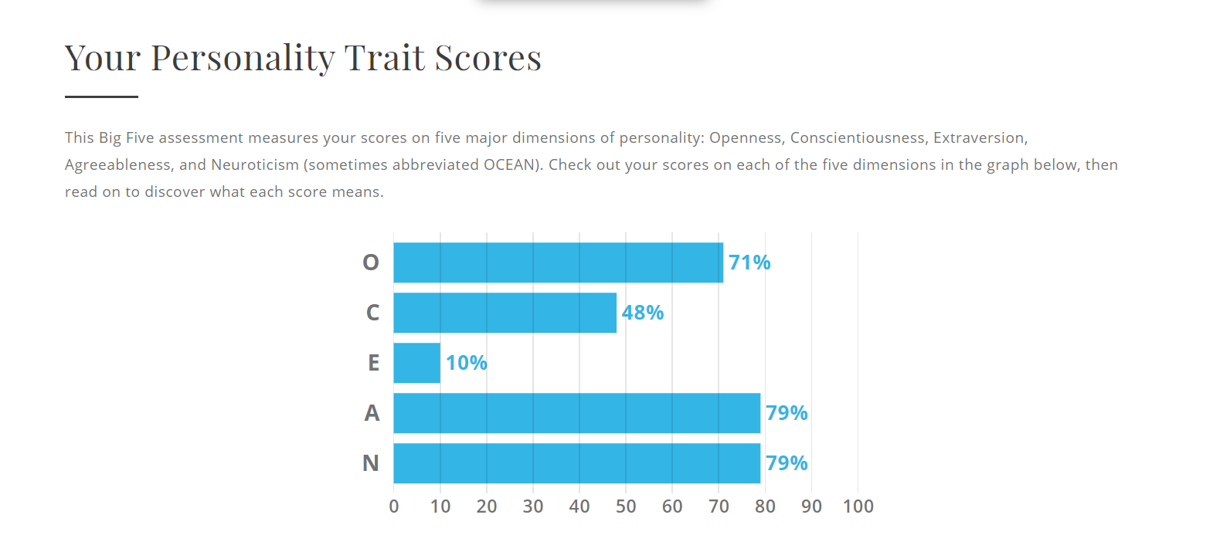 The result of Big Five Personality test shows that I am an abstract thinker, a flexible but easily sidetracked person. According to the result, I am also trustworthy, helpful and vulnerable to stress. In a team, I can make a working plan clearly and help other team members with their works. But when works do not go as plan, I am often stress out myself and then I make mistakes. After several incidents, eventually I figured out it was because I set my goals unrealistically. Therefore, whenever I makes a plan, I would try my best to set the goals small and achievable, so that I would not feel frustrated if things did not go well.

Project Idea

In game project “The Returners”, player’s goal is to find out the villain who has killed his village and bring him to justice. This project will be a Role - playing game, with big talent tree, good combat system, various kinds of weapons, magic and armor. The game takes place in a fantasy world called Eredia, where there are many races live together. In the game, the player will start as a young man who has lost everything after the tragedy happens at where he lives. On his adventure, he will eventually find companions who assist him to fight monsters and enemies.

I chose to do this project since playing games is an inseparable part of my life since I was a child. In all kind of game genres, I like Role - playing games most. This genre has enticing storyline and I can immerse myself into the beautiful world that I can spend hours to explore, amazing stories which help me learn more about the past of characters as well as the childhood dream of becoming a hero. I always get so much enjoyment when fighting with bosses and monsters that are much stronger than me. The satisfying feeling of achieving victory after a long and hard battle makes everything before that worth it.

When you start the game, you will have to make your own a character. In this stage, there are many customization for you to take into consideration. Firstly is your character’s face, there are some details you can change such as eyes, nose, scars and hair. After that, you have to choose the race of your character. It can be a Dwarf with high strength attribute but lacks of dexterity, or an Elf with mobility and high accuracy. You can also choose Human race with average attribute or Godlike with high Will attribute, which is important if you want to be a wizard. Next is the class/job choice. There are 8 classes in total, which were barbarian, wizard, monk, rogue, ranger, paladin, fighter, chanter. Each class has its own talent tree as well as skill tree. After this, you press complete button to finish the customization and now you are ready for the adventure. Like any Role - playing games, your character has health bar and action point. If your health is zero, you will lose the game. Each skill uses different amount of action points, so it is a good strategy to use the skills wisely. You will use weapons and skills to fight with the monsters and other villains. The enemies will drop some gold and items after being defeated, when help you become stronger. Every time you defeat enemies, you will receive a proportion of experience, so that when you gain a level, you can access to more powerful attacks. Throughout the game, eventually you will find and make friends with some Non - player characters, who will follow and assist you during the adventure. The world of Eredia is islands and seas, therefore you will need a ship with the crews. In this game, because you will travel by ship, voyages play an important role that can affect the storyline. You will also have to manage to resources of your ship, such as food, drinks and morale of the crew. The morale affects heavily to gameplay of the game. If the morale is low, the crew will fight poorly against the pirates. When it is under a certain threshold, there will be even riots. There is a variety of food and drinks in the game, which will boost the morale. You can also gain money from having naval fights with pirates or other ships, which you can buy better food, drinks or upgrades for your ship. If you have a lot of money, you can even buy a bigger ship, which means it will need more crew, resources to maintain. In the game, aside from main quest, there are many side ones that you can do, some of them will reward valuable resources, such as items, crew and companions. During the adventure, there are events that will influence to the storyline. Depending on how you choose, your companion might leave or even be against with you, which might lead to different endings.

In order to make this game, I use Unreal Engine because of its flexibility and free offer. Inside Unreal Engine, there is a complete suite of development tools to work with real - time technology. The Blueprint feature allow me to put simple scripts together and work flawlessly. It also has visual interfaces so that even if there is a person who never learns how to code before, some short tutorials can help you make a working game. The Engine use the PBR workflow for its materials and rendering, when combined with shadow and lightning effects, will allow a few incredible photorealistic contents that are able to run in real - time.

To learn how to use Unreal Engine properly, some skills are required. Firstly, the knowledge of C++ programming language is needed. You also know how to create, rig and animate models. Secondly, you need to know how to create digital content and render videos, visualization as well as 3D sculpting. To learn those skills, Unreal Engine has a documentation representing some basic knowledge about them and how to use it on the engine. There are also some classes teaching programming language and editing videos, which are 3 to 6 months in length. To gain experience, the only way is to do it by your own and learn from it.

If this project is successful, it will be a meaningful memory for me. I might publish this game and earn some money, gain feedback from customers to improve the game furthermore. I have always wanted know make my own game for a long time, but I did not have the sufficient time and resources until recently. This game can be a achievement for me to gain new experience, and can help me stand out among other candidates in the job market.