# The Sop have 2 part: Use and Maintain

# Use

1. **Dir path**

Default path is certificate folder ,put the certificate which you need here

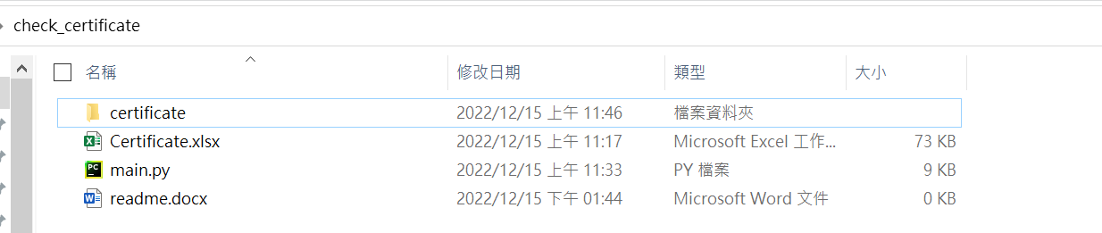

1. **Filename rule**

Follow the txt filename rule as below

“RC( Site)( HW).txt” the text in parentheses is optional depend you need.

e.g.

ARC1 SiteA HW.txt

ARC1 SiteA.txt

ARC2.txt

The 1-3 column will create like:





1. **Content rule**

1.line 1 is the start don’t leave any ‘\n’ space line

2.last line can have 1 ‘\n’ space line or 0, don’t leave more than 1 ‘\n’ space line

3.every object at least need name e.g. “arc2vm85 his” and notAfter will decide the expiry day, remain_day will create automatically by excel formula.

e.g.

ARC2.txt with this content:

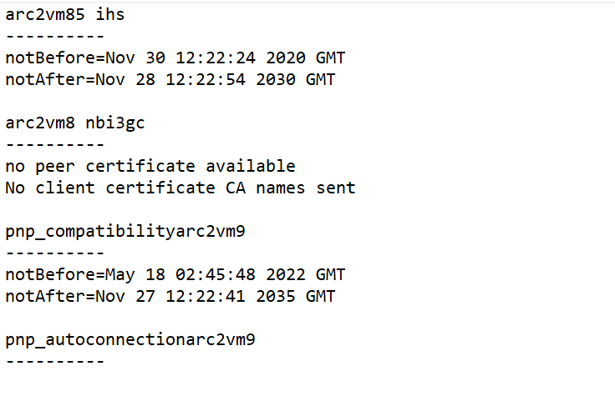

The 4-6 column will create like:

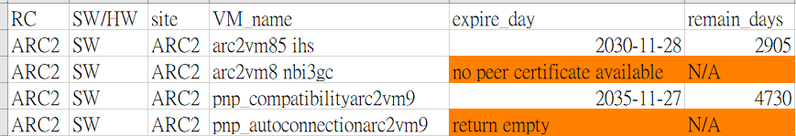

1. The tool create as below:



In the “Sheet” G2 can control the remain_days mark yellow condition

“other” record the Object not put in any sheet please follow the maintain part and check conditions.

1. important

If want past the exist web excel the “expire day” may become mm/dd/yy or another ,can select date by yyyy-mm-dd fix it; remain_days will become value not formula please drag the past formula ,it should be like =IF(Ex="","",IFERROR(Ex-TODAY(),"N/A")) x means row num.

# Maintain

█ means variable █ means function name █ means other code

1. class machine() with 6 attribute RC, ware ,site, name, expire_day, remain_days

construct by RC,site,name, expire_day

ware auto decide by “site”

remain_days create by “expire_day” but now it no longer used because it just a number not a formula, can’t auto update, it replace by sheet_fill_value().

1. func get_data(path) find all certificate txt file and use left and right [l:r+1] to take the name and expire_day , return all_vm include all certificate and use sheet_classification() create the ‘Sheet’ page.
2. func sheet_classification(wb,sheet_name, classification_data)

the function will use internal func as below and create the Sheet by sheet_name and data by classification_data the try …except to check if have sheet name now,

sheet = wb[sheet_name] will into except normally because we didn’t create the sheet

, but “Sheet” will not ,because Sheet will be created automatically when the excel be created. So I put yellow controller ‘G2’ in try.

sheet_init()

the function will set every page title.

sheet_fill_value (vms)

the function will see classification_data as vms and set every classification_data attribute in the sheet

sheet_fill_color_rule()

the function will set the style mark orange and mark yellow condition.

1. if__name__==”__main__”
2. get_data from folder ‘certificate’
3. create excel and First page “Sheet” and its content
4. create a dict classification key=sheet_name ,value=[content object]
5. use for to classify all_vm from get_data(path) and put into dict classification by if and many elif conditions.
6. use for to create every page in the dict classification.
7. save excel.
8. If you want to create/delete a sheet you need:

list classification need to add your sheet name

add elif conditions in i.name then classification["your sheet name"].append(i)