Index.html validation

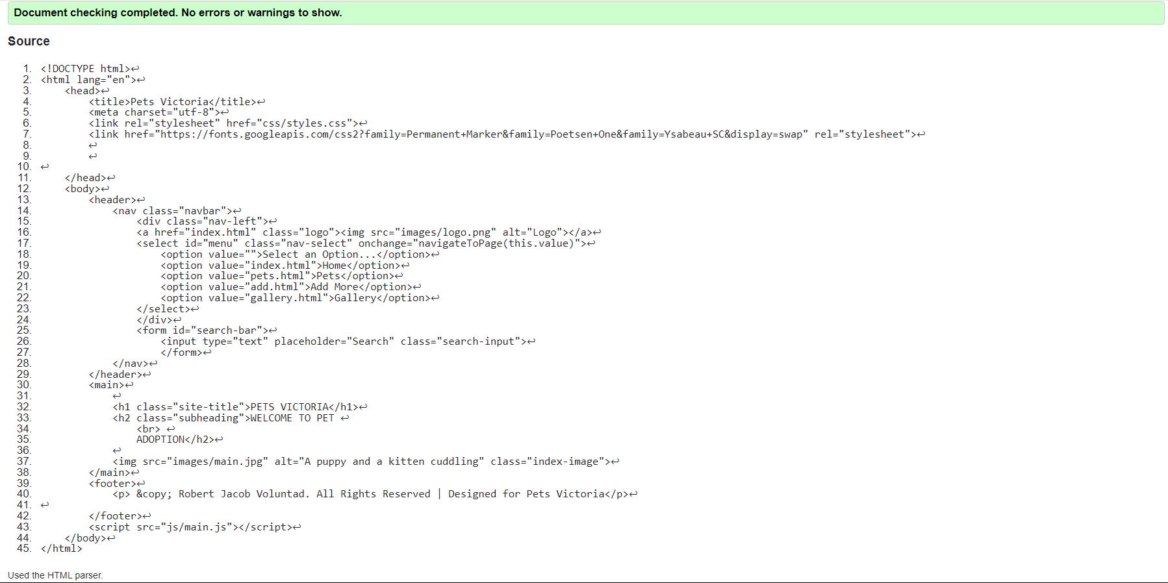

Pets.html validation

Add.html validation

Gallery.html validation

Css file validation

