assessment 3: Team project

COSC2196 – Introduction to Information Technology A2

Contents

Team25 - Profile 2

Team Name 2

Team25 Members 2

Niki Arrogante 2

Debborah Bryce 4

Samuel Claydon 7

Caden Maxwell 9

Group Processes – Looking Back on A2 11

Career Plans 11

Niki 11

Debborah 11

Samuel 12

Caden 12

Comparing Our Plans 12

Tools 13

Microsoft Teams 14

GitHub 14

MATH GAME – Our New Project 17

Aim 18

Plans and Progress 20

Roles 22

Scope and Limits 22

Tools and Technology 22

Testing 22

Timeframe 23

Risks 25

Group Processes and Communications 25

Skills and Jobs 25

Group Reflection 27

References 28

Credits 29

# Team25 - Profile

## Team Name

Our team collectively decided to name ourselves **Team25**. It was named after the group number we joined in Canvas. It is easy to remember, straightforward, and involves a nice, rounded number that everyone can appreciate.

The team has seen some unexpected changes, and we have shrunk down to a four-person group since our last foray. Regardless, we intend to take things in stride, and hope our report will represent our efforts.

## Team25 Members

The four members of Team25 are (in alphabetical order):

### Niki Arrogante

Sydney-born and raised, Niki is currently a full-time student following years working in various sectors including telecommunications and logistics. He is a big fan of virtual reality and hopes to find ways to implement the technology in new, exciting ways. Outside of studies, he enjoys gaming, motorcycles, and spending time with his two-year old daughter and partner.

[Niki’s Website](https://s3851498.github.io/intro-to-it-assessment1/)

Ideal Job: Hardware/Software Developer (VR)

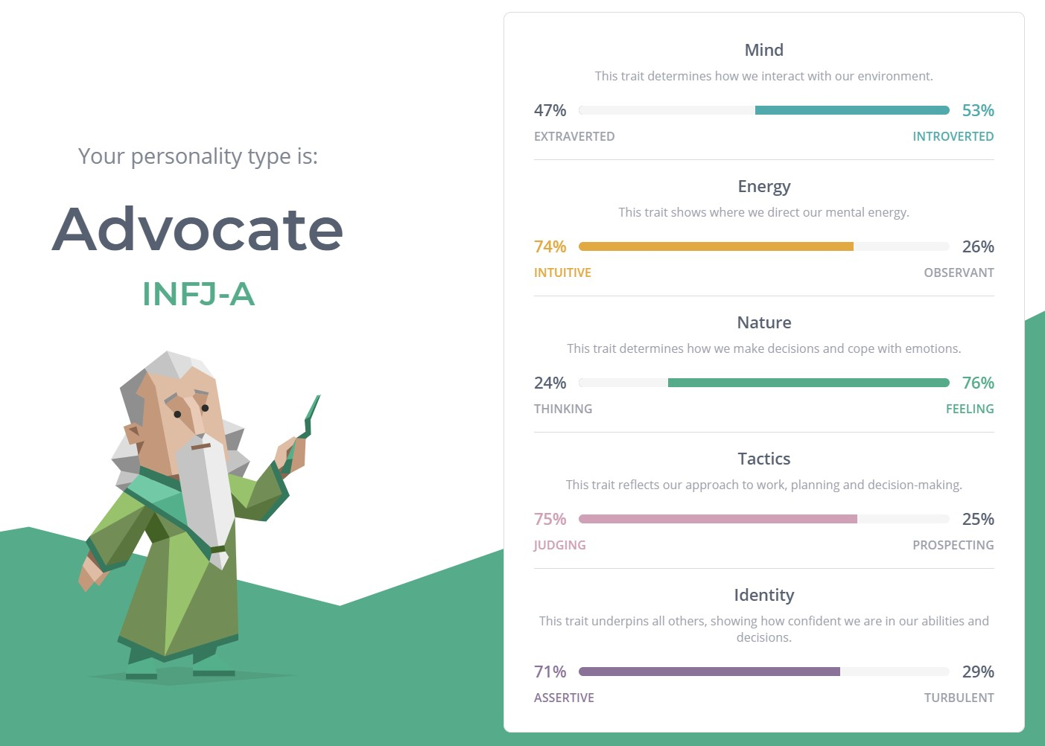

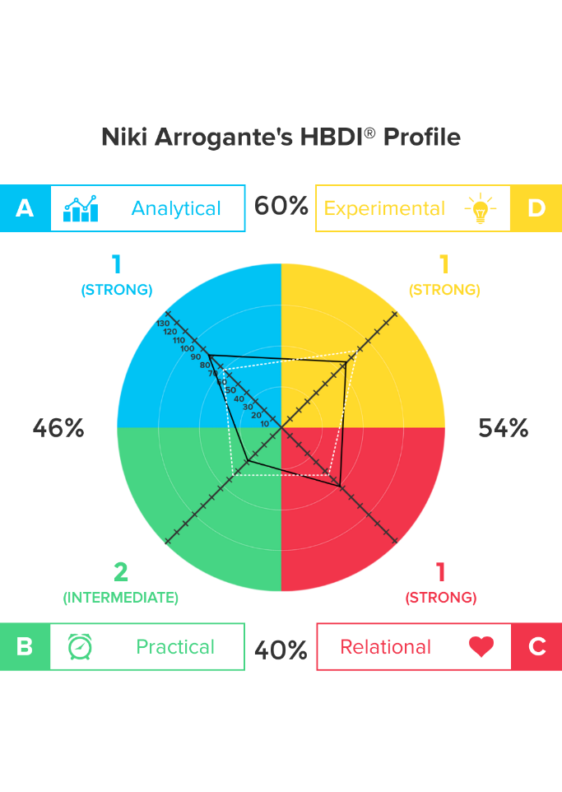

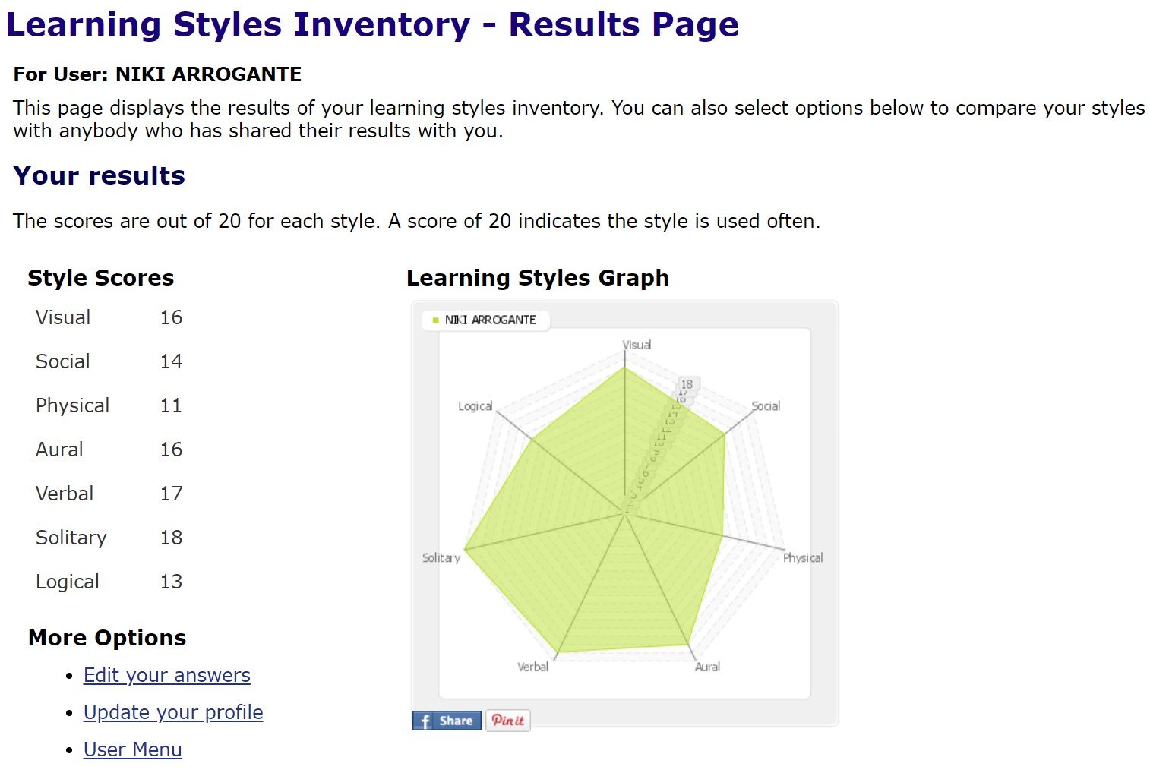

### Debborah Bryce

Mum of four kids, two cats, and two dogs, Debborah was born and raised in Australia with English Scottish heritage. Debborah plays netball on the weekends and currently works in IGA. She is fascinated with modern technology and enjoy learning new skills, languages and reading.

[Debborah’s Website](https://xerxasjade.github.io/Team25/Clone-of-Debs/)

Ideal Job: Data Analyst

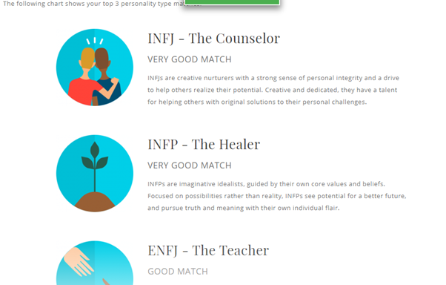

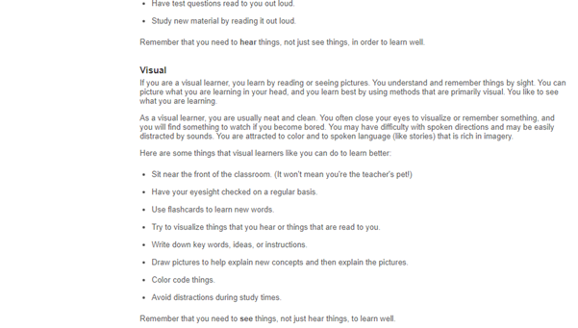

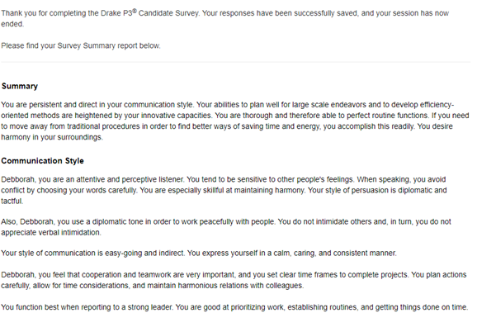

### Samuel Claydon

Sam is a proudly born and raised Tasmanian, living in a rural town named Kempton, which has a population of roughly four hundred. At the age of twenty-three, he is currently undertaking two online courses, our current “Introduction to IT” course, as well as an “Academic and Professional Communications” course. Sam’s passion for video games was discovered thanks to an old computer given to him by a family friend, and he has loved them ever since. After spending a lot of time with a professional computer repairer, he was inspired to pursue a career in the IT industry. <https://cadenmaxwell.github.io/Caden-Profile/>When he isn’t exploring the ins and outs of computers, Sam likes to spend quiet moments with a good book.

[Samuel’s Website](https://samclaydon96.github.io/My-Profile/)

Ideal Job: Computer Repair Technician.

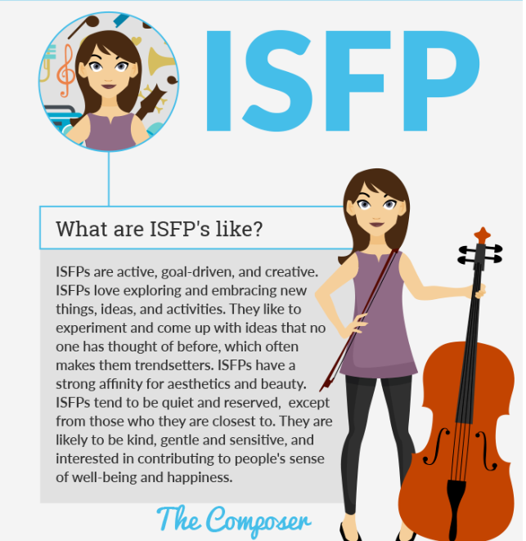

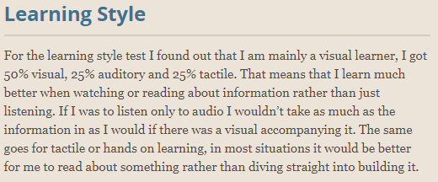

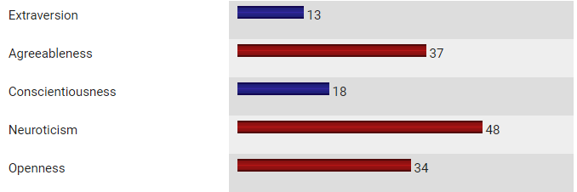

### Caden Maxwell

Caden hails from Wagga Wagga in New South Wales and is of Australian-New Zealand descent. He recently completed his high school and HSC, during which he studied many IT-focused subjects including “Information and Digital Technology”, “Software Design and Development”, and “Information Processes and Technology. Caden is now working his way towards a Certificate III for IT.

Caden was the newest member to the team, but quickly assimilated and contributed greatly to our report.

[Caden's Website](https://cadenmaxwell.github.io/Caden-Profile/)

Ideal Job: Software Developer (Gaming/General Application)

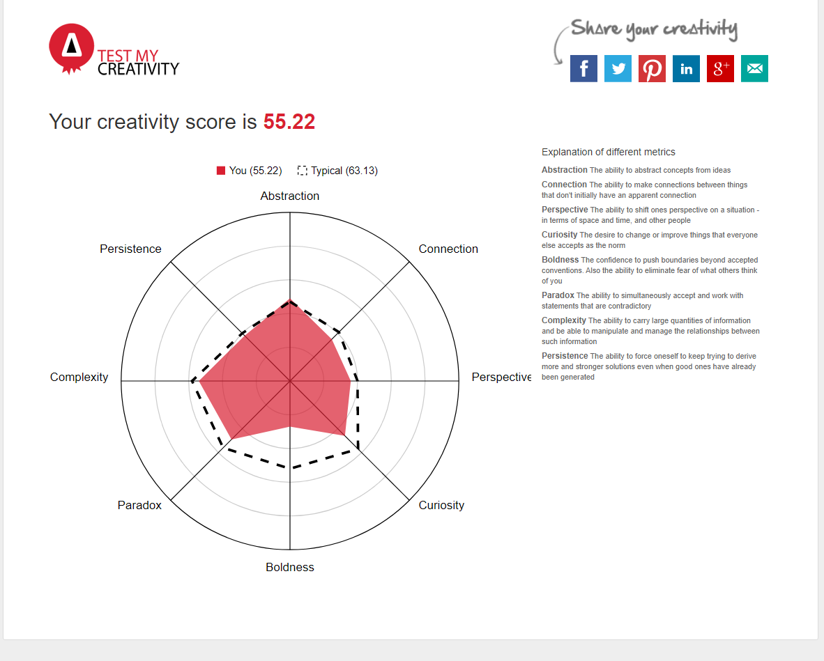

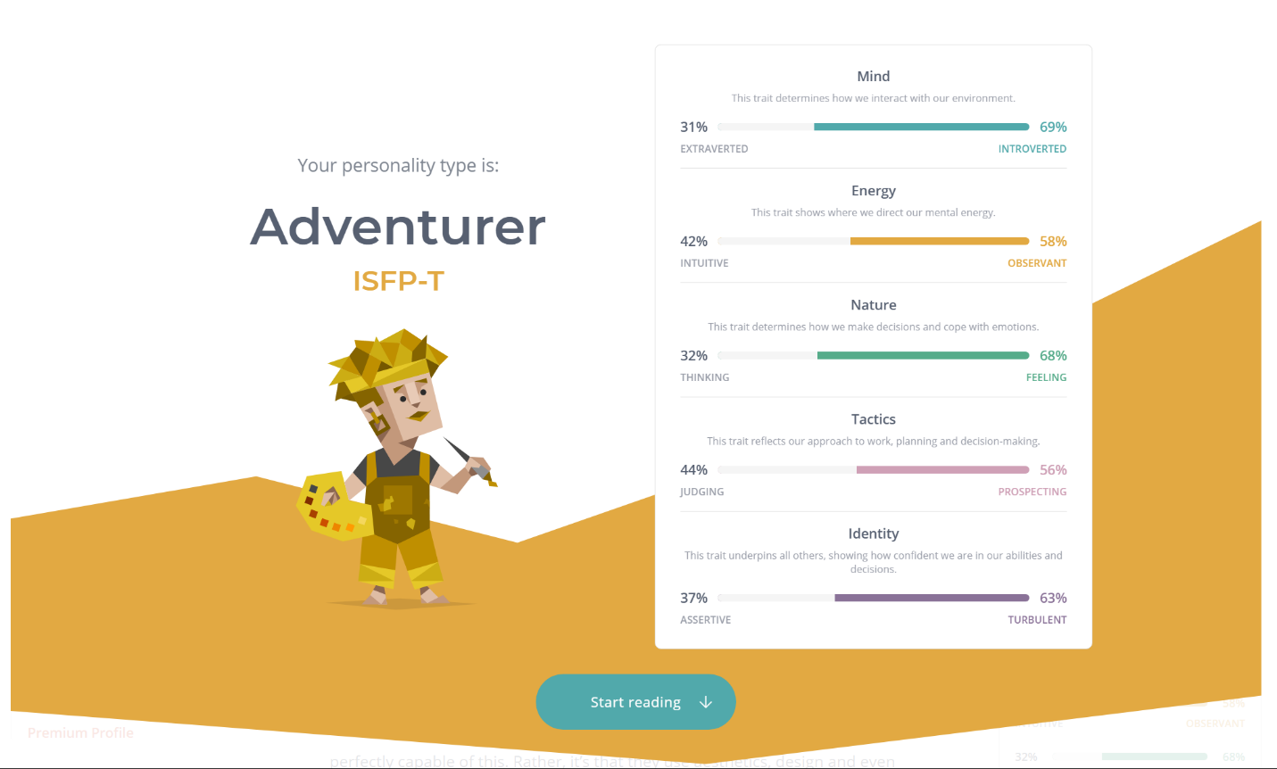

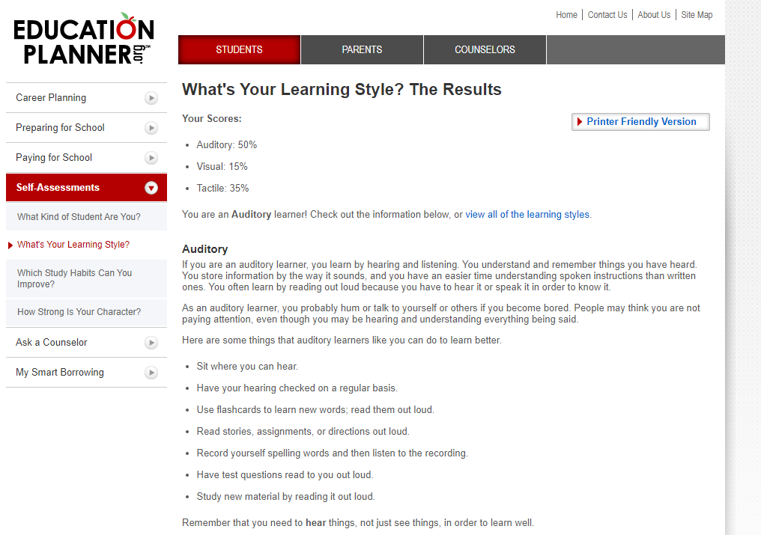

# Group Processes – Looking Back on A2

Operations in our previous assignment ran smoothly thanks to strong communicative practices and agile time management. Unfortunately, we received some scathing feedback on the quality of our output in the previous assessment regarding the quality of our answers, and the underwhelming lack of imagery.

In response, we decided to take it back to the drawing board to find a more attainable project, which will be detailed further in this report. While this change foresaw roughly a fortnight’s loss due to the intensity of the change, we concluded that moving to a smaller project would allow us to produce a more polished and focused product.

In a stroke of poor luck, we unfortunately lost some members during our preparation for this project. This resulted in almost a week’s worth of productivity lost.

We intend to take this feedback to help guide us throughout this report and attempt to correct the errors made previously.

# Career Plans

The team took a moment to consider their career plans and discuss what we thought of them. Here is what we had to say:

Niki

Right now, my hope is to find a flexible working life in the future. While I do plan on entering the industry within an established company (preferably working as a programmer/developer but my working history gives me plenty of options), I intend to build a strong portfolio with independent projects and take a stab at working as a freelancer/indie from home. Honestly, I just want to spend more time with my partner and daughter, and my plans are always open to change with that in mind.

Debborah

My career plan is to become qualified and accredited to be able to use data analysis software, data entry, data visualisation, MS excel and other programs. I will also work towards certification in programming languages such as Python, SQL, Oracle etc. I will also need to do a mathematics course to refresh my knowledge. I would really like to work in medical research or social health setting.

For the next 3 years I will work towards a degree in Data science or data analysis as well as a degree in Information Technology, so I can have flexible work options such as working remotely or onsite. I would also like to work or volunteer for charities in a business analysis role, which would require a certificate or degree in business analysis.

Samuel

My career plan is to get a degree in information technology so that I can eventually get a job as a computer technician. I’m not sure where exactly I would want to work but I’d like to work on a variety of PC’s and systems so being a contractor sounds good for what I want to do. I don’t have any experience, so I’d probably need to start in a different position than I want. From there I would learn as I work to become qualified enough to join a bigger company or maybe start my own.

Caden

My career plans are to finish university with either a degree in computer science or information technology, from there I want to be able to work as a contractor for software development so that I can be my boss and work from home. After earning enough money and skills, I would like to start my own business in the software development world.

If I can start up as a contractor I would find a reasonable business to work for, one that I would find enjoyable to do development for and that pays pretty decently, I would join the company as high of a position that they would offer me and try to work my way up so that one day I would be able to run my own business.

## Comparing Our Plans

It appeared that most of us had a vision of working contractually after achieving our degrees. We shared sentiments of the nature of what the IT industry was like in terms of employment, and for the most part agreed that building a portfolio of our own as contractors would yield more success in finding secure employment.

We all valued flexibility as part of our career plans, lockdown status notwithstanding. Our individual lifestyles appreciated the idea of having our careers work around our personal lives, be it family, ulterior goals, or simply to have more time to enjoy hobbies (which luckily could coincide with some of our careers anyway!).

There were unique aspects in each of our goals: Niki was prioritising the flexibility to spend more time with his family; Debborah was the only one whose plan was strictly aimed at employment with a company and not pursue contracts; Samuel shows more interest in the physicality of the IT industry over the digital; and Caden has set his goals for higher, more demanding positions.

It is surprising to us how different and similar our goals were at the same time and emphasised how vast the industry was. We also deduced there was great potential to diversify our plans as we discovered more about the field. However, we all agreed that studying has helped us plot our paths more accurately, and are eager to see where we’ll be in another three years.

# Tools

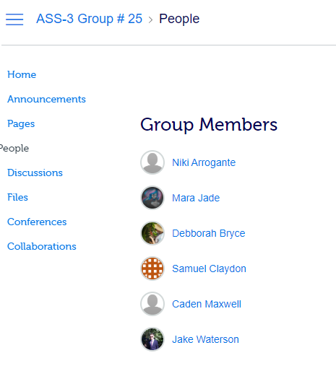

(Note: Jake and Mara still appeared on our team in Canvas, but were not longer taking part in the course by this time)

As with our previous assessment, we all fell in line with Canvas’s group but had no real use for it as we were already established with our previous tools, **Microsoft Teams** and **GitHub**. We previously also used **Trello**, however due to the reduction in team size we felt it would be less beneficial and instead opted to keep things simpler.

Much like our old team website, we have set up our [website](https://s3851498.github.io/Team25a3-5/) on GitHub with a repository [here](https://github.com/s3851498/Team25a3-5). Conversely, we used two separate repositories for file organisation and the website due to unforeseen difficulties in taking up a website from a now-defunct member.

The GitHub this time around is more accurately able to represent our progress, or rather, it emphasises the lack of productivity in the starting weeks due to the teammate dramas, along with the perseverance of updates once we were back on track.

## Microsoft Teams

As with our last assessment, Microsoft Teams is the backbone of our collaborations. We set up team channels to hold and distribute information and hosted our team meetings via chat and voice through the team chat.

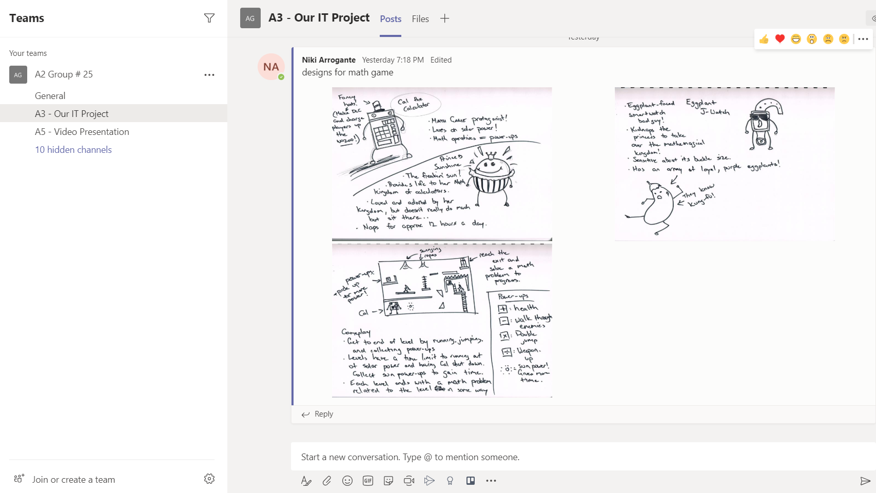

Learning from past grievances, more organisational efforts were made to try and streamline the flow of information. Less separate channels have been used compared to last time as we found it became tedious to cycle through them all. Older channels were archived, and we shared our work through two channels: one surrounding the report, and the other for the video presentation.

## GitHub

While we have continued to use GitHub for our website and file hosting, our experience is still lacking on maximising its potential. The initial setup for our website began with copying over our previous website from Tamara’s GitHub to our new one, hosted by Caden.

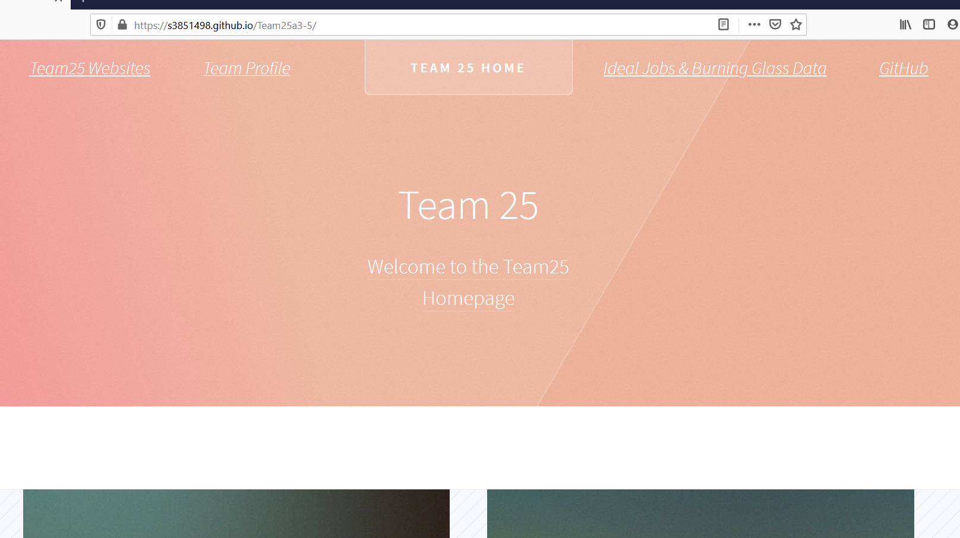

Unfortunately, the website was not hosting properly and could not be shared. This was rectified by Niki creating a separate GitHub for the website away from the rest of our files. We also found we did not have the details for how Tamara set up this website and could not redesign banners in a way that would fit the rest of the site.

Time constraints did not allow us to troubleshoot this in time for submission, but preferably this would be fixed early in the hypothetical work cycle posed by the assessment.

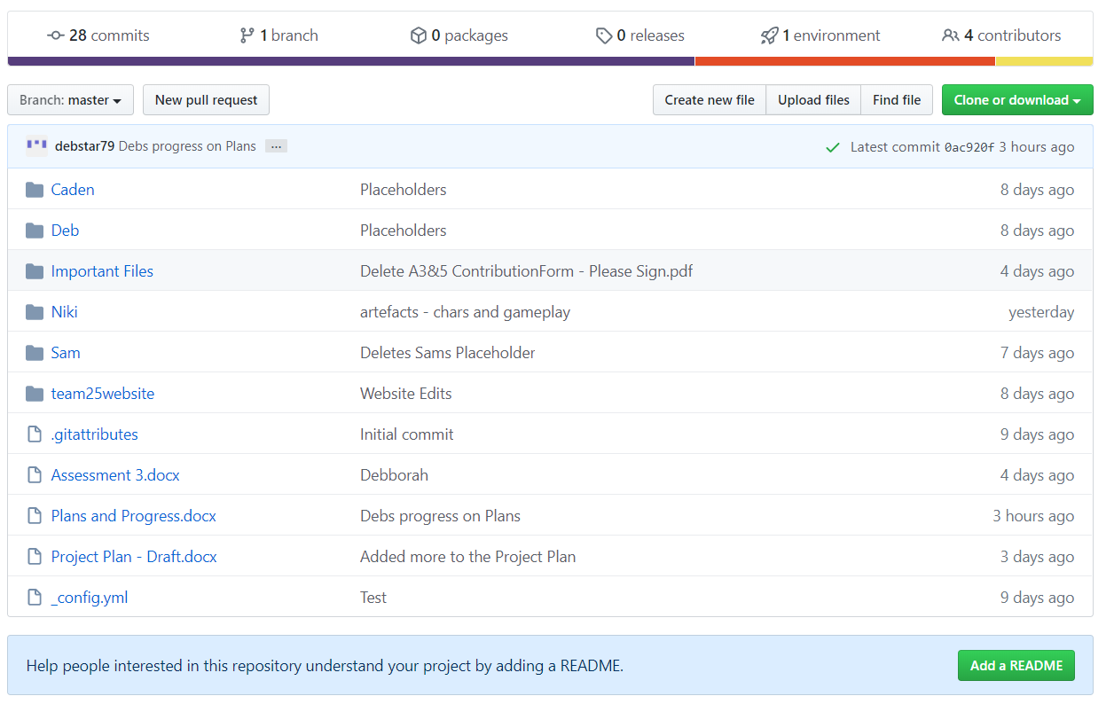

Individual folders were created to help us keep our files better organised, as previously we were bogged down by a slew of files lacking any order or administration. Some of our members still had a hard time understanding how to use their folder, but the result was still a step up. In the future, we would look at providing additional training and support for our less technically minded personnel.

# MATH GAME – Our New Project

Written by Samuel, co-written by Niki:

Team25 have been conceptualising an application that was realistically producible, while also retaining the virtuous nature of our previous aspirations. As we discussed our options, we aimed to incorporate gaming, as it turned out to be one of our shared affinities.

MATH GAME is designed to be an interactive and engaging application to help teach and produce interest in mathematics for young audiences. We foresee it being readily available on release as a PC/iOS release, focusing on Apple’s App Store and Microsoft Windows.

Our personal enjoyment of video games aside, gaming is a remarkable industry giant in modern society and holds global appeal. In 2018 the gaming industry generated a revenue of $US119.6 billion (Webb K. 2020) and is forecasted to keep rising. With more families staying home in the current situation, we hope to take this as an opportunity to present our product as an option for continued education benefits at home, or in situations where schooling may be affected.

The landscape of the gaming industry is extremely diverse and continues to expand. Our success in the market will depend on superb marketing and a polished product. Educational games are a niche genre now and are not typical to critical acclaim. If we can elevate an educational game to a more prolific status, which we hope to do with MATH GAME, we believe that we can direct the industry to creating more edutainment games such as ours.

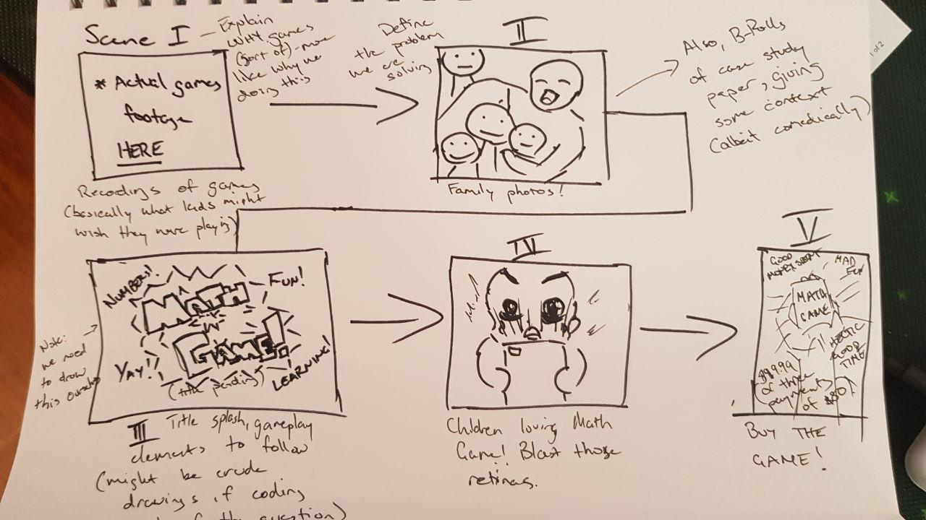

## Aim

The aim of our project is to create a story-based educational game than will keep children interested and make them want to keep learning. Most educational games are repetitive and become boring after a short time, our goal is to make our game appealing to kids so that they want to keep playing, and by playing more continue to learn. The success of our product will mean that parents and teachers have an effective tool for trying to keep their kids focused.

For our first goal, we want a presentation design that can capture the attention of young learners. We will need to get together and brainstorm the whole story, then we will have someone write up a rough draft so we can work out anything that might be wrong with the story or might not appeal to kids enough. After sorting out any problems the whole story will need to be written.

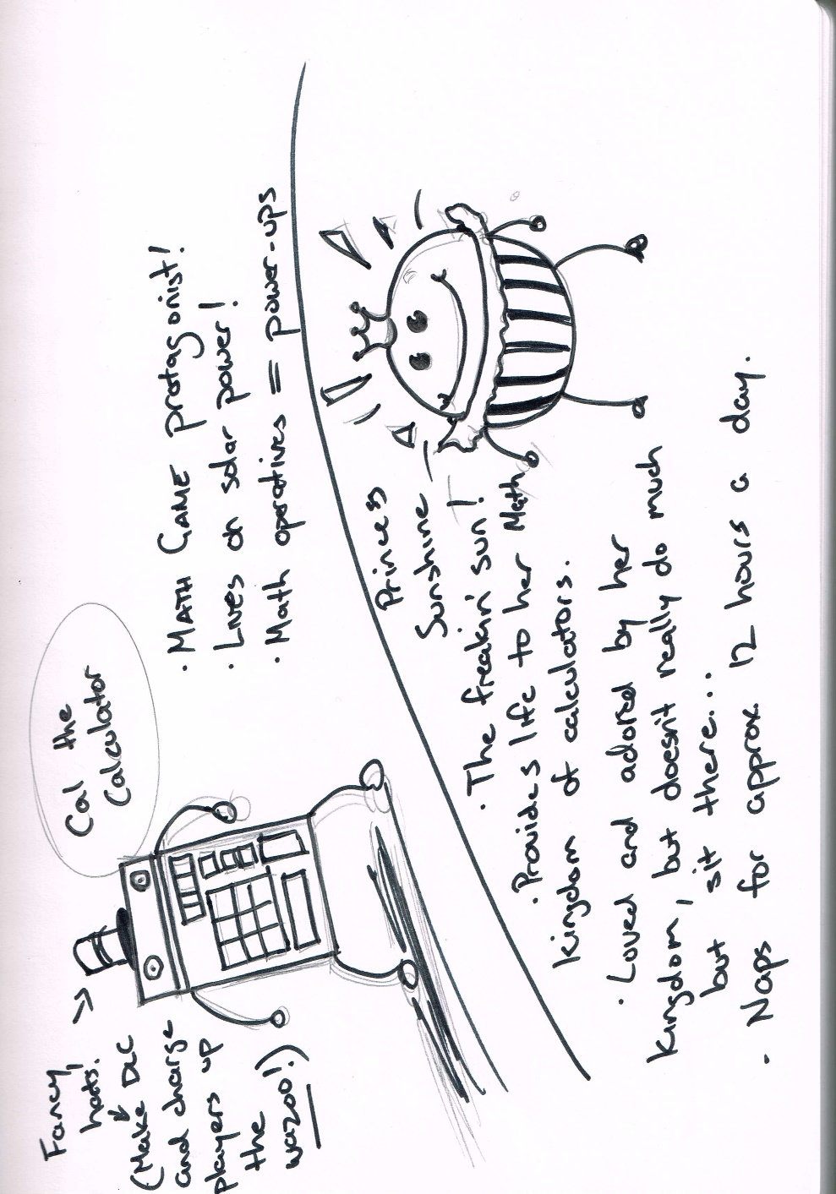

Second will be choosing the style of game and the gameplay. If the core gameplay is not engaging, there is not much that separates our project from a visual novel. The gameplay must be both fun and educational, while also keeping with the general theme of the story. We will need to create a prototype of the game so that we can test for any bugs that pop up, and then decide if we like the gameplay or want to change it to something else.

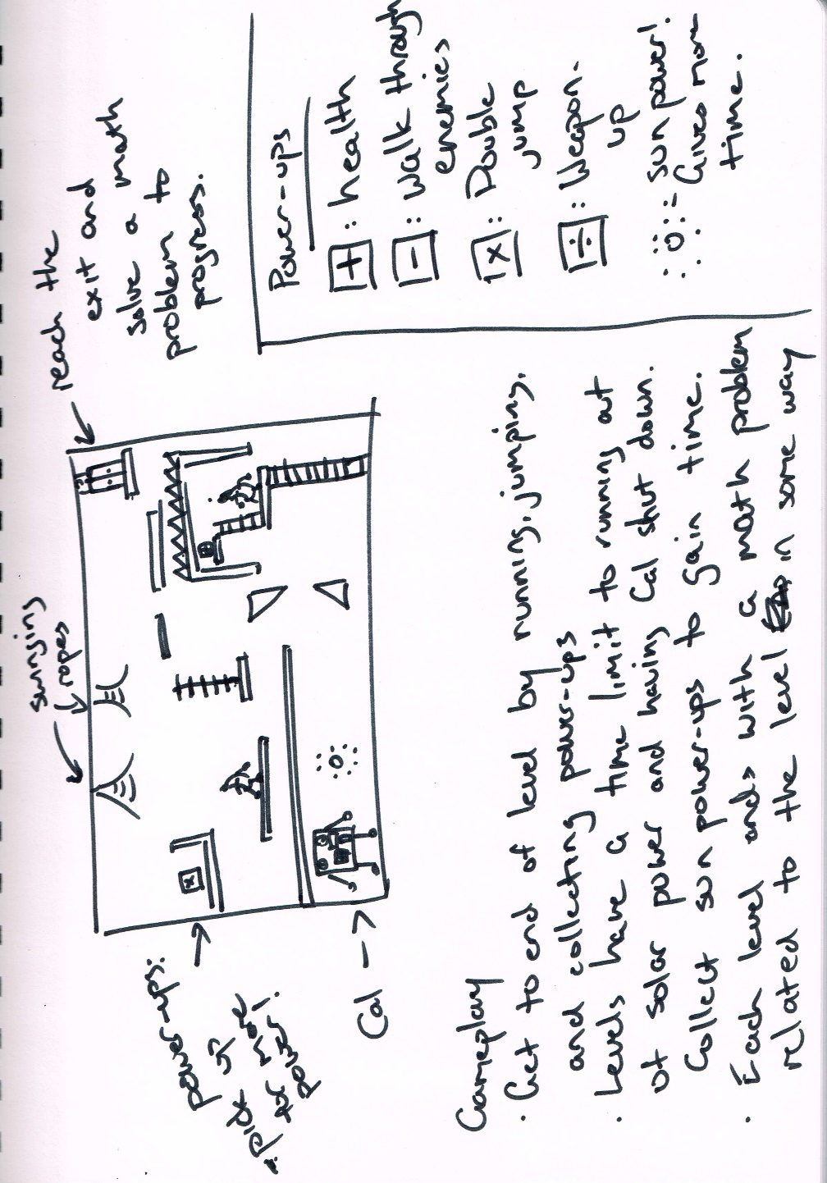

Third we will need to work on the animations and art we want to put into the game. The story would become boring quickly without some artwork to go along with it. This will be heavily based off the story, at a basic level we could include drawings of scenes during the story but if we have enough time, we could include cutscenes for important parts of the story. The artwork will already be described in the story, but we need to make sure the character artwork looks interesting to keep kids engaged.

Next we would need to find and decide on what variety of math problems we would put into the game, we’ll need to research what kids from age 6-10 are learning in school and create different sets of problems to implement into the gameplay. With different sets of math problems, we could create different levels of difficulty so that our game could be useful for students at different levels of learning. It is important to devote research and development to the difficulty curve as well, so students will be challenged adequately without feeling they are incapable.

With the main core of the game in the works now we would need to start work on music and possibly voice acting. A simple background track would add a lot to the gameplay and story, we’d need to decide what types of music we want at certain points of the story and then either create it ourselves or find some music online that is royalty free or we like enough to buy it. If we have enough time and resources, we could consider voice acting for each character or maybe just a narrator.

At this point we would have a prototype which we could put together and test it for bugs and organise to have children try it out. We would try to organise a children’s focus group to get them to test the game, doing so would give us the feedback we need and potentially find more problems with the game that we didn’t think about or notice prior.

After the testing we’d be moving into the final stages of the project, the game would need to be finalised, all the other goals would need to be complete and any problems that occurred during development would need to be fixed. Now we would need to make sure the game will work on platforms other than windows, such as iOS, Android, and Mac so that we could launch the game on as many devices as possible.

## Plans and Progress

Written by Debborah:

When we started our original project idea in Assessment 2, we had a full team of 6 people. Our initial project idea was to develop some glasses that could be used by the disabled to communicate within their world.

The glasses (which we would base off Google eyeware) would use similar technology to the eyegaze application on devices, or eye tracking technology, the user would look at words or phrases to activate the voice or audio translation, to allow them to have a voice.

Although this idea seemed to be great we ran into more and more problems as we pushed through and submitted it. We defiantly needed more guidance and expertise to get this off the ground, to be a successful invention. But, coming up with the artefact, accessing trademarked glasses and the licensing around this would of meant a lot of work and we probably would have been met with a lot of negative or “no” outcomes.

When we received our feedback from Assessment 2, it was confirmed that we would have to look at starting our project idea again and abandon our original plans. After seeking permission from our instructor, we switched plans and decided, after much discussion within the team, to go with an edugaming idea.

The educational game would be targeted at math-based learning and designed for primary aged children (6years to 9years). This idea was based on the current environment of home learning because of the COVID-19 lockdowns. Talking amongst our selves in team chats, we realised a lot of parents were struggling to engage their children to complete or attempt learning task, instead of playing games.

During week 9 we lost a team member, this was disheartening but we were determined to share the load and achieve our tasks. Week 10 saw another loss of a team member bring us to 4 members. Our educator suggested we apply for an extension, which we applied for after a few days of discussion and were granted a week’s extension.

This meant that between the 4 of us we would have to take on more work each, as daunting as this seemed we managed to help each other and get the tasks and sections completed.

We looked at other games and apps that are already available for inspiration and decided on a story-based game with maths problems to solve so that you could get to the next level. Our story board was based on a rough sketch of characters and how the levels would roughly look. Niki took care of this part, it was his creativity and drawing skills that brought the game components to life.

We would ideally like to see our game being used on mobile devices, tablets etc through IOS and PC platforms, Unity which uses programming codes C++ and javascript would handle the digital aspects of the game, Niki and Caden have experiences with older versions of Unity (Legacy) but have no experience with Swift. It was also suggested that if this game idea was to succeed at this current time in real life we would have to outsource the programming to more experienced persons.

The name of the game was named “Maths game title pending…” which we decided to leave. Another problem-solving game on the market is “Untitled goose game” which is very popular and the writer would like to think we are paying homage to this game.

The video report was done in the style of an advertisement which was created by Caden in collaboration with Niki, Including stills, example of play and voice overs.

Since the former GitHub website was hosted by another team member that has now left, Sam recreated a website on Niki’s Github repository for uploading to RMIT’s canvas website.

If this project idea was to be handed over to another team or extended for another 10 weeks a few things would need to be done.

Thorough research on marketing the game, would we start with a free download then pay to get further levels? Would we have a benefactor, investors or develop our own company with outsourcing the programming as we lack the skills in this department. How much actual time and money would it cost to achieve these things as well as advertising and licensing the game

What kind of educational expertise would be use? Teachers, researchers and class-based surveys on primary aged children. Could we perhaps collaborate with teachers and researchers?

How would we go about measuring the success of the game and what would be the most effective way to test or get feedback on the enjoyment and educational value? After all we would like it to encourage children to take an interest in maths and hopefully perfect their base knowledge of simple maths problems like addition, subtraction, multiplication and division. Game based learning or learning through play has been widely researched and theorist like Piaget, have done successful research on the success of learning through play.

Now on the verge of submitting our project, we have all agreed that this has been an interesting and challenging project. If we were doing this in a company or for a company or workplace it would have run more smoothly and stress free if we could replace our 2 team members that left, this does happen in real life and it is over come, but as humble students learning about the Information Technology industry the writer feels we did very well considering our circumstances.

## Roles

Internally we will be dividing ourselves into four core aspects: programming, research, design, and administration. Outsourcing would be a consideration, but in the mindset of operating with minimal budget, the goal will be to produce everything inhouse unless a publisher deal is obtained.

Programming will cover the digital aspects of the game, primarily the coding and work through Unity. Caden is our inhouse lead on programming and will be responsible for the process.

Design will be a blanket covering of all creative aspects for the game, including visuals, audio, story, and characters. Niki will take charge of the design and collaborate with Caden often.

Administration handles the physicality of the project, operating the office (if existing), handling finances, and preparing equipment and process as required.

Research will dictate the method in which education is delivered within the game by collaborating with research and educative bodies to ensure the product is effective.

## Scope and Limits

Within the scope of the project, we are aiming for a very playable beta build. It should be a completely working product, but potentially underwhelming in features. With the time limit we expect to leave out some features that we would have liked to include. Voice acting and cutscenes will likely be left out of the game for budget and time constraints.

## Tools and Technology

As we intend to release on iOS and PC, we plan to start our initial programming on Unity for its multi-platform compatibility, as well as its active community. The design of our game should not be exceptionally complex that further tools would be required, but a foray into the Swift programming language may be undertaken if the benefits seem worthwhile.

Our team’s experience with Unity is older than preferred, with Caden and Niki having used legacy versions of Unity, and nil experience with Swift.

## Testing

Consistent testing to make sure there are no bugs and that everything is working smoothly. When we’re at a point where we feel the core of the game is ready, we’ll organise a children’s focus group consisting of children aged 6-10 so that we can get the people the game is made for to try it and see if they enjoy it. We could create this group by advertising that we’re making a game and are willing to pay if parents will let their kids try it out for an hour or so, we’d ideally get about 6 kids to help us test the game. Based on the feedback from that we will learn what children in that age bracket enjoy or dislike about our game.

## Timeframe

|  |  |  |  |  |
| --- | --- | --- | --- | --- |
| **Week** | **Caden** | **Debborah** | **Niki** | **Sam** |
| **1** | Short break after last assignment. | Short break after last assignment. | Short break after last assignment. | Short break after last assignment. |
| **2** | Spent a week waiting for a team member who left the course. | Spent a week waiting for a team member who left the course. | Spent a week waiting for a team member who left the course. | Spent a week waiting for a team member who left the course. |
| **3** | Decided on project idea and set roles. | Decided on project idea and set roles. | Decided on project idea and set roles. Wrote storyboard for presentation. | Decided on project idea and set roles. |
| **4** | Started working on presentation, wrote career plan. | Started skills and jobs section of the report, wrote career plan. | Wrote career plan and the reflection on the career plans. | Wrote career plan. |
| **5** | Working on presentation and website. | Finished the skills and jobs section of report. | Started on report consolidation and artefacts. | Began work on project plan. |
| **6** | Finished presentation. | Helped finish project plan. | Finished website and artefacts to deliver. | Finished project plan. |
| **7** | Assigned to programming team, begin coding MATH GAME with Unity. | Assigned to research and analysis, begin researching education techniques. | Assigned to creative team, begin designing the audio, visuals, story, etc. | Assigned to office and information administration, procure necessary equipment and forecast budget. |
| **8** | Completion of the alpha build of the program. Present to team at end of Week 11. | Prepare and present guidelines for the delivery and quality of educative aspects. Present at end of Week 11. | Complete final design draft. Present at end of Week 11. | React to the needs of the team, present budget meeting at end of Week 11. |
| **9** |
| **10** |
| **11** |
| **12** | Begin beta build following feedback and collaboration from team. | Begin organising test groups with relevant parties (teachers, students, educators) with the current builds of game. | Finalise designs and collaborate with Caden to code into game. | Prepare the product for test groups, test and QA different platforms and available hardware. |
| **13** | Collaborate beta build with Niki for finalising video/audio cues. | Obtain testing feedback and provide Sam results. Begin marketing campaign with education sectors and consumers. | Collaborate beta build with Caden for finalising video/audio cues. | Advise Niki and Caden on compatibility, test group response, and QA feedback. |
| **14** | Finish a representative beta build, polish where plausible. | Continue marketing campaign. | Assist Caden with final beta. | Assist Caden with final beta. |
| **15** | Potentially have a completed beta for an Early Access release. Alternatively, settle with a proof-of-concept demo release to garner interested parties. | | | |

## Risks

A major risk for our project is that we might not be able to assemble a focus group to help us test our game. Our game is focused towards young children which means it can be hard to decide whether they like the game or not without proper testing. While we have some experience programming there is always the risk that it will be tougher to figure out an aspect of the coding language than we imagined, which could lead to big delays with game development.

The financial side of the project also carries risks, as we are assuming to operate without a publisher or benefactor being confirmed. It may be fiscally unreasonable to expect the game to provide a revenue that would be profitable, especially if we miss our mark on getting an audience.

The industry as a whole is extremely competitive as well, and we must be ready to provide a product that is of high quality, otherwise it will not stand out of the crowd enough to gain traction.

## Group Processes and Communications

Our group communicates using Microsoft Teams, we use text chat almost daily as well as holding a group meeting in voice chat once a week. We have each other’s email addresses so we can email them directly in case anything goes wrong. Early in the project we had a group member who was previously very active go silent on us, we lost a week waiting for him and it turned out he left the course. In the future if a team member stops responding we will be sending an email quicker or try to work around the absence in other ways.

# Skills and Jobs

As a leader of a 4member team, I would surmise that the following positions would be necessary and appropriate to finish our Educational Maths Game App.

**Game Designer**: According to, https://study.com/articles/Game_Designer_Job_Info_and_Requirements_for_Becoming_a_Game_Designer.html,Study.com(2020) these are the skills and qualifications for a Game Designer.

Degree Level Bachelor's degree

Degree Field(s) Game design, computer engineering, or computer science

Licensure/Certification Certification in programming languages and certificates available

Experience Sample projects typically required or having worked on similar projects.

Key Skills Creativity; knowledge of computer systems and languages; communication, collaboration, and project management skills

Associate's degree in web design or a similar field, would be highly regarded, web developers can create and design websites, sometimes creating the content.

**Gaming Engineer** Learn.org (2020) suggests that Gaming Engineers have the following required skills and qualifications

Degree Required Bachelor's Degree

Education Field of Study Game programming, game software development, coding for gaming

Key Responsibilities Developing software; programming, planning or testing the software used for the game.

Experience Proof of previous project work.

**Game Programmer**

Degree Required Undergraduate degree in Computer programming and coding

Education Field Computer science

Key responsibilities Working with the other team members to ensure coding languages and programs test and run well.

Experience Previous similar project experience with game development

**Analytics and Marketing**

Degree Required Bachelor Degree in IT with Marketing and analytics Certifications

Education Field Information Technology, Marketing and analytics

Responsibilities Promoting the game, gathering useful data to help with the development and finalisation of the game, communication and breaking down the test results, finding the target audience, selling marketing the game.

# Group Reflection

Written by Niki:

*This one time, we tried to bake a pie.*

Our team has had an unfortunate series of events throughout this assessment and has been significantly more difficult to get through than our previous one. While I could list any number of factors – the rough feedback, people leaving unannounced, teammates with varied abilities and availabilities, the difficulty of working with unknown software and newly acquainted people – in the end, we can only be marked for what can be seen.

One thing that defined our team greatly, as may be evident from our contribution forms, is that we believed in an equal footing for everyone. We all make the effort we can, and we all receive a slice of the pie.

Dividing our tasks to accurately represent a quarter of the work was difficult to say the least. It was certainly less strenuous with a team of six, however I think the blow to our confidence came more from the shock of the revelation, rather than the loss in manpower. Ultimately, we divided the work with the intention of having us each support each other where we could.

Intentions can only carry us so far however, and with varying degrees of ability and availability, the ride was rough. But we all put our noses to the grindstone, and continued working on the project through our extension, virtually up to the last hour. Simply put, we should have managed our time and expectations better.

We do not want to say that this is the best work we can produce. We want to say that we learned a lot through this project. We have discovered some personal strengths, as well as weaknesses. We realised how much we learned about IT in general, and yet also how much farther we must go.

This paper will probably not be proofed to perfection. It will have some contrasts in tonality and grammar that our last paper did not. Our referencing styles will not match throughout the paper, because we ran out of time to add polish and editing. As a case in study, it will scream confusion and chaos.

We know this project did not go perfectly. We know that no matter what caused it, we had to scrape through by the inch of our teeth. And we know that at the end of the submission time, we will not be in any hurry to look back on this experience.

*But we baked the damn pie.*

The taste is a bit weak; the crumb is a bit off… but I guarantee you this, on behalf of Team25.

*We know what* ***not*** *to do next time.*

# References

*Project Plan:*

Webb, K., 2020. *The $120 Billion Gaming Industry Is Going Through More Change Than It Ever Has Before, And Everyone Is Trying To Cash In*. [online] Business Insider Australia. Available at: <https://www.businessinsider.com.au/video-game-industry-120-billion-future-innovation-2019-9?r=US&IR=T> [Accessed 28 May 2020].

*Skills and Jobs:*

[https://study.com/articles/Game_Designer_Job_Info_and_Requirements_for_Becoming_a_Game_Designer.html Retrieved May 14th 2020](https://study.com/articles/Game_Designer_Job_Info_and_Requirements_for_Becoming_a_Game_Designer.html%20%20Retrieved%20May%2014th%202020)

[https://learn.org/articles/Game_Engineer_Your_Career_and_Salary_Questions_Answered.html Retrieved May 14th 2020](https://learn.org/articles/Game_Engineer_Your_Career_and_Salary_Questions_Answered.html%20Retrieved%20May%2014th%202020)

<https://gameanalytics.com/blog/category/marketing>

Retrieved 15th of May 2020

# Credits

Niki Arrogante – s3851498 – Team Leader, Report Writer/Editor/Designer, Organiser, Creative Lead (Drawings & Concepts), Website Host, Time Planner (w7-w15)

Debborah Bryce – s3853719 – Writer of Plans and Progress & Skills and Jobs, Project Collaborator

Samuel Claydon – s3857563 – Project Writer, Website Editor, Time Planner (w1-w6)

Caden Maxwell – s3853897 – Video Producer/Editor, Voice Artist, Repository Host