**Table of contents**

1. Personal Information 2

2. Interest of IT 3

3. Ideal job 4

4. Personal profile 6

5. References 8

**MY PROFILE**

# **Personal Information**

My full name is Nguyen Luu Quoc Bao. You can also call me Kyle. I am currently a freshman in Information Technology major at RMIT Viet Nam with the student ID number of s3877698. I was born on August 10th2002, in Soc Trang city, which is located about 300 kilometers south of Ho Chi Minh city. Having finished tertiary education, I can speak two languages, including Vietnamese, my mother tongue, and English, the RMIT's official language. I consider myself a sporty person as I love participating in playing physical sports such as basketball and badminton. I have taken part in some basketball tournaments and have gotten some achievements. In terms of mental sports, I can play chess and esports, such as leagues of legends. This kind of sport helps me relax very well after stressful working days. Besides sports, I love studying science subjects, especially in chemistry and English. When I was in high school, I participated in chemistry and English competition, in which I achieved second prize and consolidation prize, respectively. For contacting, you can reach me through my email: [s3877698@rmit.edu.vn](mailto:s3877698@rmit.edu.vn).



**Figure 1***. I was competing on a tournament while in high school*

# **Interest of IT**

There are various great fields in information technology such as the Internet of things, big data, front end development, and machine learning. Honestly, I want to discover all of those advanced knowledges in the future, but if I had to choose the most attractive ones, it would be machine learning. The application of artificial intelligence in that helps people in numerous ways, including physical-required tasks and metal-required tasks. A clear illustration of this is that self-driving technology has facilitated the moving activities of people. They do not have to put concentration on observing the road and adjusting the steering wheel to control the situations safely. Furthermore, voice recognition, which is a popular application of machine learning, allow people to control electronic devices by speak out the command or use their voice as a password. This technology saves lots of time and makes things more accessible. In the future, I think this technology will be more and more developed.

Soc Trang, where I have lived for the better part of the last 18 years, is a small town. Therefore, students hardly expose to computers or modern devices. It was not until in grade 8 that I learned Pascal in my computer science lesson. I found it quite impressive at first. However, I gradually realized that this programming language was out of date, and I started to learn Python after four years. Moreover, one of the inspirational events leading me to the IT pathway is when I saw the automatic selling system in Australia's supermarkets during the summer camping tour last year. I found that this automation can reduce a great deal of budget for hiring staff. Furthermore, it saves a significant amount of time as customers do not have to wait to be changed or check barcode. All the processes are executed almost immediately by the products recognition technology. This modern technology put on me a motivational impact to follow the IT program for the university.

My motivation in IT is not only led by me but also my family, friends, and an old teacher. He taught me maths in secondary school. Despite being an aged teacher, he is a high-tech person who always learns about new technologies and re-teach it to his students. He day-by-day instructs me to AI and many interesting things related to IT. Gradually, my passion for IT is bigger and bigger, which leads to my decision to follow the IT pathway.

Having determined the destination, I spent a great deal of time searching and comparing many prestigious universities. At first, it was confusing because I found that many universities are leaning towards theoretical knowledge, which makes the learning progress inactive. Moreover, subjects which are not related to the major such as philosophy and physical education are compulsory. Those kinds of subjects take much time, which put a strain on the students as they are too tired with theoretical knowledge. Finally, I came across RMIT website while surfing the website. Through discovering, I have found that RMIT is a prestigious international university, whose students stand an extremely high chance to land high-paid jobs after graduation. Furthermore, this university is famous for high-quality education as well as the facility. Another reason is that the lectures are taught in English, which progressively develops my English for other purposes, such as attending the exchange program provided by RMIT.

Hopefully, I am looking forward to absorbing not only new and advanced knowledge in IT but also developing soft skills and working skills. In terms of IT knowledge, I cannot wait to study programming, website, machine learning, and a myriad of knowledge that I have not known before so that I can work effectively after graduation. Besides, it is undeniable that soft skills such as communication, events operation, and presentation skills play an essential role in working. I think the projects will help me develop myself on this aspect. Moreover, I hope to achieve more in self-study and teamwork skills, which is crucial for collaborating with colleagues. In terms of physical development, I hope that I will be fit and healthy to meet the deadlines by joining basketball club of RMIT. The last thing that I want to achieve is good relationships since studying at RMIT. I hope that I will have more good friends, in whom I can trust and share happiness as well as sadness.

# **Ideal job**

My ideal job is to become an employee in the major of Senior Web Developer of Cloud Nine Solution, which is a prestigious software and web development company: <https://itviec.com/it-jobs/senior-web-developer-java-php-python-cloud-nine-solutions-1444>

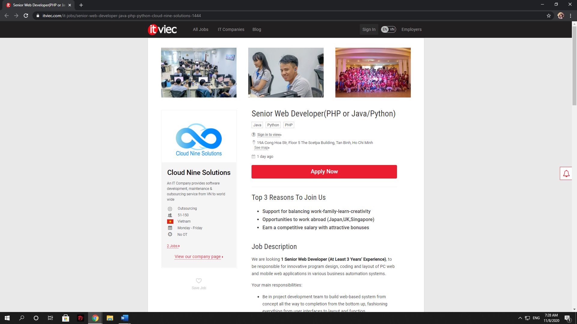

**Figure 2**. *The web that offers job*

The primary purpose of this job is to build full-stack websites using HTML and CSS in projects, which require the developer to build the website and design the interface and layout. Also, this job requires coding, testing and using best software development practice. Moreover, developers have to create software and maintain it monthly. Besides, integrating data various from backend and database is also a required skill.

There are myriad of offers that attract me to this occupation. Firstly, this company provides advanced pieces of equipment, which facilitate my working process as physical errors such as broken mouses or keyboards will not frequently happen. Moreover, the working environment is suitable for me since they have separate areas for developers, which maximizes their concentration to create optimal products. Also, I have found that I will have chances working abroad at high-technology countries such as Japan, UK, and Singapore, which is very good since I have more exposure with foreigners and learn numerous useful things from them. Another critical point is that the salary is highly competitive, compared with others company. Besides, the company will bonus for employees with high contributions, which strongly attract me to this job. Finally, Cloud Nine Solution commit that they will support employees to balance between work and life, which helps me avoid being stress during the work. Therefore, I can spend more time on my hobbies as well as my family

The company require various skills, including soft-skills, communication skills, and academic knowledge. Firstly, the candidates must have at least three- year-experience in PHP, Java, or Python language. Also, the company requires deep knowledge in HTML5, CSS3, Bootstrap, jQuery and its plugins, responsive design. Furthermore, candidates must have a solid standard on web applications consist of security, session management, and best development practices. Additionally, the company require general understanding in Relational/NoSQL database systems, OOP, web application development, Git/SVN, Redmine, Eclipse, NetBeans, and Vagrant. Also, creativity in solving problems and good English is required by the company. Besides, having soft skills such as team management, teamworking, and communication skills offers candidates some advantages. In addition, having experience in working others programming languages such as C, C++, or C# brings candidates significant advantages. Having knowledge in Japanese with N3 certification is also highly recommended.

Currently, I have owned some of the skills required by the company. I have a solid standard of English. Besides, I consider myself a good teamworking person as I always encourage members and try my best to complete the tasks. Also, I have studied a little about human management in high school, which meets their additional requirement. However, I have exposed to Python for one month, which needs to be enhanced in the future. Similarly, I have not known about HTML and CSS for a long time. Therefore, I need to develop these academic knowledges in the future during studying in RMIT.

In the future, my plan is to study the crucial programming languages such as JavaScript, Python, C, and C++, which create a solid base for me to code and create software. Next, I will expand my knowledge to website and database aspect such as HTML, CSS, Git, and MySQL in my sophomore year. During learning those academic knowledges in RMIT, my soft skills such as teamworking and communication will be improved as while learning those subjects in RMIT, the projects are teamwork. In the senior year, I will contact the job shop for an internship at an IT company, which improve my background qualification as well as collecting more experience. After graduation, I am planning for further study at RMIT Melbourne in major of software engineering before coming back to Vietnam and apply for the job. Furthermore, if I have time, I will start studying Japanese, which brings me a great advantage for applicating to the company.

# **Personal profile**

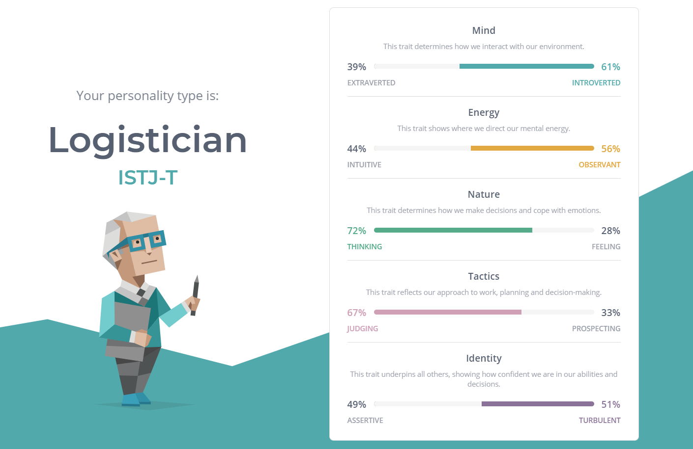**Figure 3.** *Result on my Myers- Briggs test* (https://www.16personalities.com)

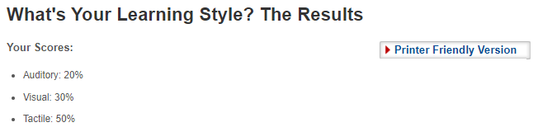

**Figure 4**. *Result on my learning style test (*https://www.how-to-study.com*)*

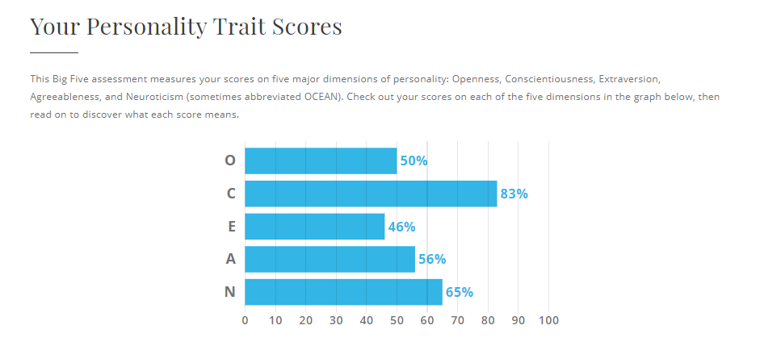

**Figure 5.** *Result on my Big Five Personality test (*https://www.truity.com*)*

As can be seen from the result, I am an introvert. However, the test points that I am a person who leans towards the reality, not the emotions. I let my head decide many things instead of my head. Generally, the tests point out that I am an organized person. For instance, I always make plans for my travel or study. Therefore, I hardly lost on the progress as I have my own navigation. However, the shortage of emotional may bring me some disadvantages in communication and relationship. Therefore, I will try to enhance my emotion for a better life. In terms of my learning style, I am a tactile learner, which means I use a lot of my vision and practical knowledge. Turning to the big five personality test, I lean towards conscientiousness and neuroticism, which are boldly related to thinking instead of speaking out for other people.

While teaming up, I rarely talk if it is not necessary. It would be better if the other teammate talks with me first and I will suggest some ideas and methods. However, I will speak up whenever a problem comes up as it may affect the result of the team if I do not speak out. Otherwise, I will try my best to complete all tasks given and help my teammate if possible.

In a team, I am always complete my tasks on time, and ready to help others member when they get into trouble. I can do well at making slides, plans and, manage the progress of the projects. However, my weakness is to communicate and presentation, which is being improved by me day by day. Therefore, I will discuss with my team at the initial stage about the strengths and weaknesses of each member for planning strategy to lead my team to success.

# **References**

Itviec, *n.d*, viewed 9 November,< https://itviec.com/it-jobs/senior-web-developer-java-php-python-cloud-nine-solutions-1444>

16 Personalities, *n.d,* viewed 9 November, <https://www.16personalities.com/>

How-to-study, *n.d*, viewed 9 November, <https://www.how-to-study.com/>

Truity, *n.d*, viewed 9 November, <https://www.truity.com/>

