**What I learned in this assignment**

In this assignment, I learned how to use object-orientation as concept to create a project. Through this concept, I can classify each part to different class. This makes the project more readable and easier to understand. 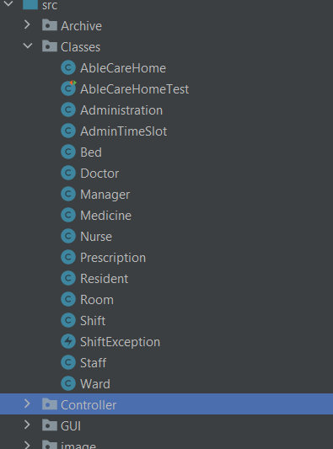

F.g.1, the classes in my src

Next, I also implemented GUI with Scene Builder and JavaFX. They are not difficult to learn and are very convenient. I create a few scenes to get information from user. 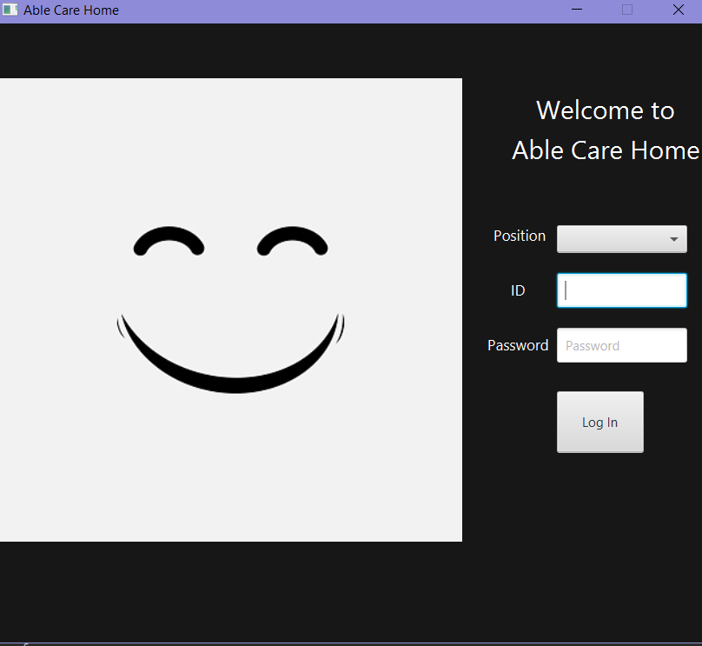

F.g.2, my log in scene

The most important part for myself is about the data saving and consistence. I saved the information for resident, doctor, nurse and manager to txt files. So that, I can access them whenever I boot the system.

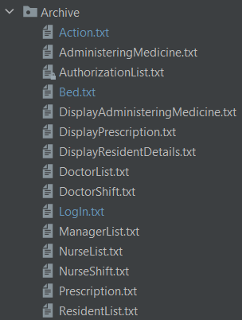

F.g.3, data in archive