COSC2083 – Introduction to Information Technology

Assignment 2: The IT World

Phong Nguyen

s3904419

I declare that in submitting all word for this assessment I have read, understood and agreed to the content and expectations of the Assessment declaration.

Table of Contents

1. Team Profile: 3

2. Tools: 3

3. Project Ideas: 4

4. IT Technologies: 8

5. IT Work: 10

6. Feedback: 13

7. Reference: 14

# 1. Team Profile:

- Team name: Amigos.

- Team profile:

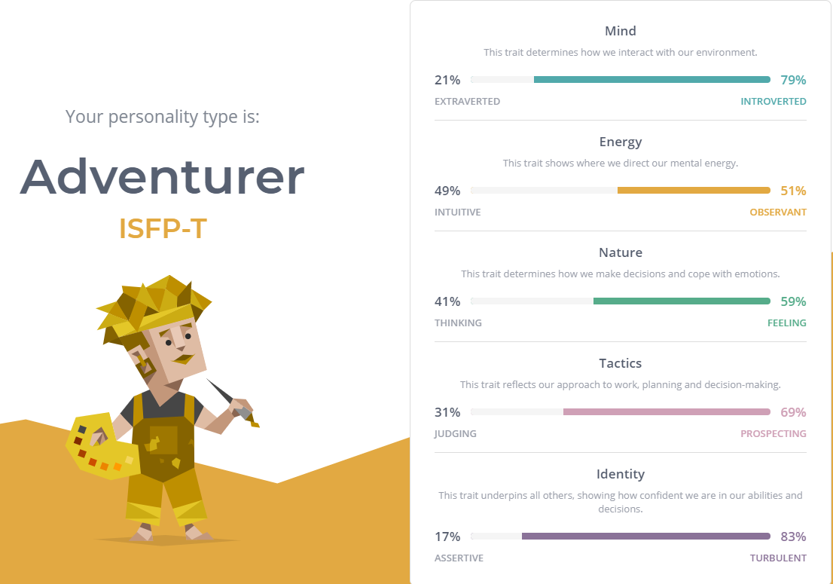I am easily stressed and having a teammate with a strong mental could really help me with my emotions. I am also not a natural team leader, however I can have many interesting idea to contribute to the team. It would be best if I can have teammates that cover most of the irrelevant tasks for me, such as asking teachers for suggestions, or designing the report or PowerPoint presentation, so that I can focus on critical thinking and contribute the best idea possible for any project. In a project, I believe that I can take more work to myself, such as covering the longest writing part in a report, or creating the first prototype for the team. Therefore, it is best if my teammates can cover my weakness, then it can be assured that I will contribute my best in any project.

# 2. Tools:

Website link: <https://s3904419.github.io/project/>

GitHub repository: <https://github.com/s3904419/project>

# 3. Project Ideas:

* Overview:

This project might have limited usage, because it serves a rather personal purpose. I have many cousins that are 3 years old or younger. The kids usually watch counting challenges videos on YouTube during lunch and dinner time, for the kids to silently eat. Some of the parents ask me if I can do a counter on some custom devices so that their children can focus on that, instead of being annoying and interrupt them. This is the purpose to create an Arduino project that basically counts the number of times the button is pressed.

* Motivation:

As mentioned in the overview, the motivation for this project is to help the parents from their little kids from interfering with their free time. Although the project is only a counter on an Arduino board, there could be many variations and updates that could help create some little games. A possible improvement is that I can add a stop clock that stops the time after the counter reaches a certain number. This could develop a quick game to decide who can press the button 10 times in a shorter time for example.

* 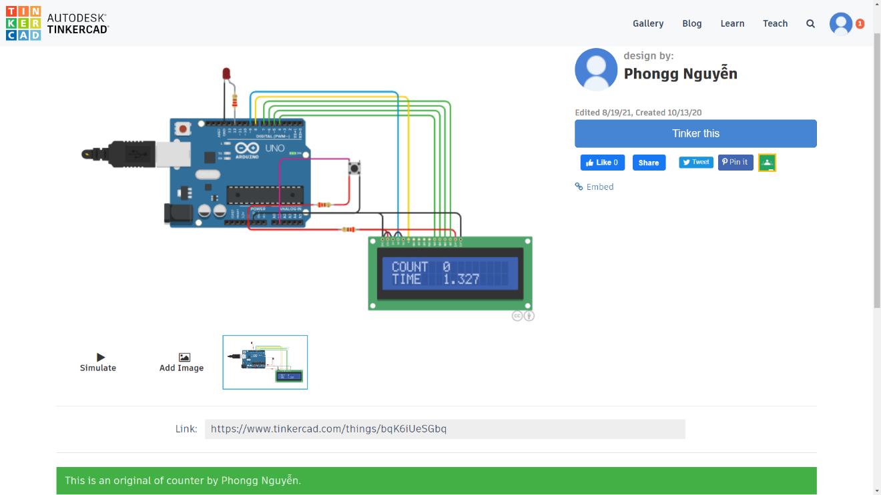Description:

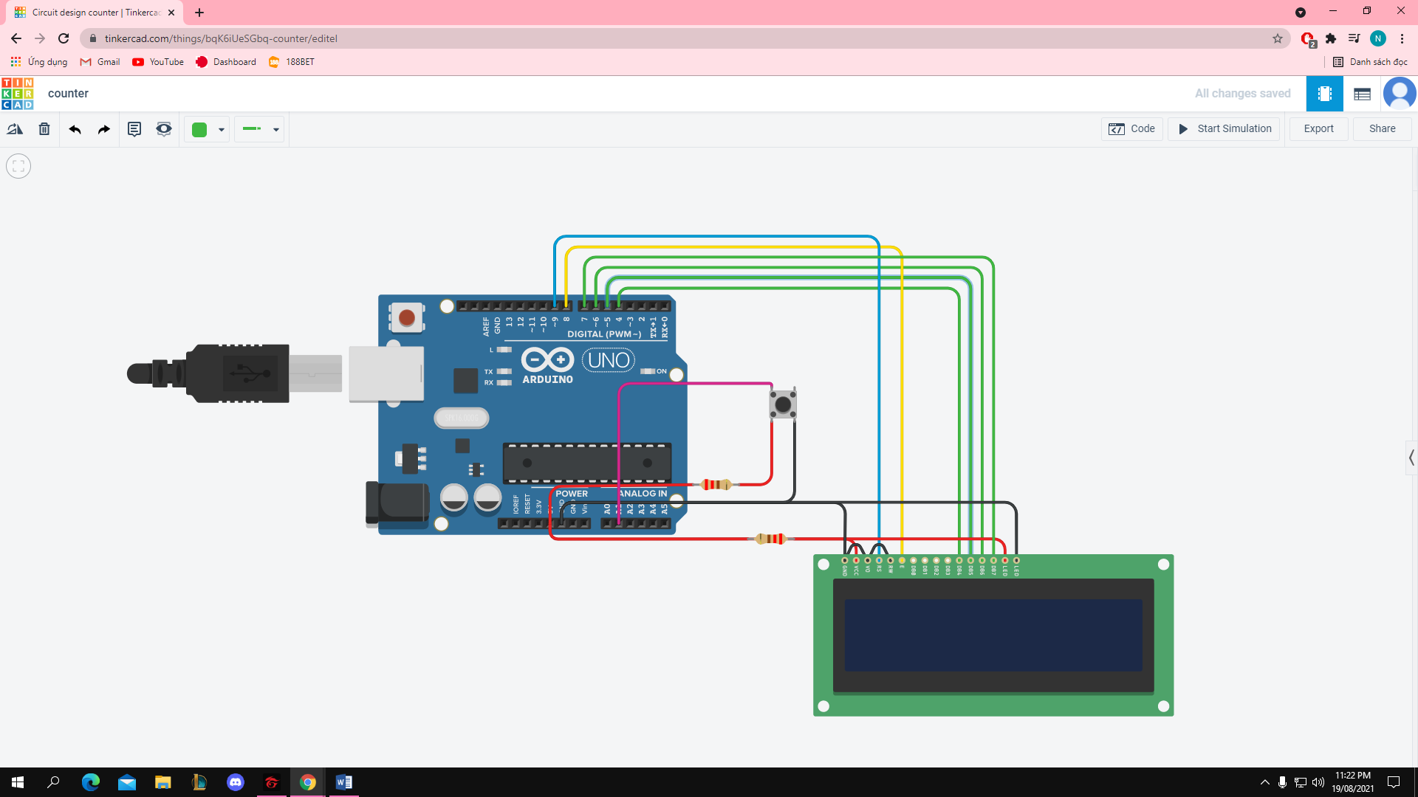This project will use an Arduino Uno R3 board and an LCD screen connected to the board to display the counter. Tinkercad provides an online simulator which is easier to demonstrate for this report, and simpler to process, since I am not familiar with Arduino. The functions are completely similar to an actual Arduino board. The red wires are connected to the anode (+) input, while the black wires are connected to the cathode (-) pins. The green wires are connected to pins 4 to 7 in both the board and the LCD screen. The button is wired to an analog input.

The code uses C++ programming language, and the Liquid Crystal library is imported to support the coding experience. Other Arduino standard libraries are also used for this project (Arduino, 2021). It can be seen in the first screenshot that the LCD screen will display the count on the first row, and timer will run on the second row. Most of the counting videos that kids under 3 year-old only counts to 10 or lower, so the program would stop both the counter and the timer when count reaches 10. The maximum count and the timer can easily be changed to fit different purposes or activities. Coding the counter to increase the number every time button is pressed is not difficult, but the timer is the trickiest part.

If the user only presses the button, the count will increase and the timer will keep running. Users can also hold the button and the timer will pause. With this feature, the simple counter can now act as a temporary stopwatch. Adults have better choices for stopwatches, but parents can take advantage of this to use as a toy for toddlers. Children 3-year-old or younger tend to have a low attention span, which leads to having low patience. Apart of spamming buttons for the counter to run, parents can use the stopwatch to trick their children to become more patient, by noticing the timer and hold the button at a particular point, and reward the kids with a small treat to encourage them.

When the simulation starts, the LCD screen will display a “Welcome” text for 2 seconds, then show the counter that starts at 0 and the timer will also start running. As mentioned above, the timer will stop permanently when the count reaches 10. There is a minor downside that is the small delay between each count, so spamming the button would not increases the count to 10 immediately, but take roughly 3.5 to 4 seconds. The timer would temporarily stop when the button is pressed and hold, and it continues when the button is released. The red button on the Arduino board would reset the entire program when pressed, and the simulation will restart, starting with the welcome message again.

This is only an online simulation, so it is difficult to add more complicating devices or techniques. However, if this can become a physical Arduino project, an Arduino microphone can be attached, and the number of features can increase dramatically. The microphone can detect voices, and count how many times a toddler say “papa” or “mama” in one day for example. This feature can be incredibly useful for parents to have more fun with their children, especially 1 or 2-year-old kids as this is the time they are learning how to speak.

* Tools and technologies:

The Arduino Uno R3 board and a compatible LCD screen is connected to it for this project. The code programming language is C++, and there are many built-in libraries provided by Arduino to support the project. There was a huge struggle that no Arduino board is available because online shopping is blocked due to COVID-19. Luckily, Tinkercad provides an online simulator for the Arduino circuits. Some experiences or features might be limited on the simulator compare to the physical Arduino boards, but this is an acceptable prototype for presentation.

* Skills required:

The most important skill needed for the project is having knowledge of C or C++ programming language. Since this is not a challenging project, students with moderate coding skills can be able to finish this work. An Arduino Uno R3 board and a 16x2 LCD screen is also required. These hardware equipment are not difficult to purchase, as it is sold online on many shopping platforms, such as Shopee or Lazada. If the hardware is not available, Tinkercad website is a good alternative for having an online simulation of this project.

* Outcome:

It is clearly noticed that this project might not have a huge impact on a large population, however it would help parents with 3-year-old children or younger have an extra tool to play around with their kid. The initial purpose of the work is to create a simple counter with easy instructions for toddlers to play with and somehow cheat on counting challenges on YouTube videos that they watch on a daily basis. This simple Arduino board can also distract children from smartphones and tablets, and focus more on having fun with toys and people around them. Stopwatches can also develop patience on children, where they are required to notice the timer and stop the clock at some particular number in exchange for a small treat from adults. A simple counter with a timer can create various flash games for children and parents to play together, therefore having a closer connection.

# 4. IT Technologies:

Arduinos microcontroller and natural language processing are the two significant IT technologies that is relevant to this project. Arduino is an open-source electronics platform based on easy-to-use hardware and software. Arduino has been the core of thousands of projects, from simple everyday objects to complex machines. The community of makers consist of different types of people - students, programmers, professionals, etc… Arduino was created at the Ivrea Interaction Design Institute as an easy tool for fast prototyping, aimed at students without a background in electronics and programming. This is why introducing Arduino to toddlers can have a huge impact in their lives, because from a programmed simple game for kids, they can create new projects themselves when they get older.

IT projects using Arduinos board are mostly on a small scale, mostly created by university students doing a particular assignment. Microcontrollers was a course that I studied in my previous university, specifically Raspberry Pi and Arduinos. However, the number of jobs related to microcontrollers are not as popular as other sections of IT. This project is also a simple creation, but it can introduce Arduinos, or microcontrollers in general, to a completely new group of audiences, that is parents and toddlers. Xbox or PlayStation machines might be too expensive for some parents, or adults simply do not want to spend too much on a game for their children. Another point is that there is a limited number of toys or games for toddlers. Arduino boards are affordable, and there are various codes available online that are interesting games or entertainment for children.

The project already has an online prototype on Tinkercad. It contains an LCD screen displaying a counter and a running timer. Many improvements and upgrades can be done from this initial prototype. An example stated earlier was too add a microphone that can detect and count the number of times a particular word is said. This variation can create extra use for the Arduino, such as counting the number of curse words being said in the house for one day, so parents would raise awareness and avoid speaking bad language in front of their children. Another interesting idea is that the microphone is set close to a baby after the kid speaks their first word, to determine how many words they speak in their first day possible. This could be a fun fact that follows the children for their remaining life.

Natural language processing is another technologies that could be included in the project. It is a branch in Artificial Intelligence, where it gives the computers the ability to detect understand texts and spoken words like human beings. Natural language processing are being applied in many fields, especially Google. Google has such a powerful natural language AI to support different apps, such as Google Translate or Google Search. Speech recognition is the most important part needed for my project, since the target audiences are toddlers, the language they speak might have incorrect grammar or pronunciations. The tasks for this project is simpler, only to detect how many words are being said. In a few years’ time, I hope to develop my skills and upgrade the functions of the natural language processing power in the project, to at least fully able to convert speech to text, and from there automatically provide a response from the keywords heard.

It is mentioned that this project would have impacts on toddlers and elementary students. Arduinos can be a crucial part for kids and their imagination for a long time. The targeted audience for this project is toddlers and parents. When those children grow up and go to elementary or middle school, they can reuse the Arduinos and start their own simple projects. Hundreds of projects are made and published by 8-15 year-old students. Arduinos can become the main entertainment for students instead of smartphones and gaming. It can be seen that most children nowadays have a personal smartphone at a young age, and it might affect their imagination when kids usually use their smartphone for social media and gaming. In my daily life, perhaps friends of my parents might see the potential of this project, and contact me for a test product. It would give me a chance to promote my Arduino program, and also to create new connections to the parents and their children.

# 5. IT Work:

<https://www.youtube.com/watch?v=EdcHU2SK8bM&ab_channel=ChauCodes>

This video is about a day of a developer working from home, where he studies MongoDB and edit some photos and videos for social media. His day starts at around 9-10 am, and he checks his work email to see if there is any work assigned to him. Then, he spends a a little time editing one photo for Instagram before completely focusing on study MongoDB. After that, he has a small break before going back to study for another few hours. After he finishes studying, he starts to edit the video for YouTube channel and call it a day.

This IT professional spends most of his time on the computer to work, and this video does not mention any interaction with coworkers or other clients or investors. It can be seen that he has a good balance between work and personal interests, where he spends an equal amount of time for studying and editing videos. This coder works from home, so his working time is flexible, and he starts the day quite late, but he manages to cover it by working in the evening. In this video, he is only studying, not actually working so there is zero interaction with any coworker or clients.

<https://www.youtube.com/watch?v=QjMJsQx_O7o&ab_channel=KalleHallden>

This video is about a day of a software engineer working from home. He describes his everyday job to be “trying to figure ways to do thing you do not really know how to do” and fixing bugs and errors existing. At 12pm he has his first meal and went for a walk after, before spending the remaining time in the afternoon to continue coding. After that, he has dinner and free time before going to bed.

This video does not mention any interaction with coworkers or other clients or investors. He spends most of his time on the computer to code, but there are also time where he spends walking outside for fresh air, or watching TV in the living room. The amount of break time is almost equal to the time he spends on the computer.

<https://www.youtube.com/watch?v=j1fc0FlCjyI&ab_channel=JustinHammond>

This video is about a day of a software engineer working from home. His working hours are flexible, and the work span various categories, from fixing bugs, writing scripts, documentation, etc… He starts the day by browsing GitHub and checking emails, mostly emails about team members pushes codes that need review, and proceeds to work on those code submission review. Then he checks the board for new tasks to do, or simply finishes the work he was working on yesterday. Next, he brings his newborn baby out for a first checkup, before going home for a team meeting and back to coding. In the afternoon, he starts pair programming with a coworker for some fresh ideas, or simply to study and have a new point of view. At the end of the day, he double check emails and Slack messages, and submit code reviews.

This video provides a closer look on how work is really done in one day, not just breaks or cooking clips. He interacts with coworkers through emails, Slack messages or online calls, interact with the public through GitHub repositories or comments on his code, and balances the work with some time for his newborn, or gaming time in the evening with his friends or coworker. He spends most of his time on the computer, and he is very productive during the day, because he has some breaks in between to refresh his mind.

<https://www.youtube.com/watch?v=fqYvp0C3pX4&ab_channel=SinghinUSA>

This video talks about a day in life of a 22 year-old software engineer working from home. He wakes up early to go to the gym, then starts a working day by checking emails and boards for tasks, before joining a team meeting call. Then he starts to work on the given tasks. Between the morning and afternoon sessions, he has a short break time for lunch, then he joins a team call again for some updates. He ends the day by going to the grocery store and stroll around the campus in the evening.

This IT professional is working on his tasks individually, and he interact with his co-workers not much for a day. Like many other IT professionals, he spends a majority of his time on the computer, with a standard lunch break and the evening off. In this video, the IT professionals seem to strictly follow company working hours, he starts at 8.30pm and finishes the day at around 5-6pm, not as flexible as other work-from-home professionals.

<https://www.youtube.com/watch?v=sS6O7Yp5xmg&ab_channel=JoshandKatie>

This video talks about a day in life of a Twitter software engineer. He comes to work at 9am and starts the day with breakfast before heading to his desk. He proceeds to code individually for around 2 hours before talking to his coworker asking for opinions. He takes a 20-minute lunch break before going back to work and has a meeting in the afternoon. After the meeting, he looks for a comfortable place and continue to get work done until 4.30pm. This video does not cover much, it shows a standard working day with no working overtime or starting the day late, because then he would have the entire evening for himself and his date.

My future desirable job is to become a programmer or a software engineer. 4 out of 5 videos are IT professionals working from home, probably because of the COVID-19 pandemic, and all the videos seem to demonstrate a pattern. They have excellent time management, follow a schedule and routine, having breaks in between, and clearly show how a productive working day should be. IT professionals working from home can have a more flexible schedule, where they can start the day later, or having more short breaks when they are coding. Some chooses to have a standard and normal schedule, where they start and finish the day in normal working time. IT professionals mostly work individually, but they also have meetings with coworkers every day to stay updated, and the work can also varies, not every day is coding only. The most challenging aspect is probably time management, because coding is very time consuming, tasks usually take a long time to finish. Without effective time management skills, IT professionals working from home can have trouble balancing work and life. For example, if he/she wakes up late, they would have to sacrifice their own free time in the evening to cover for the missing morning working time. Although there are many challenges for IT professionals working from home, time management can be considered the hardest problem.

# 6. Feedback:

Dat Nguyen (s3894433): “The Arduino project is a great idea as the parent will have another simple toy to play with their kid. Moreover, this could attract the kid to stay away from mobile devices. However, there are some problems with safety here, how about the little baby under 3 years old, do they allow to play with this toy due to their awareness is not enough and it can cause some issues, for instance, they can bite it…”

Dung Le (s3915085): “The project of Arduino is a fantastic and interesting idea for kids since most of the parents these days tend to let their kids deal with technology too soon such as phone, iPad and more, it might cause them addiction if they do not have a strict schedule of using them. What if the Arduino can be also considered a fun toy for children? In addition to work as a counter, it could have more things to do like having alphabetical games, playing some kid music or more perhaps. Furthermore, the project should provide some safety information since it is the most important thing when dealing with kids who have no awareness.”

The two feedbacks briefly compliments the idea, but also states the disadvantages of the project. The comments are quite short and might not be constructive enough, but I agree with all the ideas being said. Both the comments have some safety concern about turning Arduinos into a toy for toddlers. It can be seen that the Arduino boards and its components are small, which could actually cause some danger for children. A possible solution is to increase the lengths of the wires, and only put the button in front of the babies. The button should also be attached to something, in case the baby grabs it and put it in their mouth. Dung comments that other games should be installed too. It is a great idea and it is very possible to happen in the future. There are many extra equipment and add-ons that are compatible with Arduino boards, and parents can easily purchase them for a cheap price to upgrade their children’s experiences with Arduinos.

# 7. Reference:

Arduino.cc. 2021. *Libraries - Arduino Reference*. [online] Available at: <https://www.arduino.cc/reference/en/libraries/> [Accessed 20 August 2021].

Arduino. 2021. *What is Arduino?*. [online] Available at: <https://www.arduino.cc/en/Guide/Introduction> [Accessed 20 August 2021].

Create.arduino.cc. 2021. *115 kids Projects - Arduino Project Hub*. [online] Available at: <https://create.arduino.cc/projecthub/projects/tags/kids> [Accessed 20 August 2021].

IBM Cloud Education. (2020, July 2). *What is natural language processing?* IBM. https://www.ibm.com/cloud/learn/natural-language-processing.

RobotShop. 2021. [online] Available at: <https://www.robotshop.com/community/forum/t/arduino-101-timers-and-interrupts/13072> [Accessed 20 August 2021].

W3School. 2021. *CSS Template*. W3CSSTemplate. Available at: <https://www.w3schools.com/w3css/tryw3css_templates_blog.htm>.