**INDEX.HTML**  
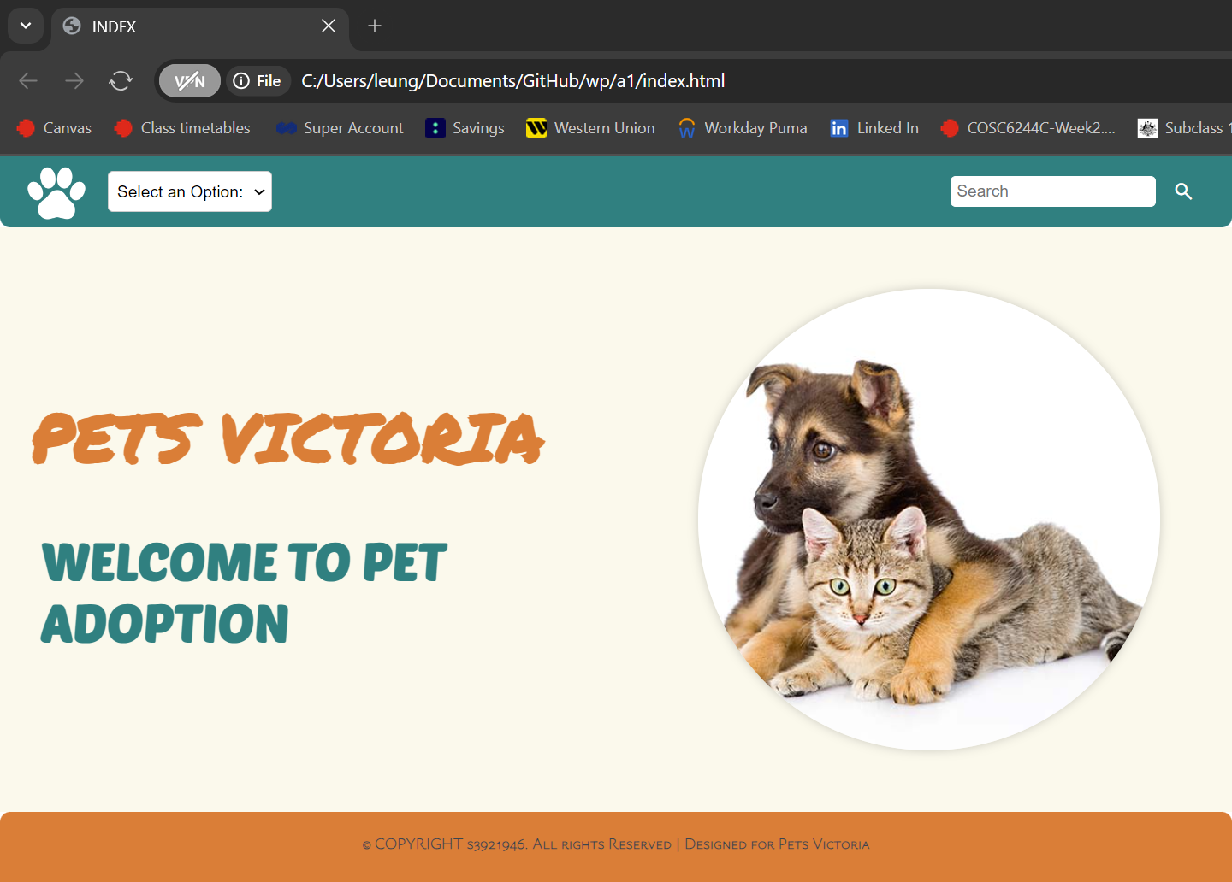 **ADD.HTML**

**GALLERY.HTML**

**Pets.html**

