**Screenshots of the validated HTML pages and the CSS file**

**Index.html**

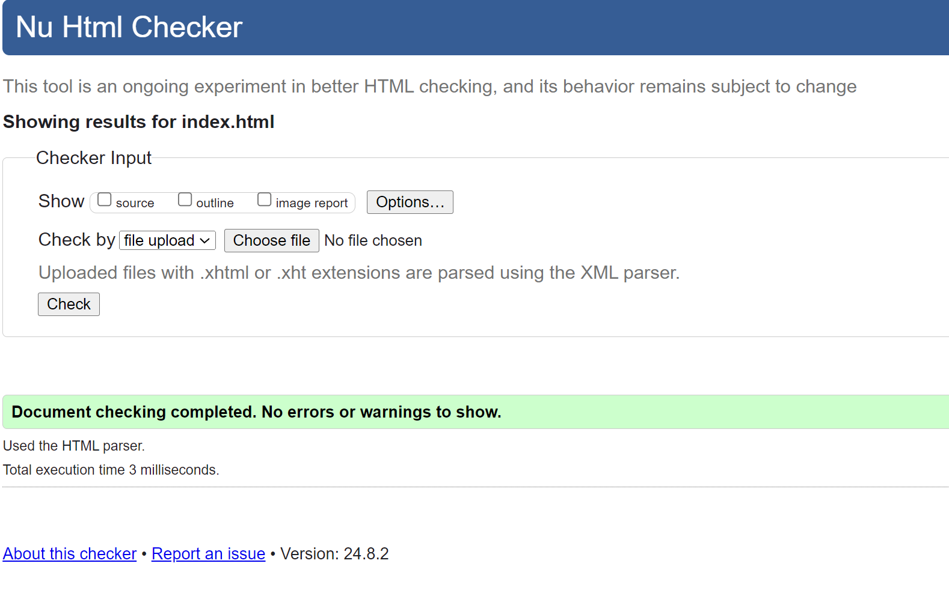

**Pets.html**

**Add.html**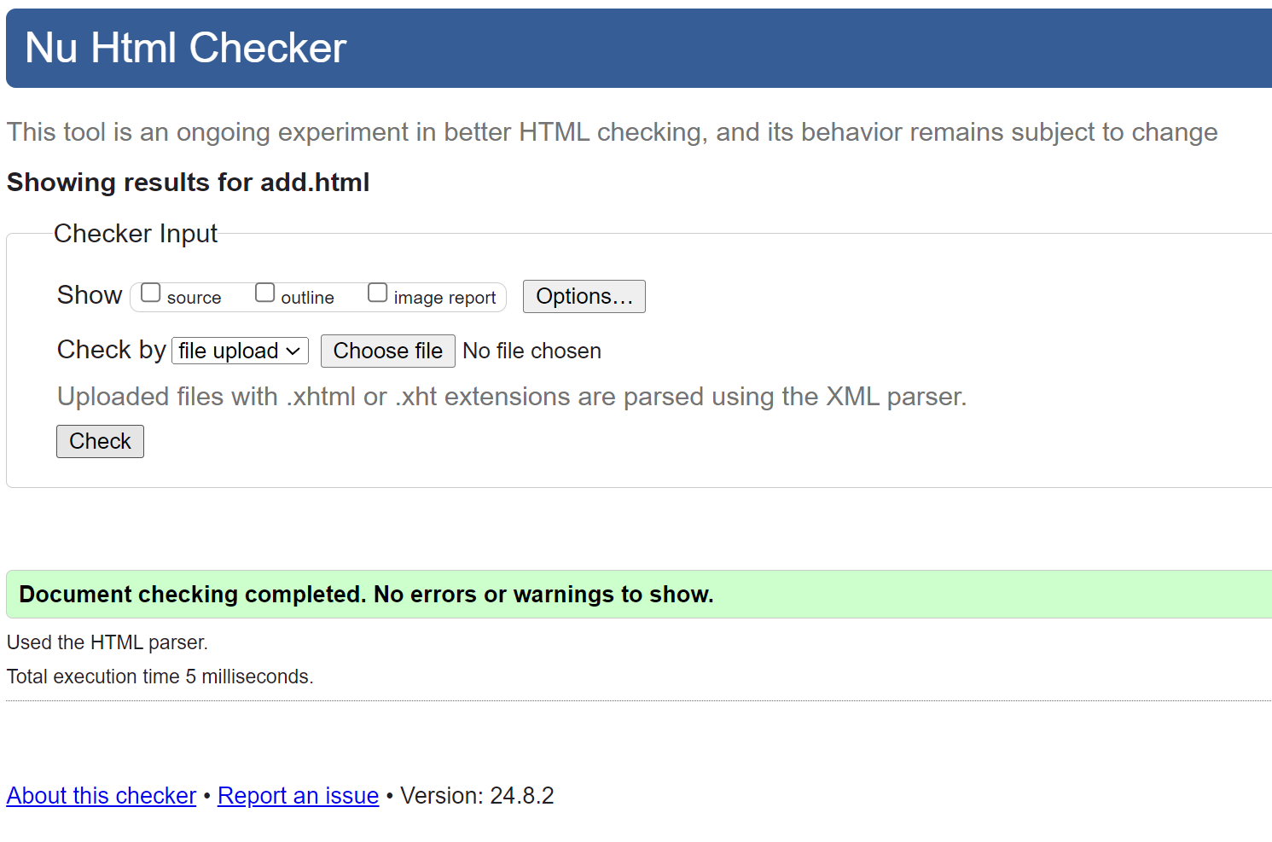

**Gallery.html**

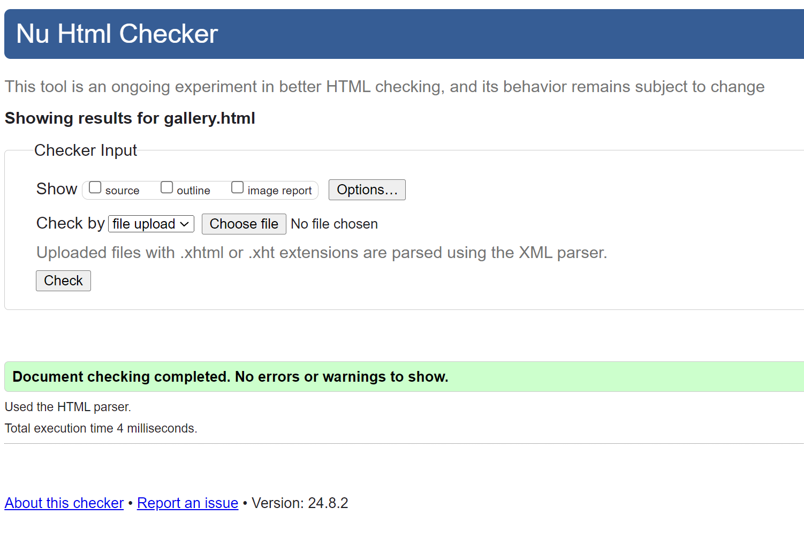

**Styles.css**