VC-461 Woofya Data Scraper Project Report
Programing Project COSC2048
Semester 2 2024
Final Version

Contents
Introduction 3
Project Objectives 4
System Architecture 5
Web Scraper Methodology for Event Data 7
Web Scraper Methodology for Accommodation Data 10
Accommodation & Events Data Validation and Cleaning 11
API Development and Integration 13
Testing and Validation 15
Challenges and Limitations 16
Future Enhancements and Recommendations 17
User Feedback and Usability Testing 18
Reflection on Project Outcomes 19
Conclusion 20

Introduction

The Woofya Data Scraper project was conceived as part of the COSC2048 Programming Project curriculum to meet the growing demand for consolidated pet-friendly event and accommodation data. Pet owners increasingly seek dog-friendly locations for events, vacations, and daily outings, yet this information is often fragmented across various sources, making it challenging for users to find reliable, comprehensive details. Recognizing this gap, Rhys and Rachael, the founders of Woofya, partnered with our team to create a solution that would unify this data in a single, accessible platform. Their goal was not only to build a resource for pet owners but to foster a connected community of individuals seeking to enjoy dog-friendly experiences with ease.
The Woofya platform is designed to provide users with a reliable, regularly updated guide to dog-friendly events, accommodations, and activities. The project differentiates itself through both technical sophistication and user-centred design. From the start, the system architecture and data pipeline were developed with an emphasis on scalability and adaptability to evolving user demands, ensuring Woofya remains a high-quality, trusted tool as data and user numbers grow. By leveraging a Python-based web scraper, an optimized MySQL database, and a secure REST API, Woofya achieves a balance between flexibility and robustness.
This report details the technical design, architecture, and data management processes that form the foundation of the Woofya platform. It explores how these components work together to deliver accurate, relevant, and up-to-date information on dog-friendly events, locations, and accommodations. The report also includes a thorough discussion of the challenges faced, solutions implemented, and recommendations for the platform’s future scalability, ensuring Woofya’s continued success as a leading pet-friendly resource.

Project Objectives

The Woofya Data Scraper project was established with the primary objective of creating a reliable, user-friendly platform that aggregates and provides up-to-date information on dog-friendly events, locations, and accommodations across Australia. To achieve this, we outlined several core goals focused on the system’s technical functionality, data quality, security, and scalability.
- Developing a Robust Web Scraper: Our first objective was to build a robust, adaptable web scraper using Python that could collect data from various websites listing dog-friendly events and accommodations. This scraper needed to be flexible enough to handle different site structures and dynamically rendered content, capturing all relevant details without manual intervention. By designing the scraper to handle JavaScript-rendered pages and pagination, we ensured comprehensive data collection, enabling Woofya to stay current with new events and listings across multiple sources.
- Ensuring Data Accuracy and Consistency: A critical objective was to maintain high standards of data quality through thorough validation and cleaning. To achieve this, we developed processes to deduplicate entries, standardize date and location formats, and validate each record’s completeness. This rigorous approach allowed us to deliver data that users could trust, reinforcing Woofya’s reliability as a pet-friendly resource. The data cleaning pipeline was designed to run automatically, ensuring that new data met quality standards before being inserted into the database.
- Designing a Scalable Database Architecture: We aimed to create a database system capable of supporting large volumes of data and quick retrieval speeds. Using MySQL as the backend, we structured the database with tables for events, locations, accommodations, and reviews, applying indexing and foreign keys to optimize query performance and maintain data integrity. This architecture not only supports current needs but is also flexible enough to accommodate future data growth as additional sources and features are incorporated into Woofya.
- Implementing a Secure REST API: Another objective was to develop a REST API using Flask/FastAPI that would allow users to interact with the platform securely. This API includes endpoints for retrieving, creating, updating, and deleting records, providing flexible access for both end users and administrators. Security was a top priority, so we implemented JWT authentication for access control and encrypted data transmission via HTTPS. These measures ensure that user data is protected, meeting the high security standards expected by our clients.
These objectives were refined and expanded upon through biweekly meetings with Rhys and Rachael. These sessions provided opportunities to align our development approach with the clients’ vision, allowing us to incorporate feedback and adjust the design to support Woofya’s long-term growth and usability. This iterative process ensured that our objectives were not only met but also adapted to the evolving needs of Woofya and its user community.

System Architecture

The Woofya system architecture is organized into three core components: the web scraper, MySQL database, and REST API, each essential to seamless data collection, storage, and retrieval. The web scraper, developed in Python, gathers data from targeted websites and manages challenges such as dynamic content and pagination. This scraper feeds the data into the MySQL database, where SQL facilitates structured, scalable data storage with optimized tables for fast retrieval. The REST API, built with Flask/FastAPI, provides authorized users with secure access to the database through JWT authentication and HTTPS encryption.
Python’s versatility in data handling and SQL’s robust querying capabilities allowed for efficient development, ensuring data is readily accessible for front-end applications. Regular meetings allowed for iterative refinements, ensuring the architecture aligned with client requirements for future scalability.

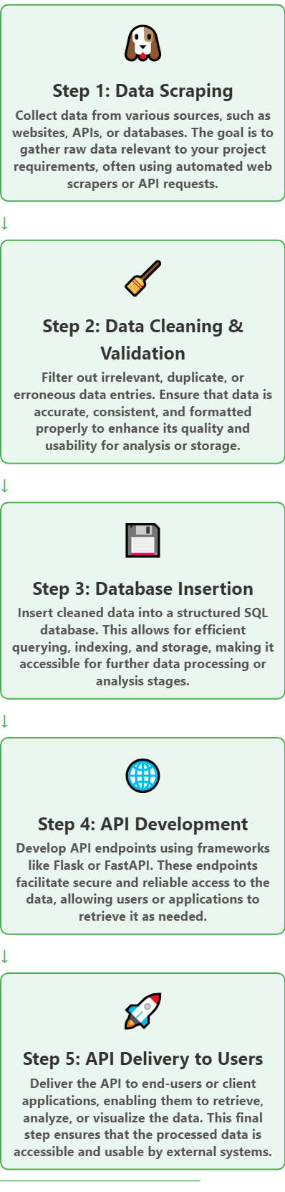

Web Scraper Methodology for Event Data

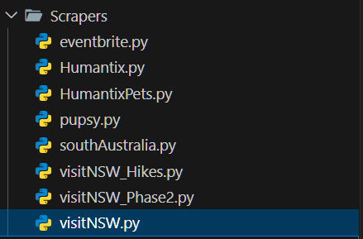
“Scrapers Project Directory”
The event data scraper for Woofya was meticulously designed to aggregate information on dog-friendly events from multiple online sources. Each script was crafted to handle different site structures, including static pages, paginated content, and dynamic JavaScript-based content, to ensure comprehensive data coverage. For this project, we targeted platforms such as Humanitix, Pupsy, Visit NSW, and South Australia Events, which list dog-friendly events across Australia. The web scraping scripts were written in Python, leveraging libraries like requests, BeautifulSoup, and requests_html to efficiently navigate, parse, and extract event data. Each script then outputs the data to a JSON file, saved in the Raw_Data directory, ready for further processing and database integration.
To ensure we targeted the correct data fields, Rhys and Rachael provided feedback during meetings, helping prioritize the information most relevant to end users. The following example demonstrates the ease with which Python libraries were used to build efficient data extraction pipelines:
Humanitix Event Scraper: The Humanitix scraper was set up to query event listings for "pets" across multiple pages. The script uses a loop to construct URLs for each page and retrieves HTML content using requests. With BeautifulSoup, it locates event blocks by their CSS class and extracts details such as event title, date, and location. Only events with "pet" in the title are stored, ensuring relevance. The extracted data is appended to a list, which is ultimately saved in JSON format. The scraper stops automatically if no events are found on a page, preventing unnecessary requests.
Pupsy Event Scraper: Targeting Pupsy's dog-friendly venues page, this scraper captures event-related venue data, including pubs and bars that host pet-friendly events. The script iterates through pages using requests and parses HTML content for venue blocks. For each venue, it extracts the name, link, and available amenities such as "Dogs Welcome Inside" and "Covered Outdoor." The amenities list provides valuable insights for users looking for specific venue features. This data is then compiled and saved in JSON format, ensuring consistent data structure and easy integration.

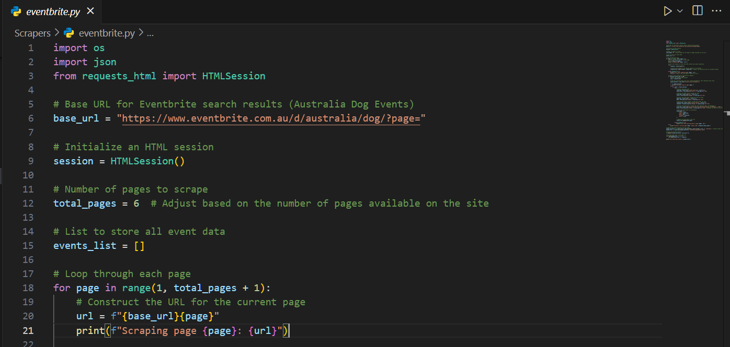
“Partial Code from EventBrite”
South Australia Events Scraper: Since South Australia Events relies on JavaScript to render dynamic content, we used requests_html to fetch and render each page. After rendering, the HTML is parsed using requests HTML’s built-in support for Beautiful Soup-like syntax. The scraper extracts each event’s title, location, and other details from specific HTML elements and stores them in JSON format. This dynamic rendering approach ensures all events are captured, despite the use of JavaScript on the website. Visit NSW Events Scraper: The Visit NSW scraper navigates through paginated search results for dog-friendly events, where pages are dynamically rendered. Using requests_html and puppeteer, the scraper loads each page, waits for JavaScript to render content, and then parses the HTML. It extracts key event details, including title, description, event link, and image URL. The extracted data is stored as JSON in the Raw Data folder, preserving metadata necessary for accurate representation in the Woofya platform. The script also includes a retry mechanism to handle timeouts effectively, ensuring comprehensive data capture.
The Eventbrite scraper, on the other hand, required a different approach due to the platform’s reliance on JavaScript to dynamically load event details. To address this, the scraper employs requests_html, which enables JavaScript rendering within the HTML session. By rendering the page content for each pagination step, the scraper accurately captures event information, including title, link, date, location, and price. Missing fields are assigned placeholders like "N/A" or "Free," ensuring the integrity of the data structure even when certain information is unavailable. Like the Humanitix scraper, the Eventbrite data is saved to JSON within the Raw Data directory.
The scripts are designed to handle errors gracefully, logging issues with data extraction and moving to the next page to maintain robustness. Each script checks that the designated output directory exists and creates it if necessary, ensuring that the final JSON file is stored in an organized, accessible location. This comprehensive and structured approach to data scraping ensures that even sources with complex page structures are effectively captured and that the data is ready for cleaning and integration into Woofya’s database.

Together, these scripts create a reliable and organized dataset that aligns with Woofya’s vision of providing pet owners with a centralized resource for dog-friendly events. The consolidated JSON data enables efficient data cleaning and preparation for database insertion, enhancing Woofya's ability to serve the pet-loving community with up-to-date, accessible event information across Australia.
This comprehensive and structured approach to data scraping enables Woofya to build a reliable and organized dataset that fulfills Rhys and Rachael’s vision of a centralized, pet-friendly event hub for Australian pet owners. The consolidated JSON data facilitates efficient cleaning and preparation for database insertion, enhancing Woofya's ability to serve the pet-loving community with up-to-date, accessible event information across Australia.

Web Scraper Methodology for Accommodation Data

The accommodation data scraper for Woofya was designed to gather information on dog-friendly accommodations from various online sources across Australia. Targeting websites that list pet-friendly lodging options, the scrapers were implemented in Python using libraries like requests, BeautifulSoup, and requests_html to navigate and extract data from different site structures, including static pages and dynamic content. Each script outputs the gathered information to a JSON file in the Raw_Data directory, facilitating easy access for further processing and integration into the Woofya database.
The scraper initiates by defining the target URL and sending a GET request with custom headers to mimic a typical browser. Upon receiving a successful response, it uses BeautifulSoup to parse the HTML content and extract key details about each accommodation, such as the name, location, description, booking link, and available amenities. These details are organized into structured dictionaries, which are then compiled into a list and saved as a JSON file for subsequent data cleaning and database insertion.
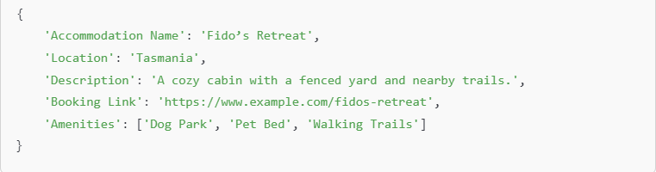
“Example of JSON for Accommodation”
To ensure reliability, the scrapers include error handling to log issues that may arise during the data extraction process, such as network errors or missing elements. This structured approach allows Woofya to compile a comprehensive dataset of dog-friendly accommodations, ultimately providing pet owners with centralized access to valuable information about lodging options. The organized JSON files enhance Woofya's ability to serve the pet-loving community effectively.

Accommodation & Events Data Validation and Cleaning
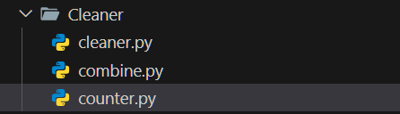
“Cleaner Directory Tree”
To ensure high data quality and reliability on the Woofya platform, we implemented a comprehensive data validation and cleaning pipeline for both event and accommodation data. This process was essential for maintaining consistency, accuracy, and usability, as inconsistencies in details such as event dates, names, and locations could compromise the platform’s effectiveness. Key steps in this pipeline included deduplication, standardization, schema validation, and completeness checks, all performed using Python scripts.
For both events and accommodations, de-duplication was the first step. Duplicate entries, typically detected by comparing titles and dates, were removed to prevent redundancy in the database. A custom function using Python’s panda’s library removed duplicates based on a combination of the event or accommodation title and date, retaining only the first unique entry. This method ensured that users would not encounter repetitive entries when searching for specific events or accommodations.
The next step was standardizing date formats to ISO 8601 (YYYY-MM-DD), which improved consistency and compatibility across data sources. Given that dates were often presented in various formats, we developed a function to identify common date formats and convert them into ISO 8601 format. This standardization allowed seamless data integration into Woofya’s database and simplified future queries based on date.
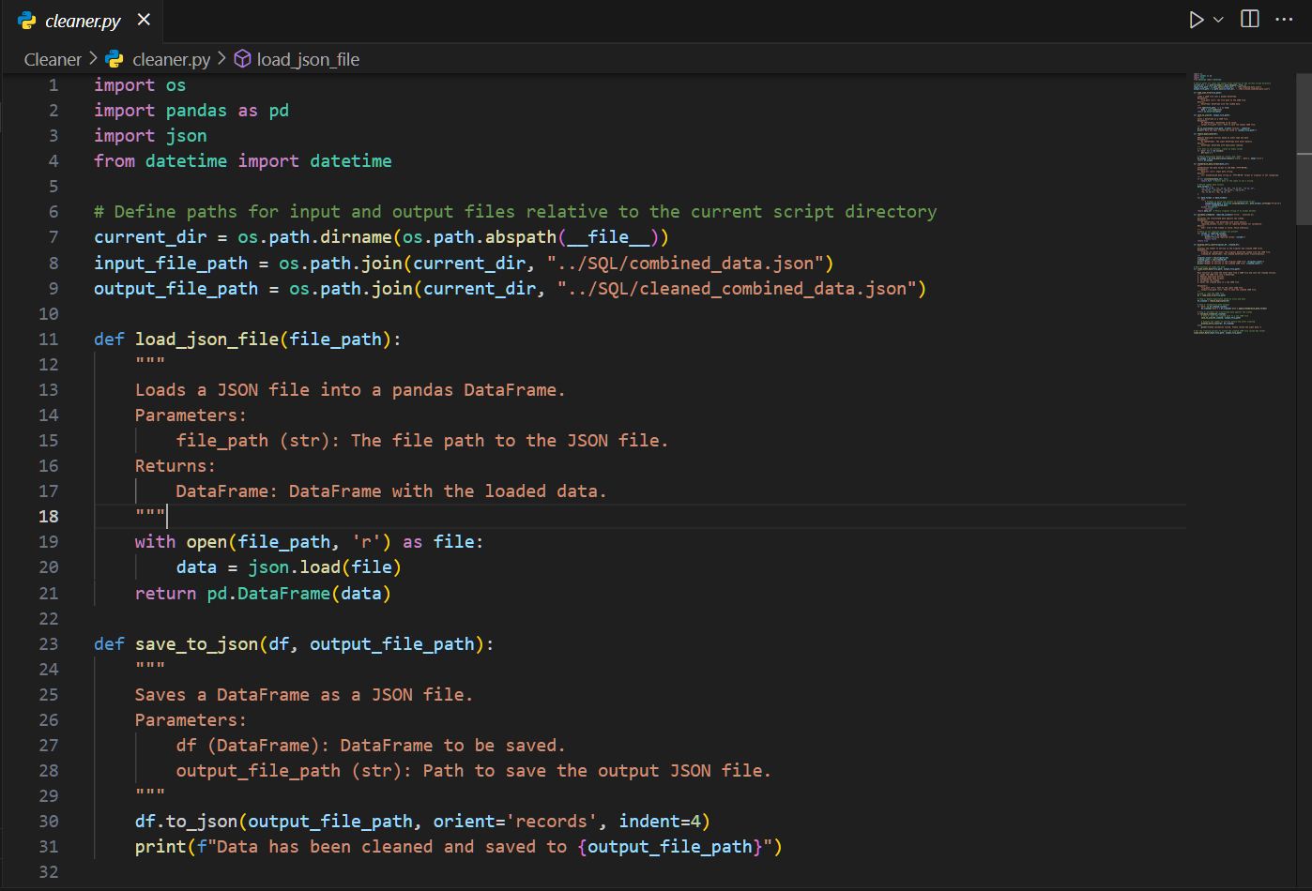
“
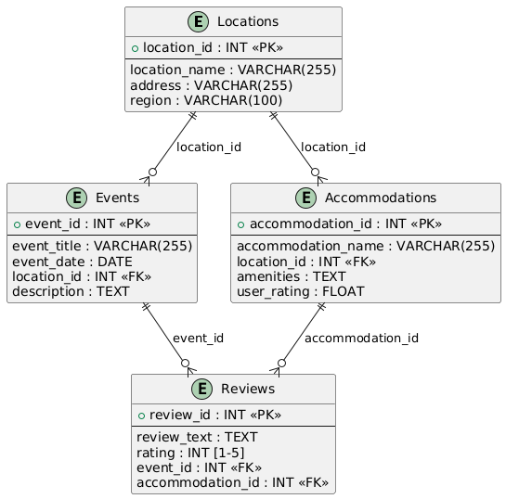
“1.1 Initial Woofya Schema”
Schema validation was another essential aspect of data cleaning. The schema validation function verified that each record contained required fields, such as title, location, and date, for events, and name, amenities, and address, for accommodations. Any entries missing these mandatory fields were flagged and excluded from the final dataset, preserving data integrity. The pipeline ensured schema adherence, promoting consistency across all records.
Finally, the cleaned data was stored in a JSON file within the SQL directory for further processing and loading into the database. A summary script displayed the number of entries before and after cleaning, providing insights into the volume and quality of the data. This robust cleaning process, reviewed with clients Rhys and Rachael during biweekly meetings, ensured the platform met their expectations for high-quality, reliable data on dog-friendly events and accommodations.

API Development and Integration
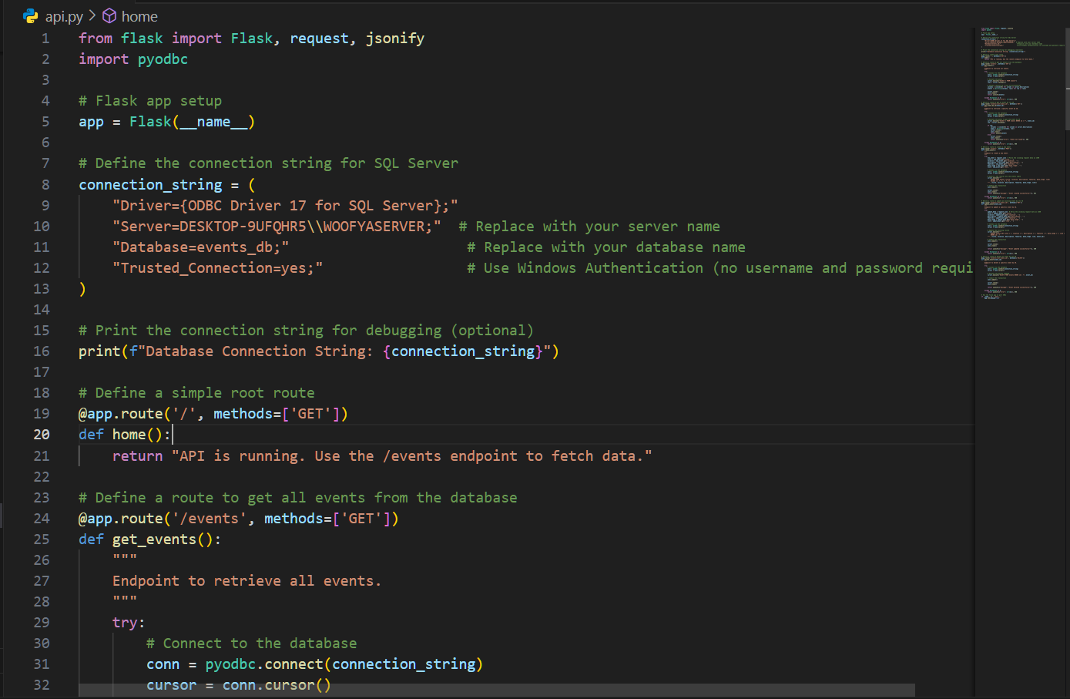
“API Code using Flask”
The API for Woofya was developed using Flask, with key design goals of providing efficient data access, ensuring security, and maintaining ease of use. The API enables the platform to handle multiple client requests, allowing users to interact with Woofya’s data on dog-friendly events and locations through standardized endpoints. Key security measures include JWT authentication for user verification and HTTPS encryption to protect data in transit, ensuring secure data exchange.
Primary endpoints include GET /events, GET /locations, and GET /accommodations, which allow users to retrieve event and location details quickly. Additionally, the API supports filtering via query parameters, enabling users to narrow results based on criteria like location and date. The design includes CRUD (Create, Read, Update, Delete) operations on events, empowering users to add, modify, or remove event details as needed. This flexibility supports a dynamic, user-driven environment where data remains current and relevant.
For the database connection, the API uses pyodbc to interface with a SQL Server database. In the GET /events endpoint, the API retrieves all events from the events table, formats each record into a dictionary, and returns it as JSON. This standardized format makes data retrieval consistent and easy to handle on the client side. To add a new event, POST /events accepts JSON input, extracts details like title, location, description, and link, and inserts the data into the database. The API’s PUT and DELETE methods allow users to update or delete events by specifying an event ID, promoting data integrity by enabling only targeted modifications.

The API's code includes error handling to manage issues such as connection failures or data mismatches gracefully, providing users with helpful messages when errors occur. During development, the API was thoroughly documented and reviewed with clients Rhys and Rachael to ensure usability and clarity, aligning with their vision of a secure and accessible data platform for Woofya users.

Testing and Validation

To ensure Woofya's platform met high standards of reliability and accuracy, testing was meticulously conducted across various stages, encompassing unit tests, integration tests, and manual validations. Each function in the system, such as data extraction, cleaning, and database interaction, underwent unit testing to confirm its correct functionality and robustness under different scenarios. For example, the web scraper was tested to handle changes in webpage structure, while the API endpoints were checked for correct responses to valid and invalid requests, ensuring stable and predictable behaviour across modules.
Integration testing was essential for validating the full data pipeline, from data collection via the scraper to the final delivery through the API. This testing phase assessed how well each component worked together, verifying that data flowed seamlessly and was accurately processed and stored. The integration tests simulated real-world usage, where data was fetched, transformed, stored in the database, and retrieved through API calls, ensuring no data was lost or misrepresented at any point in the process.
In addition to automated testing, manual checks were implemented to review samples of database entries for accuracy and completeness. This process involved comparing data points, such as event names, dates, and locations, with information on source sites to confirm alignment. These samples provided a snapshot of data quality and consistency, helping identify any discrepancies early.
Our biweekly meetings with clients Rhys and Rachael allowed us to share testing outcomes and gather their insights on data accuracy, usability, and response times. This iterative feedback loop facilitated continuous improvements and ensured that the platform not only met technical requirements but also aligned with user expectations for reliability and performance. Through this comprehensive testing and validation process, Woofya was rigorously optimized to provide pet owners with an accurate, dependable resource for discovering dog-friendly events and accommodations.

Challenges and Limitations

The Woofya project presented several challenges and limitations that required thoughtful strategies and ongoing adjustments. One of the main challenges involved dealing with websites that relied heavily on dynamic content or frequently updated their HTML structure. These changes occasionally disrupted the scraper’s parsing logic, necessitating regular code updates to ensure consistent data extraction. Dynamic content loading via JavaScript, in particular, posed additional hurdles, as it required the scraper to handle and render JavaScript to capture the full scope of event and accommodation data. Regular monitoring and updates helped address these issues, but the need for ongoing maintenance remains an operational consideration.
Scaling security measures to accommodate anticipated growth was another crucial focus area. As Woofya’s user base and data sources expand, the platform’s security infrastructure must evolve to protect sensitive information and manage increased data access. In meetings with Rhys and Rachael, we discussed best practices for enhancing security, such as implementing stricter access controls, regular API key rotations, and monitoring for unauthorized access attempts. The platform’s current security setup, which includes JWT authentication and HTTPS encryption, provides a strong foundation, yet ongoing updates and audits will be essential to keep pace with evolving security needs.
Additionally, verifying that all listed events and accommodations were genuinely pet-friendly posed a unique challenge. Many listings lacked explicit indications of pet-friendliness, making it difficult to filter results accurately based on the pet-friendly requirement. To address this, the platform occasionally relies on manual reviews to verify ambiguous listings and maintain data relevance. While effective, this approach is time-intensive and may need to be scaled with more advanced techniques, such as natural language processing (NLP), to automate content filtering. These challenges, while manageable, highlight areas for future improvement as Woofya continues to grow, ensuring the platform remains a trusted, accurate resource for the pet-owner community.

Future Enhancements and Recommendations

As Woofya continues to grow, scalability and advanced functionality will be essential to support an expanding user base and data volume. One recommendation is to consider moving to a more robust database solution, such as PostgreSQL or even a distributed database system, to handle larger datasets more effectively. This would allow for faster query performance and enhanced data management as new features and data sources are added. To improve the verification of pet-friendliness in event listings, implementing natural language processing (NLP) could automate the detection of pet-friendly terms within event descriptions, reducing the need for manual verification. Additionally, expanding data sources to cover a wider range of pet-friendly events and accommodations would further enrich the platform's offerings and attract more users. Finally, enhancing security measures, such as multi-factor authentication for administrators and routine API key rotations, will protect user data and maintain trust as the platform evolves. Together, these improvements will support Woofya’s growth, ensuring it remains a reliable and secure resource for pet owners.

User Feedback and Usability Testing

Initial usability testing with clients Rhys and Rachael provided valuable insights into the platform's functionality and user experience. Their feedback highlighted the importance of fast data retrieval and clear navigation, especially when users are looking for specific types of events or locations. Based on their input, we streamlined the user interface to make filtering by date and location more intuitive and responsive. Rhys and Rachael also emphasized the need for accurate, pet-friendly labeling, which informed our approach to data validation and manual checks. Additionally, they suggested displaying events with high pet-friendliness ratings prominently, leading us to explore ways to prioritize such listings in the user interface. This feedback helped shape Woofya into a more user-friendly and relevant tool, aligning the platform closely with the needs of its target audience.

Reflection on Project Outcomes

The Woofya project was a significant achievement, successfully creating a robust platform that aggregates and delivers accurate, pet-friendly event and accommodation data. Through this project, our team gained valuable insights into the intricacies of web scraping, data management, and API development, especially when working with dynamic content and multiple data sources. One of the key successes was deploying a scalable, automated data pipeline on AWS, which ensured that our data remained up-to-date and accessible without manual intervention.
The challenges we faced provided critical learning opportunities, particularly in adapting to frequent changes in web structures and handling JavaScript-rendered content. These experiences underscored the importance of flexible, modular code that can be adjusted as data sources evolve. Additionally, managing the project’s security concerns, such as securing API endpoints and scaling authentication measures, strengthened our understanding of best practices in secure data handling. Regular feedback sessions with Rhys and Rachael were instrumental in refining the platform to meet user needs, fostering an iterative, client-focused development approach. Overall, this project has not only met its goals but has also provided us with skills and strategies that will be invaluable in future projects.

Conclusion
The Woofya project successfully delivered a dynamic, user-focused platform for pet-friendly event and accommodation listings. By integrating Python-based web scraping, data validation, SQL database management, and a secure API, we created a scalable solution that meets the client’s vision for a reliable pet-friendly resource. The project’s success reflects a strong commitment to technical accuracy, adaptability, and user-centric design, achieved through effective project management and close collaboration with Rhys and Rachael. Moving forward, Woofya’s platform is well-positioned for future growth, with options for enhanced data sources, improved verification through NLP, and security scalability. This project exemplifies how targeted, well-organized development can transform data into a valuable resource, empowering pet owners across Australia to make informed decisions for their pet-friendly outings.

